Stat123_MT#1

#VNUM: V01003221

#Name: Evan O’Toole

#a)  
hours <- c(25,35,10,20,40,50)  
sum_hours <- sum(hours)  
avg_hours <- mean(hours)  
len_hours <- length(hours)  
len_hours

[1] 6

sum_hours

[1] 180

avg_hours

[1] 30

#b)  
df <- data.frame(hours, c("BC","ON","QC","MB","SK","AB"))  
names(df[,1]) <- df[,2]  
  
#c)  
hours <- df[,1]  
names(hours) <- df[,2]  
pie(hours)



The length of this sample is 6

The total in of the hours is 180

The average hours from these numbers is 30

#2  
#a)  
Protein <- read.csv("protein.csv")  
#b)  
colnames(Protein)

[1] "Country" "RedMeat" "WhiteMeat" "Eggs" "Milk" "Fish"   
 [7] "Cereals" "Starch" "Nuts" "Fr.Veg"

#c)  
class(Protein)

[1] "data.frame"

#d)  
ProteinMatrix <- as.matrix(Protein[,c(2,3)])  
ProteinMatrix

RedMeat WhiteMeat  
 [1,] 10.1 1.4  
 [2,] 8.9 14.0  
 [3,] 13.5 9.3  
 [4,] 7.8 6.0  
 [5,] 9.7 11.4  
 [6,] 10.6 10.8  
 [7,] 8.4 11.6  
 [8,] 9.5 4.9  
 [9,] 18.0 9.9  
[10,] 10.2 3.0  
[11,] 5.3 12.4  
[12,] 13.9 10.0  
[13,] 9.0 5.1  
[14,] 9.5 13.6  
[15,] 9.4 4.7  
[16,] 6.9 10.2  
[17,] 6.2 3.7  
[18,] 6.2 6.3  
[19,] 7.1 3.4  
[20,] 9.9 7.8  
[21,] 13.1 10.1  
[22,] 17.4 5.7  
[23,] 9.3 4.6  
[24,] 11.4 12.5  
[25,] 4.4 5.0

#e)  
names(ProteinMatrix) <- c("Beef", "Chicken")  
ProteinMatrix

RedMeat WhiteMeat  
 [1,] 10.1 1.4  
 [2,] 8.9 14.0  
 [3,] 13.5 9.3  
 [4,] 7.8 6.0  
 [5,] 9.7 11.4  
 [6,] 10.6 10.8  
 [7,] 8.4 11.6  
 [8,] 9.5 4.9  
 [9,] 18.0 9.9  
[10,] 10.2 3.0  
[11,] 5.3 12.4  
[12,] 13.9 10.0  
[13,] 9.0 5.1  
[14,] 9.5 13.6  
[15,] 9.4 4.7  
[16,] 6.9 10.2  
[17,] 6.2 3.7  
[18,] 6.2 6.3  
[19,] 7.1 3.4  
[20,] 9.9 7.8  
[21,] 13.1 10.1  
[22,] 17.4 5.7  
[23,] 9.3 4.6  
[24,] 11.4 12.5  
[25,] 4.4 5.0  
attr(,"names")  
 [1] "Beef" "Chicken" NA NA NA NA NA   
 [8] NA NA NA NA NA NA NA   
[15] NA NA NA NA NA NA NA   
[22] NA NA NA NA NA NA NA   
[29] NA NA NA NA NA NA NA   
[36] NA NA NA NA NA NA NA   
[43] NA NA NA NA NA NA NA   
[50] NA

The names are: Country, RedMeat, WhiteMeat, Eggs, Milk, Fish, Cereals, Starch, Nutes, Fr.Veg

Protein is a data frame

#3a)  
head(airquality)

Ozone Solar.R Wind Temp Month Day  
1 41 190 7.4 67 5 1  
2 36 118 8.0 72 5 2  
3 12 149 12.6 74 5 3  
4 18 313 11.5 62 5 4  
5 NA NA 14.3 56 5 5  
6 28 NA 14.9 66 5 6

hist(airquality$Temp, main = "Maximum daily temperature at La Guardia Airport", xlab = "Temperature in degrees Fahrenheit", breaks = seq(50,100), col = "darkmagenta", fill = "darkmagenta")

Warning in plot.window(xlim, ylim, "", ...): "fill" is not a graphical  
parameter

Warning in title(main = main, sub = sub, xlab = xlab, ylab = ylab, ...): "fill"  
is not a graphical parameter

Warning in axis(1, ...): "fill" is not a graphical parameter

Warning in axis(2, at = yt, ...): "fill" is not a graphical parameter

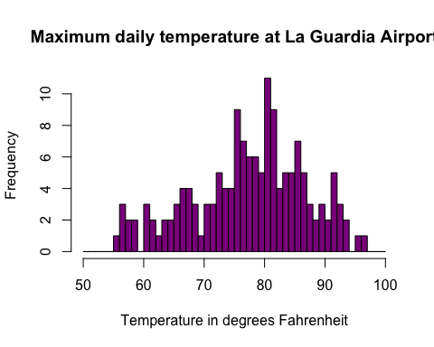

#b)  
library(ggplot2)  
ggplot(airquality, aes(x = Temp)) + geom_histogram(breaks = seq(50,100), col = "darkmagenta", fill = "darkmagenta") + labs(x = "Temperature in degrees Fahrenheit", title = "Maximum daily temperature at La Guardia Airport", y = "Frequency")

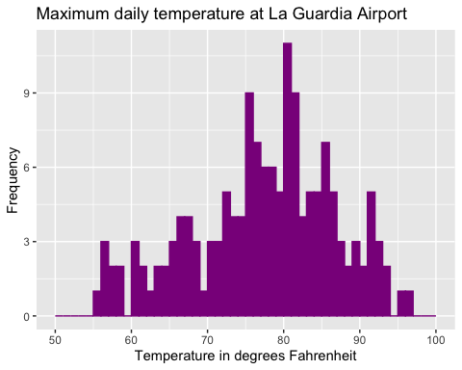

?par  
gear=as.factor(mtcars$gear)  
disp=as.factor(mtcars$disp)  
  
library(ggplot2)  
ggplot(mtcars, aes(x = cyl)) + geom_bar()

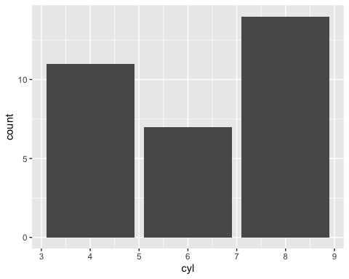

ggplot(mtcars, aes(x = gear)) + geom_bar()

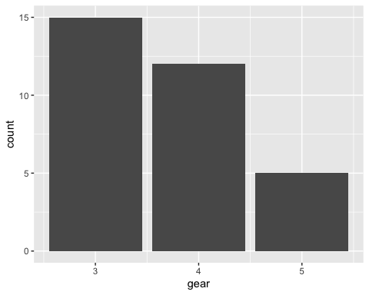

hist(mtcars$gear)

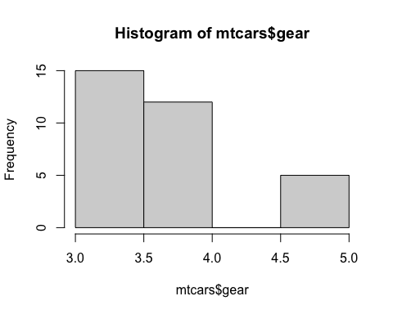

hist(mtcars$cyl)

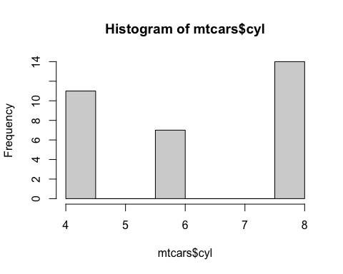

?hist