STAT 261 Lab 2

Fill in your name

Fill in the date

# General Instructions

* Execute each chunk of code to ensure that your code works properly.
* Save this .Rmd file and then knit the entire document to pdf.

# Learning outcomes

* use of hist() to plot histograms of generated/observed data (and appearance customization!)
* Adding density lines to histograms to model the relationship between the Chi-square and standard normal distributions
* use of geometric distribution functions, rgeom() and dgeom()
* understanding how to code (log-)likelihood and (log-)relative likelihood functions in R
* use of optimize() to find the MLE of your (log-)likelihood function
* use of uniroot() to find 100p% likelihood intervals
* use of round() to present rounded numerical values

## 1. The Normal(0,1) and Chi-squared distribution.

In this section, we see the relationship between Normal(0,1) random variables and the Chi-squared(1) distribution. Normal(0,1)^2 ~ Chi-squared(1)

# First generate 1000 random observations from N(0,1)  
set.seed(12345)  
myz <- rnorm(1000)  
  
# Plot a scaled histogram and overlay normal pdf  
h <- hist(myz, breaks=10, col="red",   
 main="Histogram with Normal Curve", prob=TRUE)   
xfit<-seq(min(myz), max(myz), length=40) #sequence of length 40  
yfit<-dnorm(xfit, mean=mean(myz), sd=sd(myz)) #normal density  
lines(xfit, yfit, col="forestgreen", lwd=50) #overlay fitted normal density

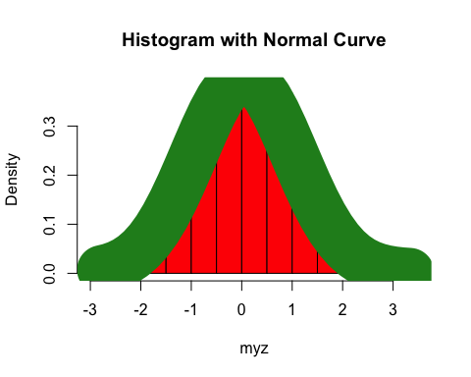

# as a little exercise, change the color in line 39 above to "forestgreen" and  
# the linewidth to 50. Congratulations, you have just made your   
# first piece of Data Art!! A very hungry caterpillar :^)  
  
# Square these observations, plot a histogram and overlay the chi-square(1) pdf  
myz2 <- myz^2  
h <- hist(myz2, breaks=10, col="red",   
 main="Histogram with Chi-squared(1) Curve", prob=TRUE)   
xfit <- seq(min(myz2), max(myz2), length=40)   
yfit <- dchisq(xfit, 1) #chi-squared(1) density  
lines(xfit, yfit, col="blue", lwd=2) #overlay Chi-squared(1) curve

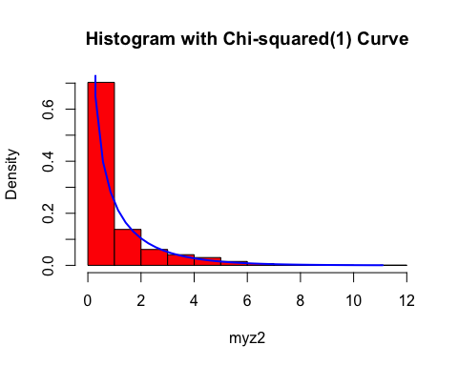

## 2. Generate n=10 observations from the Geometric distribution.

*type ?rgeom() to read which form of the PMF R computes (i.e. does it include or exclude the final successful trial?)*

set.seed(54321)  
n <- 10  
geo.dat <- rgeom(n, prob=.07) # this generates n geometric observations  
  
geo.mle <- 1/(1+mean(geo.dat)) #We derived this MLE during the basketball tryouts example  
geo.mle

## [1] 0.04048583

## 3. Write a function to compute the log-likelihood given the n observations and plot the log-likelihood.

In this section, we write a function which computes the Geometric log-likelihood given arguments:  
* theta, a scalar or vector of probabilities and  
* x, a vector of observations.

# Write a function to compute geometric log-likelihood with arguments  
# theta = scalar or vector of geometric probabilities  
# x = vector of observations  
  
ell <- function(theta, x){  
 loglike <- 0  
 for (i in 1:length(x)){  
 loglike <- loglike + dgeom(x[i], prob=theta, log=TRUE)   
 #computes the sum of the log of geometric probabilities over each of the observations  
 }   
 return(loglike)  
}  
  
theta <- seq(0.01, 0.15, by=.005) #a vector sequence of theta values  
gloglike <- ell(theta, geo.dat) #compute the log-likelihood for each value in theta, given data geo.dat  
head(cbind(theta, gloglike)) #head prints the top values

## theta gloglike  
## [1,] 0.010 -48.43363  
## [2,] 0.015 -45.57898  
## [3,] 0.020 -43.90827  
## [4,] 0.025 -42.88912  
## [5,] 0.030 -42.28441  
## [6,] 0.035 -41.96771

plot(gloglike ~ theta, ylab='Log-Likelihood', xlab='theta', type='l') #plot(y ~ x) version  
title(paste('Geometric Log-likelihood for Lab 2, n=', n, sep=''))

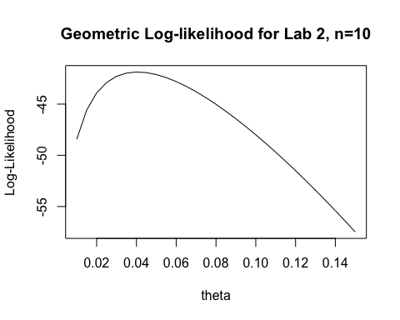

## 4. Compute the MLE using the function we defined.

#?optimize #see the arguments and outputs for optimize; see optional arguments ...  
# we pass a function to optimize, starting interval, and any other arguments required by ell  
  
thetahat <- optimize(ell, c(.02, .10), maximum=TRUE, x=geo.dat)  
thetahat #how does the maximum compare with 1/(1+mean(geo.dat)) computed above?

## $maximum  
## [1] 0.04047153  
##   
## $objective  
## [1] -41.86282

thetahat$maximum #extract the maximum

## [1] 0.04047153

thetahat$objective #extract value of function ell at maximum

## [1] -41.86282

## 5. Write a function to compute the log relative likelihood, r(theta) and graph.

# Function to compute the log relative likelihood, r(theta)  
# theta = scalar or vector of Binomial probabilities  
# thetahat = the MLE of theta  
# x = vector of observations  
  
logR <- function(theta, thetahat, x){  
 ell(theta, x) - ell(thetahat, x)  
}  
  
logR(theta, thetahat$maximum, geo.dat)

## [1] -6.570816e+00 -3.716168e+00 -2.045456e+00 -1.026300e+00 -4.215957e-01  
## [6] -1.048979e-01 -7.555313e-04 -6.052590e-02 -2.510181e-01 -5.485788e-01  
## [11] -9.357624e-01 -1.399338e+00 -1.929039e+00 -2.516742e+00 -3.155912e+00  
## [16] -3.841222e+00 -4.568272e+00 -5.333388e+00 -6.133478e+00 -6.965914e+00  
## [21] -7.828448e+00 -8.719145e+00 -9.636329e+00 -1.057854e+01 -1.154450e+01  
## [26] -1.253310e+01 -1.354334e+01 -1.457435e+01 -1.562537e+01

# Function to compute the log relative likelihood - ln(p) for   
# 100p% Likelihood interval computations  
# theta = scalar or vector of Binomial probabilities  
# thetahat = the MLE of theta  
# x = vector of observations  
logR.m.lnp <- function(theta, thetahat, x, p) {logR(theta, thetahat, x) - log(p)}  
  
p <- .1 #10% likelihood interval  
plot(logR.m.lnp(theta, thetahat$maximum, geo.dat, p) ~ theta, ylab='r(theta)-ln(p)',  
 xlab='theta', type='b')  
abline(h=0) #add horizontal line at zero  
title('Lab 2, Log Relative Likelihood - ln(p)')

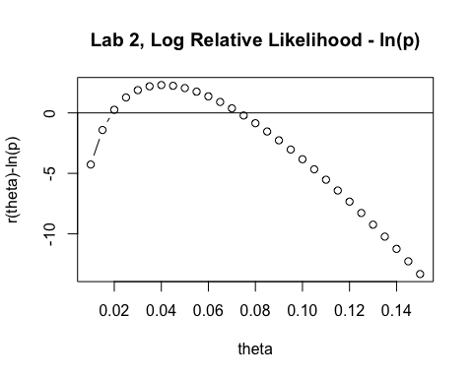

## 6. Compute the 10% Likelihood Interval as the roots of r(theta) - ln(.10) = 0

#?uniroot #see the arguments for uniroot  
# use the graph to obtain starting interval for root finding search  
  
#Likelihood intervals, supply the function, starting interval and arguments   
lower <- uniroot(logR.m.lnp, c(.01, .04), thetahat$maximum, geo.dat, p)  
lower

## $root  
## [1] 0.01905715  
##   
## $f.root  
## [1] 0.002134804  
##   
## $iter  
## [1] 5  
##   
## $init.it  
## [1] NA  
##   
## $estim.prec  
## [1] 6.103516e-05

upper <- uniroot(logR.m.lnp, c(.06, .10), thetahat$maximum, geo.dat, p)  
upper

## $root  
## [1] 0.0732256  
##   
## $f.root  
## [1] 0.0006077995  
##   
## $iter  
## [1] 4  
##   
## $init.it  
## [1] NA  
##   
## $estim.prec  
## [1] 6.103516e-05

# Summary:

The maximum likelihood estimate of theta is, 0.0404715 and its 10% likelihood interval is (0.0190571, 0.0732256).

(Rounded version) The maximum likelihood estimate of theta is, 0.04 and its 10% likelihood interval is (0.019, 0.073).