Evan_O’Toole_MT2
Evan O’Toole V01003221, Midterm2, test version B.
library(tidyverse)
Warning: package 'lubridate' was built under R version 4.3.3
── Attaching core tidyverse packages ──────────────────────── tidyverse 2.0.0 ──
✔ dplyr 1.1.4 ✔ readr 2.1.5
✔ forcats 1.0.0 ✔ stringr 1.5.1
✔ ggplot2 3.5.1 ✔ tibble 3.2.1
✔ lubridate 1.9.4 ✔ tidyr 1.3.1
✔ purrr 1.0.2
── Conflicts ────────────────────────────────────────── tidyverse_conflicts() ──
✖ dplyr::filter() masks stats::filter()
✖ dplyr::lag() masks stats::lag()
ℹ Use the conflicted package (<http://conflicted.r-lib.org/>) to force all conflicts to become errors
#a)
ggplot(airquality, aes(x = Wind)) + geom_density()
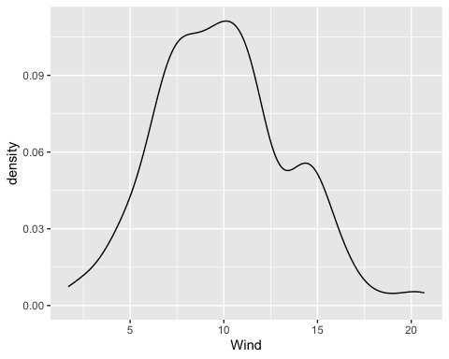
#b)
qqnorm(airquality$Wind)
qqline(airquality$Wind)
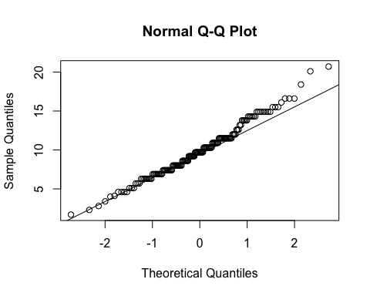
#c)
shapiro.test(airquality$Wind)
Shapiro-Wilk normality test
data: airquality$Wind
W = 0.98575, p-value = 0.1178
this p-value is high enough that the data does not reject that it follows a normal distribution, more evidence for this is provided by the bellcurve-like density curve and the qqnorm plot (some what matching the line) though it is not perfect.
#d)
quantile(airquality$Wind, c(0, 0.25, 0.5, 0.75, 1))
0% 25% 50% 75% 100%
1.7 7.4 9.7 11.5 20.7
#e)
quantile(airquality$Temp, c(0.05, 0.95))
5% 95%
60.2 92.0
#this is the 90% CI end points
#f)
air = airquality
air$Month = as.factor(air$Month)
boxplot(Temp~Month, air, xlab = "months", main = "boxplots for temperatures across 5 months")
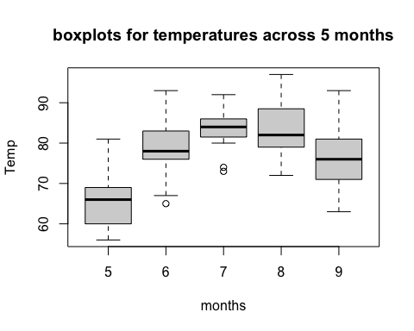
#g)
air = airquality
air$Month = as.factor(air$Month)
ggplot(air, aes(x = Month, y = Temp)) + geom_boxplot() + ggtitle("Boxplots for temperatures across 5 months")
