FINALEXAM123PART3
library(tidyverse)
Warning: package 'lubridate' was built under R version 4.3.3
── Attaching core tidyverse packages ──────────────────────── tidyverse 2.0.0 ──
✔ dplyr 1.1.4 ✔ readr 2.1.5
✔ forcats 1.0.0 ✔ stringr 1.5.1
✔ ggplot2 3.5.1 ✔ tibble 3.2.1
✔ lubridate 1.9.4 ✔ tidyr 1.3.1
✔ purrr 1.0.2
── Conflicts ────────────────────────────────────────── tidyverse_conflicts() ──
✖ dplyr::filter() masks stats::filter()
✖ dplyr::lag() masks stats::lag()
ℹ Use the conflicted package (<http://conflicted.r-lib.org/>) to force all conflicts to become errors
library(GGally)
Registered S3 method overwritten by 'GGally':
method from
+.gg ggplot2
#a)
sales <- data.frame(Revenue = c(150,200,250,300,350,400), Month = c("January", "February", "March", "April", "May", "June"))
mean(sales$Revenue)
[1] 275
#b)
barplot(sales$Revenue ~ sales$Month, xlab = "Months", ylab = "Monthly Revenue", main = "Company Sales - Monthly Revenue", col = "darkorange")
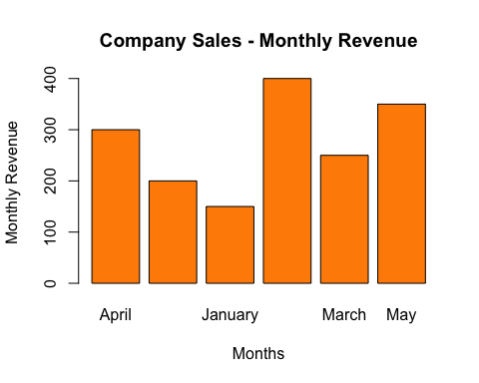
#c)
ggplot(sales, aes(x = Month, y = Revenue)) + geom_col(fill = "darkorange", col = "black") + labs(x = "Month", y = "Monthly Revenue", title = "Company Sales - Monthly Revenue")
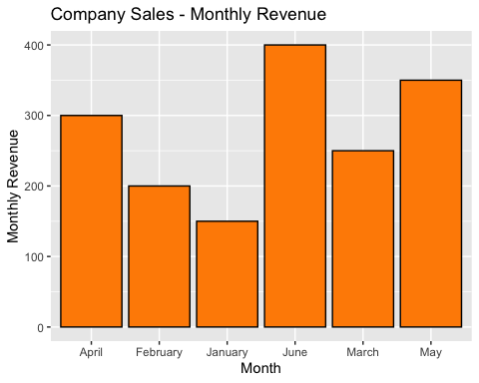
#d)
pie(sales$Revenue, col = c("orange", "blue", "red", "green", "purple", "black"), main = "Revenue by months 1-6")
