FINALEXAM123PART6
library(ggplot2)
set.seed(4172025)
Weather = sample(c("rainy", "cloudy", "sunny"), 100, replace = TRUE)
Time = sample(c("Morning", "Afternoon", "Night"), 100, replace = TRUE)
#a)
tab = table(Weather, Time)
barplot(tab, main = "Stacked barplot of weather and time", xlab = "Time", ylab = "Weather", col = c("blue", "green", "pink"))
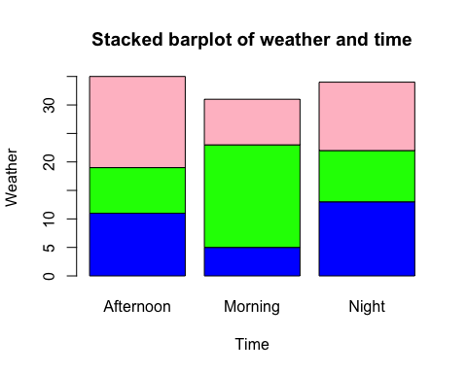
#b)
WT.data <- data.frame(Weather, Time)
ggplot(WT.data) + geom_bar(aes(Time, fill = Weather)) + labs(title = "Stacked barplot of weather and time", x = "Time", y = "Weather")
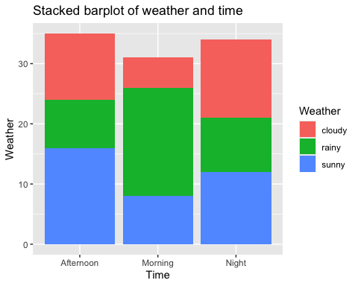
#c)
ggplot(WT.data) + geom_bar(aes(x = Weather, fill = Time), position = "dodge") + labs(title = "Side by side plot for weather and time")
