FINALEXAM123PART7
library(tidyverse)
Warning: package 'lubridate' was built under R version 4.3.3
── Attaching core tidyverse packages ──────────────────────── tidyverse 2.0.0 ──
✔ dplyr 1.1.4 ✔ readr 2.1.5
✔ forcats 1.0.0 ✔ stringr 1.5.1
✔ ggplot2 3.5.1 ✔ tibble 3.2.1
✔ lubridate 1.9.4 ✔ tidyr 1.3.1
✔ purrr 1.0.2
── Conflicts ────────────────────────────────────────── tidyverse_conflicts() ──
✖ dplyr::filter() masks stats::filter()
✖ dplyr::lag() masks stats::lag()
ℹ Use the conflicted package (<http://conflicted.r-lib.org/>) to force all conflicts to become errors
library(GGally)
Registered S3 method overwritten by 'GGally':
method from
+.gg ggplot2
hours.studied = 1:14
exam.score = c(45,50,55,60,65,70,75,80,85,90,92,93,94,95)
#a)
cor(hours.studied, exam.score)
[1] 0.9828987
#there is a very strong positive linear correlation between these data
#b)
data <- data.frame(exam.score = exam.score, hours.studied = hours.studied)
ggplot(data, aes(y = exam.score, x = hours.studied)) + geom_point() + geom_smooth(method = "lm")
`geom_smooth()` using formula = 'y ~ x'
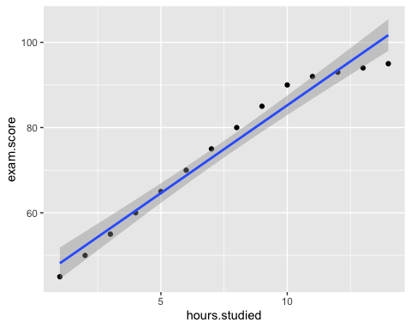
#c)
model <- lm(exam.score~hours.studied)
#c)
summary(model)
Call:
lm(formula = exam.score ~ hours.studied)
Residuals:
Min 1Q Median 3Q Max
-6.7143 -2.0440 -0.0495 2.5192 4.7692
Coefficients:
Estimate Std. Error t value Pr(>|t|)
(Intercept) 44.0220 1.8977 23.20 2.45e-11 ***
hours.studied 4.1209 0.2229 18.49 3.48e-10 ***
---
Signif. codes: 0 '***' 0.001 '**' 0.01 '*' 0.05 '.' 0.1 ' ' 1
Residual standard error: 3.362 on 12 degrees of freedom
Multiple R-squared: 0.9661, Adjusted R-squared: 0.9633
F-statistic: 341.9 on 1 and 12 DF, p-value: 3.481e-10
#the amount that can be explained is 96.61% (r^2)
#e)
dat <- data.frame(hours.studied = 7)
predict(model, newdata = dat, interval = "predict")
fit lwr upr
1 72.86813 65.28287 80.45339
#f)
sd_vec <- numeric(10000)
for(i in 1:10000){
samp <- sample(exam.score, size = length(exam.score), replace = TRUE)
sd_vec[i] <- sd(samp)
}
mean(sd_vec)
[1] 16.72659

