FINALEXAM123PART3
library(tidyverse)
Warning: package 'lubridate' was built under R version 4.3.3
── Attaching core tidyverse packages ──────────────────────── tidyverse 2.0.0 ──
✔ dplyr 1.1.4 ✔ readr 2.1.5
✔ forcats 1.0.0 ✔ stringr 1.5.1
✔ ggplot2 3.5.1 ✔ tibble 3.2.1
✔ lubridate 1.9.4 ✔ tidyr 1.3.1
✔ purrr 1.0.2
── Conflicts ────────────────────────────────────────── tidyverse_conflicts() ──
✖ dplyr::filter() masks stats::filter()
✖ dplyr::lag() masks stats::lag()
ℹ Use the conflicted package (<http://conflicted.r-lib.org/>) to force all conflicts to become errors
library(GGally)
Registered S3 method overwritten by 'GGally':
method from
+.gg ggplot2
#a)
head(diamonds, 6)
# A tibble: 6 × 10
carat cut color clarity depth table price x y z
<dbl> <ord> <ord> <ord> <dbl> <dbl> <int> <dbl> <dbl> <dbl>
1 0.23 Ideal E SI2 61.5 55 326 3.95 3.98 2.43
2 0.21 Premium E SI1 59.8 61 326 3.89 3.84 2.31
3 0.23 Good E VS1 56.9 65 327 4.05 4.07 2.31
4 0.29 Premium I VS2 62.4 58 334 4.2 4.23 2.63
5 0.31 Good J SI2 63.3 58 335 4.34 4.35 2.75
6 0.24 Very Good J VVS2 62.8 57 336 3.94 3.96 2.48
quantile(diamonds$carat, c(0,0.25,0.5,0.75,1))
0% 25% 50% 75% 100%
0.20 0.40 0.70 1.04 5.01
#b)
boxplot(diamonds$table~diamonds$cut, xlab = "Diamond Cut", ylab = "amount of diamonds in this range", main = "Measuring Amounts of Each diamond cut")
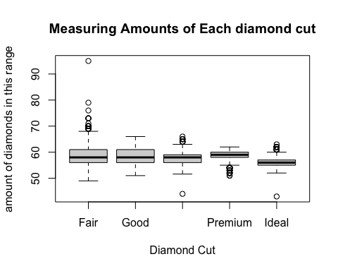
#c)
ggplot(diamonds, aes(x = cut, y = table)) + geom_boxplot() + labs(x = "Diamond Cut", y = "amount of diamonds in this range", title = "Measuring Amounts of Each diamond cut")
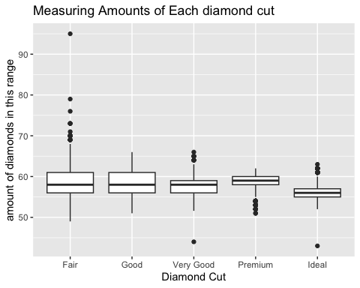
#d)
quantile(diamonds$price, c(0.05, 0.95))
5% 95%
544.0 13107.1
#e)
ggplot(diamonds, aes(x = price)) + geom_histogram(aes(y = after_stat(density))) + geom_density(col = "red")
`stat_bin()` using `bins = 30`. Pick better value with `binwidth`.
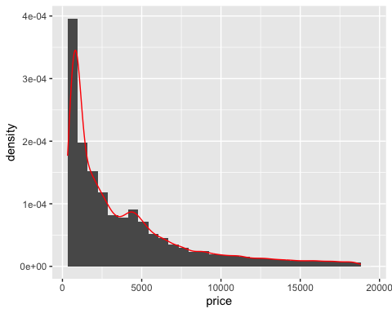
#f)
qqnorm(diamonds$price)
qqline(diamonds$price)
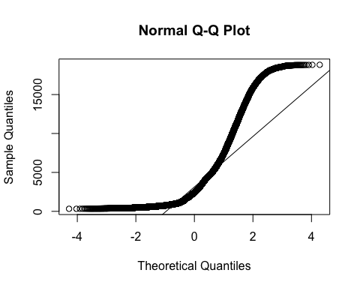
#it does not appear normal. It does not fit the straight line

