Stat123_A4_
Evan O’Toole
library(tidyverse)
Warning: package 'lubridate' was built under R version 4.3.3
── Attaching core tidyverse packages ──────────────────────── tidyverse 2.0.0 ──
✔ dplyr 1.1.4 ✔ readr 2.1.5
✔ forcats 1.0.0 ✔ stringr 1.5.1
✔ ggplot2 3.5.1 ✔ tibble 3.2.1
✔ lubridate 1.9.4 ✔ tidyr 1.3.1
✔ purrr 1.0.2
── Conflicts ────────────────────────────────────────── tidyverse_conflicts() ──
✖ dplyr::filter() masks stats::filter()
✖ dplyr::lag() masks stats::lag()
ℹ Use the conflicted package (<http://conflicted.r-lib.org/>) to force all conflicts to become errors
library(GGally)
Registered S3 method overwritten by 'GGally':
method from
+.gg ggplot2
#a)
admissions <- read_csv("AdmissionPredict.csv")
Rows: 400 Columns: 8
── Column specification ────────────────────────────────────────────────────────
Delimiter: ","
dbl (8): Serial No., GRE Score, TOEFL Score, University Rating, SOP, LOR, UG...
ℹ Use `spec()` to retrieve the full column specification for this data.
ℹ Specify the column types or set `show_col_types = FALSE` to quiet this message.
ggpairs(admissions |>
select(`TOEFL Score`, `GRE Score`, UGPA, `University Rating`, SOP, LOR, `Chance of Admit`))
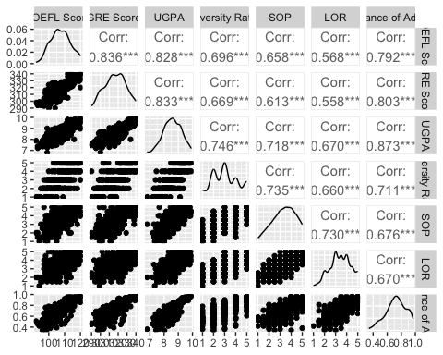
#b)
admission <- admissions |> select(`GRE Score`, `TOEFL Score`, UGPA, `Chance of Admit`)
#c)
ggpairs(admission)
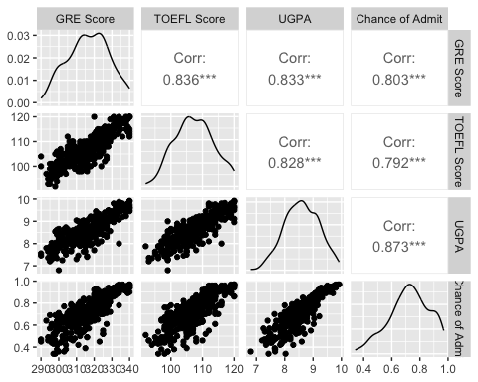
#the correlation values are generally higher and there is a more clear linear relationship
#between the data.
#d)
plot(admission$UGPA, admission$`Chance of Admit`,
main = "UGPA vs. Chance of Admit",
xlab = "UGPA", ylab = "Chance of Admit")
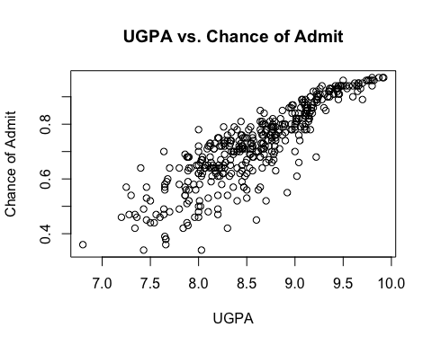
cor(admission$UGPA, admission$`Chance of Admit`)
[1] 0.8732891
ugpa_model <- lm(`Chance of Admit` ~ UGPA, data = admission)
summary(ugpa_model)
Call:
lm(formula = `Chance of Admit` ~ UGPA, data = admission)
Residuals:
Min 1Q Median 3Q Max
-0.274575 -0.030084 0.009443 0.041954 0.180734
Coefficients:
Estimate Std. Error t value Pr(>|t|)
(Intercept) -1.07151 0.05034 -21.29 <2e-16 ***
UGPA 0.20885 0.00584 35.76 <2e-16 ***
---
Signif. codes: 0 '***' 0.001 '**' 0.01 '*' 0.05 '.' 0.1 ' ' 1
Residual standard error: 0.06957 on 398 degrees of freedom
Multiple R-squared: 0.7626, Adjusted R-squared: 0.762
F-statistic: 1279 on 1 and 398 DF, p-value: < 2.2e-16
#e)
q25 <- quantile(admission$UGPA, 0.25)
q50 <- quantile(admission$UGPA, 0.50)
q75 <- quantile(admission$UGPA, 0.75)
percentiles <- data.frame(UGPA = c(q25, q50, q75))
percentiles
UGPA
25% 8.1700
50% 8.6100
75% 9.0625
predict(ugpa_model, newdata = percentiles, interval = "predict", level = 0.88)
fit lwr upr
25% 0.6347702 0.5261713 0.7433691
50% 0.7266630 0.6181342 0.8351918
75% 0.8211664 0.7125556 0.9297771
#f)the residuals may not be evenly distributed across the data by observation. this could be bad because the model could be less accurate at lower values and more accurate at higher values etc.
#2 a)
age <- c(2,3,4,5,8,12,14,17,21,28,39,50,67,83)
run.time <- c(60,55,40,37,32,26,18,16,17,17,23,29,42,59)
#age is explanatory and runtime is response
#b)
ggplot(data = NULL, aes(x = age, y = run.time)) +
geom_point() +
geom_smooth(method = "lm", formula = y ~ poly(x, 2), se = TRUE) +
labs(x = "Age (years)", y = "Run Time (seconds)",
title = "Running Time vs. Age (Quadratic Fit)") +
theme_minimal()
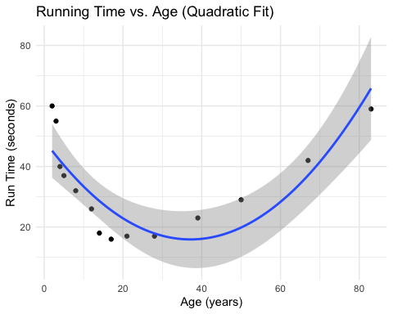
#c)
agesq <- age^2
quad_model <- lm(run.time ~ age + agesq)
summary(quad_model)
Call:
lm(formula = run.time ~ age + agesq)
Residuals:
Min 1Q Median 3Q Max
-10.617 -5.048 -2.693 6.482 14.793
Coefficients:
Estimate Std. Error t value Pr(>|t|)
(Intercept) 48.635730 4.573375 10.635 3.98e-07 ***
age -1.762006 0.348789 -5.052 0.000371 ***
agesq 0.023723 0.004306 5.509 0.000184 ***
---
Signif. codes: 0 '***' 0.001 '**' 0.01 '*' 0.05 '.' 0.1 ' ' 1
Residual standard error: 8.738 on 11 degrees of freedom
Multiple R-squared: 0.7393, Adjusted R-squared: 0.6919
F-statistic: 15.6 on 2 and 11 DF, p-value: 0.000615
#d)
predict(quad_model, newdata = data.frame(age = 45, agesq = 45^2), interval = "predict")
fit lwr upr
1 17.38403 -4.178831 38.94689
#e)
summary(quad_model)$r.squared * 100
[1] 73.92886

