Lab 7
Evan O

1. Sometimes we can avoid for-loops.
Doing computations in different ways.
# Show your result for each part. They should be the same.
# (a) for loop
#n <- 10
n <- 20
x <- 0
for (num in 1:n){
x <- x + num**3
}
x
[1] 44100
# (b) without loops
(sum((1:n)**3))
[1] 44100
# (c) formula (require Math knowledge)

2. Bootstrapped Sampling with for-loops
library(ggplot2)
# This code will generate a vector of 500 data points. Let us assume this is a
# representative sample of the population.
x1 <- runif(500, 0, 10)
#(a) histogram of the sample. Adjust the binwidth value so
# your histogram looks informative.
df <- as.data.frame(x1)
head(df)
x1
1 6.96540862
2 2.48493353
3 2.88762716
4 9.10463098
5 0.02879607
6 6.53649226
ggplot(df, aes(x = x1)) + geom_histogram(fill = "green", col="blue")
`stat_bin()` using `bins = 30`. Pick better value with `binwidth`.
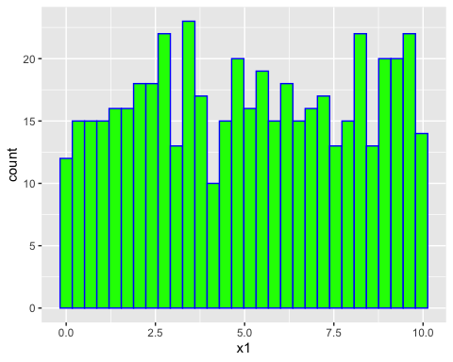
quantile(x1, 0.1)
10%
1.056227
#(b)
x2 <- sample(x1, size = 500, replace = TRUE)
quantile(x2, 0.1)
10%
0.9931089
#yes they are quite similar
#(c)
q10 <- c()
for (num in 1:3000){
x2 <- sample(x1, size = 500, replace = TRUE)
new <- as.vector(quantile(x2, 0.1))
q10 <- c(q10, new)
}
#print(q10)
#(d) histogram of approximate sampling distribution. Adjust the binwidth value so
# your histogram looks informative.
q10 <- as.data.frame(q10)
ggplot(q10, aes(x=q10)) + geom_histogram(fill = "green", col = "blue")
`stat_bin()` using `bins = 30`. Pick better value with `binwidth`.
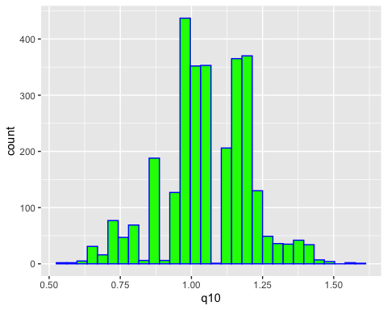
#(e)
q10est <- mean(q10$q10)
print(q10est)
[1] 1.05796
#(f) A 95% bootstrapped confidence interval
con <- 0.95
low <- (1-con)/2
high <- 1-low
quantile(q10$q10, c(low,high))
2.5% 97.5%
0.7190783 1.3615098

3. Different Population Shapes
# A different population shape
x2 <- rexp(500, rate = 1/5)
# (a) histogram of the sample. Adjust the binwidth value so your histogram looks informative.
df <- as.data.frame(x2)
head(df)
x2
1 0.2303646
2 0.1400095
3 5.4318908
4 0.7280516
5 6.6808556
6 2.1413453
ggplot(df, aes(x = x2)) +
geom_histogram(fill = "green", col = "blue")
`stat_bin()` using `bins = 30`. Pick better value with `binwidth`.
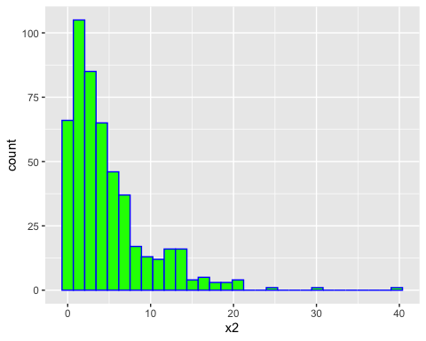
# Calculate the variance of the sample
var(x2)
[1] 23.66094
# (b) Same thing again to verify variance
sampx2 <- sample(x2, size = 500, replace = TRUE)
var(sampx2)
[1] 20.16257
# (c) Now, we perform bootstrapping using `sample` to sample with replacement
q10 <- c()
for (num in 1:3000) {
x2_sample <- sample(x2, size = 500, replace = TRUE)
new <- var(x2_sample)
q10 <- c(q10, new)
}
# (d) histogram of approximate sampling distribution of variance
q10 <- as.data.frame(q10)
ggplot(q10, aes(x = q10)) +
geom_histogram(fill = "green", col = "blue")
`stat_bin()` using `bins = 30`. Pick better value with `binwidth`.
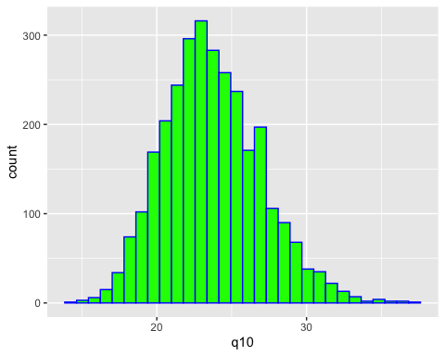
# (e) Calculate the mean of the approximate sampling distribution
q10est <- mean(q10$q10)
print(q10est)
[1] 23.71216
# (f) A 90% bootstrapped confidence interval
con <- 0.90
low <- (1 - con) / 2
high <- 1 - low
# Compute the quantiles for the 90% confidence interval
quantile(q10$q10, c(low, high))
5% 95%
18.79581 29.34539
#

4. Another Population Shapes
  - x2 <- c(rnorm(25000, 1, 2), rnorm(25000, 9, 2))
# (a) histogram of the sample. Adjust the binwidth value so your histogram looks informative.
df <- as.data.frame(x2)
head(df)
  - x2
1 2.330931004
2 0.408187445
3 1.013482125
4 1.499269361
5 0.005701056
6 0.983271827
  - ggplot(df, aes(x = x2)) +
geom_histogram(fill = "green", col = "blue")
  - `stat_bin()` using `bins = 30`. Pick better value with `binwidth`.
  - 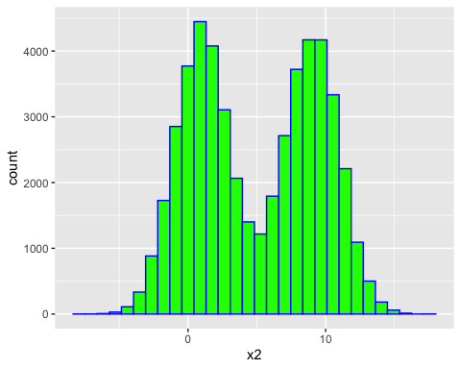
  - sd(df$x2)
  - [1] 4.476615
  - # (b) Same thing again to verify standard deviation
sampx3 <- sample(x2, size = 25000, replace = TRUE)
sd(sampx3)
  - [1] 4.49476
  - # (c) Perform bootstrapping using `sample` to sample with replacement
q10 <- c()
for (num in 1:3000) { # Repeating 3000 times
x2_sample <- sample(x2, size = 500, replace = TRUE)
new <- var(x2_sample)
q10 <- c(q10, new)
}
# (d) histogram of approximate sampling distribution of variance
q10 <- as.data.frame(q10)
ggplot(q10, aes(x = q10)) +
geom_histogram(fill = "green", col = "blue")
  - `stat_bin()` using `bins = 30`. Pick better value with `binwidth`.
  - 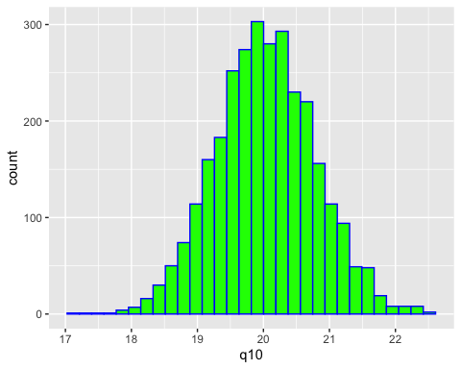
  - # (e) Calculate the mean of the approximate sampling distribution
q10est <- mean(q10$q10)
print(q10est)
  - [1] 20.0342
  - # (f) A 99% bootstrapped confidence interval
con <- 0.99
low <- (1 - con) / 2
high <- 1 - low
# Compute the quantiles for the 99% confidence interval
quantile(q10$q10, c(low, high))
  - 0.5% 99.5%
18.15302 22.10042

