Lab 9
Your name
2025-04-02

1. Read in data file and set up data frame for analysis.
#
realestate <- read.csv("realestate.csv", header = TRUE)
#head(realestate)
#1a.
house <- realestate |>
select(X2.house.age, X3.distance.to.the.nearest.MRT.station, X4.number.of.convenience.stores, Y.house.price.of.unit.area)
#1b.
house <- house |> rename(age = X2.house.age,
mrt.dist = X3.distance.to.the.nearest.MRT.station,
num.conv.stores = X4.number.of.convenience.stores,
price = Y.house.price.of.unit.area)
#1c price vs age
ggplot(house, aes(x = age, y = price)) +
geom_point() +
geom_smooth(method = "lm", color = "blue", se = FALSE) +
labs(title = "House Age vs Price", x = "House Age", y = "Price")
`geom_smooth()` using formula = 'y ~ x'
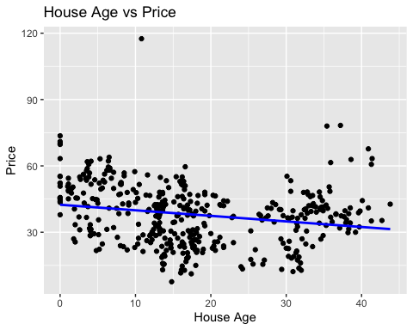
#1c price vs distance to mrt station
ggplot(house, aes(x = mrt.dist, y = price)) +
geom_point() +
geom_smooth(method = "lm", color = "blue", se = FALSE) +
labs(title = "Distance to MRT vs Price", x = "Distance to MRT", y = "Price")
`geom_smooth()` using formula = 'y ~ x'
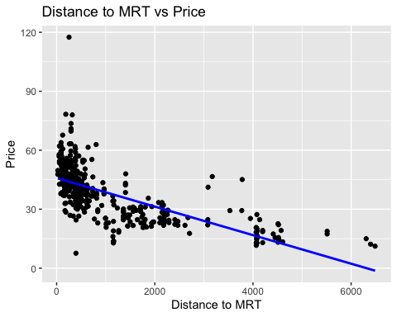
#1c price vs no. of convenience stores nearby
ggplot(house, aes(x = num.conv.stores, y = price)) +
geom_point() +
geom_smooth(method = "lm", color = "blue", se = FALSE) +
labs(title = "Number of Convenience Stores vs Price", x = "Convenience Stores", y = "Price")
`geom_smooth()` using formula = 'y ~ x'
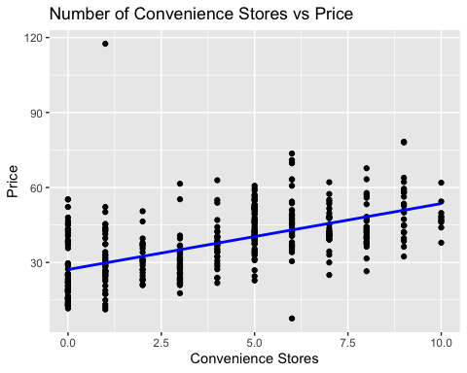
#1d
#for the first there does not seems to be much of a linear relationship, the plot is quite spread out and not linear
#for the second it also does not appear very linear
#the third is a bit more linear looking but still quite spread out.

2. Individual correlations.
cor(house$age, house$price)
[1] -0.210567
cor(house$mrt.dist, house$price)
[1] -0.6736129
cor(house$num.conv.stores, house$price)
[1] 0.5710049

3. Correlation matrix for all variables.
cor_matrix <- cor(house)
print(cor_matrix)
age mrt.dist num.conv.stores price
age 1.00000000 0.02562205 0.04959251 -0.2105670
mrt.dist 0.02562205 1.00000000 -0.60251914 -0.6736129
num.conv.stores 0.04959251 -0.60251914 1.00000000 0.5710049
price -0.21056705 -0.67361286 0.57100491 1.0000000
cor(house$num.conv.stores, house$mrt.dist)
[1] -0.6025191

