

|  |
| --- |
| *Evreka Co. Ltd.*  *ODTÜ Teknokent KOSGEB Tekmer No:401 ANKARA/TURKEY* |

|  |
| --- |
|  |
| User Manual |
| Version: 1.1.0 |
|  |

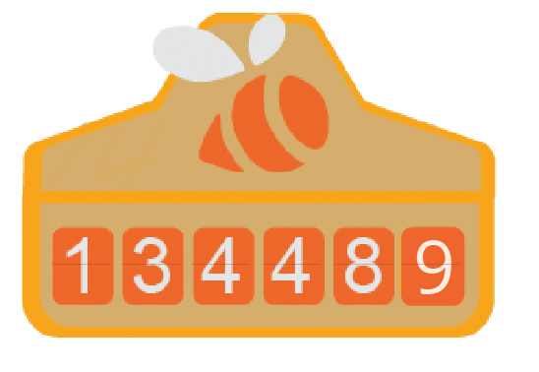

Table of Contents

3 Chapter 1: About Multify

3 What’s new on Multify?

4 Chapter 2: Getting Started

4 Package Contents

4 Multify at a glance

5 Multify LED Indicator Status

6 Chapter 3: Navigating Multify.Co Website

6 Accessing Login Screen

6 Login Screen

6 Dashboard

7 Changing the Password

7 “Verify My Multify” Page

7 Changing the Registered Venue

8 Creating Foursquare Authorization Key

9 Chapter 4: Using Multify

9 Turning Multify On

9 Connecting to Internet

9 “Verify My Multify” Application

11 Chapter 5: Safety and Usage

11 Cautions for safety

11 Cautions for usage

About Multify 1

Congratulations. You’ve just purchased Multify.

***WARNING:***To prevent any possible accidents, read Chapter 5, Safety and Usage before using Multify.



Multify is an interactive check-in counter which boosts the number of customers by using the impact of social media on place preferences. Use Multify by placing it in sight of customers.

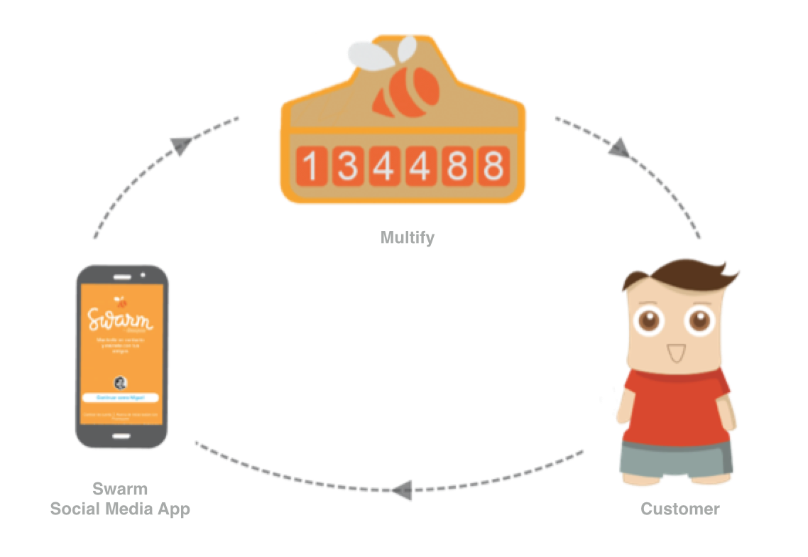

Multify attracts attention when placed in sight of customers and invites them to a different check-in experience. When a customer checks-in via Swarm app in the place, it increases the total check-in number on Multify.

What’s new on Multify?

* Swarm Media App Compatibility
* More attractive and stylish design
* Easy internet access
* “Verify My Multify” Application
* Customer board on Multify.co
* Access to check-in details with Foursquare Authorization
* Weekly-Monthly Check-in Reporting*
* Low consumption of energy
* Durable case

*For more information, send a regarding e-mail to info@multify.co

Getting Started 2

Read this chapter to get information about the features of Multify, learning how to control and further.

Multify Package Contents

Make sure that the Multify package includes all units below:

* Multify
* Micro SD Cards and SD Card Adapter
* Power adapter and cable
* Turkish User Manual
* Quick Start Guide
* Certificate of Warranty

Multify at a glance

|  |  |
| --- | --- |
| **Unit** | **Task** |
| **Power Adapter and Cable** | Cable to provide operative voltage for Multify. |
| **Power Cable Input** | 12 V DC input for power cable |
| **Power Switch** | Button to turn Multify on and off. |
| **Reset Button** | Button to reset Multify. |
| **LED Indicator** | Unit to show operating condition of Multify. |
| **SD Card Slot** | Slot for SD card and adapter. |
| **Micro SD Card and Adapter** | External memory card to store required information of Multify. |
| **Number Cards** | Cards to form and increase the numbers of counter. |

Operating Multify with using power adapter and cable:

**1 Connect Multify power cable and adapter and plug the other end in Multify.**

**2 Plug power adapter in an operating power outlet.**



***WARNING:***Before using Multify power adapter and cable, read Chapter 5, Safety and Usage.

Multify LED Indicator Status

LED Indicator Light has 3 different status.

**Turning on** After turning on Multify with power switch, LED Indicator will blink once. This shows that Multify is turned on.

**Connecting to the internet** When Multify attempts to connect to the internet, LED Indicator will be continuously green. If the light turns off, this shows that the Internet connection is established. If the Internet disconnects, LED Indicator will be green until the reconnection.

**Counter Mode** When Multify is in the counter function, LED Indicator will blink at 3-5 second intervals. This situation continues until the internet disconnects or power goes off.

Navigating multify.co Website 3

Manage your Multify devices using customer board on multify.co

Accessing Login Screen



You can access login screen by clicking “Login” button on the top right corner on [www.multify.co](http://www.multify.co)

Login Screen

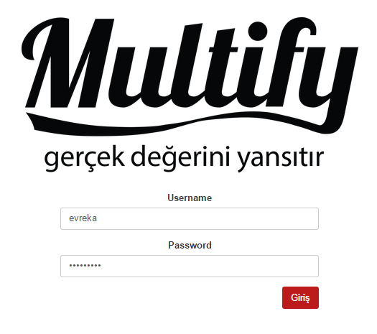

You can login with username and password given to you. If the login is successful, you will be navigated to dashboard.

Dashboard

After successfully logging in, you access to the dashboard. The options on the dashboard are *Profile*, *Correct My Multify*, *Change Venue Code*, *Regenerate Foursquare Token*, *Change Language* and *Log Out*.

On the *Profile* page, there are *Venue Name*, username on your behalf, current check-in number of your enterprise, unique check-in number and foursquare authorization key.

On your Profile, there is also a tablet on which there are details of last 10 check-in for your enterprise. You need a foursquare authorization key to use this table. You can find additional information in ‘Creating Foursquare Authorization Key’ chapter.

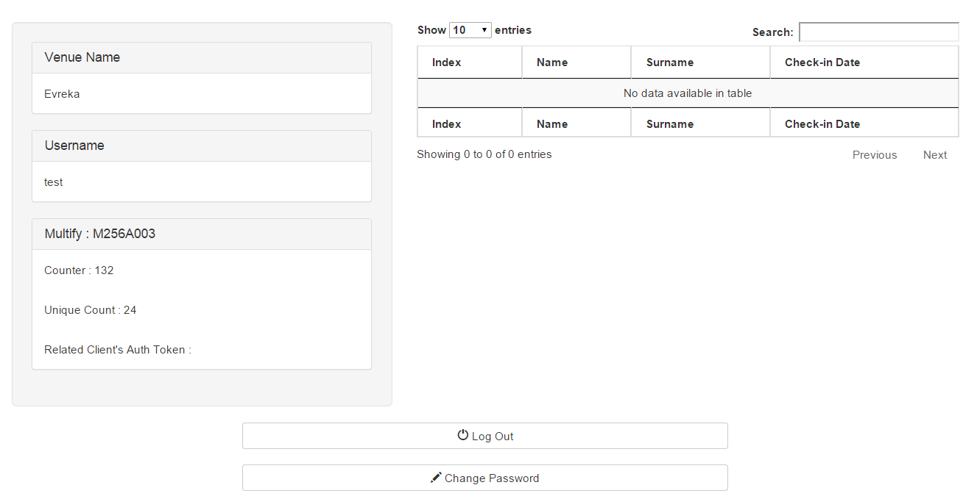

Changing the Password

You need to use your password to access Multify board for the first time. We recommend changing the password after the first usage. Your temporary password is submitted to you via e-mail and it is also included in the SD Card came with your Multify.

You can change your password by clicking ‘Change Password’ button on your Profile page. After filling up the form, your new password will become available.

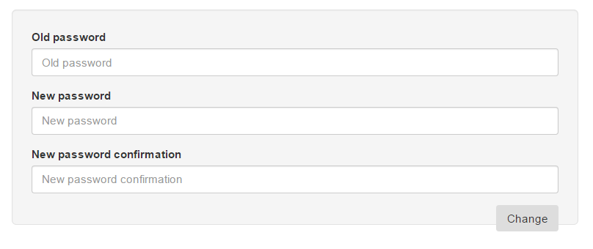

“Correct My Multify” Page

On the “Verify My Multify” board, there are a list of all placed Multify devices. The function of this page is to correct any possible mistakes occur in devices.

***WARNING:***Before using Verify My Multify application, read Chapter 4, “Verify My Multify”.



Changing the Registered Venue

Your Multify will be preset before being sent to you. You can use this board to change the Venue of which you want to count check-ins.

After you access ‘Change the Venue’ board from the menu, there will be a form on which you will see the Foursquare Key and Venue Name of the current registered Venue. To change this Venue, you need to enter the Foursquare Key of the new Venue and click ‘Change’ button.

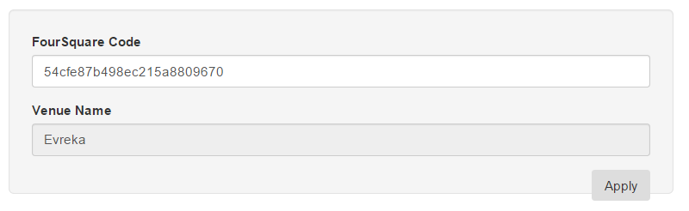

After this process, your Venue name and check-ins will automatically be updated.

Creating Foursquare Authorization Key

Your Multify does not only count your check-ins, it also keeps their details. Multify keeps details of users who checks-in like Name-Surname, Profile Picture, Gender, Check-in Date and it helps you to access some of this information on your profile. For more information about our services, you can reach us at info@multify.co

To access check-in details, you must create a Foursquare Authorization Key for your venue. Before creating this authorization key, you must make sure that you purchased related service of Foursquare. You can get more information at foursquare.com or you can send an e-mail to us at [info@multify.co](mailto:info@multify.co)

After you are registered to Foursquare, click ‘Regenerate Foursquare Token’ button on dashboard to register your Foursquare key to Multify. This button will directly navigate you to the related page of Foursquare for authorization. After this process, you will have access to the last 10 check-in details on your profile page.

Creating authorization key once will be enough. This key will be stored on the system for every login. If you cannot reach check-in details, we recommend updating your authorization key with the same process.



***WARNING:***While using this function, be sure that you are logged in as your manager account on Foursquare. Otherwise wrong token will be generated.

Using Multify 4

Read this chapter to get information you may need while using Multify.

Turning Multify On

To turn on Multify, turn power switch ‘on’. When Multify turns on, LED indicator light will instantly blink a few times. While establishing the internet connection, LED indicator will continuously be lit. After establishing the internet connection, LED indicator will continue to blink at 2-5 sec. intervals.



***WARNING:***Before turning Multify on, make sure that power cable is plugged in to the power input and SD card is plugged in to the SD card slot.

***WARNING:***If SD card is not plugged in when Multify is running, you must restart Multify by pressing Reset button after plugging SD card in or you must plug SD card in after you turn off Multify and then turn it on again by pressing power button.



Connecting Multify to the Internet

You must register your internet network to your Multify for the first usage. To do so, you need to plug the SD card came along with Multify and enroll your network name and password into the file named ‘internet’ inside of the SD card. Make sure that you use ‘comma’ after your network name and password.

Next, plug SD card into the slot behind of Multify and start Multify. It will automatically connect to the internet.

If you want to change the network and/or its name/password, you will need to repeat this process.



***WARNING:***Before plugging SD card out of the slot, make sure that Multify is turned off. Do not turn Multify on without the SD card.



***WARNING:***Do not pull SD card while plugging out. Pressing it gently will be enough to make it out of the slot. After this, you can pull it off.

“Correct My Multify” Application

“Correct My Multify” application is a web application designed to prevent any possible counting errors or fix wrong counts while the device is off. On this application, there is a name list of all your Multify devices.

To fix your Multify device which has counting error, first login to [www.multify.co](http://www.multify.co) and then navigate to “Correct My Multify” board. (see. Multify.co Dashboard). On this panel, select the device which has counting error. After the selection, enter the count number you see on that Multify to the related field and click “Apply” button. After this process, Multify will automatically be reflecting the actual check-in number.

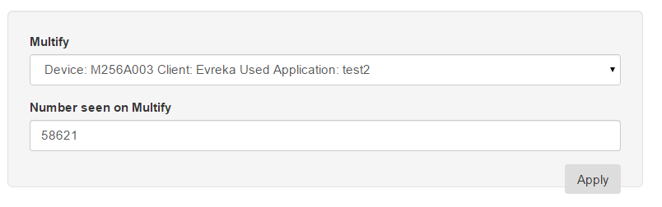

***WARNING:***Make sure that Multify is on while you are using this application. (Multify power cable should be plugged in, power switch should be on, SD card should be plugged in, internet connection should be established and LED indicator should be indicating ‘On’ mode.) If Multify was off when you were applying the process, repeat the proces after meeting these prerequirements.



When there is a poor internet connection, this process may take long or be timed out. In this case, repeat the process and check your internet connection. In case of recurrence, receive support from Multify Technical Support.



***WARNING:***There can not be any numbers having more than six digit, any letters or symbols on the wrong number entry. Otherwise the process will be failed and you will receive an error message.

Safety and Usage 5



***WARNING:***Disregarding these safety instructions may cause fire, shock or any other physical injury and harm to your Multify or other furniture. Before using Multify, read all the safety instructions below.

*Keep Multify User Manual as you may need to get information in the future.*

Cautions for safety

**Usage** Use Multify carefully. There are sensitive electronic components inside Multify.

If Multify is dropped, burnt, drilled, crushed or contact with any liquid, it may be damaged. Do not use a damaged Multify.

**Repair** Do not disassemble Multify and try to repair Multify by yourself.

Disassembling Multify may cause injuries or may harm Multify. If Multify is damaged, has operating errors or contacted with any liquid, call Multify Technical Support.

**Power Connection** Connect Multify to power with power adapter and cable came along. Using damaged cables or adapters and using at a wet place may cause shock. Make sure that power cable is fully plugged into the power adapter before plugging it to the outlet. Power adapters may get warm while operating and may cause injuries in case of long-term contact. Make sure that air conditioning near power adapters is sufficient.

Cautions for usage

**Using connectors, gateways and buttons** Never try to assemble a connector with force or pressure on a button, otherwise this cause harms out of warranty. If the connector and gateway can not be assembled easily, they may not fit each other. See if there is a block in front of the gateway and make sure that the connector is fitting gateway and you try to assemble within the correct direction.

**Showing sensitivity to Number Cards** Multify number cards have a special design and they are sensitive in order to turn smoothly. Protect them against impact, burning and scratching. Do not turn the cards manually when Multify is on or off. This situation will cause harm to cards and Multify equipment.

O**perating Multify at acceptable temperature** Multify is designed to operate in places at the temperature from 0º to 35º C (32º - 95º F) and stored from -20º to 45º C (-4º - 113º F). Multify may be damaged if it is operated or stored above or below these temperature degrees. Avoid operating Multify at excessive temperature or moisture.

|  |  |
| --- | --- |
| Evreka Software Hardware Consultancy Education Limited Liability Company | Third party product names are only mentioned for elucidating and they have no means of suggestion and promotion. Evreka refuses any responsibility of usage and performance of those products.  If available, all agreements, contracts and warranties are dealt directly within seller companies and potential users. |
| © 2015 Evreka Co. Ltd. All rights reserved. |
| Other Venue and product names mentioned here might be trademarks of their companies. | This manual is taken care with due diligence in case of accuracy. Evreka is not responsible for any printing and writing errors. |