TECHNICAL NOTE — COMPUTATIONAL ACTUARIAL MODELLING
Diversifiable and Undiversifiable Longevity Risk
in a Stylised Belgian Occupational Pension Fund
A reproducible compound-Poisson-FFT stress framework
Erik Van Releghem · July 2026
Abstract
This note quantifies systematic (undiversifiable) longevity risk for a stylised Belgian occupational pension fund and locates it against the idiosyncratic demographic tail and the dominant interest-rate risk. A closed occupational fund is modelled with income-segmented Gompertz–Makeham mortality; the best-estimate liability and stochastic liability distribution are built by compound-Poisson FFT aggregation. Conditional on a fixed mortality table, idiosyncratic demographic risk diversifies almost entirely (a tail of roughly €34M on a €4.6B liability). A common longevity shock — an exogenous mortality improvement arriving at a future year and shifting the senescent hazard of all members — does not diversify: across a grid of ten structural scenarios (shock timing × magnitude) the between-scenario spread reaches €424M, about thirteen times the idiosyncratic tail, and two structural scenarios exceed the Solvency II −20% longevity stress. A closure lemma shows the Gompertz–Makeham family is invariant under the shock, so the FFT machinery reruns unchanged per scenario. The contribution is not methodological novelty but an accessible, reproducible computational actuarial case study with genuine benefit-severity structure and a temporal longevity-stress grid.

1. Motivation and positioning
For a large, diversified closed pension fund, how much of the total longevity risk actually matters for capital? A stochastic capital model built on independent per-member mortality answers only half the question. Conditional on a fixed mortality table, the law of large numbers applies and demographic randomness averages away across ten thousand members; the resulting liability distribution is narrow. That narrowness is real, but it measures only idiosyncratic risk. The risk that a pension fund is most concerned with — a sustained, common improvement in longevity that lengthens every liability at once — is systematic, and by construction it does not diversify.
This note illustrates that distinction quantitatively using a stylised Belgian occupational pension fund. It is deliberately not a claim of methodological novelty. Compound-Poisson mortality aggregation, the systematic/idiosyncratic decomposition, exact value-at-risk without Monte Carlo, and cause-of-death scenario analysis are all present in the prior literature, most directly in Hirz, Schmock and Shevchenko (2017), whose extended-CreditRisk+ framework performs exact aggregate mortality risk under Solvency II and includes a neoplasm-reduction health scenario closely related to the stress grid used here. That the law of large numbers breaks under stochastic rather than deterministic mortality is established theoretically by Milevsky, Promislow and Young (2006) and, in the comonotonic-bounds tradition, by Denuit and Dhaene (2007).
Within that established framework, this note makes four contributions: an accessible and fully reproducible computational actuarial case study for the occupational-pension domain on Belgian income-segmented Gompertz–Makeham mortality, a domain those references do not occupy; a closed-form structural longevity shock under which the Gompertz–Makeham family remains closed, so no per-scenario re-derivation of the aggregation is required; a temporal stress grid over shock timing and magnitude rather than a single fixed risk-factor realisation; and an empirically-calibrated benefit-severity structure whose materiality is measured explicitly. The positioning is thus Olivieri–Pitacco (2003) scenario structure, Hirz et al. (2017) computational philosophy, contemporary open tooling, a Belgian occupational-pension case.

2. The model
2.1 Mortality and income segmentation
Crude unisex mortality is taken from the Human Mortality Database for Belgium and a Gompertz–Makeham law is fitted by nonlinear least squares over ages 40–90:
q_{x} = A + B e^{Cx}
with A the age-independent Makeham background and B e^{Cx} the senescent component growing exponentially with age. Income-specific curves for the low, mid and high segments are constructed by anchoring group-specific parameter shifts to the empirical rate at age 55, so that below the anchor all groups share the empirical curve and above it the three curves diverge. High-income members carry both longer life expectancy (about 1.5 years at age 65 relative to low income) and larger benefits, so the surviving population tilts toward large annuities at late durations.

2.2 Liability and stochastic capital
A synthetic closed fund of ten thousand members is projected. The best-estimate liability (BEL) is the present value of projected pension cashflows under income-specific survival at a 2% discount rate. For the stochastic capital layer, aggregate liability is modelled as a compound-Poisson sum: in each future year the number of paying survivors is Poisson with intensity λ_t equal to the sum of member survival probabilities, and each survivor receives a lognormal benefit. Because the years are independent and each is compound Poisson, the total liability is compound Poisson by closure, and its full distribution — hence VaR and TVaR — is obtained by FFT convolution using the open-source aggregate package (Mildenhall, 2024). Fast Fourier convolution is chosen over Panjer recursion for its O(m log m) cost against Panjer's O(m²) (Embrechts and Frei, 2009), and over comonotonic bounds because the structural shock keeps the aggregate exactly compound Poisson rather than requiring bounding.
Conditional on the mortality table, this stochastic layer contains only idiosyncratic risk. On the fund studied here the resulting tail is thin: TVaR99 exceeds the mean liability by roughly €34M, about 0.74% of the BEL, a direct consequence of the law of large numbers acting on Poisson survivor counts of order several thousand per year.
3. The longevity shock and a closure lemma
A systematic longevity gain of Δ years is modelled as advancing the senescent component of mortality by Δ, leaving the Makeham background untouched — representing a structural longevity improvement affecting senescent mortality while leaving accidental mortality unchanged. The anchored curves used in valuation are, above the anchor age, themselves Gompertz–Makeham, which yields a clean closure property.
Lemma (closure under the longevity shift).
For income group g with anchored curve q̃_{x} = Ã_{g} + B̃_{g} e^{Cgx} (x ≥ anchor age), a longevity gain of Δ years acts as
Ã_{g} + B̃_{g} e^{Cg(x−Δ)} = Ã_{g} + (B̃_{g} e^{−CgΔ}) e^{Cgx}
so the shock is the single rescaling B̃_{g} → B̃_{g} e^{−CgΔ}, with Ã_{g} and C_{g} unchanged. The Gompertz–Makeham family is therefore closed under the shock, and the FFT inner layer reruns unchanged on the shocked survival probabilities — only λ_{t} and the mean severity are recomputed. The equivalent proportional senescent reduction is r_{g} = 1 − e^{−CgΔ}; because C_{g} differs slightly by group, a uniform Δ implies mildly heterogeneous reductions across income strata (about 22–23% at Δ = 2 years), which are reported rather than suppressed.
Two points of implementation matter. First, the hazard-level equivalence does not carry to the survival function: shocked survival must be re-integrated from the shocked rates by fresh cumulative product, never read off baseline survival at a shifted age, since the Makeham term accumulates linearly and the product’s lower limit is fixed at the anchor. Second, below the anchor age mortality is the raw empirical curve, on which a senescent-only rescaling has no defined action; that segment is left unshocked, a stated simplification immaterial to the liability because senescent mortality dominates only at retirement ages. The Solvency II longevity stress, a uniform q_{x} → 0.80 q_{x}, scales the Makeham background as well and so is not structural in this sense; it serves as an external regulatory benchmark.

4. The systematic-longevity stress grid
The outer, systematic layer is a ten-row grid consisting of a baseline and a three-by-three grid of shock timing T ∈ {5,10,15} years and magnitude Δ ∈ {1,2,3} years. These structural scenarios model persistent future improvements in longevity: delayed in onset, acting only on the senescent component, while leaving the Makeham background unchanged.
As an external benchmark, the standard Solvency II longevity stress was implemented independently of the structural scenario framework: an immediate, permanent reduction of all mortality rates, qₓ → 0.80 qₓ, at every age and every projection year, with survival, cashflows and the full stochastic distribution recomputed exactly as for the structural rows. It is included not as a variant of the structural mechanism but because actuaries recognise it instantly as a reference point: immediate rather than delayed, scaling the entire mortality table including the Makeham background, and calibrated for regulation rather than medical interpretation. The structural scenarios are realistic what-if analyses; the Solvency II stress is the familiar benchmark against which they are compared.
Once a mortality scenario has been specified, all subsequent calculations are identical. Both the structural scenarios and the external Solvency II benchmark therefore share a common valuation pipeline—survival reconstruction, cash-flow projection and compound-Poisson FFT aggregation—differing only in the mortality transformation applied.
The shock is calendar-time-inhomogeneous — baseline mortality applies before year T, shocked mortality from year T onward — so survival is recomputed per scenario rather than shifted by age. Everything downstream of survival is propagated: cashflows, BEL, λ_t, mean severity and duration. The inner, idiosyncratic layer is then the compound-Poisson FFT of Section 2, run conditionally and unchanged on each scenario's shocked inputs; the benefit-severity coefficient of variation is held at its fitted value, since a mortality shock changes how many survive, not how much each is paid.
The grid carries no probabilities: it is a deterministic scenario table. Systematic risk appears as the spread between rows (undiversifiable); idiosyncratic risk remains the thin within-row tail. Any later probability weighting must mix distributions before reading a quantile, never average VaRs. Figure 1 shows the resulting architecture.
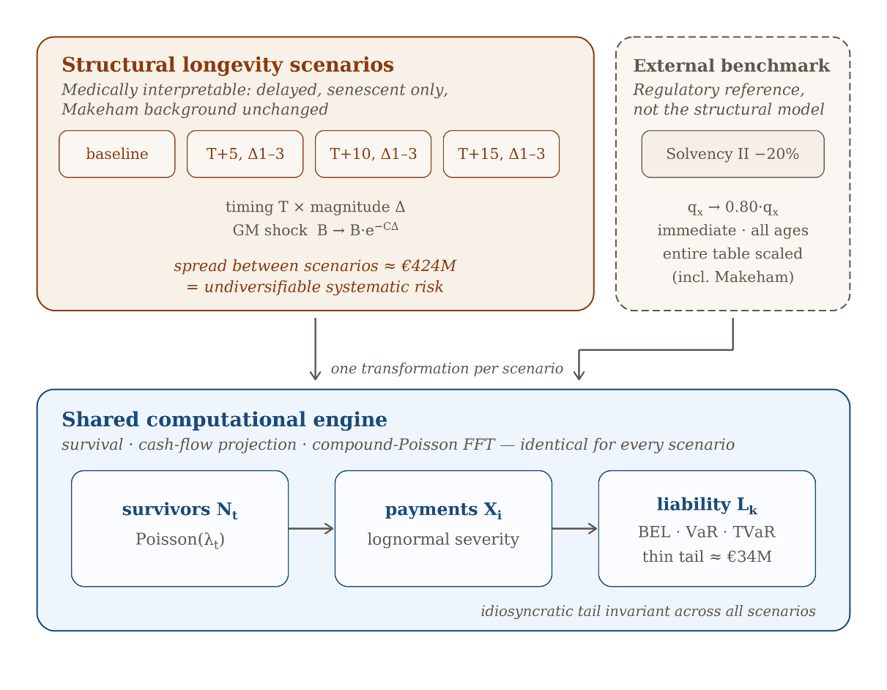
Figure 1. Model architecture. Ten structural longevity scenarios (delayed, senescent-only shocks) and the external Solvency II benchmark (immediate, whole-table) each define one mortality transformation; all feed the same computational pipeline — survival reconstruction, cash-flow projection, compound-Poisson FFT — yielding BEL, VaR and TVaR per scenario. Systematic risk is the spread between scenarios (≈€424M); the idiosyncratic within-scenario tail (≈€34M) is invariant.

5. Results
Table 1 summarises the principal results. The full scenario grid comprises ten structural scenarios; for brevity, only the largest longevity improvement (Δ = 3 years) at each shock timing is shown, together with the baseline and the external Solvency II benchmark.

Table 1. Systematic-longevity stress grid (75-year horizon, 2% discount). Figures in EUR.
Scenario | ΔBEL vs baseline | Duration | TVaR99 | Within-row tail
baseline | 0 | 23.34y | 4,561M | 33.6M
T+5y, Δ3y | +424M | 24.29y | 4,987M | 34.8M
T+10y, Δ3y | +359M | 24.43y | 4,921M | 34.6M
T+15y, Δ3y | +306M | 24.48y | 4,868M | 34.4M
SII −20% | +342M | 23.87y | 4,905M | 34.7M

5.1 The diversification result inverts
The within-row idiosyncratic tail is essentially invariant across every regime, ranging only from €33.6M to €34.8M: conditional on any mortality table, deaths are independent and the law of large numbers applies regardless of the table. The systematic between-row spread reaches €424M at the earliest, largest shock (T+5, Δ=3), about thirteen times the idiosyncratic tail. The narrowness of the conditional distribution measures only what is diversifiable; the systematic component, excluded from the stochastic layer of Section 2, is the larger risk by an order of magnitude. This result provides a concrete illustration of the theoretical breakdown of pooling under stochastic mortality described by Milevsky, Promislow and Young (2006) and Denuit and Dhaene (2007). Figure 2 contrasts the two directly: the nearly constant within-row tails against the between-scenario shift.
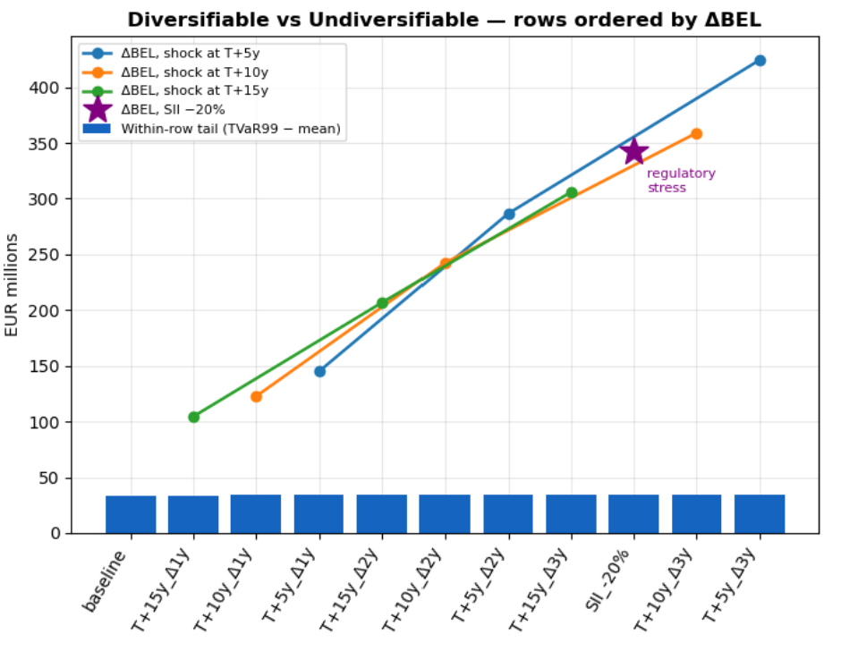
Figure 2. Within-row idiosyncratic tail (TVaR99 − mean) against between-row systematic shift (ΔBEL vs baseline), scenarios ordered by ΔBEL. The flat tails are the diversifiable component; the rising shift is the undiversifiable systematic risk. The Solvency II anchor is marked.

5.2 Two structural scenarios exceed the regulatory stress
The Solvency II −20% stress raises the liability by €342M. Two structural scenarios exceed it: a three-year longevity gain arriving in five years (€424M) or in ten years (€359M). A plausible longevity improvement within a decade therefore costs more than the standard regulatory longevity stress. Unlike the structural shocks, the Solvency II stress scales the Makeham background and applies immediately at all ages; its duration signature (23.87 years) is shorter than the late structural shocks' despite a larger liability increase than the T+15 rows, illustrating why the structural shock is the more faithful representation of a gradual longevity improvement and the regulatory row an anchor rather than an equivalent.

5.3 Longevity and interest-rate risk compound
The systematic spread, though large, remains below a 50-basis-point discount-rate move (€586M), preserving the familiar hierarchy in which economic risk dominates. But the two interact rather than add. A longevity shock lengthens liability duration — from 23.34 years at baseline to 24.48 years under the worst shock — which amplifies the dominant rate sensitivity. Evaluated jointly, the worst shock at a 1.5% discount rate raises the BEL by roughly €81M more than the sum of the two effects taken separately, an increase of about 13% in rate sensitivity under the shocked regime. Longevity risk matters not only in its own right but through its amplification of interest-rate risk. Figure 3 places the shock response against the idiosyncratic tail, the Solvency II stress and the rate-move reference lines.
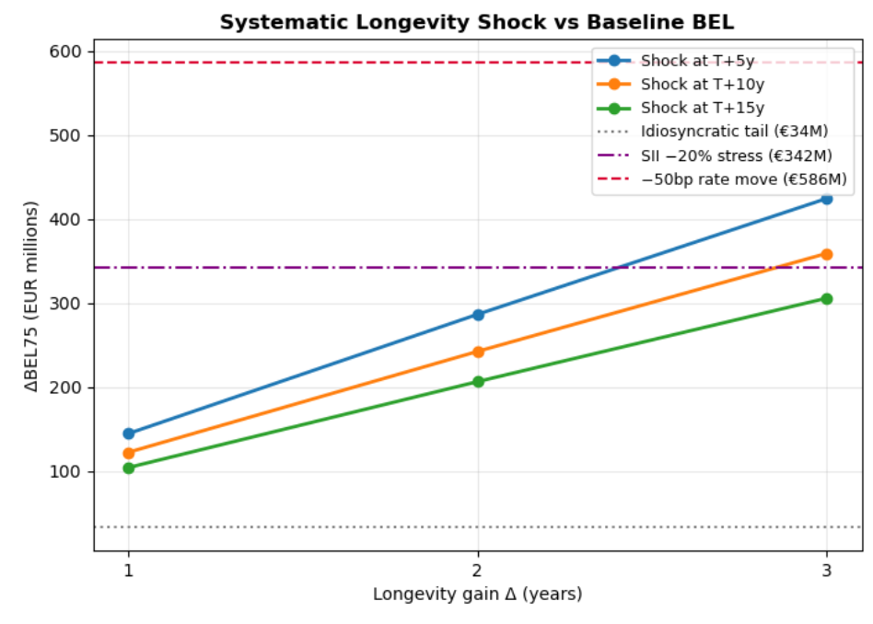
Figure 3. ΔBEL under the systematic longevity shock as a function of magnitude Δ, by shock timing T, against three reference levels: the idiosyncratic tail (≈€34M), the Solvency II −20% stress (≈€342M) and a −50bp discount-rate move (≈€586M). Two structural rows cross the regulatory stress.

5.4 Severity heterogeneity is second-order
The aggregation uses a pooled lognormal benefit severity. Decomposing severity by income segment — within-segment coefficients of variation of 0.27 to 0.36, against a pooled 0.56 inflated by between-segment mean dispersion that the frequency calibration already captures — shifts VaR99 and TVaR99 by under €0.2M on a €4.6B tail, and by a near-identical amount under the strongest shock. At portfolio scale the frequency law of large numbers dominates; benefit-severity structure, although absent from purely count-based aggregation, is a second-order refinement immaterial to the capital metrics. The result is reported rather than assumed.

5.5 Model validation
The compound-Poisson FFT aggregation was verified against an independent Monte Carlo simulation, against variation of the discretisation grid, and against its own analytic moments.
The Monte Carlo draws each year’s aggregate payment from a gamma distribution matched to the exact compound-Poisson mean and variance, then sums across the projection horizon; at survivor counts of order 10³ per year the central limit theorem renders the per-year gamma essentially exact. Over 10⁶ paths the FFT mean liability agrees with the simulation to within 0.53 standard errors at baseline and 1.13 under the strongest shock (T+5, Δ = 3 years), consistent with an unbiased estimator. The 99% value-at-risk and tail-value-at-risk agree to relative differences below 10⁻⁵: at baseline, VaR₉₉ of EUR 4.5570×10⁹ against a simulated EUR 4.5570×10⁹ (difference EUR 4.0×10⁴), and TVaR₉₉ of EUR 4.5612×10⁹ against EUR 4.5613×10⁹ (difference EUR 1.8×10⁴). Two methods sharing no computational path thus coincide to five significant figures.
Discretisation error was assessed by varying the bucket size and grid length. The mean liability is invariant to six significant figures (EUR 4.52764×10⁹) across bucket sizes from EUR 2×10³ to EUR 8×10³ and grid lengths from 2²¹ to 2²²; VaR₉₉ and TVaR₉₉ are stable to five significant figures for bucket sizes up to EUR 4×10³, degrading only at EUR 8×10³ (a downward shift in VaR₉₉ of about EUR 1.2×10⁶, in the fourth significant figure) as resolution coarsens. The production choice of bucket size EUR 2×10³ with a 2²⁴ grid — total span EUR 3.355×10¹⁰, roughly seven times the liability’s upper tail — therefore sits well within the converged region, with ample headroom against the circular-convolution wrap-around to which FFT aggregation is otherwise susceptible.
Finally, the FFT reproduces the analytic aggregate mean — the sum over projection years of expected survivors multiplied by mean discounted benefit — to a relative error of 1.3×10⁻⁸, confirming that the discretisation introduces no bias in the central estimate.

All results, figures and tables are reproducible from open Python code: the mortality fit, the scenario grid, the FFT aggregation and the validation above regenerate from a single notebook with configurable parameters, using the open-source aggregate package (Mildenhall, 2024) for the fast Fourier convolution. The same computational pipeline is used throughout; only the mortality transformation differs between scenarios.

6. Limitations and discussion
Several simplifications are stated plainly. Per-year independent Poisson counts ignore the serial persistence of survival within a member's lifetime, and Poisson approximates the binomial survivor count. A uniform Δ across income strata idealises a cause-specific improvement, which would hit segments unequally. Salary growth and the discount rate are deterministic, and full interest-rate stochasticity is treated separately through sensitivity rather than jointly. A fully stochastic mortality trend — a Lee–Carter or Cairns–Blake–Dowd process — would replace the deterministic stress grid with a distribution over trajectories; the grid is the transparent precursor to that step, and the compound-Poisson FFT machinery carries over unchanged.
The compound-Poisson FFT aggregation used here is not specific to pension liabilities; the same construction applies to segmented motor portfolios, where frequency and severity vary across rating cells. Treating analytic aggregation as an alternative to Monte Carlo across both settings is a direction we pursue in related work.

7. Conclusion

This study demonstrates that, for a large stylised occupational pension fund, idiosyncratic longevity risk diversifies almost completely, whereas systematic improvements in longevity remain undiversifiable and dominate demographic uncertainty by more than an order of magnitude. A structural longevity transformation preserving the Gompertz–Makeham family allows the same compound-Poisson FFT framework to be reused unchanged across all scenarios, including an external Solvency II benchmark. The resulting framework combines transparent actuarial assumptions, exact aggregate distributions, computational efficiency and full reproducibility. Although illustrated on a stylised pension portfolio, the underlying computational approach readily extends to richer stochastic mortality models and to other insurance applications requiring repeated evaluation of aggregate liability distributions.

References
Brouhns, N., Denuit, M. and Vermunt, J. K. (2002). A Poisson log-bilinear regression approach to the construction of projected lifetables. Insurance: Mathematics and Economics, 31(3), 373–393.
Denuit, M. and Dhaene, J. (2007). Comonotonic bounds on the survival probabilities in the Lee–Carter model for mortality projection. Journal of Computational and Applied Mathematics, 203(1), 169–176.
Embrechts, P. and Frei, M. (2009). Panjer recursion versus FFT for compound distributions. Mathematical Methods of Operations Research, 69(3), 497–508.
Hirz, J., Schmock, U. and Shevchenko, P. V. (2017). Actuarial applications and estimation of extended CreditRisk+. Risks, 5(2), 23.
Mildenhall, S. J. (2024). Aggregate: fast, accurate, and flexible approximation of compound probability distributions. Annals of Actuarial Science, 19(2), 193–232.
Milevsky, M. A., Promislow, S. D. and Young, V. R. (2006). Killing the law of large numbers: mortality risk premiums and the Sharpe ratio. Journal of Risk and Insurance, 73(4), 673–686.
Olivieri, A. and Pitacco, E. (2003). Solvency requirements for pension annuities. Journal of Pension Economics and Finance, 2(2), 127–157.

