D4 - Stockpile Block Model and Model Outputs
Pit I HG stockpile - current state after the 2026-03-29 survey (provisional through 2026-03-31)

1. Model files
File | Format | Use
outputs/blockmodel/stockpile_block_model.csv | CSV, one row per block containing material (2,699 blocks) | Excel, Vulcan, Datamine, Leapfrog, Deswik (import with centroid + size)
outputs/blockmodel/stockpile_block_model.vtk | VTK structured points, cell data | ParaView 3-D viewing (Threshold tonnes > 0)
outputs/blockmodel/block_model_definition.json | JSON | Origin, block size, dimensions, units, CRS note
outputs/movement/*.asc | ESRI ASCII grids (1 m) | Floor plane, pre-record surface, final model surface, latest surveyed surface (GIS / CAD)
outputs/movement/load_destinations.csv | CSV | Where each truck load was placed (destination centroid, push distance, spread)
outputs/blockmodel/summary_*.csv | CSV | Inventory by material source (exact class split), by dominant information class (whole blocks), confidence class, 4 m bench; grade-tonnage
Block definition. Origin (lower-left-bottom corner) E 511,290, N 7,122,280, Z 4,474.0. Blocks 5 × 5 × 2 m; 27 × 26 × 10 blocks. Partial blocks are exported with fill_frac and their true material volume. Coordinates are in the mine grid (see D2, A-01).
Units. Tonnes are as reported by the FMS (moisture basis not stated, A-26). Block volumes use the in-pile volume T × f_v / Dens with the calibrated volume factor f_v = 1.472. In the base case the in-pile density is 1.40 t/m³ (A-06; D2 Section 2.5). Cu is in %, Au and Ag in g/t (as supplied, see QA-F04). Contained Cu is in tonnes, Au and Ag in kg (1 koz = 31.1035 kg).

1.1 Block fields
Field | Meaning | Info type
ix, iy, iz, xc, yc, zc, dx, dy, dz | Block index, centroid, size | -
volume_m3, fill_frac | Material volume in block; fraction of block filled | Measured geometry + inferred where unsurveyed
tonnes, density | Total tonnes; derived in-pile density (tonnes ÷ volume) | Measured tonnes, calibrated volume (FMS); assumed by class otherwise
cu_pct, au_gpt, ag_gpt | Best-estimate grade (all classes) | Mixed: see class fractions
cu_t, au_kg, ag_kg | Contained metal | Mixed
t_fms, t_unattributed, t_legacy, t_provisional | Tonnes by information class (t_legacy = pre-record core) | -
frac_fms, frac_unattributed, frac_legacy | Class fractions | -
cu_pct_fms, au_gpt_fms | Grade of the FMS-tracked part only | Measured inputs, model-generated placement
cu_sd_within, au_sd_within | Grade heterogeneity among the loads mixed into the block | Model-generated
n_eff_loads, n_loads_ge1pct, top_loads | Effective number of loads; loads ≥ 1% of block; top three cycle IDs with share | Model-generated provenance
mean_place_date | Tonnage-weighted placement time of FMS material | Measured + model
top_surveyed_frac | Fraction of block footprint whose top surface was surveyed | Measured
cu_p10/p50/p90, au_p10/p50/p90, tonnes_p10/p90, cu_cv, au_cv, tonnes_cv | Uncertainty (Monte Carlo, 60 realisations; prior load-scale range for blocks < 50% FMS-tracked, see grade_range_basis) | Model-generated
info_class | Dominant class: FMS-reconciled / Unattributed-imputed / Legacy-assumed / Provisional | -
confidence | High / Medium / Low / Uninformed (rules in D3, Section 5.1) | -

2. Inventory

2.1 By information class (base case)
Inventory by information class (FMS grades/metal shown for the whole FMS class)
class | tonnes | share | Cu % | Au g/t | Cu (t) | Au (koz) | basis of grade
FMS-tracked, survey-reconciled | 44,422 | 32.1% | 8.42 | 8.00 | 3,760 | 11.5 | measured inputs; location model-generated
FMS-tracked, provisional (after last survey) | 228 | 0.2% |  |  |  |  | measured inputs; location from forward model
Unattributed (surveyed volume, no FMS record) | 3,901 | 2.8% | 10.22 | 8.82 | 399 | 1.1 | imputed (same/adjacent intervals)
Record-period total | 48,551 | 35.1% | 8.57 | 8.06 | 4,159 | 12.6
Pre-record core (legacy) | 89,795 | 64.9% | 8.42 | 8.00 | 7,562 | 23.1 | assumed (FMS mean); geometry inferred
Whole pile modelled | 138,346 | 100.0% | 8.47 | 8.02 | 11,722 | 35.7
Read the record-period total first. It is the material placed during the FMS record (15-31 March) and is tied to surveyed fill. The pre-record core has inferred geometry and an assumed grade. The whole-pile total includes it.
Not included in any range in this table: the interpretation that the 47% volume excess is loads missing from the FMS. In that case record-period tonnes would be 71,338 t (scenario X2, D6 Section 10.2).
Two class tables. This table is the exact split: every block’s tonnes are divided among the classes. summary_by_dominant_info_class.csv instead counts each whole block under its dominant class, for maps and reclaim planning, so its class totals differ even though the grand total is the same.
Identical grades across classes follow from the assumptions: legacy grade = FMS mean (A-22), and unattributed grade is imputed from the same loads (A-21).
Grade units are as supplied and unconfirmed (QA-F04).
Reading this table. Only the first two rows rest on measured grade data. The unattributed row has a measured volume but an imputed grade. The pre-record core’s grade is assumed, and its volume depends on assumptions A-13 and A-14.

2.2 By confidence class
Table 8.1 - Inventory by confidence class
confidence | blocks | tonnes | cu_pct | au_gpt | cu_t | au_koz
High | 667 | 35,591 | 8.22 | 7.89 | 2,925 | 9.0
Medium | 270 | 11,229 | 9.31 | 8.38 | 1,046 | 3.0
Low | 122 | 6,574 | 8.97 | 8.30 | 590 | 1.8
Uninformed | 1,640 | 84,951 | 8.43 | 8.01 | 7,161 | 21.9

2.3 By 4 m reclaim bench
Table 8.2 - Inventory by 4 m reclaim bench (all classes; see D4 for class split)
bench | blocks | tonnes | cu_pct | au_gpt | cu_t | au_koz
4490-4494 | 18 | 50 | 8.72 | 9.96 | 4 | 0.0
4486-4490 | 460 | 14,305 | 8.75 | 8.15 | 1,251 | 3.7
4482-4486 | 671 | 40,591 | 8.45 | 8.02 | 3,429 | 10.5
4478-4482 | 757 | 46,928 | 8.43 | 8.00 | 3,957 | 12.1
4474-4478 | 793 | 36,472 | 8.44 | 8.00 | 3,080 | 9.4
Source: outputs/blockmodel/summary_by_bench_4m.csv (model run 20261008T173954).

3. Visualisations
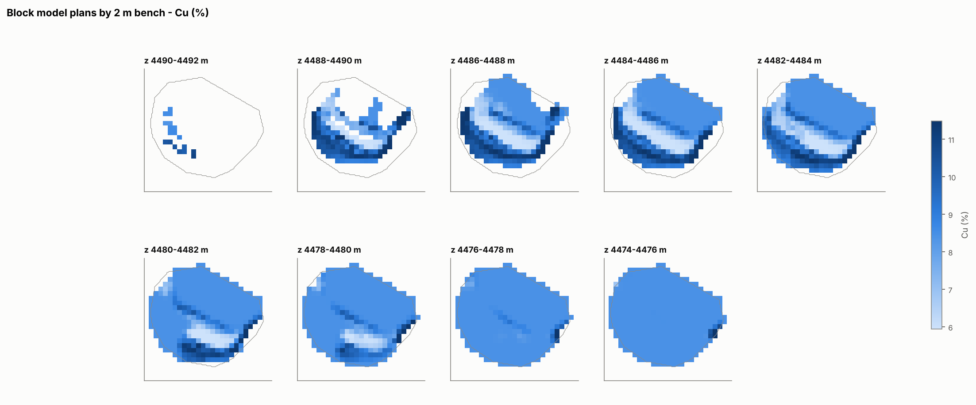
Cu grade by 2 m bench
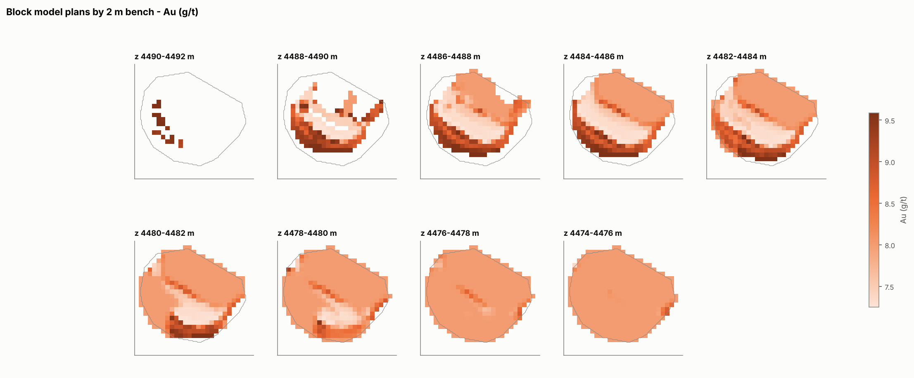
Au grade by 2 m bench
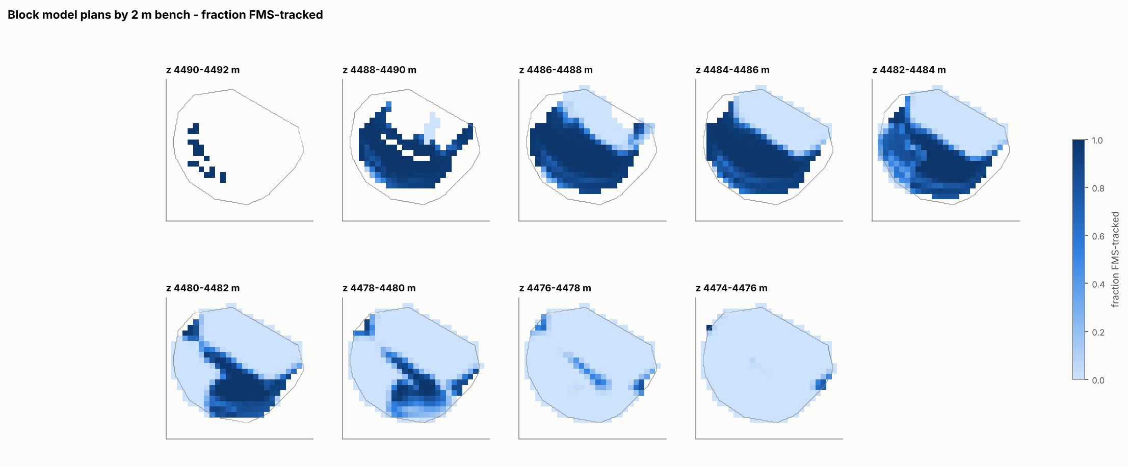
Fraction of block tonnes that is FMS-tracked
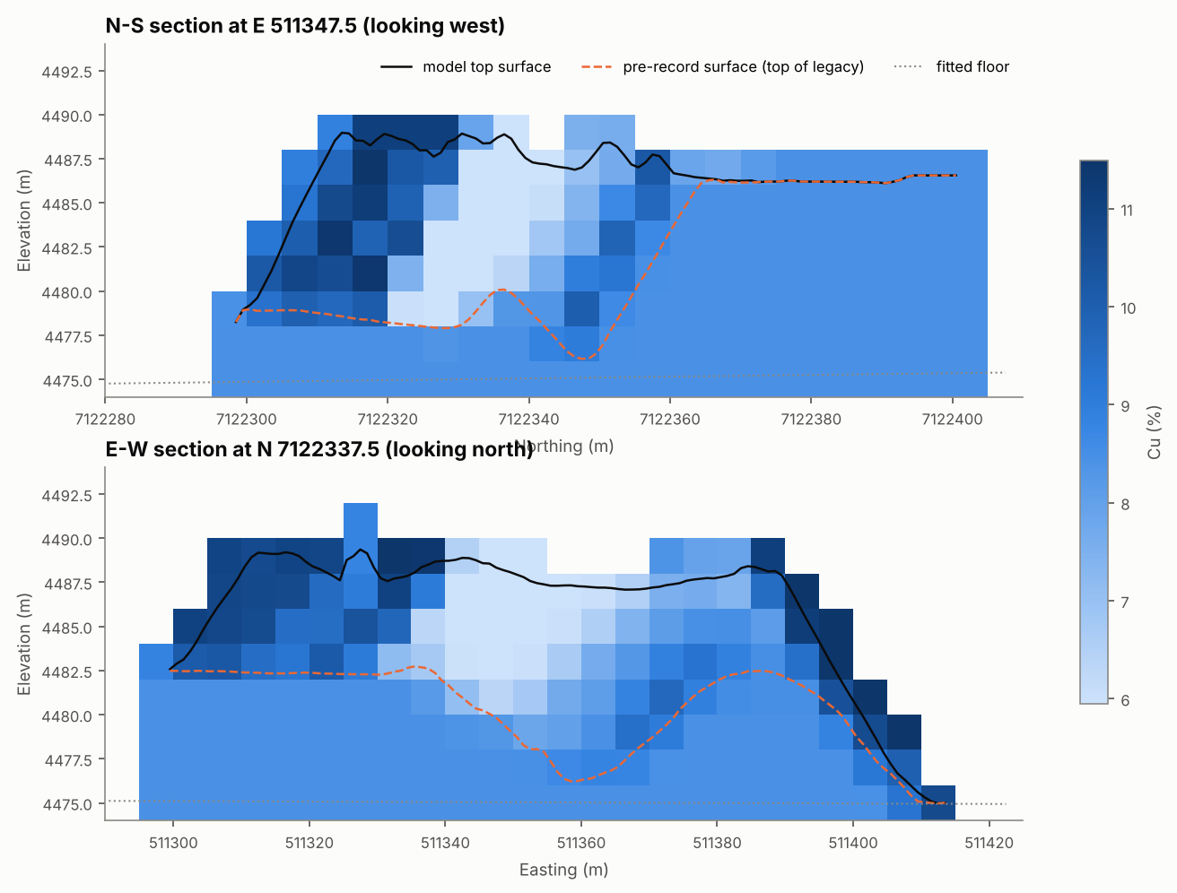
Sections through the tonnage-weighted centre of FMS material
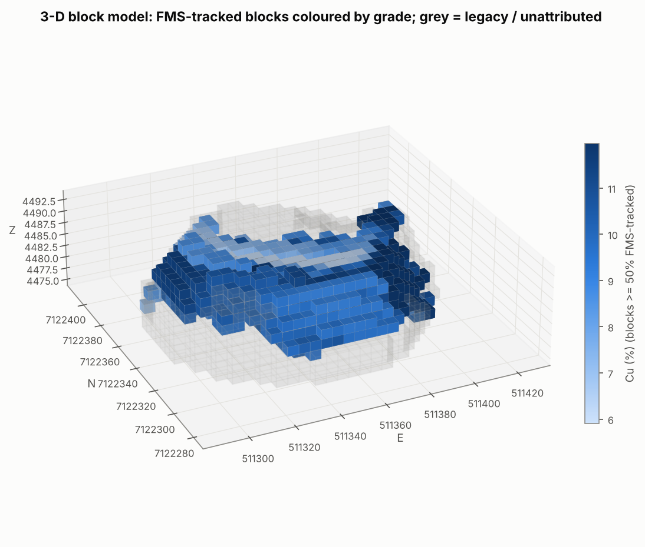
3-D view: FMS-tracked blocks coloured by Cu
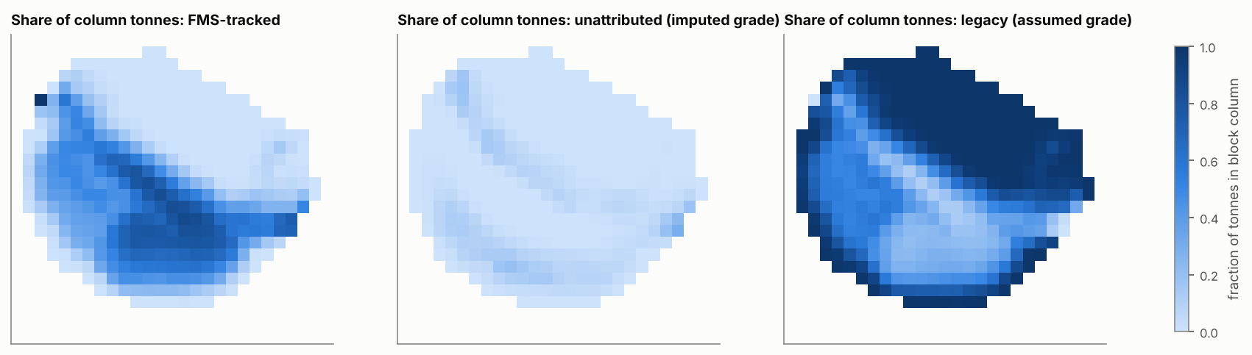
Share of column tonnes by information class
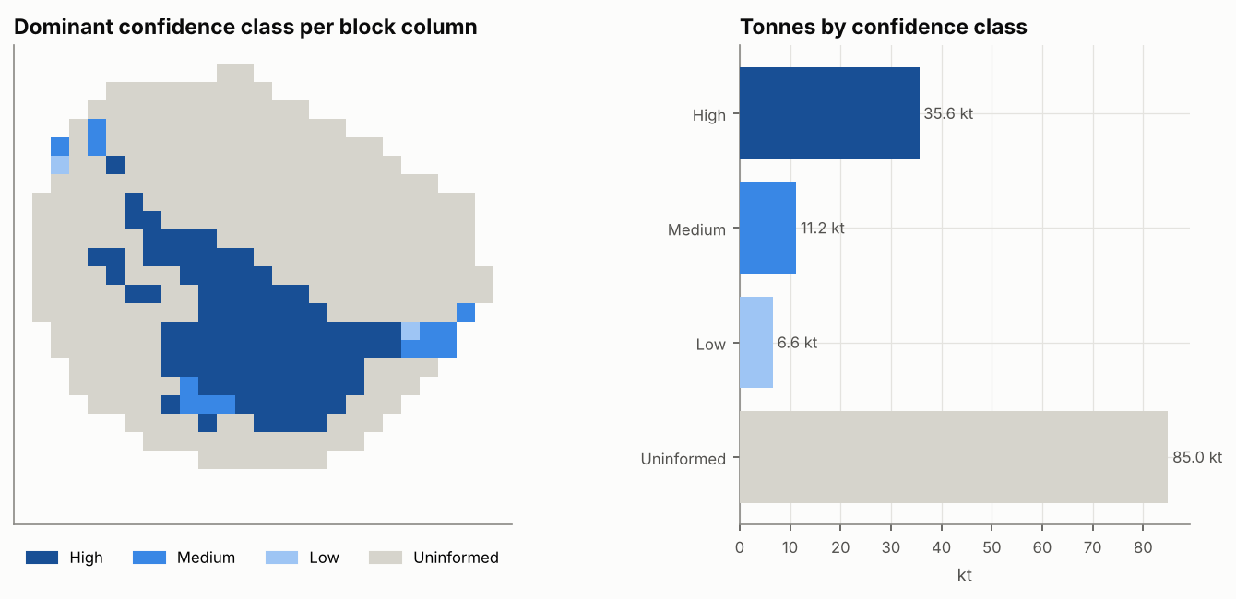
Confidence classes
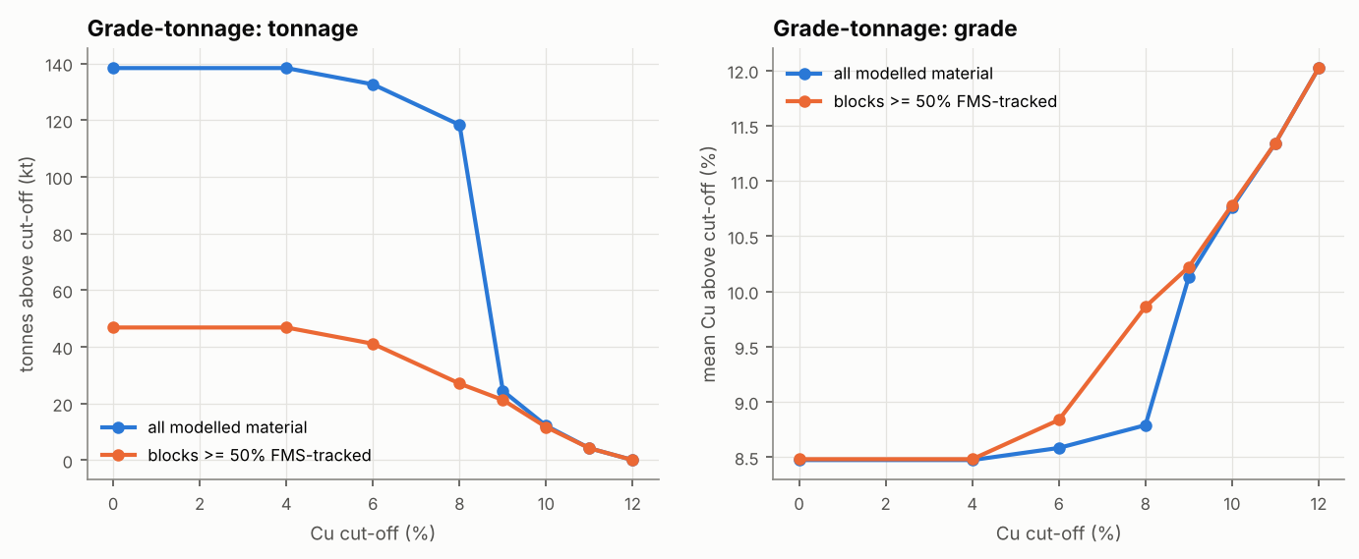
Grade-tonnage curves
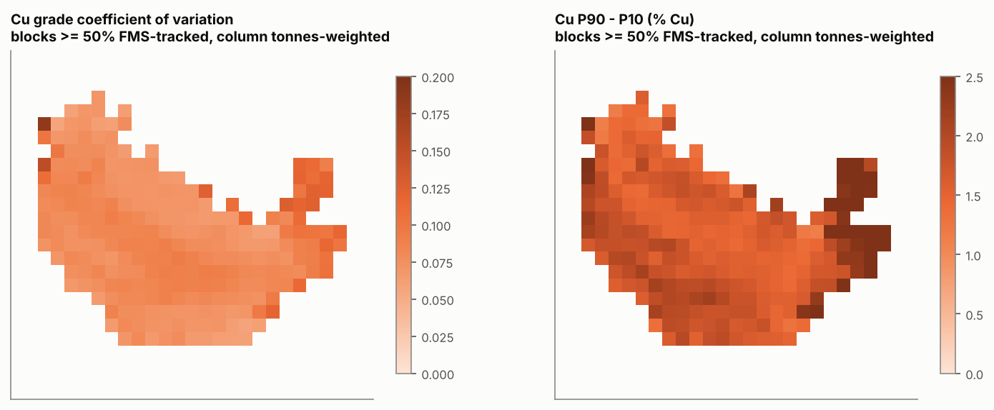
Block uncertainty (Monte Carlo)

4. How to use the model
- Reclaim sequencing / blending. Filter confidence ∈ {High, Medium} for material whose grade rests on FMS data. Use cu_p10 and cu_p90 to test blends against plant constraints. Treat Legacy-assumed blocks as unknown-grade material until sampled.
- Plant-feed / metal forecasting. Use the bench summaries with their P10-P90 ranges. Report the record-period inventory first and separately from the pre-record core (D6, Section 13). Quote the scenario X2 next to any tonnage range.
- Reconciliation. top_loads and load_destinations.csv let mill or stacker grade measurements be compared with the loads predicted to be in a reclaimed block. This is how ε and the push parameters should be calibrated in operation.
- Updating. After each new survey run python -m spbm update. Provisional blocks will be re-reconciled.

