D3 - Technical Methodology and Algorithm
Constrained Push-and-Settle Transport (CPST) for stockpile reconstruction and block modelling

1. Purpose and design philosophy
The movement of material from a truck dump point to its final place in the pile is never observed. Two kinds of observation constrain it:
- where material came from: FMS dump coordinates, tonnage and grade (sources);
- where volume appeared: the sequential survey change solids (sinks).
Physics-only rules (push to the crest, roll down at the angle of repose) can predict the shape of a deposit, but they predict where fill appears only moderately well. Our forward model places 40% of predicted volume inside the observed fill footprint on unseen periods (Section 9.3). A reconstruction used for inventory must therefore be constrained by the surveys. The design principle is:
Let the surveys decide where volume went, let the FMS decide what went there, and use a physically based transport cost (dozer push work over the real terrain) to decide which source filled which part of the observed fill, conserving mass and metal exactly.
This is a classical earth-moving problem. Optimal transport was formulated by Monge (1781) to move déblais (cuts) to remblais (fills) with minimum work. We use its modern entropy-regularised form (Cuturi, 2013; Peyré and Cuturi, 2019), where the regularisation strength is a physically interpretable mixing length. We name the method CPST: Constrained Push-and-Settle Transport. A separate forward physics model (dozer push to crest + avalanche cellular automaton at the angle of repose) is used for prediction (temporal validation), for loads not yet surveyed (nowcast), and to generate known-truth data (synthetic twin validation).
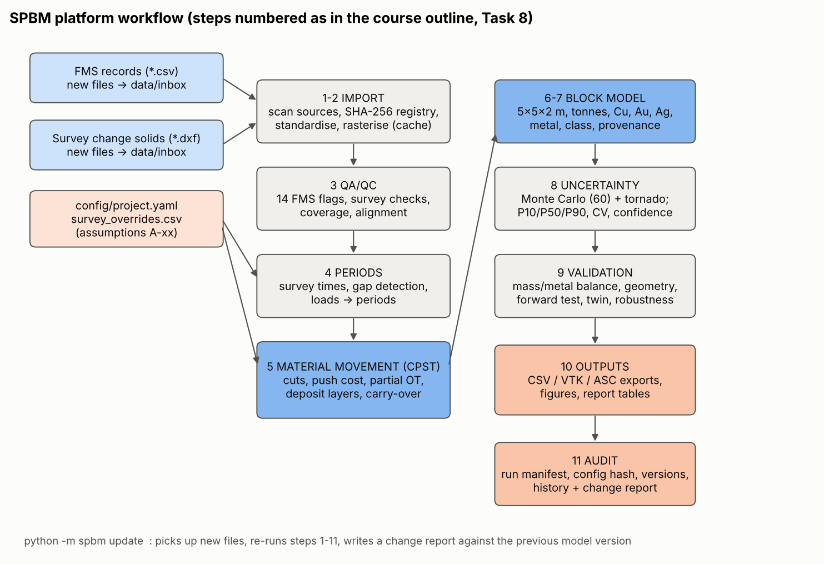
Platform workflow

2. Data model

2.1 Grid and survey change solids
A regular grid of cell size $Δ$ = 1 m (A-24) covers all data plus a 6 m margin. Its origin is snapped to a 10 m lattice so that grids of different resolution share block boundaries. Each survey file s is a closed triangulated solid (QA-S01). It is rasterised at cell centres $c$ by barycentric interpolation. The highest face through a centre gives ${\text{top}}_{s}\left(c\right)$ and the lowest gives ${\text{bot}}_{s}\left(c\right)$. Cells crossed by no face are outside the solid. The implementation is vectorised (spbm/grid.py::rasterize_triangles) and independent of face winding.

2.2 State: stratigraphic columns
The stockpile state is a column of layers for every cell. Each layer $ℓ$ has a bottom and top elevation and a vector of extensive properties:
$$π_{ℓ}=\left(V, T_{F},Cu_{F},Au_{F},Ag_{F}, T_{U},Cu_{U},Au_{U},Ag_{U}, T_{L},Cu_{L},Au_{L},Ag_{L}, Σm g_{Cu}^{2}, Σm g_{Au}^{2}, Σm t, Σm^{2}, T_{R}\right)$$
Here $V$ is volume (m³) and $T$ is tonnes. $Cu$ is tonnes of copper ($m g_{Cu}/100$). $Au$ and $Ag$ are kilograms ($m g/1000$). The subscripts F, U, L and R mean FMS-tracked, unattributed, legacy and provisional. Every operation of the algorithm (deposit, split, cut, mix) is a non-negative linear combination of these vectors. Mass and metal are therefore conserved by construction, and grades are always derived as ratios (e.g. $g_{Cu}=100 ∑Cu/∑T$), never averaged directly.

2.3 Periods
Survey s is assigned the time $t_{s}$ = 23:59 on its (corrected) date (A-05). Period s is $(t_{s−1},t_{s}]$. A load with time $t_{k}$ belongs to period s if $t_{s−1}<t_{k}≤t_{s}$. Loads after the last survey are provisional. A period is a gap period if $t_{s}−t_{s−1}>36$ h, or if more than 10% of previously surveyed cells inside solid s have ${\text{bot}}_{s}$ above the model surface by more than τ (a missing intermediate survey).

3. The CPST algorithm (one period)
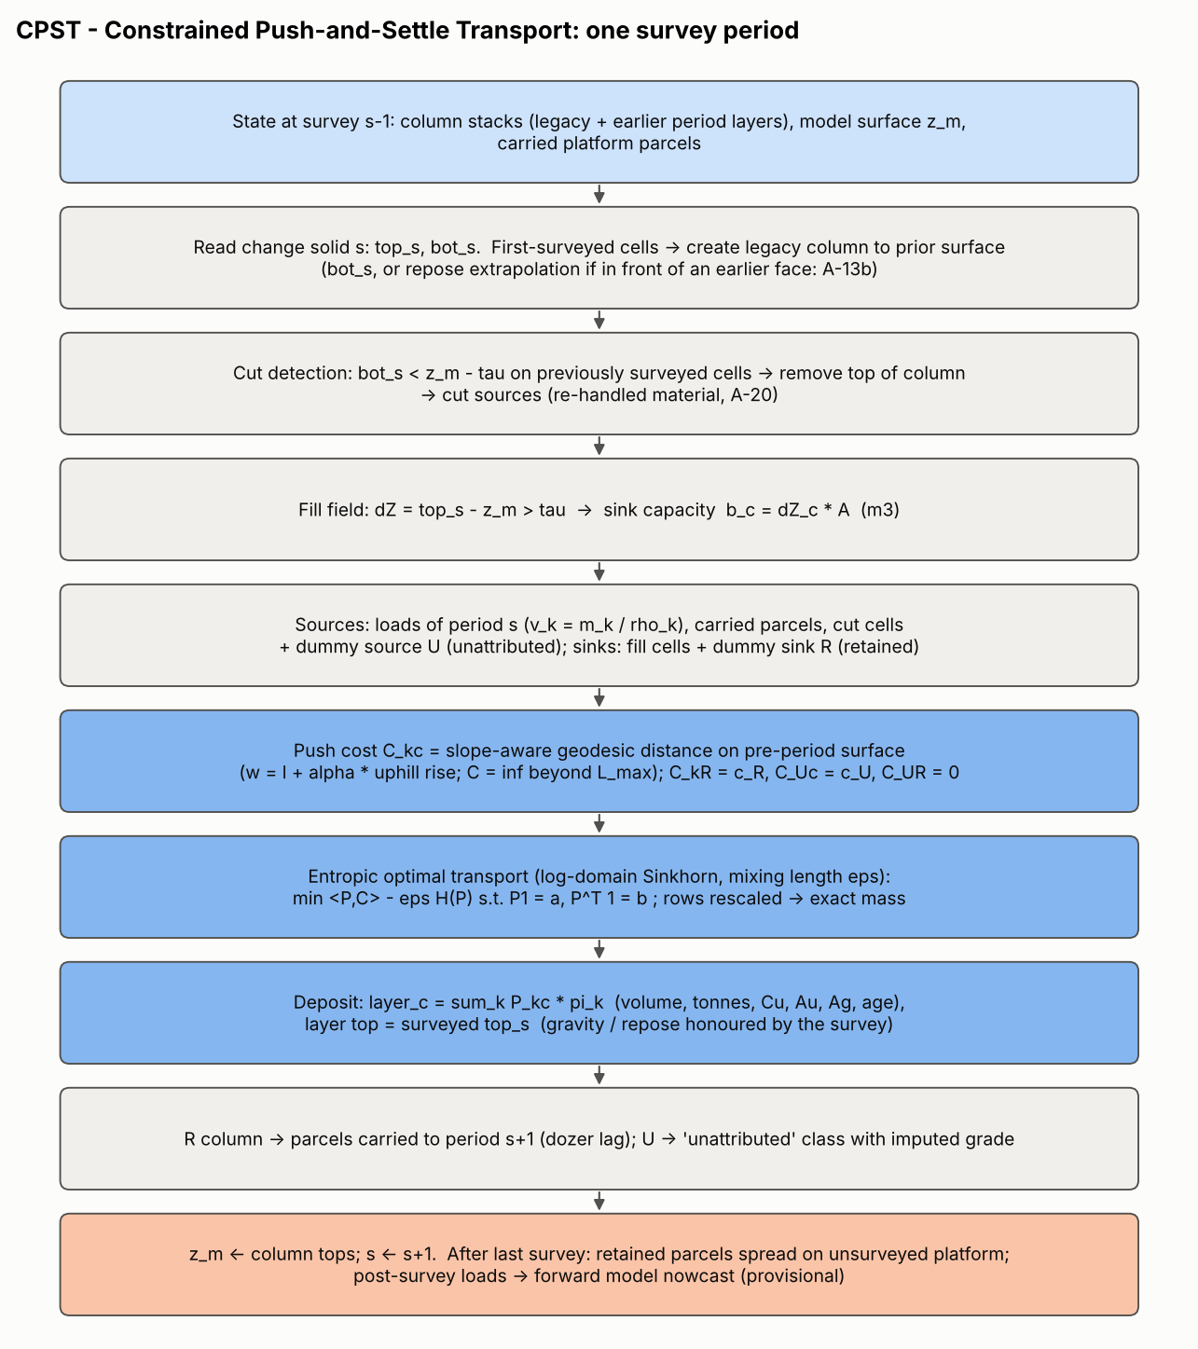
CPST algorithm

3.1 Prior surface and legacy material (first-surveyed cells)
For a cell surveyed for the first time, the prior elevation $z_{c}^{0}$ is the solid bottom ${\text{bot}}_{s}\left(c\right)$, with one exception (A-13b). If the cell lies in front of a previously surveyed face, its prior elevation cannot exceed the repose-angle continuation of that face:
$$z_{c}^{\text{inf}}=max​\left(B_{c}, z_{n}−d_{cn}tanϕ\right), z_{c}^{0}=\left\{\begin{matrix}z_{c}^{\text{inf}} & \text{if }z_{c}^{\text{inf}}<{\text{bot}}_{s}\left(c\right)−τ \\ {\text{bot}}_{s}\left(c\right) & \text{otherwise}\end{matrix}\right.$$
Here $n$ is the nearest surveyed cell, $d_{cn}$ the distance, $ϕ=37°$ and $B$ the fitted floor plane. “In front” is decided by the down-slope direction of the surveyed surface at $n$. The cell is in front if the vector $n→c$ points down-slope (|cos| > 0.3); otherwise the cell is behind (on the platform). The difference ${\text{bot}}_{s}−z^{0}$ is fill placed during the record that no solid captured (toe-clipped solids, missing surveys). It joins this period’s fill. A legacy layer from $min\left(B_{c},z_{c}^{0}\right)$ to $z_{c}^{0}$ is created with assumed properties (A-22).

3.2 Cuts (elevation decrease)
For previously surveyed cells, $δ_{c}={\text{bot}}_{s}\left(c\right)−z_{m}\left(c\right)<−τ$ indicates material removed since the last observation (A-20). The top $\left|δ_{c}\right|$ of the column is removed. Its extensive properties $Π_{j}$ (split proportionally within the cut layer) become a cut source $j$ located at cell $c$.

3.3 Fill field (sinks)
$$ΔZ_{c}={\text{top}}_{s}\left(c\right)−z_{m}\left(c\right), b_{c}=ΔZ_{c} Δ^{2} \text{for} ΔZ_{c}>τ$$
with the detection limit $τ=k\sqrt{2} σ_{z}$ = 0.14 m (A-08, A-09).

3.4 Sources
- Loads $k$ of the period: $v_{k}=m_{k}/\left(κ ρ_{k}\right)$ m³, located at the dump cell (for the 14 records with a default FMS position, the tonnage-weighted centroid of the period’s other dumps, A-32). Properties per m³: $π_{k}=Π\left(m_{k},g_{k}\right)/v_{k}$ (question A: initial placement is a point parcel at the reported X/Y; GPS uncertainty is handled by Monte Carlo, Section 7).
- Carried parcels from the previous period (A-23), at their original dump cell.
- Cut sources $j$ (Section 3.2).
- Dummy source U (unattributed) with volume VF=c​bc.
Sinks are the fill cells $c$, plus a dummy sink R (retained on the platform) with capacity VS=k​vk+j​Vj. The problem is balanced: $∑a=V_{S}+V_{F}=∑b$.

3.5 Push cost (questions B, C)
On the pre-period surface $z$ (surveyed or inferred), a directed 8-neighbour graph is built. The edge weight from cell $i$ to neighbour $j$ is
$$w_{ij}=ℓ_{ij}+αmax\left(0, z_{j}−z_{i}\right)$$
where $ℓ_{ij}$ = 1 or √2 m and α = 4 is the uphill penalty (A-16). The push cost is the geodesic (Dijkstra) distance $C_{kc}=\min_{\text{paths}}∑w$, with $C_{kc}=∞$ if $C_{kc}>L_{max}$ = 90 m (A-17). Dummy costs: $C_{kR}=c_{R}$ = 90 m, $C_{Uc}=c_{U}$ = 90 m, $C_{UR}=0$. Because $c_{R}+c_{U}>L_{max}$, a load is always sent to reachable fill before being retained. U fills only the volume that available sources cannot (partial optimal transport).
Direction (B) is therefore the least-work route over the actual terrain: down-slope pushes are cheap, pushing over a crest and down the face is cheap, uphill is expensive. The survey decides which face sector actually received fill. Distance (C) is set by the capacity constraint: material stops where observed accommodation space exists, and the least-cost assignment is used. Movement beyond $L_{max}$ is not allowed. Material that finds no reachable fill stays on the platform (R) and is carried to the next period (dozer lag).

3.6 Allocation: entropic optimal transport (questions E, F, G, H)
P⋆=argminP≥0 k,c​PkcCkc − εHP s.t. P1=a, P⊤1=b, HP=−∑PkclogPkc−1
The solution is $P_{kc}=exp\left(\left(f_{k}+g_{c}−C_{kc}\right)/ε\right)$. It is computed by log-domain Sinkhorn iterations (numerically stable with infinite costs):
$$f_{k}←εloga_{k}−ε {\text{LSE}}_{c}​\left({g_{c}−C_{kc}}/ε\right), g_{c}←εlogb_{c}−ε {\text{LSE}}_{k}​\left({f_{k}−C_{kc}}/ε\right)$$
Iteration stops when k​c​Pkc−ak/∑a<10−6 (max. 5000 iterations). A final row rescaling Pkc←Pkc ak/c​Pkc makes each source’s volume exactly conserved. The remaining column residual (≤ 8×10⁻⁷ relative in all periods) is reported as the numerical reconciliation error.
ε is the mixing length (A-18). As ε → 0 the plan becomes the work-minimising deterministic assignment (no mixing beyond what is geometrically forced). As ε → ∞ every source is spread uniformly over the period’s fill, giving the “period-average” model. ε = 6 m represents GPS error, blade spill and rolling on the face. Its effect is quantified by the twin experiment, the tornado and the Monte Carlo.

3.7 Deposit (questions D, E, F, I)
Each fill cell receives one new layer from $z_{m}\left(c\right)$ up to zmc+k​Pkc/Δ2, which equals the surveyed ${\text{top}}_{s}\left(c\right)$ to solver tolerance:
πlayer,c=k​Pkc πk + PUc πU, Σmc2=k​(Pkc mk/vk)2
Downslope behaviour (D) is honoured because the layer top is the surveyed surface: faces are at the measured angle of repose (median 36.7°), and the material that formed them, including what rolled to the toe, is assigned by the transport plan. Within one period the layer is vertically homogeneous (A-19). Mixing (E) is the volume-weighted combination of sources in the same cell. Grades follow from metal over tonnes, so mixing of loads with different densities is handled correctly. Surface reconciliation (F) holds because the column marginals equal the observed fill: the model surface equals the survey (Section 9.2). The unattributed U volume carries the imputed properties $π_{U}$ (A-21).

3.8 Sequential updating (I) and closing the record
After deposit, $z_{m}$ = column tops, the volume in column R becomes carried parcels, and the next period starts from this state. After the last survey:
- Never-surveyed domain cells receive legacy columns up to the inferred pre-record surface (A-13).
- Parcels still retained are spread (Gaussian kernel, σ = 6 m) over unsurveyed platform cells around their dump point.
- Loads after the last survey are placed by the forward model (Section 4) and flagged Provisional. When the next survey is imported they are automatically reconciled like any other load.

3.9 Mass and metal conservation (G, H)
- Every source row of $P$ sums exactly to the source volume, so no FMS tonne is created or lost.
- Cuts move extensive properties from columns to sources and back into columns.
- The dummy U adds volume only to the unattributed class; legacy volume is only in the legacy class. FMS totals are therefore checked separately from them.
- Verification: FMS tonnes, Cu, Au and Ag in the final block model differ from the FMS input by 3×10⁻¹² (relative), i.e. floating-point round-off. This is enforced by the automated test tests/test_core.py::test_end_to_end_mass_and_metal_conservation.

3.10 Numerical stability (J)
Setting | Value | Effect tested
Grid cell | 1 m (0.5 and 2.5 m tested) | Robustness table, Section 9.6
Detection limit τ | 0.14 m (k = 1-4 tested) | Volume not moved: 96 m³ (0.2%)
Sinkhorn tolerance | 10⁻⁶ (10⁻⁴, 10⁻⁸ tested) | Column residual ≤ 8×10⁻⁷
Log-domain Sinkhorn | always | No underflow with costs ≫ ε
Time step | one survey interval (data-driven) | Gap periods flagged
Block size | 5 × 5 × 2 m (2 × 2 × 1 and 10 × 10 × 4 tested) | Tornado
Typical convergence takes 10-230 Sinkhorn iterations per period. A full reconstruction takes about 6 s.

3.11 Pseudocode
INPUT surveys s = 0..S-1 (top_s, bot_s, t_s), loads k (x, y, t, m, g, rho), config
STATE columns[c] = list of (z_bot, z_top, props); z_m[c]; observed[c]; carried = []
B <- fit_floor_plane(toe cells) ; domain <- hull(survey cells, dumps)
for s in 0..S-1:
F <- cells with finite top_s
for c in F not observed: # first-surveyed cells
z0 <- bot_s[c]
if s>0 and front_of_earlier_face(c): z0 <- min(z0, repose_extrapolation(c))
columns[c] <- [legacy layer B..z0]
for c in F observed and bot_s[c] < z_m[c]-tau:
cut_sources += remove_top(columns[c], z_m[c]-bot_s[c])
fill <- {c in F : top_s[c]-z_m[c] > tau}, b_c <- (top_s-z_m)*A
sources <- carried + loads(period s) + cut_sources
a <- [v_k ..., V_fill], b <- [b_c ..., V_sources]
C <- geodesic_cost(surface, alpha, L_max) ; add dummy costs c_R, c_U, 0
P <- sinkhorn_log(a, b, C, eps) ; P <- rescale_rows(P, a)
for c in fill: append layer sum_k P[k,c]*pi_k + P[U,c]*pi_U to columns[c]
carried <- {k : P[k,R] > 0} # dozer lag
observed[F] <- True
add legacy columns on never-surveyed domain cells (inferred surface)
spread carried parcels on unsurveyed cells; nowcast post-survey loads (forward model)
blocks <- integrate layers into 5x5x2 m blocks (exact partial-layer fractions)

4. Forward (predictive) physics model
Used where no survey constrains the result (temporal validation, nowcasting, synthetic truth). Code: spbm/forward.py.
- Crest detection. On the surface smoothed with a 1.5 m Gaussian, a face cell has slope > 20° and at least 5 m of local relief within 11 m. Crest cells are gentle cells adjacent to a face and near the local maximum. Only crests within the surveyed area are used.
- Dozer push. Each load is pushed to the nearest crest cell and released down-slope onto the face (release offset 0-4 m, calibrated), as a disc of radius 2-5 m (calibrated).
- Gravity / avalanche cellular automaton. Only the newly placed (mobile) material may move. For each cell $i$ and neighbour $j$, the excess is $e_{ij}=max\left(0,z_{i}−z_{j}−ℓ_{ij}tanϕ\right)$. The cell releases $o_{i}=min\left(1/2\max_{j}e_{ij}, {\text{mobile}}_{i}\right)$, distributed to neighbours in proportion to $e_{ij}$. This repeats until $maxo_{i}<0.01$ m. Volume is conserved exactly (unit test). Slopes relax to ≤ φ.

5. Block model construction (Task 5)
- Blocks: 5 m × 5 m × 2 m, origin (511,290; 7,122,288; 4,474). Horizontal size: GPS error (σ ≈ 3 m) plus the mixing length (6 m) mean no information exists below about 5 m. Vertical size: 2 m gives 6-8 slices over the 13-15 m face, matching the vertical resolution of daily layers (median solid thickness 0.9-3.0 m). It also suits loader reclaim slices. Larger and smaller blocks were tested (tornado).
- Discretisation / partial blocks: layers are integrated exactly into blocks (the fraction of each layer’s thickness inside each 2 m slice). No sub-blocking is needed: each block carries its fill fraction and true material volume; partial blocks are exported, not rounded.
- Density: per-load FMS density × κ for FMS material. Imputed density for unattributed fill. Mean FMS density for legacy. Block density = tonnes / volume (derived, never averaged).
- Grade compositing / mixing: tonnage-weighted via extensive metal. The within-block heterogeneity $s_{Cu}=\sqrt{Σmg^{2}/Σm−{\overset{‾}{g}}^{2}}$ is reported.
- Provenance: a sparse load × block tonnage matrix built from the stored transport plans. It gives the effective number of loads $n_{\text{eff}}={\left(∑t\right)}^{2}/∑t^{2}$ and the top three contributing cycle IDs per block (traceability for reconciliation with mill results).
- Uninformed regions: legacy (pre-record) material and unattributed fill are kept in separate tonnage fields. A block’s info_class is its dominant class. Geometry is flagged by top_surveyed_frac.
Fields exported per block: indices and centroid, dimensions, volume, fill fraction, tonnes, density, Cu %, Au g/t, Ag g/t, contained Cu (t), Au (kg), Ag (kg), tonnes by class, FMS-only grades, within-block SD, n_eff, top loads, mean placement date, surveyed-top fraction, Monte Carlo P10/P50/P90 and CV, information class and confidence class.

5.1 Confidence classification
Class | Rule
High | ≥ 80% of tonnes FMS-tracked, Cu CV ≤ 10%, ≥ 50% of footprint has a surveyed top
Medium | ≥ 50% FMS-tracked and Cu CV ≤ 20%
Low | ≥ 20% FMS-tracked
Uninformed | < 20% FMS-tracked (legacy or unattributed dominated)
These are internal planning classes, not JORC/NI 43-101 resource categories. Public reporting would require a Competent/Qualified Person.

6. Information types
Quantity | Type
Dump X/Y, timestamp, payload, source grade, density | Measured (with stated errors)
Survey top/bottom surfaces in solid footprints | Measured
Survey time-of-day, file re-dating | Inferred from data
Floor plane, pre-record surface outside solids, front-of-face prior | Inferred
Legacy grade/density, unattributed grade, κ, φ in unsurveyed areas | Assumed
Location of each load inside the fill, block grades, uncertainty ranges | Model-generated

7. Uncertainty methodology (Task 7)
Monte Carlo (60 realisations, seed 413). Each realisation runs the full reconstruction with jointly sampled inputs:
Source | Sampling
Truck GPS error | X, Y + N(0, 3 m) per load
Tonnage measurement | × (1 + N(0, 0.08)) per load, × (1 + N(0, 0.03)) systematic
Assay / source grade | × (1 + N(0, 0.10)) per grade signature (Cu, Au, Ag independently)
Density / compaction | κ ~ U(0.80, 1.05)
Survey error | vertical bias N(0, 0.05 m) per survey
Survey timing | survey time ∈ {21:00, 22:00, 23:00, 23:59}
Degree of mixing | ε ~ U(2, 15) m
Unknown dozer trajectories | α ~ U(1, 10)
Movement distance | L_max ~ U(50, 130) m
Missing data | unattributed grade drawn by tonnage-weighted bootstrap of the period’s loads
Blocks are accumulated on the base block grid. For each block we report P10/P50/P90 and the coefficient of variation of Cu, Au and tonnes; for the whole stockpile we report P10/P50/P90 totals. One-at-a-time sensitivity (tornado) varies ε, α, $L_{max}$, κ, σz, survey time, grid cell, block size and the A-13b switch individually.

8. Validation methodology (Task 6)
Area | Metric
Geometry | RMSE, bias, P1/P99, volume difference of model top vs latest surveyed top; fraction within τ; error map
Mass balance | FMS tonnes in vs block model (by class); unattributed and retained volumes per period
Metal balance | Cu, Au, Ag in vs block model
Temporal | Forward model calibrated on periods 1-5, tested on 6-9 (unseen). Metrics: Wasserstein-1 (earth mover’s) distance between predicted and observed fill (m), capture ratio (share of predicted volume inside observed fill), centroid error. Baseline: no dozer push
Inversion skill | Synthetic twin: truth generated with the forward model (push jitter 6 m), observed with GPS noise (3 m), payload noise (5%), 15% missing FMS records and survey noise. Block Cu/Au RMSE and correlation vs truth for CPST variants and baselines
Robustness | Grid 0.5/1/2.5 m, Sinkhorn tolerance, detection limit: totals, top-bench grade, mean absolute block change

9. Implementation map
Function | Module
Source scanning, hashing, readers | spbm/io.py, spbm/dataset.py
Rasterisation | spbm/grid.py
Floor, domain, inference | spbm/surfaces.py
QA/QC | spbm/qaqc.py
Periods, alignment, growth | spbm/growth.py
CPST engine | spbm/movement.py (reconstruct, sinkhorn, geodesic_cost)
Forward model | spbm/forward.py
Block model, exports | spbm/blockmodel.py, spbm/bmviz.py
Validation | spbm/validation.py
Uncertainty / sensitivity | spbm/uncertainty.py
Audit trail | spbm/audit.py
Orchestration / CLI | spbm/pipeline.py, spbm/__main__.py

References
- Monge, G. (1781). Mémoire sur la théorie des déblais et des remblais. Histoire de l’Académie Royale des Sciences de Paris.
- Cuturi, M. (2013). Sinkhorn distances: lightspeed computation of optimal transport. Advances in Neural Information Processing Systems 26.
- Peyré, G. and Cuturi, M. (2019). Computational optimal transport. Foundations and Trends in Machine Learning 11(5-6), 355-607.
- Chizat, L., Peyré, G., Schmitzer, B. and Vialard, F.-X. (2018). Scaling algorithms for unbalanced optimal transport problems. Mathematics of Computation 87, 2563-2609.
- Bak, P., Tang, C. and Wiesenfeld, K. (1987). Self-organized criticality: an explanation of 1/f noise. Physical Review Letters 59, 381-384 (sandpile cellular automata).
- Wheaton, J.M., Brasington, J., Darby, S.E. and Sear, D.A. (2010). Accounting for uncertainty in DEMs from repeat topographic surveys. Earth Surface Processes and Landforms 35, 136-156 (level of detection).
- Caterpillar Inc. Caterpillar Performance Handbook (current edition). Dozer production and grade-correction factors.
- Dijkstra, E.W. (1959). A note on two problems in connexion with graphs. Numerische Mathematik 1, 269-271.

