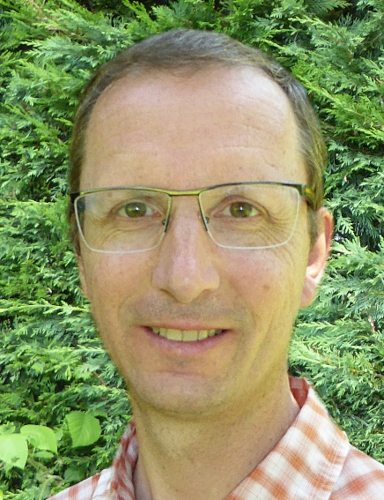

IDENTITY

48 years old,   
Married, 4 daughters

Annecy

evrignaud@gmail.com

GOAL

Put in action my consulting, innovation, creation and mentoring capabilities

SKILLS

* Design of innovative technical solutions based on functional requirements
* Backlog estimate
* Continuous improvement, code reviews
* Security strengthening, security alerts auditing (Fortify)
* Future architectures prototyping
* Mentoring of developers and dissemination of knowledge

**I’m open to new opportunities**

I'm actively searching for a new job  
I'm looking forward for a job proposal

* [LinkedIn profile](https://www.linkedin.com/in/etienne-vrignaud-630810a9/)
* [PDF English resume](https://evrignaud.github.io/hireme/Etienne%20Vrignaud%20-%20Senior%20Full%20Stack%20Architect%20-%20en.pdf)
* [PDF French resume](https://evrignaud.github.io/hireme/Etienne%20Vrignaud%20-%20Architecte%20Full%20Stack%20Senior%20-%20fr.pdf)

**Etienne Vrignaud**

**Senior Full Stack Architect**