**Part 3:**

1. **Exploratory Data Analysis:**

In uber_data_challenge.json, there are 12 features and 50,000 records of users.

Except two features signup_date and last_trip_date, the other 10 features are listed below:

|  |  |
| --- | --- |
| **Feature Types** | **Feature Names** |
| **Numerical** | avg_dist |
| avg_rating_of_driver |
| avg_surge |
| surge_pct |
| trips_in_first_30_days |
| avg_rating_by_driver |
| weekday_pct |
| **Categorical** | phone |
| city |
| uber_black_user |

All customers signed up during 2014-01, users tend to sign up later in the week. So it might suggest that we could target ads for signups more heavily during Fridays and Weekends.

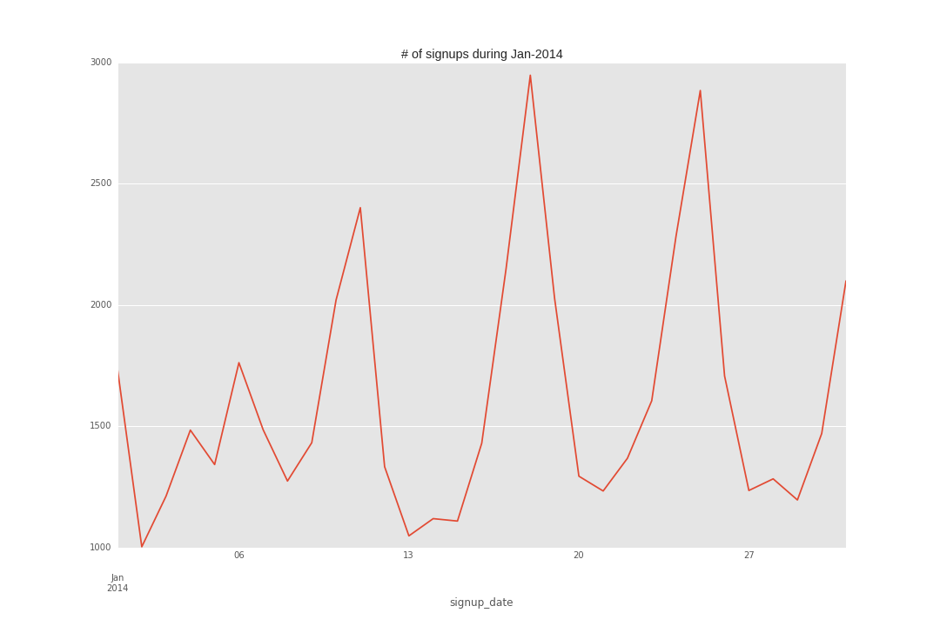

A user retained if they were “active” (i.e. took a trip) in the preceding 30 days. Within 50,000 users, **37.61%** users are active in the preceding 30 days.

Below is a quick summary statistic table for the numerical features, first thing to note is that there is some missing values among features, but not that much, mainly for avg_rating_of_driver, which might suggest we need to improve our rating experience for users.

We will use median value to fill in the missing values in this analysis

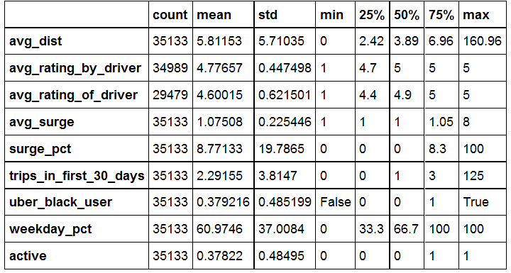

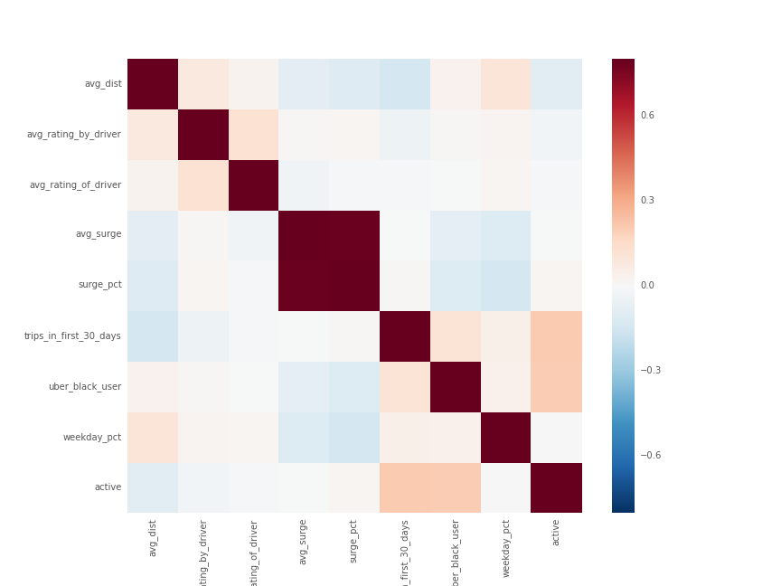Let us examine the correlation between the features and target variable ‘active’. Avg_surge and surge_pct has high correlation, the reason could be that, if surge_pct is high, means the user use service when surge multiple is > 1 quite often, and thus his avg_surge should be high also. In order to avoid multicorrlinearity, we will drop avg_surge in building our final model.

We could also plot the histogram for all the numerical features, for example, below is the histogram for avg_rating_of_driver, most of the rating are between 4 and 5, which makes rating like 1 and 2 outliers, we decide to transform following features to categorical values,

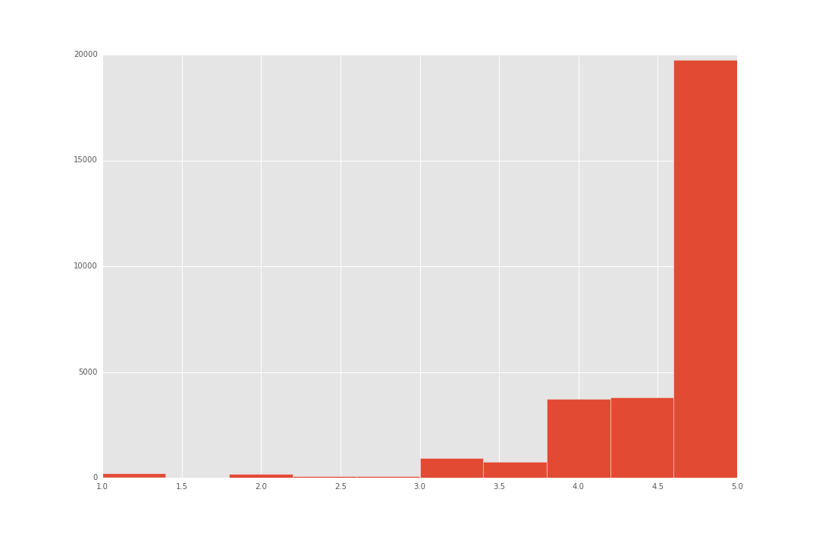avg_rating_of_driver, avg_rating_by_driver, surge_pct, avg_dist and trips_in_first_30_days. For example, for avg_rating_of_driver, we transform it into five categories: aweful, not good, average, good, great using intervals [1,2,3,4,4.5,5]. We could have done these programmatically using maximum entropy, but given that there are handful of features, we could set the bins manually, the advantage of this is that, the bins makes more sense to others, rather than purely from mathematical calculations.

After we transform these features into categorical values, we could extract more meaningful information from them. For avg_rating_by_driver, we could see from below that, if a user has a high rating by driver, he has a better chance to stay active compared to a user with really low rating, which makes sense since if a user behaves really bad, there is a low chance for him to continue to use uber service.

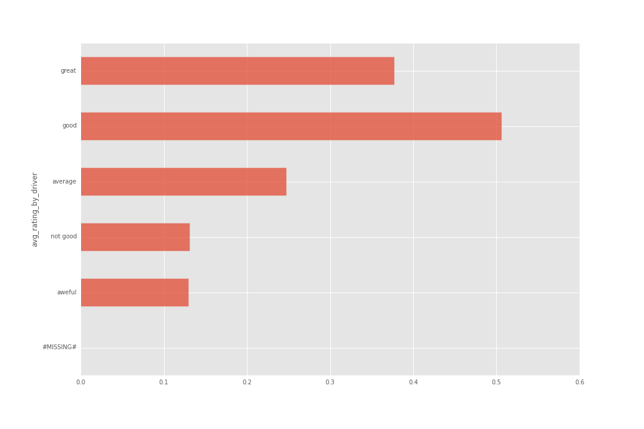

We also observe interesting stats from city feature, it seems users from King’s landing has much high chance stay active compared to Astapor and Winterfell, probably because users from King’s landing are more social. There are more interesting findings but given the time limit, I will omit these findings for now.

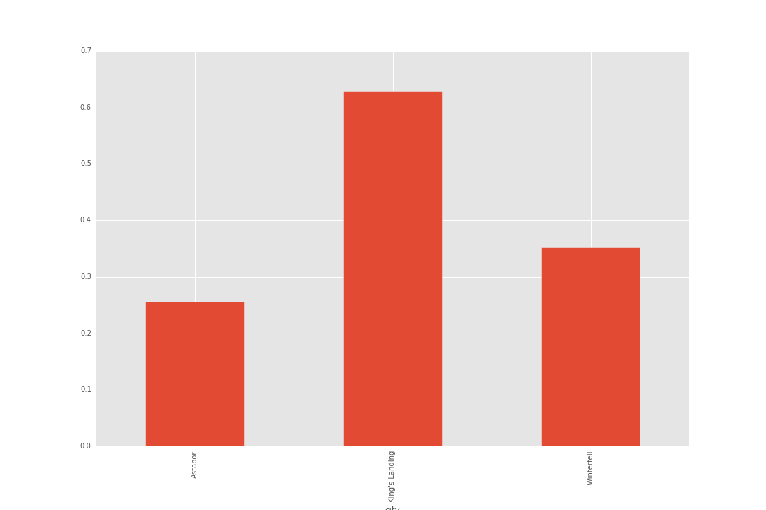

1. **Build predictive model**

We will first try out some simple models like logistic regression and Naïve Bayes. 70% data will be used in training (including train and cross validation), 30% data will be used in final test, note that we will only be using the test data once after we finish all the analysis to avoid any bias.

One thing to note is that, after we transform all the features to categorical values, we would then transform them into probabilities. For example, feature uber_black_user will be transformed into following probabilities based upon their stay active prob.

Astapor 0.255715

King's Landing 0.628134

Winterfell 0.351945

I also drop the avg_surge and only use surge_pct since they have high correlation. Now we are ready to build our models. From logistic regression result below, we could see that all features have significant confidents,

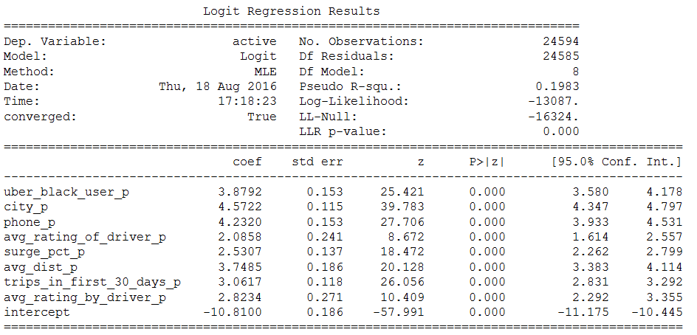

Since we are building classification models, we will use Logloss and AUC ROC, precision, recall accuracy and confusion matrix to evaluate model performance. For logistics regression, the stats and plots are below:

logloss: 0.52, auc roc: 0.802

recall: 0.556 , precision: 0.697, accuracy: 0.743

|  |  |  |
| --- | --- | --- |
| True label/Prediction | 0 | 1 |
| 0 | 5625 | 956 |
| 1 | 1756 | 2203 |

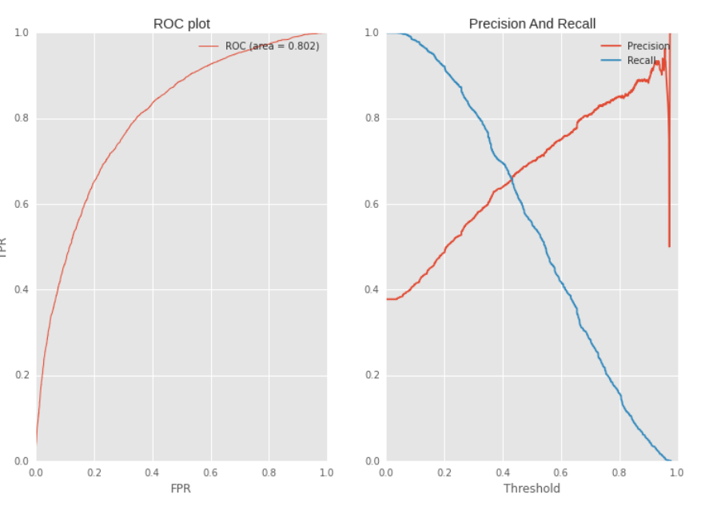

Next we will try out Naïve Bayes model, the stats and result plot are below:

logloss: 0.645, auc roc: 0.784

recall: 0.589, precision: 0.656, accuracy: 0.73

|  |  |  |
| --- | --- | --- |
| True label/Prediction | 0 | 1 |
| 0 | 5359 | 1222 |
| 1 | 1629 | 2330 |

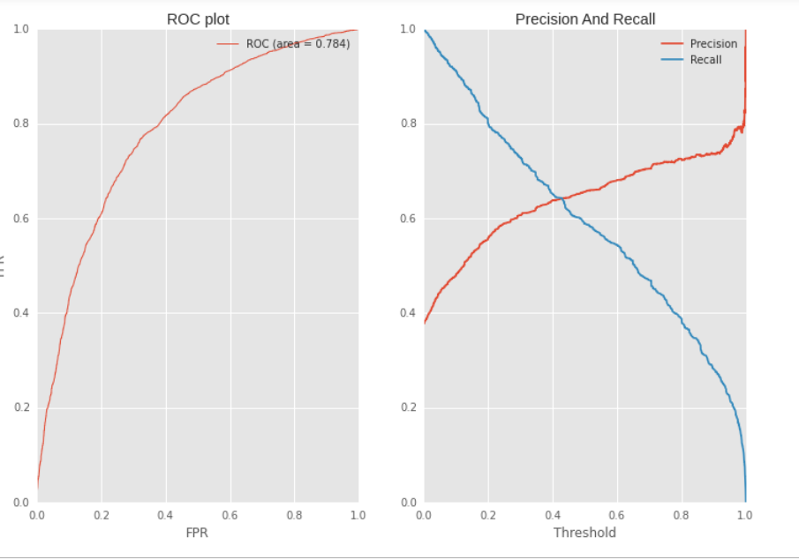

Overall, from the stats above, we could conclude logistic regression outperforms Naïve Bayes.

Let us try more complex model like Gradient Boosting Machine (GBM).

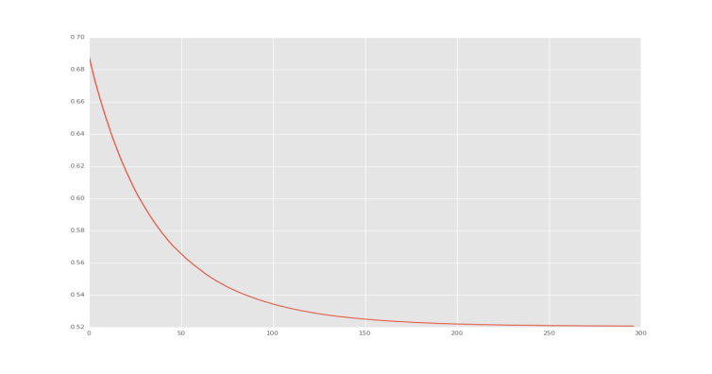Compared to Logistic regression and Naïve Bayes, GBM has more parameters we could tweak, such as max depth of tree, subsample ratio, feature sample ratio, # of iterations etc. One way to select them is to use cross validation. For example, if we want to choose the best # of iterations, we could plot the logloss on CV data set against # of iterations, from the plot below, we could see that after ~300 iterations, the logloss does not decrease much, so we would choose 300 as our optimal iteration num.

The other nice output from GBM is that, it could show you the importance of each feature. We could tell that, avg_dist and trips_in_first_30days has the largest impact in our model.

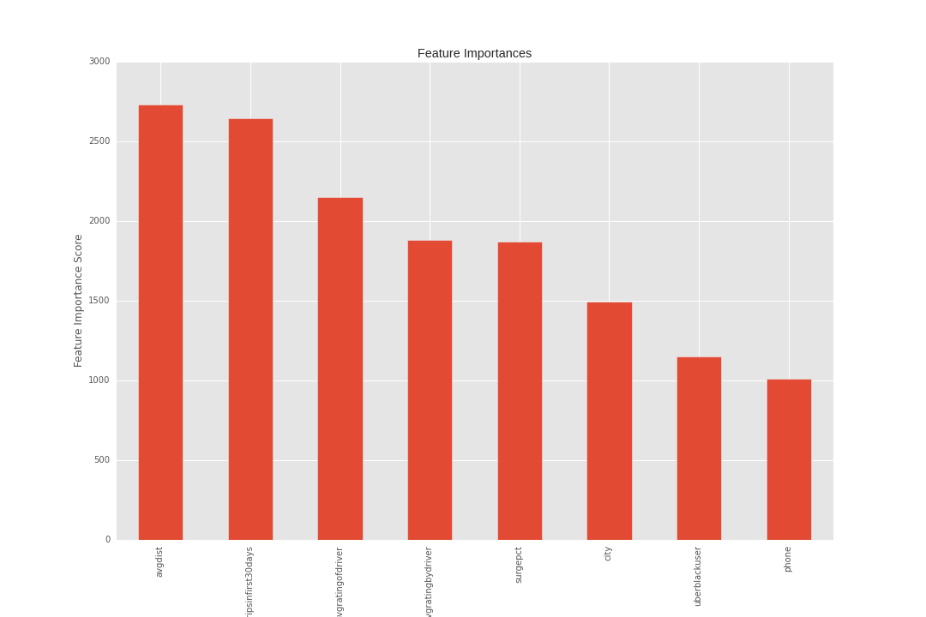

As a final step, we could test the three models’ performance on the hold out test data set, see which one works best in the wild. It is quite clear that GBM outperforms both Logistic regression and Naïve Bayes in all evaluation metrics.

|  |  |  |  |
| --- | --- | --- | --- |
| **Test Result** | **Logistic Regression** | **Naïve Bayes** | **GBM** |
| AUC ROC | 0.784 | 0.781 | 0.799 |
| LOGLOSS | 0.543 | 0.641 | 0.521 |
| ACCURACY | 0.731 | 0.73 | 0.741 |
| PRECISION | 0.689 | 0.663 | 0.712 |
| RECALL | 0.517 | 0.551 | 0.506 |

1. **Summary:**

Quite a few features show that they could be strong indicators for predicting whether a user will be active after six months. For example, users from King’s landing has a larger chance still active, it could be due to the nature of users’ mind set in King’s landing, but it also suggest that we could spend more time to further improve our business in Astapor and Winterfell. Also, it seems Apply users has high chance staying active compared to Android users, this could be suggesting we need to improve user experience on Android platform. Trips_in_first_30days tell us to target users who do not use our service quite often after the first 30 days. Uber black users also have a higher chance to stay active.

Overall, this is a quite interesting data set to analyze, and given more time, maybe we could find much more interesting ideas to implement and provide more insight to retain more users.