The ChocAn Simulator

Requirements Document

Table of Contents

1 Introduction 4

1.1 Purpose and Scope 4

1.2 Target Audience 4

1.3 Terms and Definitions 4, 5

2 Product Overview 6

2.1 Users and Stakeholders 6

2.1.1 Patients 6

2.1.2 Providers 7

2.1.3 Operators 7

2.1.4 Managers 7

2.1.5 Developers 7

2.1.6 Acme 7

2.2 Use cases 7

2.2.1 Validate Membership Status 8

2.2.2 Bill for a Service 8

2.2.3 Request Provider Directory 8

2.2.4 Prepare and Send Patient Report 8

2.2.5 Prepare and Send Provider Report 9

2.2.6 Store Data for Provider Payroll 9

2.2.7 Prepare and Send Accounts' Payable Summary 9

2.2.8 Add, Update, or Delete a Member or Provider 9

2.2.9 Update Membership Status 9

3 Functional Requirements 10

3.1 Process Service Transaction 10

3.1.1 Validate Member Status 10

3.1.2 Validate Provider Service 10, 11

3.1.3 Confirm Service Provided 11

3.1.4 Write Transaction to Database 11, 12

3.2 Print Reports 12

3.2.1 Provider Reports 12

3.2.2 Patient Reports 13

3.2.3 EFT Reports 13

3.2.4 Accounts Payable Reports 13

3.3 Process Acme Financial Standing Input 13

3.3.1 Suspend Member 13

3.3.2 Reinstate Member 13

3.4 Provider Terminal 13

3.4.1 Provider Login 13

3.4.2 Check Patient's Membership Status 14

3.4.3 Start Service Transaction 14

3.4.4 Display Provider Directory 14

3.5 Manager Terminal 14

3.5.1 Manager Login 14

3.5.2 Create, Update, or Remove Service 14

3.5.3 Access Patient Report 15

3.5.4 Send Patient Report 15

3.5.5 Access Provider Report 15

3.5.6 Send Provider Report 15

3.6 Operator Terminal 15

3.6.1 Operator Login 15

3.6.2 Create, Update, or Remove Patient 16

3.6.3 Create, Update, or Remove Provider 16

4 Nonfunctional Requirements 17

4.1 Operating Environment 17

4.1.1 Operating System 17

4.1.2 Java Runtime Environment 17

4.1.3 SQLite Environment 17

4.2 Reliability 17

4.3 Terminal User Interface 18

4.4 Usability 18

4.4.1 Ease of Use 18

4.4.2 Information Accuracy 18

4.5 Confidentiality 18

5 Milestones and Deliverables 19

5.1 Requirements Document 19

5.2 Design Document 19

5.3 Test Plan 20

5.4 Final Product and Project Retrospective 20

5.4.1 Final Product 20

5.4.2 Project Report 20

# Introduction

The Chocoholics Anonymous organization has requested a software system that will allow employees to process and monitor services that patients utilize. To meet this need, our team has met with the Chocoholics Anonymous client representative to elicit the needs of all parties involved and the overall requirements of the software system.

## Purpose and Scope

This document outlines the requirements of the software product that will be used by the Chocoholics Anonymous organization. In defining users, stakeholders, use cases, functional and nonfunctional requirements, this document serves as a foundational framework for the design and developmental process.

## Target Audience

This document will be viewed by the Software Development Team and the client, Chocoholics Anonymous, represented by Christopher Gilmore.

## Terms and Definitions

**Acme–**Acme Accounting Services, a third-party organization responsible implementing EFTs and administers the membership of ChocAn patients**.**

**CA**–Chocoholics Anonymous, the software product.

**CA Data Center–**The server hosting the CA database within the data center, owned and operated by ChocAn.

**ChocAn**–Chocoholics Anonymous, the organization.

**CRUD**–Create, Read, Update, Delete. The responsibilities of CA.

**EFT**–Electronic Funds Transfer.

**Manager**–Supervisors at ChocAn who receive patient, provider, EFT, and accounts payable reports.

**Operator**–Employees of ChocAn who create, update, and delete patients and providers.

**Patient**–Any individual who accesses services and is billed for them.

**Provider**–Any ChocAn-affiliated company or individual who provides services.

**Provider Directory**–A list of Services provided by ChocAn.

**Service**–Any procedure or treatment performed by a Provider for a Patient.

**Software Development Team**–The group of programmers in charge of creating the software.

**Transaction**–A single billable service given by a provider during a visit.

# Product Overview

This section defines the users, stakeholders, and use cases important to the development and deployment of the CA system. A user is any individual who will interact directly or indirectly with the CA system. Stakeholders include parties who are affected by the system and have a direct or indirect interest in its development. Use cases are general narratives of user interaction with the system.

## Users and Stakeholders

CA is a CRUD application that concerns two primary groups–users and stakeholders. For the scope of this application, the users are ChocAn Managers, Operators, and Providers. The stakeholders include Acme and ChocAn, and the developers of the CA system.

CA does not include any of the following:

* Accounting or billing. This is performed by Acme.
* Emailing reports. Reports are solely saved as files.
* Provider’s terminal, only a simulation will be created.
* Manager’s terminal, only a simulation will be created
* Communication software, only a simulation will be created
* Acme software, only a simulation will be created
* EFT component
  + 1. **Patients**

CA’s development process will be driven by the needs of ChocAn’s patients. Their role as a software user is to provide member information input, access and receive services through a provider, be billed for received service, and make payments accordingly to maintain an active ChocAn membership.

* + 1. **Providers**

Providers are employees of ChocAn that deliver Services to Patients. Providers access the CA system to bill patients and receive reports on Services rendered.

* + 1. **Operators**

Operators are employees of ChocAn who are responsible for adding, updating, or removing patients and providers from the CA database.

* + 1. **Managers**

Managers are supervisory employees as defined by ChocAn, who receive and may request patient reports, provider reports, accounts payable summaries, and EFT records. They also create, update, and remove Services from the CA database.

* + 1. **Developers**

A developer is a member of the Software Development Team. Collectively, they are responsible for designing, building, and testing the CA system.

* + 1. **Acme**

Acme is a third-party organization responsible for financial procedures, including

* 1. Recording payments of membership fees.
  2. Suspending members whose fees are overdue.
  3. Reinstating members on payment of overdue fees.

Additionally, the Acme system is responsible for updating relevant ChocAn Data Center membership records.

* 1. **Use cases**

Use cases identify individuals involved in a scenario and describe how they interact with the software system. This section pinpoints use cases for the CA system as requested by the client.

* + 1. **Validate Membership Status**

To receive health care services from ChocAn, the member hands his or her card to the provider, who slides the card through the card reader on the terminal. The terminal then dials the ChocAn Data Center, and the ChocAn Data Center computer verifies the member number. If the number is valid, the word “Validated” appears on the one-line display. If the number is not valid, the reason is displayed, such as “Invalid Number” or “Member suspended”; the latter message indicated that fees are owed (that is, the member has not paid membership fees for at least a month) and member status has been set to “suspended”.

* + 1. **Bill for a Service**

To bill ChocAn after a service has been provided to the member, the Provider again passes the card through the card reader (or keys in the member number). When the word “Validated” appears, the Provider keys in the date of the service in the format MM-DD-YYYY. Next, the Provider uses the Provider Directory to lookup the appropriate six-digit service code corresponding to the service provided.

The Provider then keys in the service code. To verify the service code, the software product displays the name of the service corresponding to the code and asks the Provider to confirm that this is the service provided. If the Provider enters a nonexistent code, an error message is printed. The Provider can also enter comments about the service provided.

Next, the software product looks up the fee associated with the service and displays it on the Provider’s terminal. For verification purposes, the Provider fills out a form with the current date and time, the date the service was provided, member name and number, service code, and fee to be paid.

* + 1. **Request Provider Directory**

A provider makes a system request for a Provider Directory, an alphabetically ordered list of service names and corresponding service codes and fees. The Provider Directory is sent to the provider as an e-mail attachment.

* + 1. **Prepare and Send Patient Report**

Every member who has consulted a ChocAn Provider during a specific week period receives a list of services provided to that member, sorted in order of service date. The report is sent out as an e-mail attachment and can be requested by a ChocAn Manager at any time during the week.

* + 1. **Prepare and Send Provider Report**

Every Provider who has billed ChocAn during that week receives an e-mail report containing the list of services provided to ChocAn members. At the end of the report is a summary of the number of member consultations and the total fees charged for that week. This report can be requested by a ChocAn Manager at any time during the week.

* + 1. **Store Data for Provider Payroll**

When weekly provider reports are processed, EFT data is written to disk; banking computers will later ensure that each Provider’s bank account is credited with the appropriate amount. This report can be requested by ChocAn Manager at any time during the week.

* + 1. **Prepare and Send Accounts’ Payable Summary**

A summary report is given to the Manager for accounts payable. The report lists every Provider to be paid, the number of consultations per Provider, and the Provider’s total fees for that week. This report can be requested by ChocAn Manager at any time during the week.

* + 1. **Add, Update, or Delete a Member or Provider**

During the day, the software at the ChocAn Data Center is run in interactive mode to allow operators to add new members to ChocAn, to delete members who have resigned, and to update member records. Similarly, Provider records are added, deleted, and updated.

* + 1. **Update Membership Status**

Acme Accounting Services, a third-party organization, is responsible for processing the payments of ChocAn membership fees. Acme is in charge of financial procedures such as recording payments of membership fees, suspending members whose fees are overdue, and reinstating suspended members who have paid overdue fees. The Acme computer updates relevant ChocAn Data Center membership records each evening at 9:00 PM.

1. **Functional Requirements**

This section outlines what the CA software is expected to do during daily operation. On a high level, the functional requirements include processing transactions, printing provider and patient reports, tracking members’ financial standings, and providing a simulation of terminals for Managers, Operators, and Providers.

* 1. **Process Service Transaction**

The CA system shall provide a means for providers to bill ChocAn for services provided to patients.

* + 1. **Validate Member Status**

Upon a service request, the Provider shall swipe the member’s card through the card reader on the terminal, which in turn sends the member number to the CA Data Center. The CA Data Center shall verify the input with one of the following displays:

1. “Validated” if the member number is valid,
2. “Invalid Number” if the member number is not valid, or
3. “Member Suspended” if the member has outstanding fees for over a month.

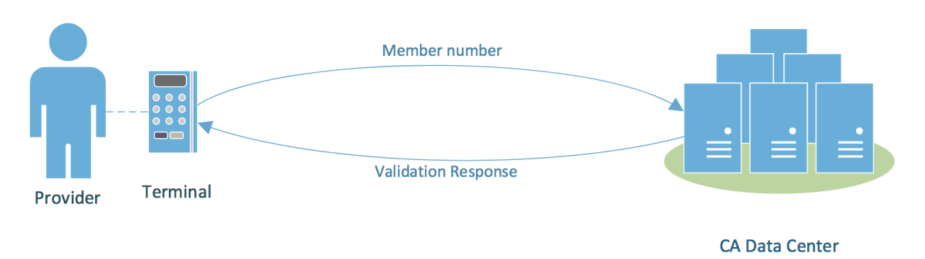

Figure 3.1.1

* + 1. **Validate Service Provided**

If the member has been validated, the terminal shall prompt the provider to enter the date the service was received (in the format MM-DD-YYYY) and the appropriate six-digit service code located in the Provider Directory. The terminal shall then send both inputs to the CA Data Center, where it will display one of the following:

1. The name of the service responding to the service code and a confirmation request, or
2. An error message due to a nonexistent service code.

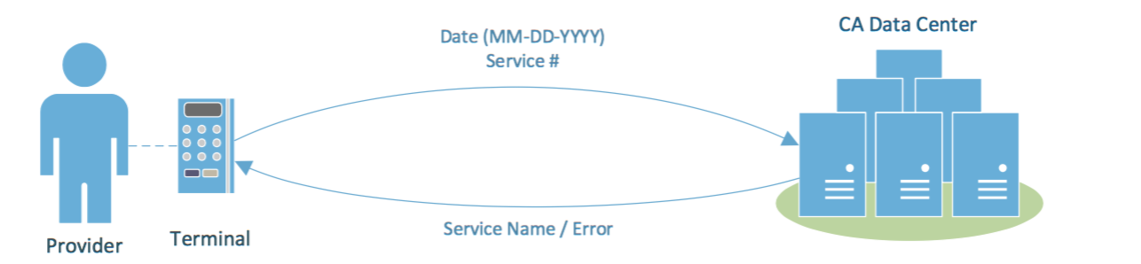

Figure 3.1.2

Additionally, the provider has the option to input comments about the service provided.

* + 1. **Confirm Service Provided**

If the service was validated, the provider will confirm whether the service name found matches the service received by the user.

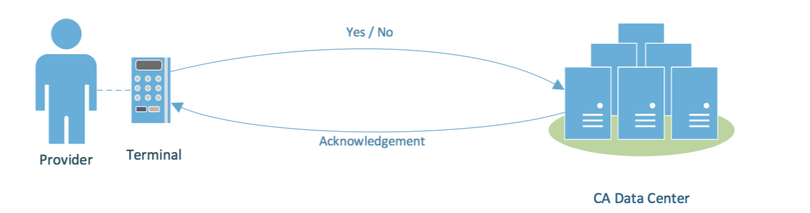

Figure 3.1.3

* + 1. **Write Transaction to Database**

One the member number has been verified and provider service validated and confirmed, the CA Data Center shall write a record of the following information to an external database:

* Current date and time (MM-DD-YYYY HH:MM:SS).
* Date service was provided (MM-DD-YYYY).
* Provider number (9 digits).
* Member number (9 digits).
* Service code (6 digits).
* Comments (100 characters) (optional)

The CA Data Center shall then search and display the fee associated with the service provided.

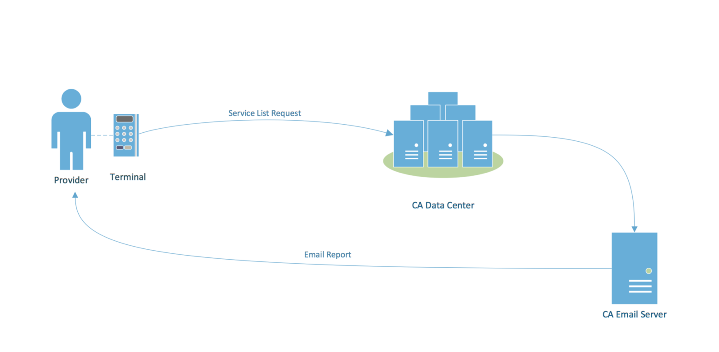

Figure 3.1.4

* 1. **Print Reports**

CA shall provide four types of reports upon request by Managers. CA shall submit database queries and save a file for each provider and member.

* + 1. **Provider Reports**

A provider report lists all services provided by a specified six-digit service code during a one-week period. The report shall state the total number of services provided and the total fees charged. Additionally, CA will generate provider reports for all Providers every Friday at midnight.

* + 1. **Patient Reports**

A patient report lists all services provided to a member during a one-week period. The report shall state the total number of services received and the total fees accrued. Additionally, CA will generate patient reports for all Patients every Friday at midnight.

* + 1. **EFT Reports**

An EFT record lists all services charged by all Providers during a one-week period. The EFT record shall be available upon a Manager’s request.

* + 1. **Accounts Payable Reports**

An Accounts Payable report shall list all payments due to Providers over a one-week period. The report shall state every Provider to be paid, the number of consultations per Provider, and the Provider’s total fees for that week. The Accounts Payable report shall be available upon a Manager’s request.

* 1. **Process Acme Financial Standing Input**

CA shall provide a means for Acme to update each patient’s membership status.

* + 1. **Suspend Member**

Acme shall have the ability to suspend any ChocAn member who has not paid their dues. The Acme computer will be able to access the CA database at 9:00PM each evening to update member status.

* + 1. **Reinstate Member**

Acme shall have the ability to reinstate any ChocAn member who has paid their overdue fees. The Acme computer will be able to access the CA database at 9:00PM each evening to update member status.

* 1. **Provider Terminal**

The CA system shall simulate a secure terminal to assist in the provider’s responsibilities when interacting with the CA system.

* + 1. **Provider Login**

A Provider shall have the ability to login to the provider terminal by entering his or her Provider number.

* + 1. **Check Patient’s Membership Status**

A Provider shall have the ability to check a Patient’s membership status in the CA Data Center by swiping the Patient’s card.

* + 1. **Start Service Transaction**

A Provider shall have the option within the terminal to start a service transaction after providing a Service to a Patient. This process is described above in 3.1.

* + 1. **Display Provider Directory**

A Provider shall have the option to request the Provider Directory within the terminal.

* 1. **Manager Terminal**

The CA system shall simulate a manager terminal to assist with receiving weekly reports and accessing reports as needed.

* + 1. **Manager Login**

A Manager shall have the ability to login to the manager terminal by entering his or her Manager number.

* + 1. **Create, Update, or Remove Service**

Managers shall have the option to enter a Service’s name, six-digit code, and fee to place a new Service into the database. Managers shall also have the ability to re-activate a Service that has been Removed.

* + - 1. **Create Service**

A manager shall have the ability to send a client their weekly reports in a single batch using an option within the manager terminal.

* + - 1. **Update Service**

Managers shall have access to a Service record to update the Service’s name or fee.

* + - 1. **Create, Update, or Remove Service**

Managers shall have access to a Service record to label it as Inactive. This will not remove it entirely from the database. It will only prevent providers from entering that Service Code in future transactions.

* + 1. **Access Patient Reports**

At any time, a Manager can pull up a Provider's report that lists the services they have provided since the last weekly report.

* + 1. **Send Patient Reports**

A Manager shall have the ability to send a client their weekly reports in a single batch using an option within the manager terminal.

* + 1. **Access Provider Reports**

At any time, a manager can pull up a Provider's report that lists the services they have provided since the last weekly report.

* + 1. **Send Provider Reports**

A Manager shall have the ability to send a Provider their weekly reports in a single batch using an option within the manager terminal.

* 1. **Operator Terminal**

The CA system shall simulate an operator terminal. This terminal will be responsible for creating, updating, or removing Patient or Provider information.

* + 1. **Operator Login**

An Operator shall have the ability to login to the operator terminal by entering his or her Operator number.

* + 1. **Create, Update, or Remove Patient**
       1. **Create Patient**

Operators shall have the option to enter a Patient’s name and address and generate an ID number to place a new Patient into the database. Operators shall also have the ability to re-activate a Patient who has been Removed.

* + - 1. **Update Patient**

Operators shall have access to a Patient’s database record to update the Patient’s name or address.

* + - 1. **Remove Patient**

Operators shall have access to a Patient’s database record to label them as Inactive. This will not remove them entirely from the database. It will only prevent them from receiving further services.

* + 1. **Create, Update, or Remove Provider**
       1. **Create Provider**

Operators shall have the option to enter a Provider’s name and address and generate an ID number to place a new Provider into the database. The Operator shall also have the ability to re-activate a Provider who has been Removed.

* + - 1. **Update Provider**

Operators shall have access to a Provider’s database record to update the Provider’s name or address.

* + - 1. **Remove Provider**

Operators shall have access to a Provider’s database record to label them as Inactive. This will not remove them entirely from the database. It will only prevent them from providing further services.

1. **Nonfunctional Requirements**

This section describes software attributes and characteristics that are independent of functional requirements. Nonfunctional requirements are constraints on the services or functions offered by the system as a whole rather than specific services or features. This could also encompass technical requirements that are not immediately visible from a user’s point of view.

* 1. **Operating Environment**

The CA software shall be portable to multiple platforms by using the Java Runtime Environment (JRE).

* + 1. **Operating System**

The CA shall operate on Windows 7, macOS 10.11.6, Ubuntu 15.10, or any later versions of these operating systems.

* + 1. **Java Runtime Environment**

The CA system requires the Java Runtime Environment, version 8, to be installed on all machines running a terminal.

* + 1. **SQLite Environment**

The CA system will use the SQLite database management system with the SQLite-JDBC connectivity interface.

* 1. **Reliability**

The provider system shall be available during normal business hours for patient validation requests. Additionally, the CA system must be operational at 12:00 AM on Friday for printing of financial transaction reports. The system shall be operational at 9:00 PM every evening for Acme’s membership status updates.

* 1. **Terminal User Interface**

CA shall simulate a terminal for each of the following users: Providers, Managers, and Operators. For the purposes of this version of the software, CA will be presented as a single system that simulates all three terminals. Upon starting the software, CA will provide an option to access each terminal.

* 1. **Usability**
     1. **Ease of Use**

The CA user interface shall be customized for each use case and presented in a clear and easy-to-follow manner.

* + 1. **Information Accuracy**

The CA system shall minimize erroneous input by validating service codes, dates, and all other user inputs.

* 1. **Confidentiality**

CA deals with confidential Patient and Provider information and shall limit database access strictly to ChocAn Operators and Managers.

1. **Milestones and Deliverables**

To keep the Software Development Team accountable for punctual product delivery, this section defines the milestones as stages of development where assessments can be made for the CA requirements compilation, design, testing, and review. The timeline of the ChocAn Simulator project spans over a period of three months, with four deliverables to be completed by specific deadlines as shown in the following Gantt chart:

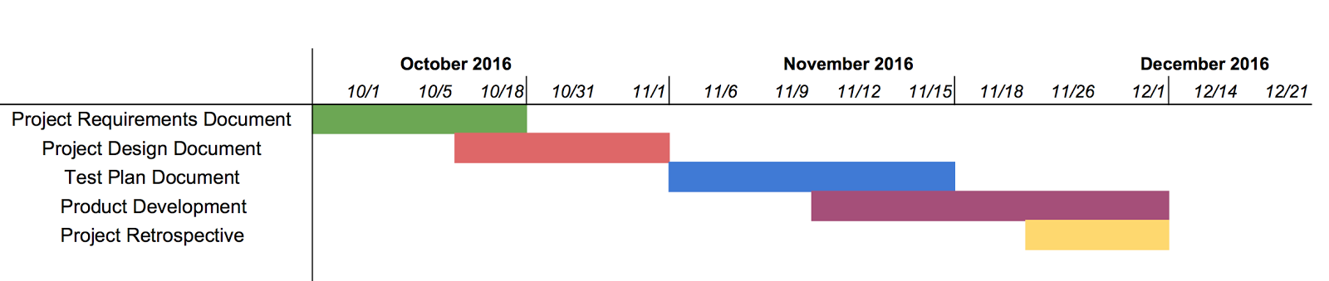Figure 1 Timeline of Deliverables

* 1. **Requirements Document: October 18, 2016**

The Software Development Team will create a document that describes the requirements of the CA system. Developers will consult with the client and analyze the needs of all stakeholders involved to provide a comprehensive requirements document.

* 1. **Design Document: November 1, 2016**

The Software Development Team will create a document that specifies the implementation of the CA system. Utilizing the Requirements Document, developers will have generated the overall layout of the CA system and methods needed to provide necessary features.

* 1. **Test Plan: November 15, 2016**

The Software Development Team will create a document that states the testing and validation procedures of the CA system. Developers will be in charge of producing test data for input and ensuring proper operation of each use case in the CA system.

* 1. **Final Product and Project Report: December 1, 2016**

The Software Development Team will provide a completed ChocAn Simulator and review the development process. Developers will implemented the Design Document, test the software as specified in the Test Plan, and prepare a final product comprising of working code once testing has concluded.

* + 1. **Final Product**

The final product is an executable CA package, which will contain the CA software and the necessary run-time environment for the operating systems specified in 4.1.1. Once executed, CA will allow the end-user to select a simulation for the Service Provider’s payment terminal, a Manager terminal, or an Operator’s terminal. Each terminal shall fulfill its respective functional and nonfunctional requirements.

* + 1. **Project Report**

The project report will consist of the retrospective and presentation slides. The retrospective will discuss the successes and challenges of the ChocAn Simulator project and reflect on possible improvements for future developmental efforts. The presentation slides will be shown to stakeholders to report software functionality, test methodologies, and any known defects or issues.