AuraGroove — Complete User Guide

The Infinite Take Orchestra
Contents
- Welcome to the Orchestra
- Getting Started
- The Navigator — the control room
- The Player (HUD) — the stage
- Studio Mixer — your seat at the sound desk
- Equalizer — the final coat of paint
- Recording & Export — taking the music home
- The Living Orchestra
- Sound & Performance
- Comfort & Personalization
- Troubleshooting & Tips
- Glossary

1. Welcome to the Orchestra

1.1 What AuraGroove is — and is not
AuraGroove is a deterministic, real-time generative music engine. It does not stream recordings, does not ask a neural network for prompts, and contains no pre-recorded tracks. Every note you hear is synthesized on the fly — in your browser, in this very moment — from fractal mathematics, Markov chains, and a genetic memory of past performances.
- It is: a live algorithmic composer and performer. Four genre "Brains." Endless unique takes. Zero tracking.
- It is not: a streaming service, an AI jukebox like SUNO or Udio, a sample player, or a replacement for music production tools.

1.2 Mathematical sovereignty, in plain words
- Fractal foundations. Every musical idea is transformed as it develops — mirrored (inversion), reversed in time (retrograde), shifted in key (transposition). Nothing ever repeats verbatim.
- Markov flow. Harmony and melody move through probabilistic state machines, so the music always "goes somewhere" instead of wandering at random.
- Genetic evolution. Each session inherits successful proportions — tempo, density, harmonic profile — from the community's liked performances, while remaining entirely new.

1.3 Why the music feels alive
- The Tension Map. Every Suite lives through a composed energy arc: tension builds, peaks, and releases — like a set played by a live band.
- The Ensemble Lottery. Instruments never enter all at once; they join in waves, the way a real ensemble warms up and locks in.
- The Breath. The Brains listen to the pauses in a melody and answer them with fills from other instruments — a real-time dialogue between musicians.
- Mandatory mutation. Even inherited material is always improvised upon — inverted, reversed, rhythmically jittered — so no two takes are ever the same.

1.4 Privacy, and who owns the music
- Zero telemetry. Zero profiles. Zero accounts. Your sessions live only on your device (localStorage / IndexedDB). The engine runs fully offline.
- Only two things touch the network, and only by your hand: a Like — sharing the anonymous musical DNA of the moment with the common gene pool — and optional cloud sync of your saved material.
- Your music is yours. AuraGroove makes no copyright claims over generated or recorded music. Your takes — your album — your rights.

2. Getting Started

2.1 The welcome screen
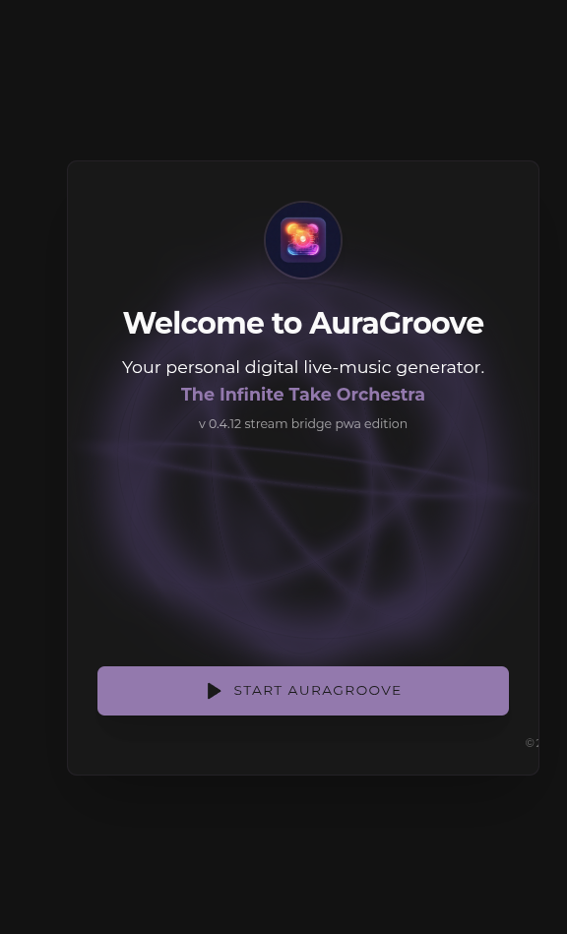
[Fig. 1 — Welcome screen: the START AURAGROOVE button]
Open AuraGroove and tap START AURAGROOVE. Browsers require one human gesture before any web app may make sound — this tap is it. It wakes the audio engine and takes you to:
- the Player (HUD), if a route already exists; or
- the Navigator, on a first run.
The welcome screen appears on every launch — by design, not by accident.

2.2 Install it like an app (PWA)
AuraGroove is a Progressive Web App. In your browser menu choose Add to Home Screen / Install — and it will live on your device as a standalone app: its own icon, full-screen, no browser chrome.

2.3 Your first route in 30 seconds
In a hurry? Any genre + any mood → + TO ROUTE → PLAY. Thirty seconds from silence to orchestra.
- In the Navigator, pick a Genre (Slow Fusion, Neuro Space, Cafe's Blues, Root Reggey) and a Mood (Melancholic, Dreamy, Calm, Joyful).
- Press + TO ROUTE — the pair becomes a Step of your Journey Route.
- Press PLAY.
The orchestra starts at once. Stay in the Navigator to keep editing — or leave it idle for a few seconds, and the full-screen Player (HUD) takes over on its own.

2.4 The two homes of the orchestra
- The Navigator is the control room: build routes, tune the mix, manage polyphony, save Journeys.
- The Player (HUD) is the stage: a minimal, immersive screen with the living Core and the essential controls.
You can always step back from the stage to the control room with ✕ — the music keeps playing.

3. The Navigator — the control room
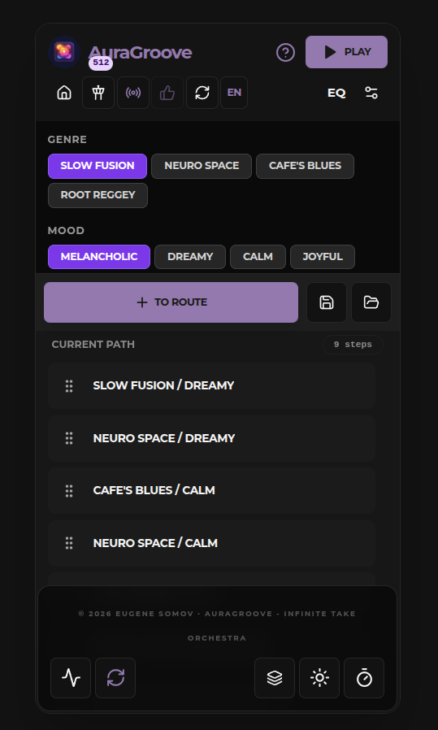
[Fig. 2 — The Navigator, annotated overview]
The Navigator is where you program the journey: build the route, shape the sound, and manage the orchestra's resources. Whenever the Player is on stage, ✕ brings you back here — the music keeps playing.

3.1 Top bar
- Voice badge (e.g. "512") — the current polyphony limit, exactly as set in Polyphony Control (3.5). A glance at the engine's headroom.
- ? — the Information Center: this guide, the disclaimer, and the credits.
- PLAY / PAUSE — starts or pauses the current route. Unlike the automatic hand-off to the Player, this button keeps you in the Navigator so you can keep editing while the orchestra plays.

3.2 The icon row
- Home — returns to the welcome screen.
- Broadcast Bridge (tower) — a special performance mode for weaker devices: generation moves entirely to the background, guaranteeing clean, uninterrupted background playback — and it can even stream the audio to other players on your network. The icon blinks purple while active. Switching it on mid-playback causes a brief 3–4 s stutter while the bridge reconfigures. Full details in 9.3.
- Recorder — a short click starts/stops a manual recording; a long press (1.5 s) arms Full Track Record. Full details in 7.
- Like (thumbs-up) — donates the musical DNA of the current moment (seed, genre, mood, tempo, mix) to the orchestra's shared gene pool. Full details in 8.1.
- Regenerate — the orchestra abandons the current musical idea and starts the current Step anew with a fresh seed. The route is untouched. Works while playing or paused.
- EN — interface language (EN / RU).
- EQ / Mixer — open the Equalizer and Studio Mixer panels.

3.3 Genre, Mood, and the route
Pick a Genre — Slow Fusion, Neuro Space, Cafe's Blues, Root Reggey — and a Mood — Melancholic, Dreamy, Calm, Joyful.
Selecting alone changes nothing that is already playing; it only prepares your next move. To put the pair to work, either:
- press + TO ROUTE to append it as a new Step, or
- press Refresh Queue (while paused) to rebuild the engine's plan around your edits.
Saving Journeys. Save stores the entire current route under a name you type; Load brings a saved Journey back. Journeys live in your browser's local storage — dozens of them, entirely offline.

3.4 Current Path
Your route, step by step; the badge shows the total (9 steps).
- Drag the grip to reorder Steps.
- Tap a Step to jump the orchestra to it instantly.
- ✕ on a Step removes it from the route.
- The active Step is highlighted and shows its DNA code — the short genetic fingerprint of the performance currently playing (e.g. ygjtv9).

3.5 The bottom row
- Spectrum Monitor (pulse) — a live frequency display of what you hear, stamped with the current Suite's DNA code, genre, and mood. Part monitoring, part meditation.
- Refresh Queue — the sync button: it reads all your route edits and rebuilds the engine's plan. Available only while paused — mid-playback the action is blocked. After a refresh, playback starts from the first Step.
- Polyphony Control (layers) — the global voice-limit slider (50–512). Lower limits save CPU on mobile; higher limits provide richer tails. The badge in the top bar mirrors your choice. Full details in 9.2.
- Sun / Moon — light / dark theme.
- Sleep Timer — set the minutes, press Activate, and the music will fade out gently when the time is up. Perfect for night listening.

4. The Player (HUD) — the stage
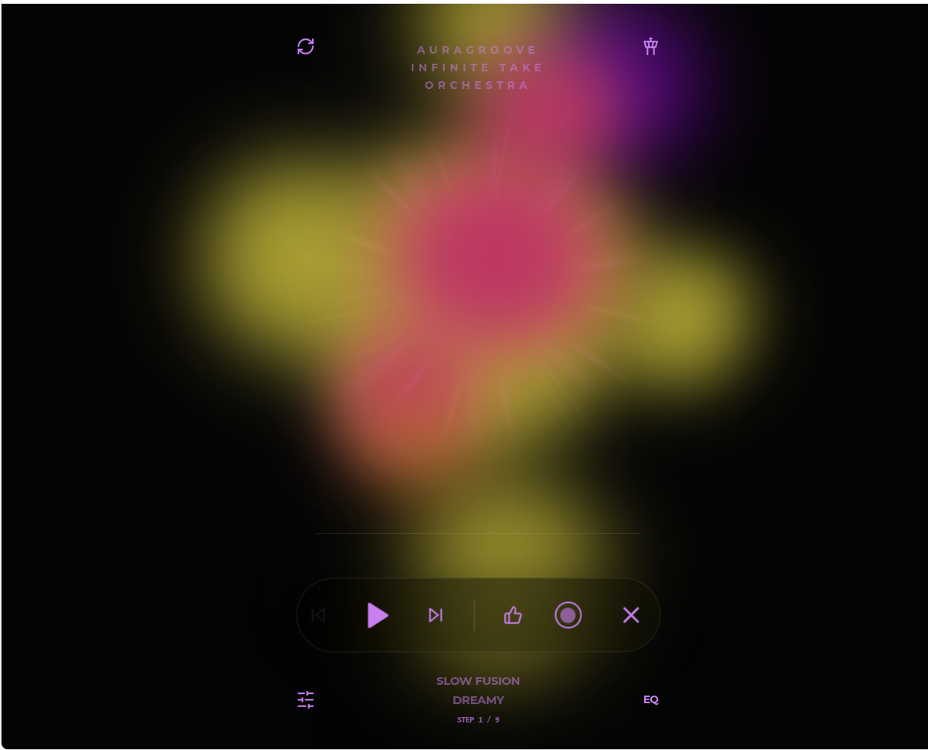
[Fig. 3 — The Player (HUD), annotated overview]
The HUD is the immersive, minimal stage: one living visual, one transport bar, nothing extra. You land here when you start AuraGroove with an existing route — or the Navigator hands you over automatically a few seconds after you stop interacting with it. ✕ returns you to the control room; the music keeps playing.

4.1 The Core
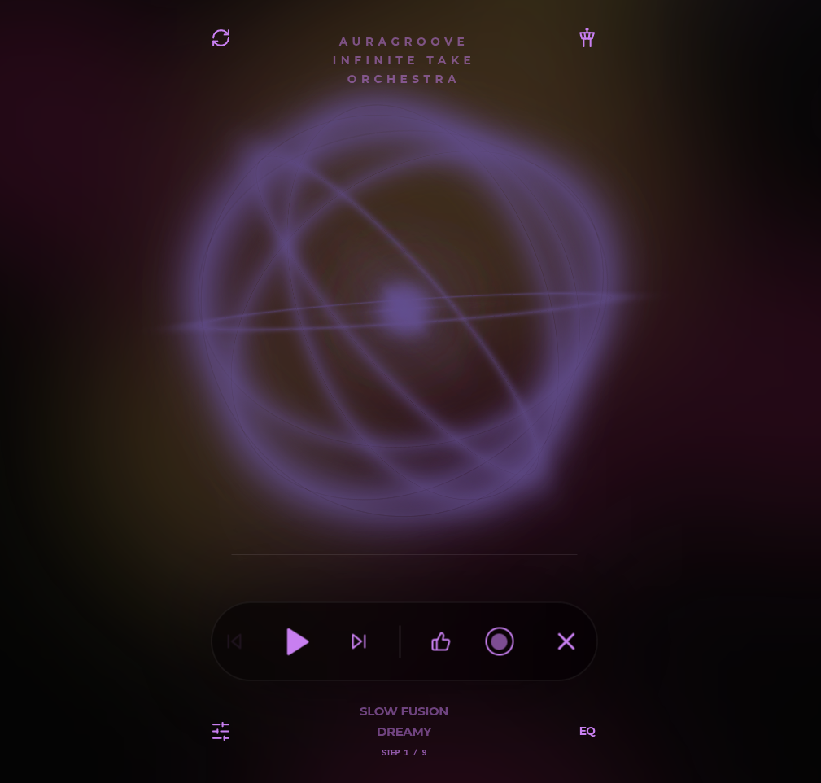 | 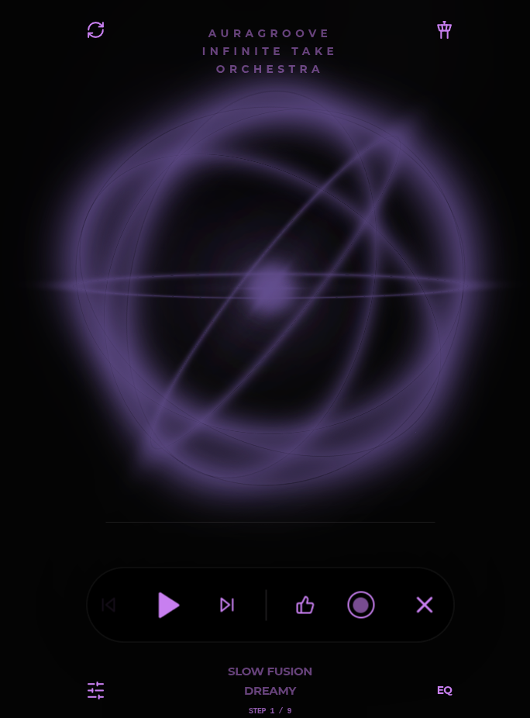 | 
[Fig. 4 — The three Core modes: Ether / Orbital / Nebula]
The glowing aura is not a picture — it is the music. It rotates slowly, takes its base color from the active genre, and its heart pulses with the kick drum (or with the bass on the downbeat when there is no kick). Double-tap the Core to cycle its three modes:
- Ether (default) — orbital rings fused with deep organic fog;
- Orbital — pure geometric orbits of light;
- Nebula — the original free-flowing artistic animation.
On mobile devices the Core runs a graphically simplified version to protect performance — the pulse and the color remain.

4.2 Top corners
- Regenerate (left) — a brand-new take of the current Step, immediately.
- Broadcast Bridge (right) — the same tower as in the Navigator; it blinks purple while the bridge is active.
- The wordmark (center) is a button too: it opens the Information Center.

4.3 The transport bar
- **⏮ / ** — previous / next Step of your route; ⏮ rests dimmed at the very first Step.
- ▶ / ⏸ — play / pause.
- The thin line above the bar is the progress of the current Step.
- Below the bar: the active Step's genre, mood, and its position — STEP 1 / 9.
When the route reaches its last Step, it loops back to the first — but never repeats: every Step returns with a fresh seed and fresh mutations. Same destination, different music.
- Like (thumbs-up) — the same gene-pool donation as in the Navigator.
- Record (circle) — manual recording and Full Track Record. Full details in 7.
- ✕ — leave the stage for the control room; the performance continues.

5. Studio Mixer — your seat at the sound desk
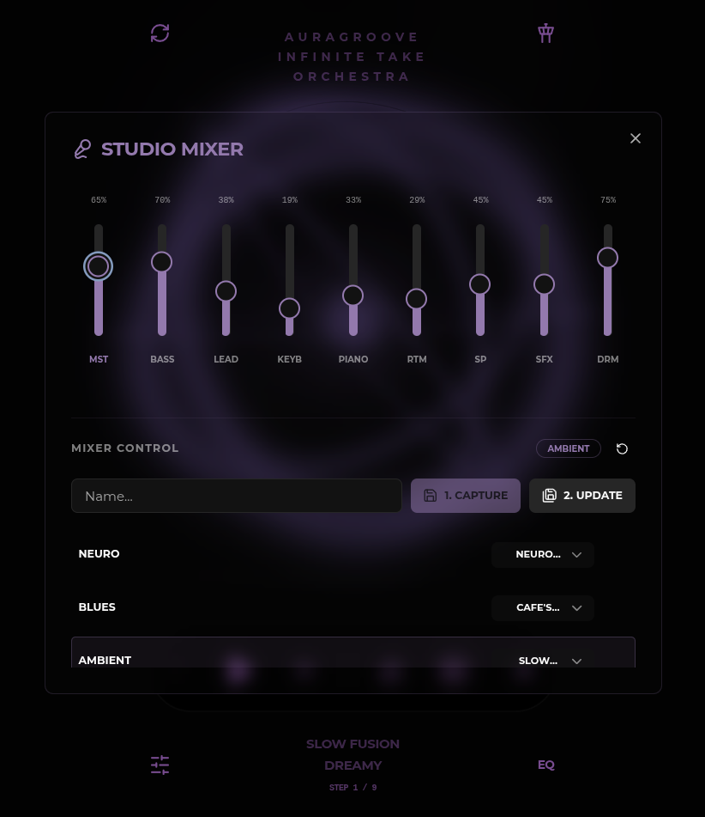
[Fig. 5 — Studio Mixer: nine faders and preset controls]
The Studio Mixer opens from the sliders icon and hands you nine faders — one per family of the orchestra, plus the master.

5.1 The channels
Fader | What lives there
MST | Master — the overall volume of the performance
BASS | The bass: foundation and groove
LEAD | Melodies and solos
KEYB | The "harmonic blanket": pads and organs that wrap the mix; it ducks for an instant under the kick, making the rhythm breathe
RTM | The "harmonic engine": rhythm-guitar chords in blues, strings and flutes in ambient; it keeps the conversation going whenever the lead rests
PIANO | Piano parts
SP | Sparkles — crystalline chimes and distant echoes scattered across the panorama; no notes, pure atmosphere and depth
SFX | Sound effects
DRM | Drums and percussion

5.2 Presets: Capture, Update, Reset
- Type a name and press 1. CAPTURE — the current position of all nine faders, Master included, is saved as your personal preset.
- Tweak an existing preset and press 2. UPDATE to write the changes back into it.
- The badge above the controls shows the active preset; when nothing is loaded it reads System Default — the house "golden balance", tuned separately for every genre.
- The Reset icon is the stop-cock: it returns the mixer to the genre's golden balance and unloads your preset.

5.3 Mix Autopilot: binding presets to genres
Every preset has a dropdown — its genre address. Bind a preset to, say, Root Reggey, and each time your route enters a Reggae Step, the system moves all the faders by itself.
The autopilot's rules of engagement:
- No presets at all → the genre's System Default plays.
- Presets without a binding stay personal: the autopilot ignores them; you load them by hand.
- One preset bound to a genre → it is applied on entering that genre.
- Several presets bound to the same genre → the one you used last wins; with no memory yet, the first bound preset is taken.
Note (Broadcast Bridge). In Bridge mode a preset change takes about half a second to reach your ears — the stream needs a moment to reconfigure.

6. Equalizer — the final coat of paint
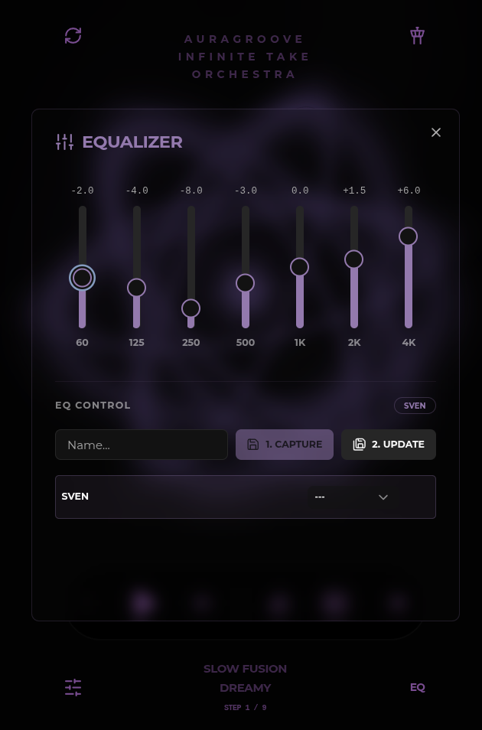
[Fig. 6 — Equalizer: seven bands and preset controls]
The EQ button opens a classic seven-band equalizer: 60 Hz, 125, 250, 500, 1K, 2K, 4K — cuts and boosts shown in decibels above each fader. Tighten the low end, warm the mids, add air on top.
Presets work exactly as in the Studio Mixer: a name plus 1. CAPTURE, 2. UPDATE, an active-preset badge, and the same genre-binding autopilot — your "night EQ" can follow the route from genre to genre on its own.

7. Recording & Export — taking the music home
Everything you hear can be captured. The Record control lives both in the Navigator's icon row and in the Player's transport bar. AuraGroove exports to .webm, and the files are written straight to your device. Two modes:

7.1 Manual recording
One tap starts capturing; a second tap stops and saves the file. Perfect for catching a spontaneous moment.

7.2 Full Track Record (FTR)
Hold the Record button for 1.5 seconds. From that moment the current Suite is recorded whole — and the engine itself stops the capture at the system event of the Suite's end, then pauses playback. No more catching track ends by ear: record take after take and assemble an album.
- A simple tap exits FTR early and saves whatever has been captured.
- FTR files carry a proud prefix, e.g. FTR_AuraGroove_reggae-melancholic_2026-08-08_55wcm.webm; manual recordings follow the same naming without the prefix.

7.3 Your music is yours
AuraGroove makes no copyright claims over what you record. The takes are original, mathematically generated performances — your album, your rights.

8. The Living Orchestra
AuraGroove is not a jukebox with a big library — it is an ecosystem that evolves. Every performance leaves a trace, and the best traces become the seeds of future music.

8.1 The gene pool, and what your Like actually does
When you press Like, AuraGroove does not copy the notes you hear, and it does not build you a personal "favorites radio." It donates the recipe of the moment — the seed, genre, mood, tempo, and mix — to the common gene pool, marking it as successful.
Future sessions, anywhere in the world, may inherit that recipe's proportions through genetic crossover: a new performance is "born" carrying the tempo, density, and harmonic profile that once moved someone — while remaining entirely new music. The more people Like, the more human the orchestra becomes over time. That is the deal: your taste shapes the evolution of the whole orchestra.

8.2 Heritage: human hands in the DNA
The orchestra also inherits from human performance. A library of phrases played by living musicians — Heritage Axioms — serves as genetic templates:
- Never played directly. An axiom is a seed for mutation, not a recording to be replayed.
- Sibling Sovereignty. Phrases recorded together prefer to stay together: when the engine picks a melodic idea from a donor track, it reaches for the bass line recorded with it — the ensemble keeps its human chemistry.
- Mandatory Mutation. Inherited material is always improvised upon — mirrored, reversed, rhythmically jittered — so nothing ever repeats verbatim.

8.3 DNA codes
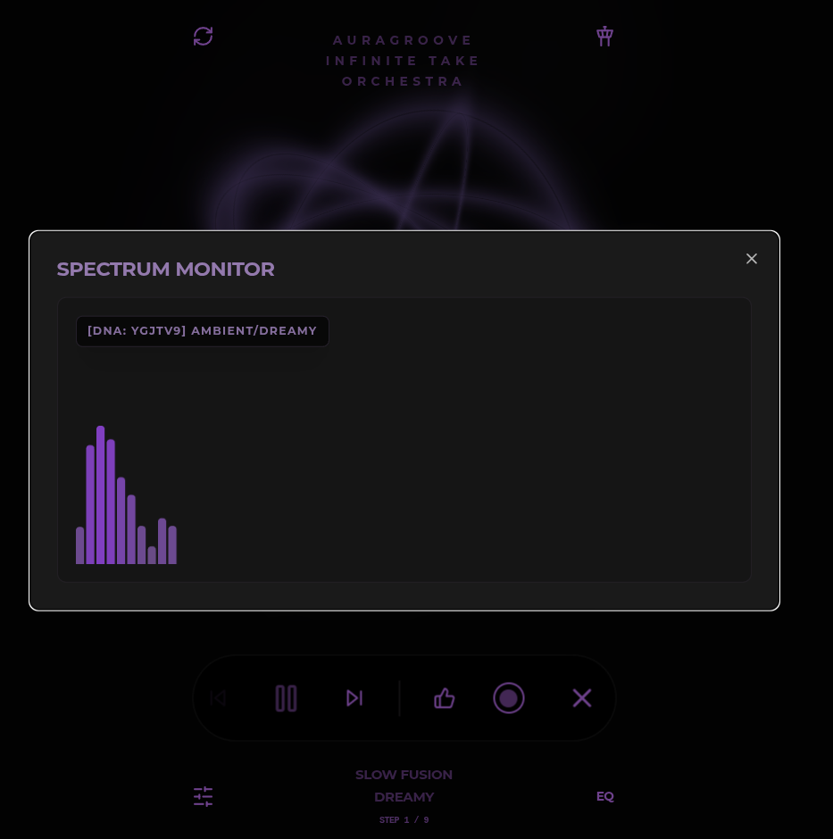
[Fig. 7 — Spectrum Monitor stamped with the Suite's DNA code]
Every performance carries a short genetic fingerprint — its DNA code, like ygjtv9. You will see it under the active Step in the Navigator and stamped on the Spectrum Monitor. Think of it as the recipe card of the take: the code names the seed from which this particular performance grew.

8.4 Offline, and still evolving
AuraGroove runs fully offline: your device keeps locally cached masterpieces, and the engine needs no network to perform. Cloud sync — your Likes and saved material — happens only when you are online, and only by your action.

9. Sound & Performance

9.1 The Velvet Standard
AuraGroove's sound is tuned by the Velvet Standard 3.0 — a house set of synthesis settings for warm, organic textures. It is deliberately background-optimized: expect velvet, not studio-mastered aggression. Two honest footnotes:
- Crossover artifacts. When a part morphs between timbre families (piano → organ, say), a 5 ms crossfade may produce a barely audible ~−3 dB dip.
- No mastering. A −6 dB limiter protects you from clipping but does not chase loudness. If you want it louder, your own player's volume is the right tool.

9.2 Polyphony: how rich is rich
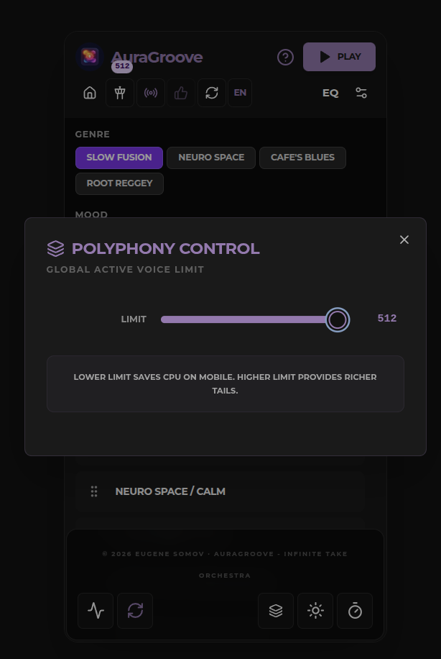
[Fig. 8 — Polyphony Control: the voice-limit slider]
Sound quality is directly proportional to the number of active voices. The Polyphony Control slider (50–512) is your dial:
- Below 50 the engine refuses to go — severe distortion and clicking live down there.
- Desktops are happy at 250+.
- Tablets sit comfortably at 128–200.
- Phones prefer 64–100.
When a dense moment exceeds your limit, the engine does not click or crackle: it quietly retires the oldest sounding voices first. You hear it only as a subtle thinning of the texture — the price of stability on modest hardware.

9.3 Broadcast Bridge
For weaker devices — roughly below 500,000 AnTuTu points — the Broadcast Bridge moves the entire generation into the background: the main thread only plays the finished, mixed stream. Benefits:
- crystal-clean, uninterrupted background playback on tired hardware;
- headroom for more active voices;
- the ability to stream the audio to other players on your network.
Costs and quirks:
- the tower icon blinks purple while the bridge is active;
- switching it on mid-playback causes a 3–4 s stutter while the bridge reconfigures;
- mixer and EQ preset changes take ~0.5 s to become audible.
Browsers cannot measure your device's strength, so the choice is honestly left to you.

9.4 Mobile realities
AuraGroove is at its best on a dedicated device. On a phone you actively use:
- an incoming call stops audio immediately — an OS limitation, not a bug;
- battery-saver modes throttle or kill the engine, causing distortion or shutdown;
- other apps steal CPU and memory, causing glitches;
- on some platforms (notably iOS in the background) the rhythm may drift slightly — the platform's house rules for web audio.
Keep it plugged in, close the heavy apps, and the orchestra will play for hours.

10. Comfort & Personalization
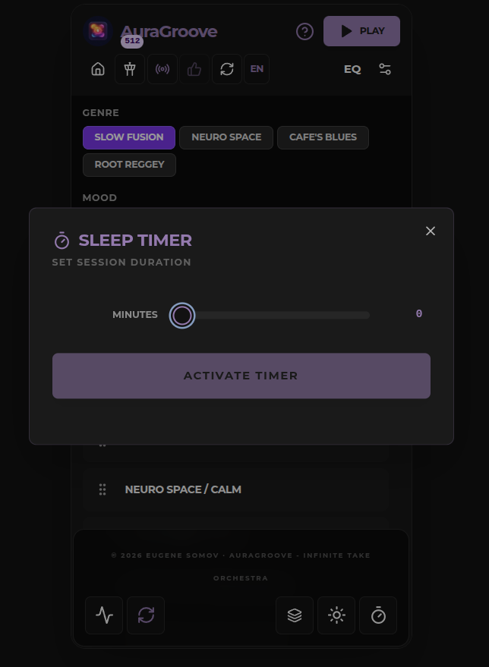
[Fig. 9 — Sleep Timer panel]
- Theme. The sun/moon toggle switches between the house dark aesthetic and a light theme for bright rooms.
- Language. The EN button switches the interface between English and Russian.
- Information Center. Opens from the ? in the Navigator or from the wordmark in the Player. Three tabs: this User Guide, the Disclaimer, and the Credits.
- Version badge. The welcome screen shows the current build (e.g. v0.4.12 "stream bridge pwa edition") — handy when comparing notes or reporting an issue.

11. Troubleshooting & Tips
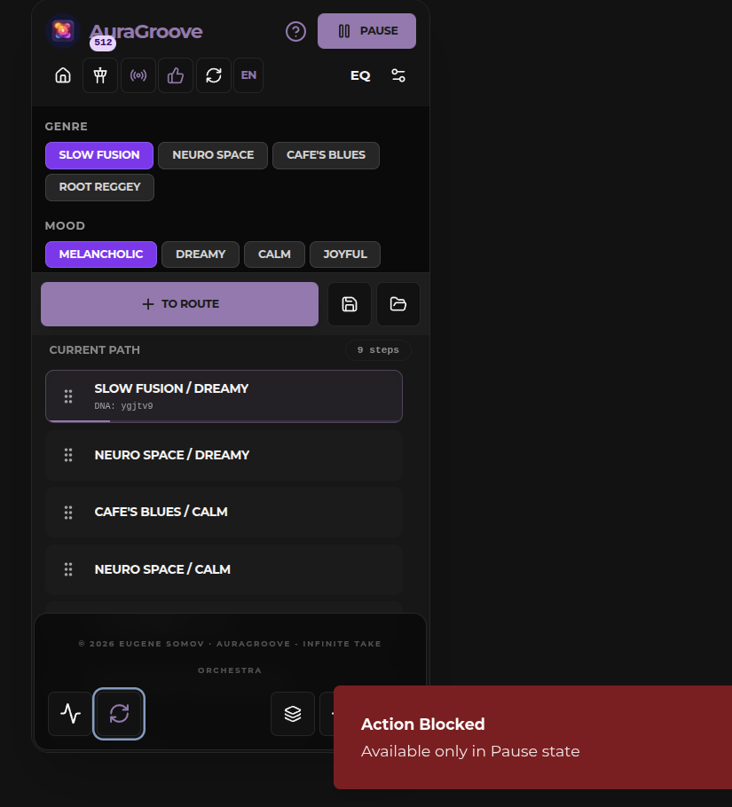 | 
[Fig. 10 — Toasts: "Action Blocked — Available only in Pause state" and "Queue Refreshed — Playback will start from the first step"]

When something seems broken
- No sound right after opening. The engine wakes only after your first tap — press START AURAGROOVE. Browsers forbid web audio before a human gesture.
- "Action Blocked" toast. The button you pressed (usually Refresh Queue) works only while paused. Pause, then retry.
- Route edits not applied. The engine follows the last synced plan. Press Refresh Queue (while paused) — playback will resume from the first Step.
- A short stutter after enabling Broadcast Bridge. Normal: the bridge reconfigures for 3–4 seconds.
- Mixer or EQ changes arrive half a second late. In Bridge mode this is expected.
- The screen changed by itself. You idled in the Navigator and the Player took over — the ambient hand-off. Press ✕ to return; the music continues.
- ⏮ looks dimmed. You are on the first Step of the route — there is simply nowhere earlier to go.
- Clicks or thin sound. Raise the voice limit in Polyphony Control; make sure battery-saver mode is off.
- Music stopped after a call. An OS limitation, not a bug. Press ▶ to resume.
- Rhythm drifts in the background on iOS. A platform house rule for web audio. Keep the app on screen — or use a dedicated device for critical listening.

Rituals that work
- A dedicated device, plugged in, heavy apps closed.
- Headphones — the Sparkles channel is scattered across the panorama, and it is worth hearing.
- Sleep Timer for night sessions.
- FTR for album assembly: hold Record for 1.5 s and let the engine catch the ending itself.
- Like generously — it is the only way the orchestra learns what moves humans.

12. Glossary
Term | Meaning
Journey Route (Take List) | your playlist: an ordered chain of Steps, played cyclically
Step (Route Point) | one entry of the route: a Genre/Mood pair
Suite | the complete performance generated for a Step — one "track" of the journey
Take | a particular performance of a Suite; regenerate or loop — and it is a new take
Seed | the numerical recipe a Suite grows from
DNA code | a short fingerprint of the seed, e.g. ygjtv9
The Core | the living visual heart of the Player
Genre Brain | a module with a genre's rules: Slow Fusion, Neuro Space, Cafe's Blues, Root Reggey
Tension Map | the composed energy arc of a Suite
Heritage Axiom | a human-played phrase used as a genetic template; never replayed directly
Gene Pool (Masterpieces) | the community collection of successful recipes
Like | donating the recipe of the moment to the gene pool
Broadcast Bridge | background generation + network streaming for weaker devices
Voice Limit (Polyphony) | maximum simultaneous voices, 50–512
Velvet Standard 3.0 | the house tuning for warm, organic sound
Full Track Record (FTR) | automatic recording of a Suite from start to finish
System Default (Golden Balance) | the house mix, tuned per genre
Saved Journey | a named route stored in your browser

