**Путешествие за сокровищем**

**1.**

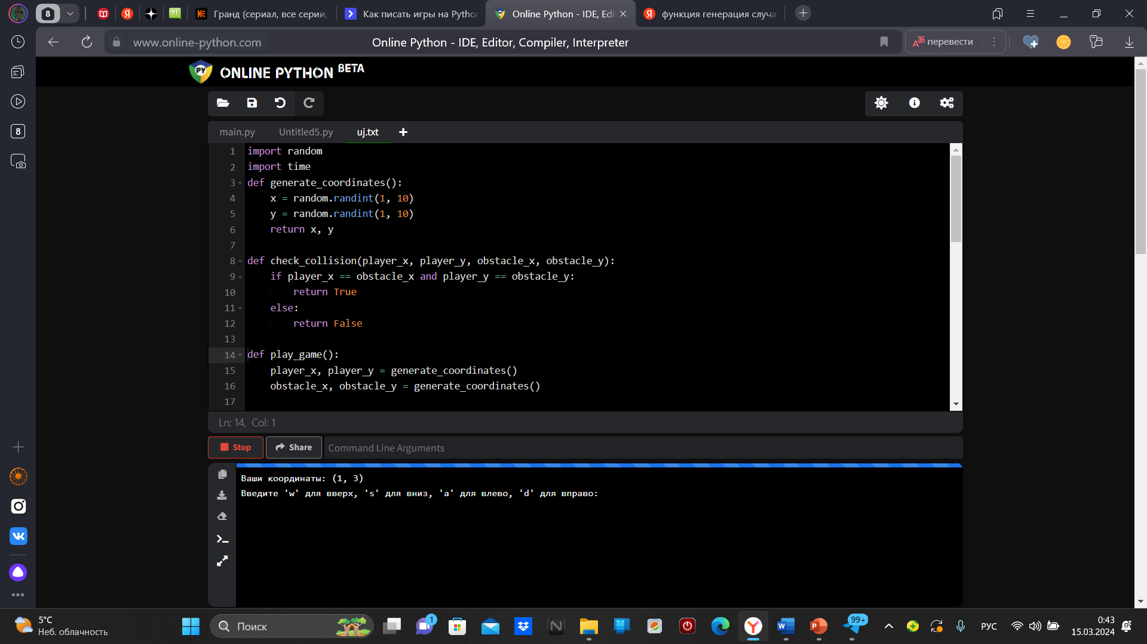

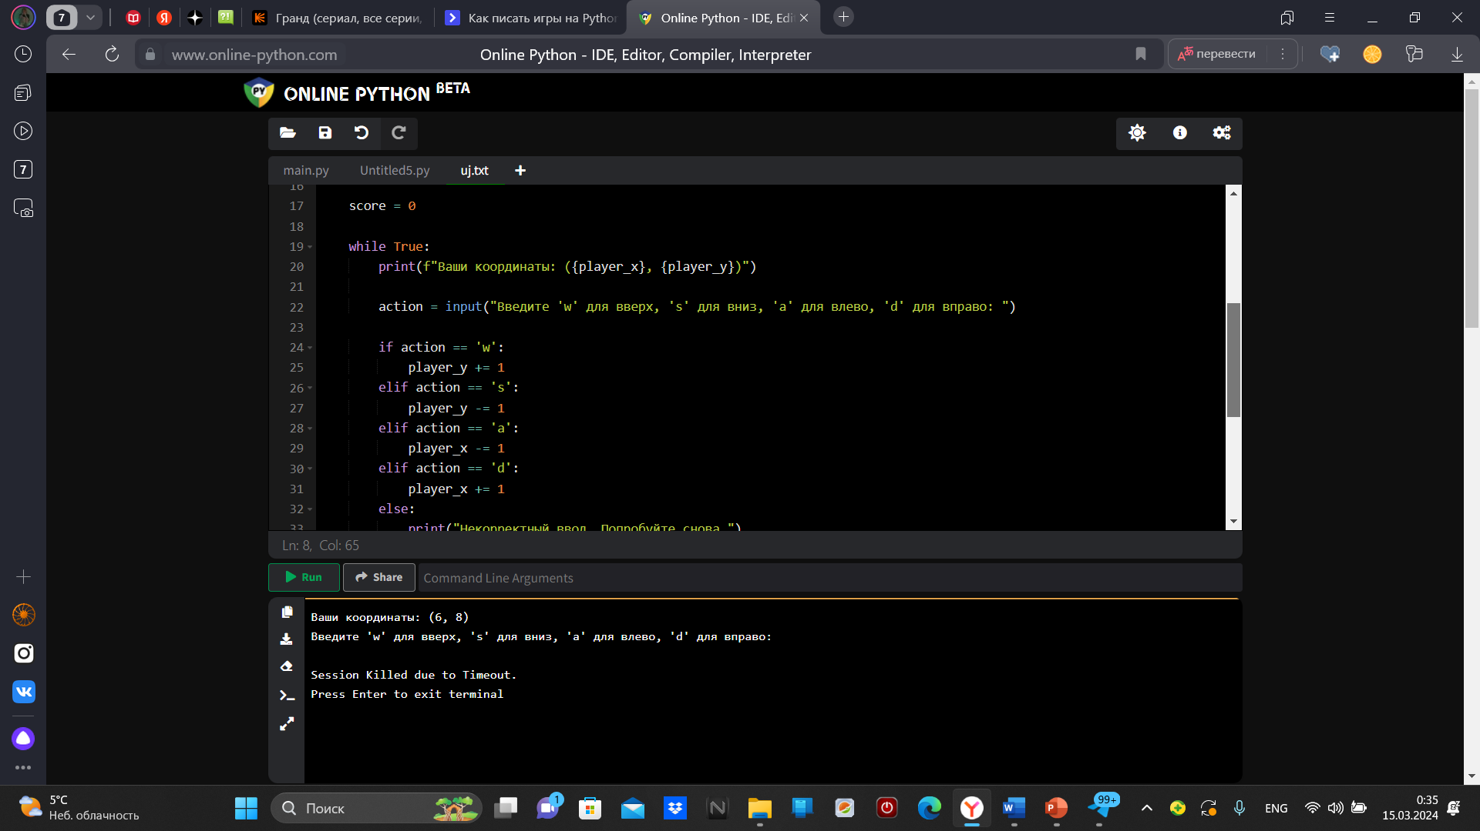

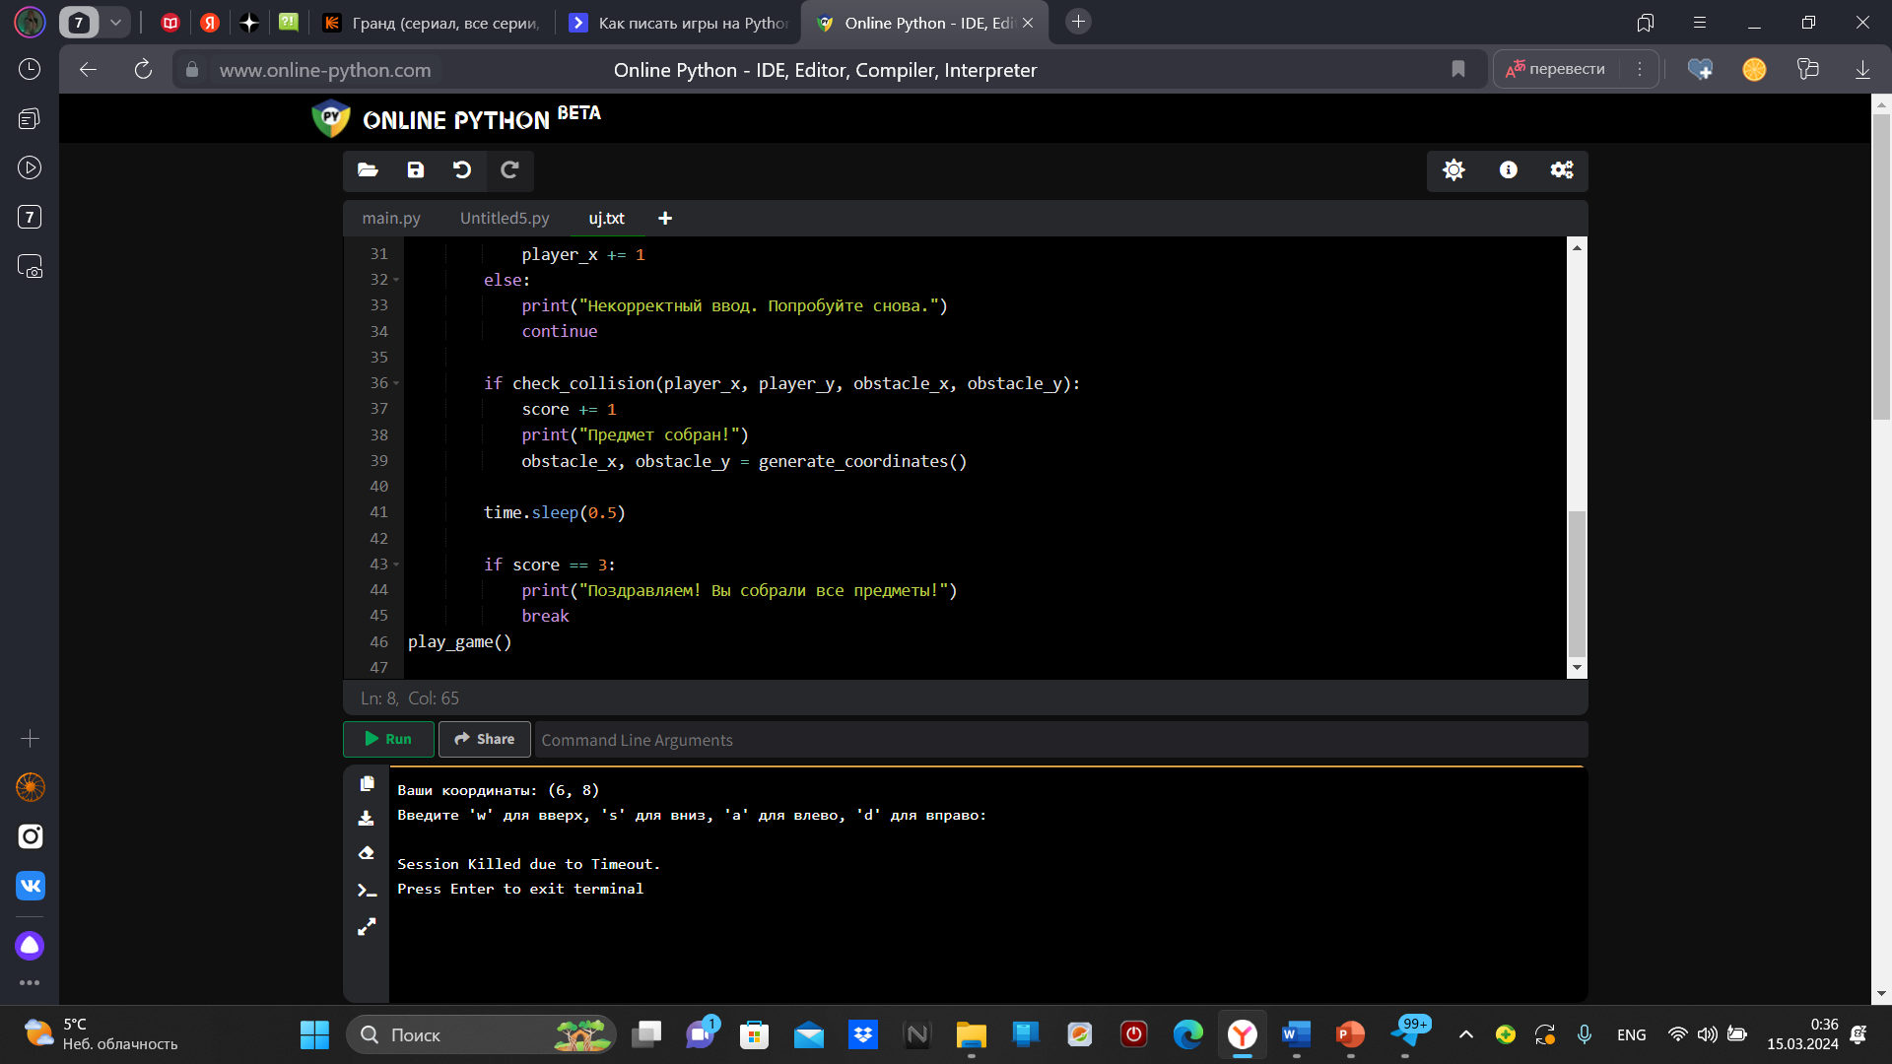

2.

import random  
import time  
def generate_coordinates():  
 x = random.randint(1,10)  
 y = random.randint(1, 10)  
 return x, y  
  
def check_collision(player_x, player_y, obstacle_x, obstacle_y):  
 if player_x == obstacle_x and player_y == obstacle_y:  
 return True  
 else:  
 return False  
  
def play_game():  
 player_x, player_y = generate_coordinates()  
 obstacle_x, obstacle_y = generate_coordinates()  
  
 score = 0  
  
 while True:  
 print(f"Ваши координаты: ({player_x}, {player_y})")  
  
 action = input("Введите 'w' для вверх, 's' для вниз, 'a' для влево, 'd' для вправо: ")  
  
 if action == 'w':  
 player_y += 1  
 elif action == 's':  
 player_y -= 1  
 elif action == 'a':  
 player_x -= 1  
 elif action == 'd':  
 player_x += 1  
 else:  
 print("Некорректный ввод. Попробуйте снова.")  
 continue  
  
 if check_collision(player_x, player_y, obstacle_x, obstacle_y):  
 score += 1  
 print("Предмет собран!")  
 obstacle_x, obstacle_y = generate_coordinates()  
  
 time.sleep(0.5)  
  
 if score == 3:  
 print("Поздравляем! Вы собрали все предметы!")  
 break  
play_game()