* **s01 topics**

**e01**

1. MongoDB

* MongoDB
* Installation
  + Installation through Homebrew

brew update

brew install mongodb

* Setup
  + Create a data/db folder where you want your databases to be sourced

mkdir –p users/evanturner/src/data/db

* Run Mongo
  + You connect to the database server, which runs as mongod
  + **mongod** is the primary daemon process for the MongoDB system.
    - It handles data requests, manages data access, and performs background management operations
  + Specify the dbpath when loading mongod

mongod --dbpath ~/src/data/db

**Macintosh HD:Users:evanturner:Desktop:Screen Shot 2014-12-22 at 1.01.36 PM.png**

* In another terminal
  + Run the mongo command

mongo

* + After starting the mongo shell your session will use the test database by default.
  + At any time, issue the following operation at the mongo to report the name of the current database:

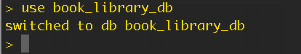

* + At this point, if you issue the show dbs operation again, it will not include the book_library_db database
  + MongoDB will not permanently create a database until you insert data into that database.

Mongod and Mongos

Mongod

* The **mongod** process is the primary database process that runs on an individual server.
* It handles data requests, manages data access, and performs background management operations
  + You can start MongoDB from a command line by issuing the mongod command and specifying option

Mongo

* mongos provides a coherent MongoDB interface equivalent to a mongod from the perspective of a client
  + The mongo binary provides the administrative shell.
  + mongos for “MongoDB Shard,” is a routing service for MongoDB shard configurations that processes queries from the application layer, and determines the location of this data in the sharded cluster, in order to complete these operations
* mongo is an interactive JavaScript shell interface to MongoDB
  + Provides a powerful interface for systems administrators
  + Provides a way for developers to test queries and operations directly with the database.

Provides a fully functional JavaScript environment for use with a MongoDB

Starting

* By default, MongoDB stores data in the /data/db directory. *On Windows, MongoDB stores data in C:\data\db*. On all platforms, MongoDB listens for connections from clients on port 27017

Specify a Data Directory

* If you want mongod to store data files at a path *other than* /data/db you can specify a dbPath.

At the moment only specifying a dbpath is working:

* mongod --dbpath /users/evanturner/src/mongodb/data/db

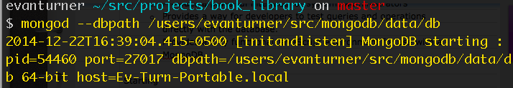

* + The dbPath must exist before you start mongod. If it does not exist, create the directory and the permissions so that mongod can read and write data to this path

Stopping

* + In a clean shutdown a mongod completes all pending operations, flushes all data to data files, and closes all data files.
    - Other shutdowns are *unclean* and can compromise the validity the data files
  + Clean shutdowns are executed with the following command:

db.shutdownServer() or Control-C or Command-period

Express.js

var express = require('express');

var app = express();

var bodyParser = require('body-parser');

var parseUrlencoded = bodyParser.urlencoded({ extended: false });

// In memory store for the cities in our application

var cities = {};

app.route('/cities')

.get(function (request, response) {

if(request.query.search) {

response.json(citySearch(request.query.search));

} else {

response.json(cities);

}

})

.post(parseUrlencoded, function (request, response) {

if(request.body.description.length > 4) {

var city = createCity(request.body.name, request.body.description);

response.status(201).json(city);

} else {

response.status(400).json('Invalid City');

}

});

app.route('/cities/:name')

.get(function (request, response) {

var cityInfo = cities[request.cityName];

if(cityInfo) {

response.json(cityInfo);

} else {

response.status(404).json('City not found');

}

})

.delete(function (request, response) {

if(cities[request.cityName]) {

delete cities[request.cityName];

response.sendStatus(200);

} else {

response.sendStatus(404);

}

});

// Adds a new city to the in memory store

function createCity(name, description) {

cities[name] = description;

return name;

}

app.listen(3000);

Node.js

Node works in as Non-Blocking code.

* + It does not do one task at a time.
    - Node will read files and carry out the tasks whenever it is finished while carrying out other tasks
      * Ruby is Blocking code

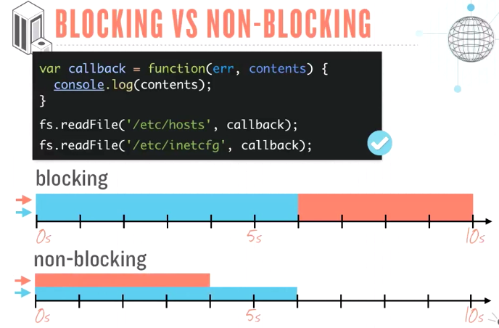

From the example above, non-blocking code can run two tasks parallel.

* + Javascript deals with this by using callbacks to ensure certain tasks are triggered following the execution of a function

Node operates in a constant event loop checking for events from a request called an Event Queue

* + request
  + connection
  + close

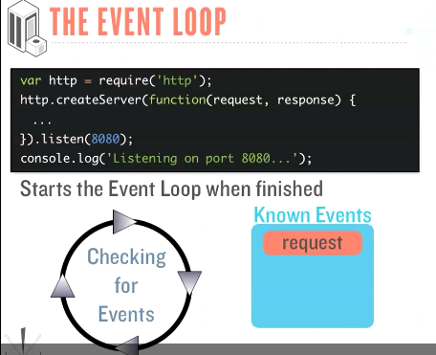

* + These events can trigger even more events form a thing called an Event Queue

setTimeout is put on these requests that calls a function or executes a code snippet after a specified delay.

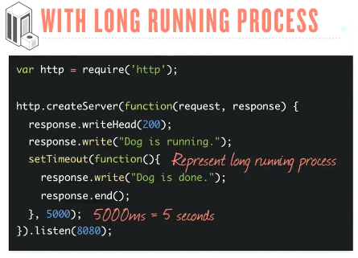

Time line of requests, callback and setTimeouts

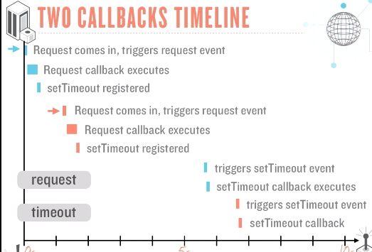

This process has no blocking code being that all these functions are being executed together and are only governed by timeouts which we can set to a time we choose.

This is with a Blocking code

