Архитектурные диаграммы
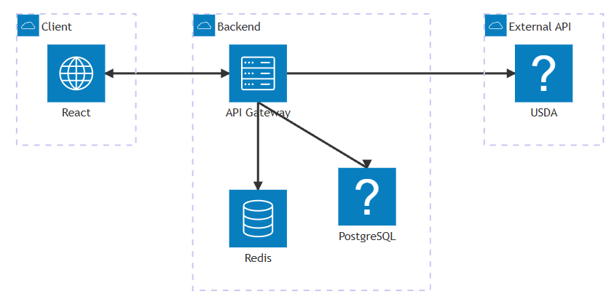
architecture-beta

group backend(cloud)[Backend]
service api(server)[API Gateway] in backend
service pg(db)[PostgreSQL] in backend
service redis(database)[Redis] in backend

group external(cloud)[External API]
service usda(api)[USDA] in external

group client(cloud)[Client]
service frontend(internet)[React] in client

frontend:R <--> L:api
api:B --> T:pg
api:B --> T:redis
api:R --> L:usda

