Диаграмма классов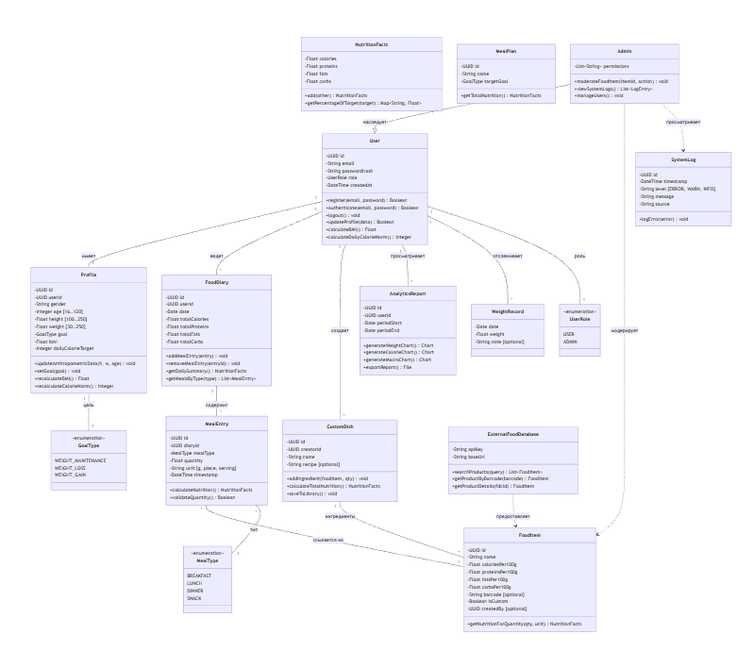
classDiagram
%% Перечисления
class GoalType {
<<enumeration>>
WEIGHT_MAINTENANCE
WEIGHT_LOSS
WEIGHT_GAIN
}

class MealType {
<<enumeration>>
BREAKFAST
LUNCH
DINNER
SNACK
}

class UserRole {
<<enumeration>>
USER
ADMIN
}

class User {
-UUID id
-String email
-String passwordHash
-UserRole role
-DateTime createdAt
+register(email, password) Boolean
+authenticate(email, password) Boolean
+logout() void
+updateProfile(data) Boolean
+calculateBMI() Float
+calculateDailyCalorieNorm() Integer
}

class Profile {
-UUID id
-UUID userId
-String gender
-Integer age [16..120]
-Float height [100..250]
-Float weight [30..250]
-GoalType goal
-Float bmi
-Integer dailyCalorieTarget
+updateAnthropometricData(h, w, age) void
+setGoal(goal) void
+recalculateBMI() Float
+recalculateCalorieNorm() Integer
}

%% Классы питания и дневника
class FoodDiary {
-UUID id
-UUID userId
-Date date
-Float totalCalories
-Float totalProteins
-Float totalFats
-Float totalCarbs
+addMealEntry(entry) void
+removeMealEntry(entryId) void
+getDailySummary() NutritionFacts
+getMealsByType(type) List~MealEntry~
}

class MealEntry {
-UUID id
-UUID diaryId
-MealType mealType
-Float quantity
-String unit [g, piece, serving]
-DateTime timestamp
+calculateNutrition() NutritionFacts
+validateQuantity() Boolean
}

class FoodItem {
-UUID id
-String name
-Float caloriesPer100g
-Float proteinsPer100g
-Float fatsPer100g
-Float carbsPer100g
-String barcode [optional]
-Boolean isCustom
-UUID createdBy [optional]
+getNutritionForQuantity(qty, unit) NutritionFacts
}

class CustomDish {
-UUID id
-UUID creatorId
-String name
-String recipe [optional]
+addIngredient(foodItem, qty) void
+calculateTotalNutrition() NutritionFacts
+saveToLibrary() void
}

class NutritionFacts {
-Float calories
-Float proteins
-Float fats
-Float carbs
+add(other) NutritionFacts
+getPercentageOfTarget(target) Map~String, Float~
}

%% Аналитика
class AnalyticsReport {
-UUID id
-UUID userId
-Date periodStart
-Date periodEnd
+generateWeightChart() Chart
+generateCalorieChart() Chart
+generateMacroChart() Chart
+exportReport() File
}

class WeightRecord {
-Date date
-Float weight
-String note [optional]
}

class MealPlan {
-UUID id
-String name
-GoalType targetGoal
+getTotalNutrition() NutritionFacts
}

%% Внешние сервисы и администрирование
class ExternalFoodDatabase {
-String apiKey
-String baseUrl
+searchProducts(query) List~FoodItem~
+getProductByBarcode(barcode) FoodItem
+getProductDetails(fdcId) FoodItem
}

class Admin {
-List~String~ permissions
+moderateFoodItem(itemId, action) void
+viewSystemLogs() List~LogEntry~
+manageUsers() void
}

class SystemLog {
-UUID id
-DateTime timestamp
-String level [ERROR, WARN, INFO]
-String message
-String source
+logError(error) void
}

%% Отношения
User "1" -- "1" Profile : имеет
User "1" -- "*" FoodDiary : ведет
User "1" -- "*" CustomDish : создает
User "1" -- "*" AnalyticsReport : просматривает
User "1" -- "*" WeightRecord : отслеживает

FoodDiary "1" -- "*" MealEntry : содержит
MealEntry "*" -- "1" FoodItem : ссылается на
MealEntry "*" -- "1" MealType : тип

CustomDish "1" -- "*" FoodItem : ингредиенты

Profile "1" -- "1" GoalType : цель
User "1" -- "1" UserRole : роль

ExternalFoodDatabase ..> FoodItem : предоставляет

Admin --|> User : наследует
Admin ..> FoodItem : модерирует
Admin ..> SystemLog : просматривает

