ER-диаграмма
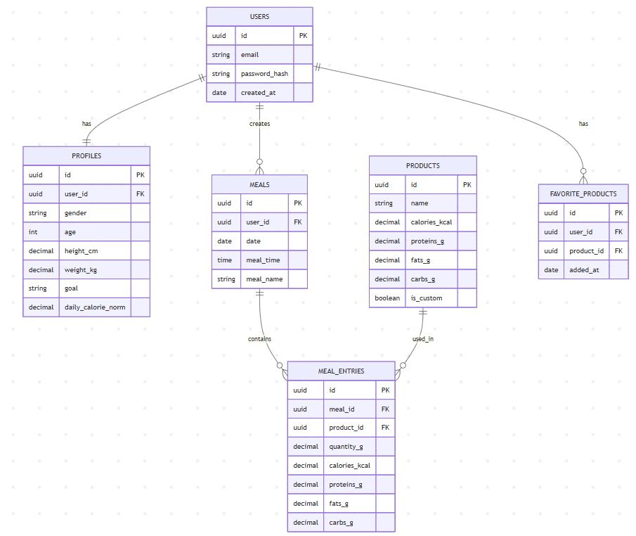
erDiagram
USERS {
uuid id PK
string email
string password_hash
date created_at
}

PROFILES {
uuid id PK
uuid user_id FK
string gender
int age
decimal height_cm
decimal weight_kg
string goal
decimal daily_calorie_norm
}

MEALS {
uuid id PK
uuid user_id FK
date date
time meal_time
string meal_name
}

PRODUCTS {
uuid id PK
string name
decimal calories_kcal
decimal proteins_g
decimal fats_g
decimal carbs_g
boolean is_custom
}

MEAL_ENTRIES {
uuid id PK
uuid meal_id FK
uuid product_id FK
decimal quantity_g
decimal calories_kcal
decimal proteins_g
decimal fats_g
decimal carbs_g
}

FAVORITE_PRODUCTS {
uuid id PK
uuid user_id FK
uuid product_id FK
date added_at
}

USERS ||--|| PROFILES : has
USERS ||--o{ MEALS : creates
USERS ||--o{ FAVORITE_PRODUCTS : has
MEALS ||--o{ MEAL_ENTRIES : contains
PRODUCTS ||--o{ MEAL_ENTRIES : used_in

