

WEB MOOD BOARD

WDD Group 18

**Warm up your Brain!**

**01 |** COLOUR PALLETE

**02 |** LOGO & TAGLINE

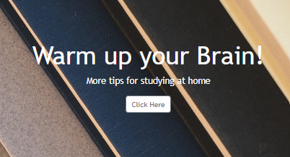

**03** | TYPOGRAPHY

***Storage:***

“Capturing a moments”

“”

*Heading* ***Trebuchet MS Bold***

*Body* **Hanken Grotesk**

**04** | PHOTOGRAPHY

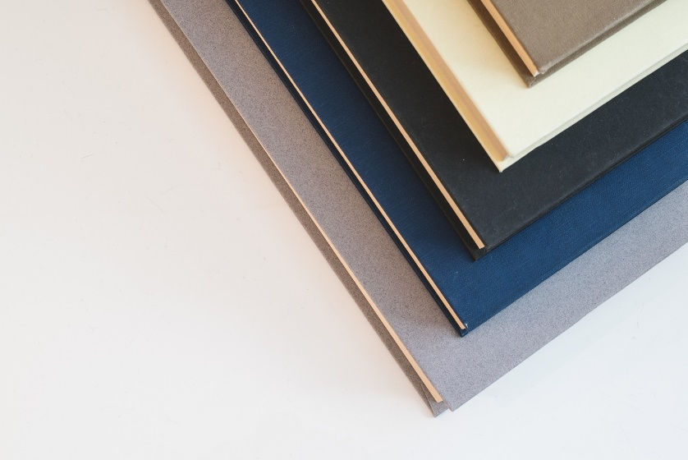

**

* Learning Online







# **Site Map**

# **Wireframe**