Insurance Claim Processing and Fraud Insight Platform
A Project Based Learning Report Submitted in partial fulfilment of the requirements for the award of the degree

of

Bachelor of Technology
in The Department of Computer Science and Engineering
DATABASE SYSTEMS ENGINEERING AND DISTRIBUTED BACKEND DEVELOPMENT ( DBS&DBD )

Submitted by
2510030054: Evyavan Anirudh Kasa
2510030119: Chinthalapthi Rishivarma
2510030134: Katta Suhas

Under the guidance of
Dr.Sasidhar Kothuru

Department of Computer Science and Engineering
Koneru Lakshmaiah Education Foundation, Aziz Nagar
Aziz Nagar – 500075
OCT - 2026.

Abstract
Insurance companies receive claims in large numbers, and every one of them has to be recorded, checked and then either paid or refused. When this work is spread across loose files and manual follow-ups, decisions slow down and doubtful claims can pass without anyone noticing. This report presents the Insurance Claim Processing and Fraud Insight Platform, a database-centred web application that we built to bring claim submission, review, fraud screening, notification and policy lookup into a single system.
The backend is divided into small FastAPI microservices for authentication, claims, fraud analysis, notifications and document search, all placed behind one API gateway. Customer, policy, claim and user records are kept in PostgreSQL, where relational constraints protect consistency. Fraud results, whose structure may change over time, are stored as documents in MongoDB. Access is controlled with JSON Web Tokens and three roles: Customer, Claim Officer and Admin. When a claim is created, an event is published to Apache Kafka and consumed by a separate notification service. A semantic search service converts insurance guidance documents into vectors with FastEmbed and stores them in Qdrant, so that staff can ask questions in ordinary language. A transparent rule engine gives every analysed claim a score from 0 to 100, a Low, Medium or High level and a list of readable reasons.
The system was tested through a browser dashboard and through the interactive documentation of each service. The captured outputs show claims being submitted, processed and rejected, fraud scores of 30 and 65 appearing as the rules predict, and policy questions returning relevant passages. The project shows that using relational, document, streaming and vector storage, each for the task it suits best, gives a practical and extensible foundation for claim management.
Keywords: insurance claims, fraud detection, microservices, FastAPI, PostgreSQL, MongoDB, Kafka, Qdrant, JWT, role-based access control, semantic search
List of Figures
Figure 1: Project poster summarising the platform, its core technologies and the end-to-end claim flow. 7
Figure 2: Layered architecture of the platform showing the frontend, API gateway, five microservices and their data stores. 10
Figure 3: Life of a claim from login to final decision, split into submission and staff review phases. 11
Figure 4: Entity relationship diagram of the PostgreSQL schema covering customers, policies, claims and users. 12
Figure 5: MongoDB fraud_analysis document design, system architecture summary and key relationships. 13
Figure 6: Sequence of events during login and during a later authorised request. 14
Figure 7: Inputs, rules and thresholds used by the rule-based fraud scorer. 16
Figure 8: Producer, topic and consumer involved in the claim-created notification. 17
Figure 9: Indexing and query paths of the semantic search service. 17
Figure 10: Folder structure of the project as seen in the editor. 19
Figure 11: Kafka container started through Docker Compose and listed as running. 19
Figure 12: Swagger interfaces of (a) Auth, (b) Claim, (c) Fraud, (d) Notification, (e) RAG services and (f) the API gateway. 20
Figure 13: Secure login page of the Insurance Fraud Detection application. 22
Figure 14: Customer dashboard: (a) a filled claim form and (b) the confirmation message after submission. 23
Figure 15: Administrator dashboard with claim and risk statistics. 23
Figure 16: Claims table with status badges and action buttons for staff. 24
Figure 17: Feedback dialogs: (a) claim processed successfully and (b) fraud analysis result for claim 32. 24
Figure 18: Stored fraud analysis records with score, risk level, amount and reasons. 25
Figure 19: Policy Knowledge Assistant section for semantic search. 25
Figure 20: Claim officer dashboard. 26
Figure 21: Claim status distribution and risk level distribution taken from the dashboard snapshot. 26
List of Tables
Table 1: Technology stack used in the platform and the role of each component 9
Table 2: Microservices, ports, data stores and responsibilities 10
Table 3: Summary of the PostgreSQL tables and their key attributes 12
Table 4: Role permission matrix enforced by the API gateway 14
Table 5: Endpoints exposed by the API gateway 15
Table 6: Claim status values accepted by the Claim service 15
Table 7: Fraud rules, point values and the reason text returned 16
Table 8: Documents loaded into the Qdrant knowledge base 18
Table 9: Functional test scenarios and expected outcomes 21
Table 10: Hand-calculated fraud scores used to verify the rule engine 22
Table 11: Selected fraud analysis results read from the dashboard 25
Table 12: Comparison between a manual claim process and the proposed platform 27
Table 13: Limitations observed during testing and the planned improvements 27
Table of Contents
1. Introduction 6
a. Background 6
b. Problem Statement 7
c. Objectives 7
d. Scope and Contributions 8
e. Organisation of the Report 8
2. Requirement Analysis and Technology Stack 8
a. Functional Requirements 8
b. Non-Functional Requirements 8
c. Technology Stack 9
d. Development Environment 9
3. System Design and Architecture 9
a. Architectural Style 9
b. Service Responsibilities 10
c. End-to-End Claim Lifecycle 10
d. Design Decisions 11
4. Database Design 11
a. Relational Model in PostgreSQL 11
b. Document Model in MongoDB 12
c. Why Two Databases 13
d. Vector Store 13
5. Methodology 13
a. Authentication with JSON Web Tokens 13
b. Role-Based Access Control 14
c. Claim Management Service 15
d. Fraud Detection Engine 15
e. Event-Driven Notifications 16
f. Semantic Search over Policy Documents 17
g. Security Considerations 18
6. Implementation and Working 18
a. Project Structure 18
b. Infrastructure Setup 19
c. Running the Services and Interactive API Documentation 19
d. Frontend Behaviour 20
e. Working Walkthrough 20
7. Experiments and Testing 21
a. Test Setup 21
b. Functional Test Cases 21
c. Fraud Rule Verification 21
8. Results and Discussion 22
a. Login Page 22
b. Customer Claim Submission 22
c. Administrator Dashboard 23
d. Claim Management 23
e. Fraud Analysis Records 24
f. Policy Knowledge Assistant 25
g. Claim Officer View 26
h. Overall Statistics 26
i. Discussion 26
9. Conclusion and Future Work 27
References 28
Insurance Claim Processing and Fraud Insight Platform
Project Report: Design, Working and Results

Introduction

Background
A claim is the moment an insurance policy has to prove its worth. Until then the policyholder pays premiums and the insurer collects them; once something goes wrong, a car is damaged or a hospital bill arrives, the paperwork begins and the whole relationship is judged on how that claim is handled. For the insurer the task is not small. Each claim has to be tied to a valid policy, checked against the incident described, assessed for its amount and finally approved or refused, and all of this has to happen without losing track of who submitted what. Many smaller offices still manage part of this chain with spreadsheets, e-mail threads and phone calls, which makes status enquiries slow and errors easy to make.
There is a second difficulty that sits quietly behind the first. Some claims are exaggerated, repeated or filed with the hope that nobody will look closely, and insurance fraud has been studied as a serious cost for insurers for a long time [1]. Catching such cases is not a matter of rejecting every large claim. Genuine customers also have expensive accidents. What an adjuster needs is a consistent way to notice which claims deserve a second look, together with a clear explanation of why. A score with no reason attached is of little use to a person who must justify the final decision.
This project, the Insurance Claim Processing and Fraud Insight Platform, is our attempt to build that supporting system for the course Database Systems Engineering and Distributed Backend Development. It brings customer and policy records, claim submission, fraud screening, event notification and policy-document search together in one web application. We chose to design it as a set of cooperating services instead of a single program, and we deliberately used three different kinds of storage, a relational database, a document database and a vector database, because the data in this domain does not all look the same. The overall idea of the platform is summarised in the project poster shown in Figure 1.
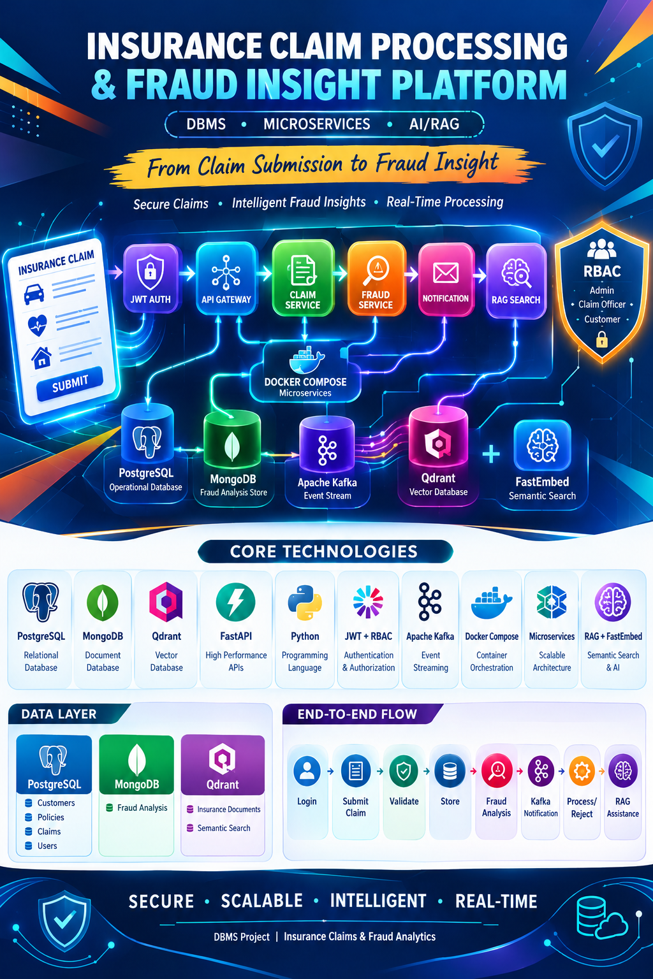
Figure 1: Project poster summarising the platform, its core technologies and the end-to-end claim flow.

Problem Statement
Claim handling in a small or mid-sized insurance setting suffers from four connected problems. First, claim data is spread across many places, so there is no single trustworthy record of a claim's current state. Second, there is no uniform and explainable method for flagging risky claims, so the quality of screening depends on whoever happens to be reading the file. Third, people with different duties, such as customers, claim officers and administrators, need different views of the same data, and mixing these up can expose private information or allow changes by the wrong person. Fourth, staff often need to look up policy rules or documentation, and keyword search over a folder of documents is a poor way of doing it. The problem we set out to solve was how to combine these needs in one maintainable backend whose parts can be understood, tested and improved separately.

Objectives
The work was organised around the following objectives, which also served as our checklist while building and testing:
- Store customers, policies, claims and user accounts in a normalised PostgreSQL schema with foreign keys, so that every claim is linked to a real customer and policy.
- Store fraud-analysis results in MongoDB, where the shape of a result (number of reasons, extra fields) can change without altering a table.
- Implement a transparent, rule-based fraud scorer that returns a number, a risk level and a list of human-readable reasons.
- Authenticate users with signed JSON Web Tokens and enforce Customer, Claim Officer and Admin permissions at the API gateway.
- Split the backend into five small FastAPI services behind a single gateway and expose interactive documentation for each.
- Publish a claim-created event to Apache Kafka and consume it in an independent notification service.
- Provide semantic search over insurance guidance documents using FastEmbed embeddings stored in Qdrant.
- Deliver a browser dashboard that changes what it shows according to the logged-in role.

Scope and Contributions
The platform covers the complete path of a claim inside one organisation: login, submission, storage, review, fraud screening, status decision and notification. It does not connect to external payment systems, hospital networks or government databases, and it does not train a machine-learning fraud model. Within that scope our contributions are the design of the service boundaries, the schema for both databases, the scoring rules, the role model enforced at the gateway, the Kafka-based event path, the semantic search service, and a working dashboard that exercises all of them. We also record the weaknesses we noticed while testing, because we think an honest list of limitations is more useful to the next person working on the code than a polished claim that everything is finished.

Organisation of the Report
The remaining chapters follow the order in which the system was built. Chapter 2 lists the requirements and the technology stack. Chapter 3 presents the architecture and the life of a claim. Chapter 4 explains the relational, document and vector data models. Chapter 5 describes the methods used for authentication, access control, claim handling, fraud scoring, messaging and search. Chapter 6 walks through the implementation and how the system is run. Chapter 7 describes the experiments and test cases, Chapter 8 presents the results with screenshots of the working application, and Chapter 9 concludes with limitations and future work.

Requirement Analysis and Technology Stack

Functional Requirements
We gathered the requirements by imagining the three kinds of people who would use such a system and asking what each of them must be able to do. A customer needs to submit a claim against a policy and be sure that nobody else can see or file it for them. A claim officer needs to see all claims, run a fraud check and decide on the claim. An administrator needs everything the officer can do and, in addition, the ability to load new knowledge documents. From these roles we derived the functional requirements below.
- Secure login that returns a time-limited token carrying the user's role and linked customer identifier.
- Claim creation with policy, type, amount, date and a free-text description; every new claim starts in the Pending state.
- Claim listing, where staff see every claim and customers see only the claims that belong to their own customer record.
- Status changes restricted to staff, limited to a fixed set of valid states.
- On-demand fraud analysis for any claim, with the result stored and retrievable later.
- An automatic notification event whenever a claim is created.
- Natural-language search over policy and fraud-guidance documents.
- A dashboard with summary counts for claims and risk levels.

Non-Functional Requirements
Beyond features, we held ourselves to a few qualities. Services should fail independently, so that an unavailable Kafka broker must not stop a claim from being saved. Passwords must never be stored in readable form. Each service should be small enough that its code can be read in one sitting. Finally, the whole system should start on a student laptop, with only the message broker needing a container, so that it can be demonstrated without special infrastructure.

Technology Stack
The technologies were selected for fit rather than fashion. Table 1 lists each layer together with the library versions pinned in the project's requirement files.
Table 1: Technology stack used in the platform and the role of each component
Layer | Technology | Version | Purpose in this project
API framework | FastAPI with Uvicorn | 0.141.1 / 0.53.0 | Five microservices and the gateway, with automatic Swagger documentation
Relational DB | PostgreSQL via psycopg2-binary | 2.9.13 | Customers, policies, claims and users with referential integrity
Document DB | MongoDB via PyMongo | 4.18.1 | Flexible storage for fraud-analysis results
Security | python-jose, passlib, bcrypt | 3.5.0 / 1.7.4 / 4.0.1 | JWT signing and verification, password hash checking
Messaging | Apache Kafka (image 4.1.0), kafka-python-ng | 2.2.3 | Claim-created events and the notification consumer
Vector search | Qdrant client, FastEmbed | 1.15.1 / 0.7.4 | Embedding and similarity search over policy documents
Validation / HTTP | Pydantic, HTTPX | 2.13.5 / 0.28.1 | Request models and gateway-to-service calls
Frontend | HTML, CSS, JavaScript | - | Login page and role-aware dashboard using the Fetch API
Containers | Docker Compose | - | Runs the single-node Kafka broker

Development Environment
All development was done in Visual Studio Code on Windows with a Python virtual environment, and the static frontend was served through the Live Server extension on port 5500, which is why that origin is the one allowed by the gateway's CORS configuration. Docker Desktop was used only for the Kafka container. Keeping the footprint this small meant that any of the three of us could start the full system in a few minutes on our own machine.

System Design and Architecture

Architectural Style
We followed the microservice style, in which an application is decomposed into small services that each own one responsibility and communicate over the network [5]. A browser never talks to these services directly. Every request goes to a single API gateway on port 8000, which checks the JWT, applies the role rules and forwards the call to the appropriate service on its own port. This keeps authorisation logic in one place and lets the internal services stay simple. The structure is shown in Figure 2.
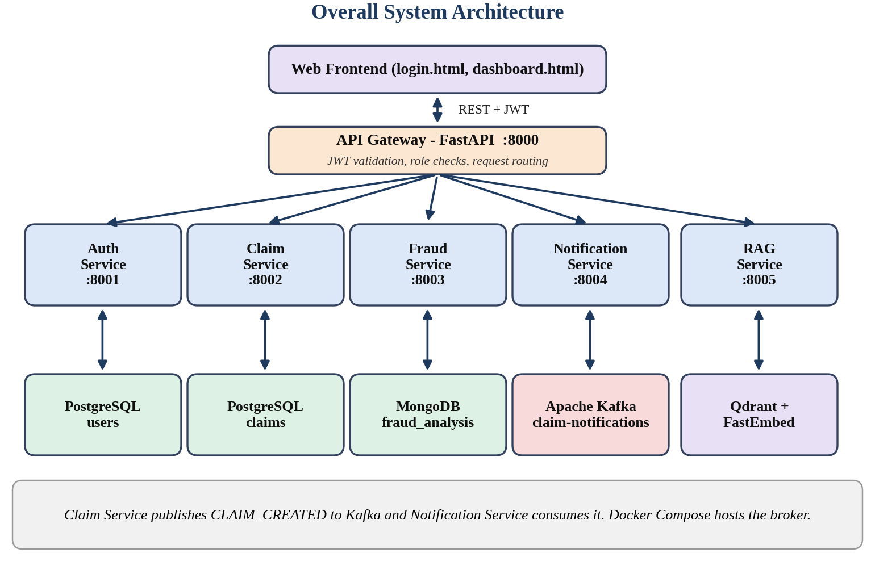
Figure 2: Layered architecture of the platform showing the frontend, API gateway, five microservices and their data stores.
The gateway and the services communicate using plain HTTP and JSON in the REST style [4], and the HTTPX client library is used for the forwarding calls. Two services, Claim and Notification, are additionally linked through Kafka. The Claim service is the producer of events and the Notification service is the consumer, and neither needs to know whether the other is currently running.

Service Responsibilities
Table 2 summarises the services. The boundaries were drawn around data ownership: the Auth service is the only one that reads the users table, the Claim service the only one that writes claims, and the Fraud service the only one that touches MongoDB. Because of this, a change in one data model does not ripple into the others.
Table 2: Microservices, ports, data stores and responsibilities
Service | Port | Data store | Endpoints | Responsibility
API Gateway | 8000 | None | /auth/login, /claims, /fraud, /rag | Token verification, role checks, routing, CORS
Auth Service | 8001 | PostgreSQL (users) | POST /login | Verifies password hash and issues the JWT
Claim Service | 8002 | PostgreSQL (claims) | POST and GET /claims, PUT /claims/{id}/status | Stores claims, validates status values, publishes events
Fraud Service | 8003 | MongoDB | POST /analyze, GET /fraud-analysis/{id} | Scores claims and stores or updates the result
Notification Service | 8004 | Kafka topic | GET /, GET /health | Runs the consumer thread for claim events
RAG Service | 8005 | Qdrant (local path) | POST /documents, POST /search | Embeds text and answers similarity queries

End-to-End Claim Lifecycle
A claim moves through the system in the sequence drawn in Figure 3. The upper row belongs to the submission phase and can be started by a customer; the lower row is the review phase, which only staff accounts can reach. The separation matters because the two phases have different risks. At submission, the main danger is a customer acting on someone else's record. At review, the main danger is an unauthorised change of the final decision.
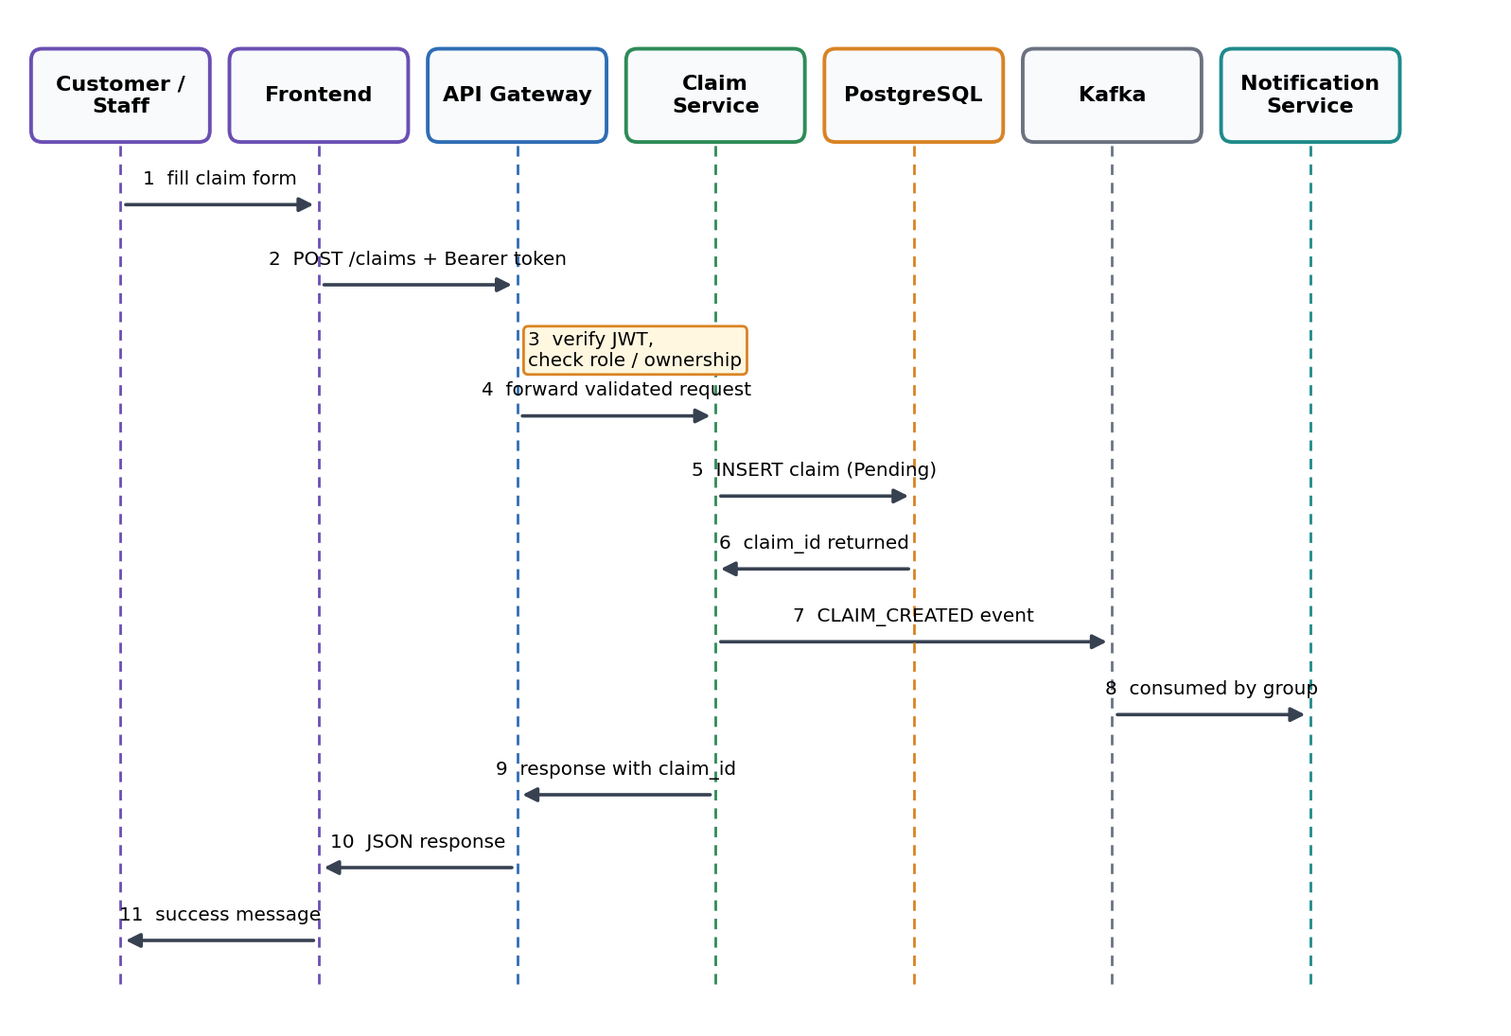
Figure 3: Life of a claim from login to final decision, split into submission and staff review phases.

Design Decisions
Three decisions shaped the design more than any others. The first was to use more than one database. Claims, customers and policies are tightly related and benefit from constraints and transactions, so they went to PostgreSQL [12]. Fraud results, in contrast, carry a list of reasons whose length varies from claim to claim, which fits naturally into a document. The second decision was to publish events asynchronously. A customer should not wait for a notification system to finish before seeing a confirmation, so the Claim service sends the event after the database commit and carries on even if the broker is down. The third decision was to keep the fraud logic as readable rules instead of an opaque model. With rules, an officer can read the reason list and see exactly which condition fired, which is what makes the output defensible.

Database Design

Relational Model in PostgreSQL
The relational design follows the classical idea of organising facts into tables joined by keys [2], and we normalised it so that each fact is stored once [3]. There are four tables: customers, policies, claims and users. A customer can hold several policies and can raise several claims, and every claim also points to the policy it is made under. Login accounts are kept in a separate users table that optionally links to a customer, which is how a Customer-role account is tied to its own data while staff accounts carry no customer link. Figure 4 shows the entity relationship diagram and Table 3 lists the important attributes.
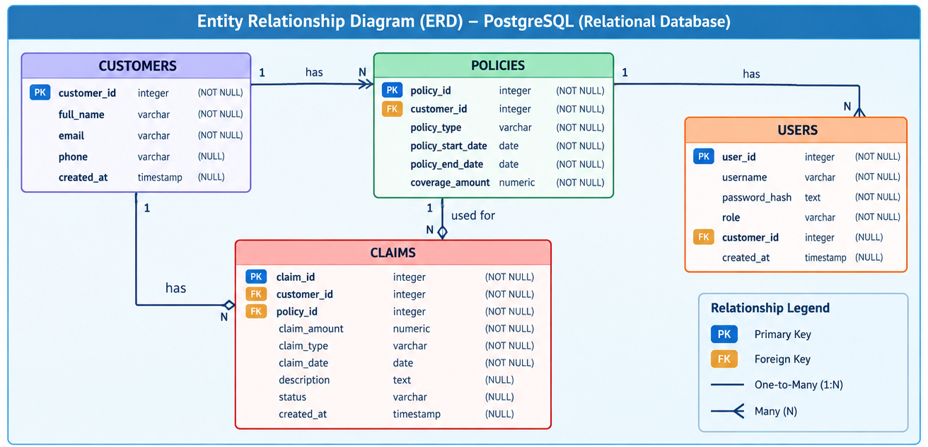
Figure 4: Entity relationship diagram of the PostgreSQL schema covering customers, policies, claims and users.
Table 3: Summary of the PostgreSQL tables and their key attributes
Table | Key attributes | Relationships and notes
customers | customer_id (PK), full_name, email, phone, created_at | Parent of policies and claims; one customer may own many user accounts
policies | policy_id (PK), customer_id (FK), policy_type, policy_start_date, policy_end_date, coverage_amount | Each policy belongs to one customer and can be used for many claims
claims | claim_id (PK), customer_id (FK), policy_id (FK), claim_amount, claim_type, claim_date, description, status, created_at | Status is set to Pending by the Claim service when the row is inserted
users | user_id (PK), username, password_hash, role, customer_id (FK, nullable), created_at | password_hash holds a bcrypt hash; role is one of Admin, Claim Officer or Customer

Document Model in MongoDB
Fraud results are stored in a collection named fraud_analysis inside the database insurance_fraud_db. Each document carries the claim identifier, the customer identifier, the claim amount, the numeric risk score, the risk level, an array of reasons and a field naming the analysis type, which is currently rule_based. The claim identifier has a unique index in the design, so one claim has one current analysis, and running the analysis again replaces the earlier document instead of adding a duplicate. Keeping the type of analysis inside the document leaves space to add, say, a machine-learning score next to the rule score later on without changing any schema [13]. The schema and the integration summary are shown in Figure 5.
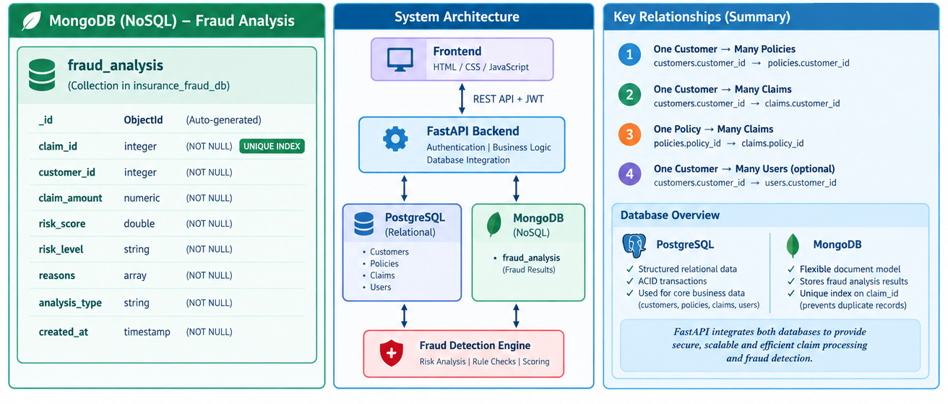
Figure 5: MongoDB fraud_analysis document design, system architecture summary and key relationships.

Why Two Databases
It is fair to ask whether one PostgreSQL database with a JSON column could have done everything. It could, and for a larger production system that might even be the better choice. We still kept MongoDB for two reasons. The first is educational: the course asks us to work with both relational and non-relational stores and to understand where each fits. The second is practical. Fraud analysis is written by a separate service, and giving that service its own store means that it can evolve, be restarted or be replaced without any lock on the claims table.

Vector Store
The third store, Qdrant, holds embedding vectors instead of ordinary rows. Each policy document is converted to a 384-dimensional vector and saved together with its text, type and source file name in a collection called insurance_documents. Section 5.f explains how this collection is queried. In the current build Qdrant runs in its embedded local mode and persists its files under rag_data/vector_db [15].

Methodology

Authentication with JSON Web Tokens
Authentication is handled by the Auth service. The login request carries a username and a password; the service looks up the user row, then compares the supplied password against the stored bcrypt hash through the passlib library. If either the username or the password is wrong, the same error message is returned, so a caller cannot tell which of the two was incorrect. On success the service signs a token with the HS256 algorithm [6]. The token payload contains the user identifier, username, role and customer identifier, plus an expiry time set sixty minutes ahead. The response also repeats the user details so that the frontend can adjust itself without decoding the token first.
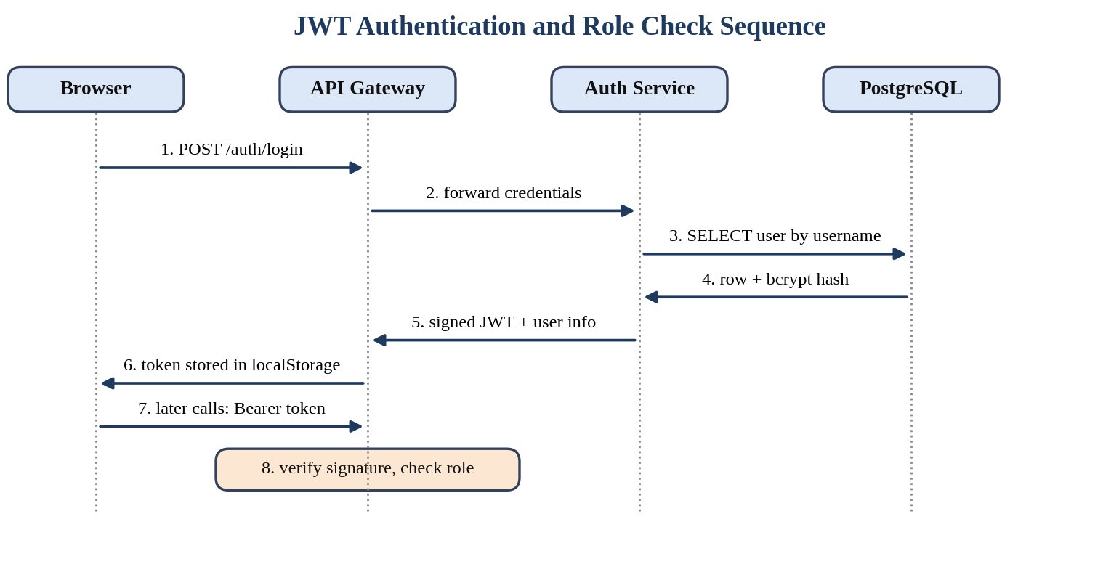
Figure 6: Sequence of events during login and during a later authorised request.
After login the browser stores the token and attaches it as a Bearer header to every request. The gateway holds the same signing secret, reads it from the environment variable JWT_SECRET_KEY, and verifies the signature and expiry in a dependency called get_current_user. This function accepts the username under either of two claim names, because the Auth service writes it as username while the standard name would be sub. Tokens that are missing, malformed or expired produce a 401 response, and the dashboard reacts to that by clearing local storage and returning the user to the login page.

Role-Based Access Control
Authorisation follows the role-based model, where permissions are attached to roles and users receive roles instead of individual rights [7]. The gateway offers a helper named require_roles, which wraps get_current_user and refuses the request with a 403 response if the role is not in the allowed list. Routes that depend on the owner of the data, such as claim creation and listing, apply extra checks in code: a Customer can only create a claim whose customer_id equals the one inside the token, and the list of claims is filtered by that identifier before it is returned. Table 4 shows the permission matrix and Table 5 lists the gateway endpoints.
Table 4: Role permission matrix enforced by the API gateway
Capability | Customer | Claim Officer | Admin
Log in | Yes | Yes | Yes
Submit a claim | Own customer ID only | Any customer | Any customer
View claims | Own claims only | All claims | All claims
Change claim status | No | Yes | Yes
Run fraud analysis | No | Yes | Yes
View stored fraud analysis | No | Yes | Yes
Search policy knowledge base | No | Yes | Yes
Add knowledge documents | No | No | Yes (API)

Table 5: Endpoints exposed by the API gateway
Method | Path | Access | Purpose
GET | / and /health | Public | Gateway status and list of service addresses
POST | /auth/login | Public | Forwards credentials to the Auth service
POST | /claims | Logged-in user | Creates a claim after ownership checks
GET | /claims | Logged-in user | Returns all claims for staff, own claims for customers
PUT | /claims/{claim_id}/status | Admin, Claim Officer | Updates the status of a claim
POST | /fraud/analyze | Admin, Claim Officer | Runs and stores a fraud analysis
GET | /fraud/{claim_id} | Admin, Claim Officer | Reads the stored analysis of a claim
POST | /rag/documents | Admin | Adds a document to the vector store
POST | /rag/search | Staff (see Chapter 9) | Semantic search over the knowledge base

Claim Management Service
The Claim service receives a validated claim, inserts it into the claims table and returns the generated identifier. The input model uses a real date type, so a malformed date is rejected before it reaches the database, and the description is optional. The insert and the commit happen first; only after the commit does the service try to publish the Kafka event. If the insert raises an error the transaction is rolled back and a 500 response is returned. When a staff member changes a status, the service checks the new value against a fixed set of four names and answers with 400 for anything else, with 404 if the claim does not exist. Table 6 describes the four states.
Table 6: Claim status values accepted by the Claim service
Status | Set by | Meaning
Pending | System, at creation | The claim has been received and is waiting for a staff decision
Under Review | Staff, through the API | The claim is being examined, for example after a high fraud score
Processed | Staff, Process button | The claim has been accepted and handled
Rejected | Staff, Reject button | The claim has been refused; no further actions remain on the row

Fraud Detection Engine
The fraud engine is a pure function that takes three inputs, the claim amount, the number of earlier claims and the number of days between policy start and claim, and returns a score, a level and reasons. Four rules contribute points, as listed in Table 7. The thresholds are simple on purpose. A claim above Rs. 75,000 adds 35 points, three or more earlier claims add 25, a claim made within seven days of the policy start adds 30, and an amount above Rs. 1,50,000 adds a further 10. The points are added, limited to a ceiling of 100, and converted to a level: 70 and above is High, 40 to 69 is Medium, and anything lower is Low. If no rule fires, the engine still returns a reason saying that no major indicator was detected, so the result is never empty. The logic is drawn in Figure 7.
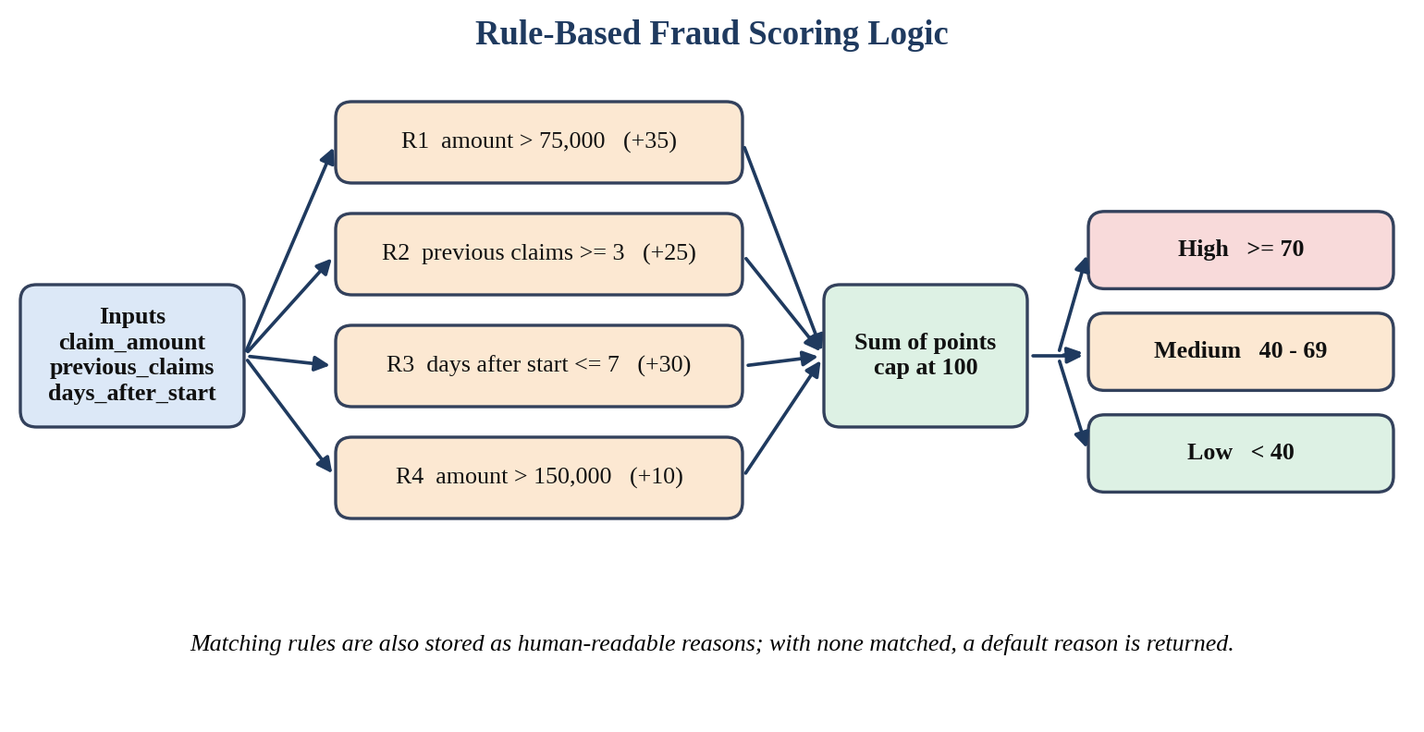
Figure 7: Inputs, rules and thresholds used by the rule-based fraud scorer.
Table 7: Fraud rules, point values and the reason text returned
Rule | Condition | Points | Reason stored
R1 | claim_amount > 75,000 | +35 | High claim amount
R2 | previous_claims >= 3 | +25 | Multiple previous claims
R3 | days_after_policy_start <= 7 | +30 | Claim submitted shortly after policy activation
R4 | claim_amount > 1,50,000 | +10 | Very high claim amount

Adding all four rules gives exactly 100, so the ceiling never changes a result today; it is a safeguard in case a rule is added later. The Fraud service then looks for an existing record with the same claim identifier and either updates it or inserts a new one, and it always closes the MongoDB connection in a finally block. The wording of the output follows a principle written into our own knowledge base: indicators do not by themselves establish that a claim is fraudulent, they only justify closer verification.

Event-Driven Notifications
Apache Kafka is a distributed log in which producers append messages to named topics and consumers read them at their own pace [8]. We used it for one event, CLAIM_CREATED, which carries the claim identifier, the customer identifier, the amount and a short message. The Claim service creates a KafkaProducer that serialises the dictionary to JSON, sends it to the topic claim-notifications and flushes. The send is wrapped in its own try block. If Kafka is unreachable, the response still reports the claim as created, and the kafka_event field explains that the notification failed. For the customer the claim exists, which is the correct behaviour; for the developer the failure is visible.
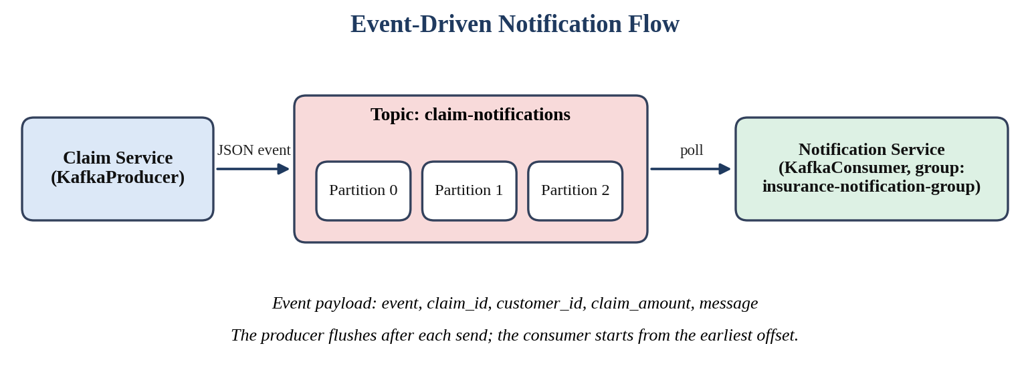
Figure 8: Producer, topic and consumer involved in the claim-created notification.
On the consuming side, the Notification service starts a daemon thread in its FastAPI startup handler. The thread builds a KafkaConsumer in the group insurance-notification-group, reads from the earliest offset, enables auto-commit and prints each event it receives. For compatibility with Kafka 4.x, the client API version is set explicitly to 4.0.0 in the consumer. Using a group identifier means a second copy of the service would share the partitions of the topic instead of receiving every message twice [14].

Semantic Search over Policy Documents
The knowledge assistant on the dashboard follows the retrieval idea behind retrieval-augmented generation [9]: documents are converted into vectors, and a question is answered by finding the vectors closest to the question's own vector. We used the model BAAI/bge-small-en-v1.5 [10], which FastEmbed runs locally without a separate server [16]. Its output has 384 dimensions, and the service reads that length from a sample embedding instead of hard-coding it when the collection is created. Similarity is measured with cosine distance. Four short text files form the initial knowledge base, listed in Table 8, and a script named ingest_documents.py embeds them and stores each one as a point whose payload contains the full text, the document type and the source file.
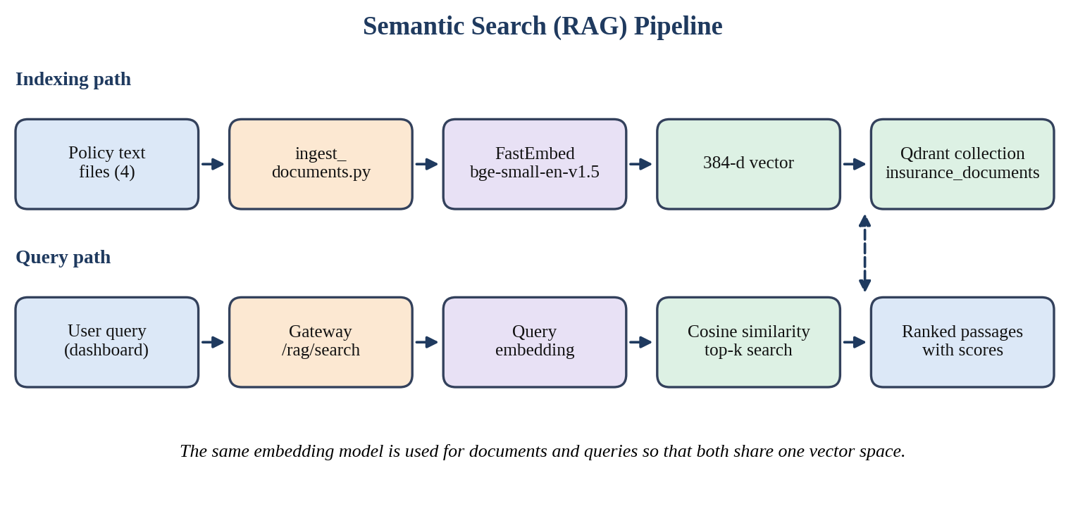
Figure 9: Indexing and query paths of the semantic search service.
Table 8: Documents loaded into the Qdrant knowledge base
ID | File | Document type | Content summary
1 | vehicle_claims.txt | Vehicle Insurance | Documents needed after an accident: policy details, registration certificate, licence, photographs, repair estimates and police reports
2 | health_claims.txt | Health Insurance | Hospital bills, discharge summary, medical reports and verification of admission and discharge dates
3 | claim_processing.txt | Claim Processing | Stages of a claim: submission, review, request for more information and the final decision
4 | fraud_indicators.txt | Fraud Detection | Examples of risk indicators and the reminder that indicators alone do not prove fraud

At query time the gateway forwards the question to the RAG service, which embeds it with the same model and asks Qdrant for the closest points. The default limit is three results, and each result returns with its similarity score. Our version of the pipeline stops at retrieval; it shows the best matching passages and does not yet compose a new answer with a language model, a point we return to in the future-work chapter.

Security Considerations
Security was treated as a property of every layer instead of a single feature. Passwords are stored only as bcrypt hashes, so even a leaked users table does not reveal them, and the login error message never says whether the username or the password was wrong. All SQL statements in the services use parameter placeholders, which prevents user input from being interpreted as SQL. Tokens expire after sixty minutes, and the gateway accepts cross-origin calls only from the two local addresses used by the development server. On the browser side, the dashboard escapes text taken from the API before placing it into the page, which protects against script injection through the claim description. Finally, ownership is checked on the server, never trusted from the form: even if a customer edited the page to send a different customer ID, the gateway would refuse it. Some weaknesses remain, such as default secrets in the source, and they are listed in Chapter 9.

Implementation and Working

Project Structure
The repository is organised so that each concern has a folder of its own, as seen in Figure 10. The api_gateway folder holds the gateway and its authentication helpers. Every microservice lives under services with its own requirements file, and the frontend, rag_data, kafka, database and docs folders hold the static pages, knowledge documents, broker settings, SQL scripts and diagrams respectively. A top-level docker-compose.yml, an environment template and a combined requirements file complete the layout.
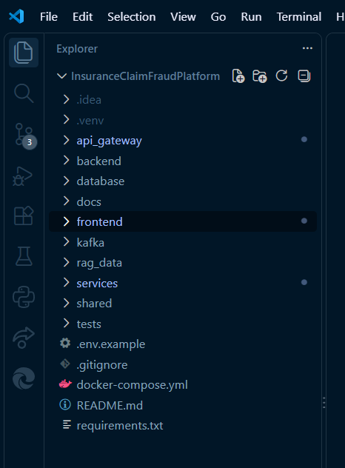
Figure 10: Folder structure of the project as seen in the editor.

Infrastructure Setup
The only component that runs in a container is Kafka. The compose file starts a single node of the image apache/kafka:4.1.0 that acts as both broker and controller, so no separate coordination service is needed. Port 9092 is mapped to the host, the advertised listener is localhost:9092, and the replication factors of the internal topics are set to one because there is only one node. New topics are created with three partitions by default. Starting it takes one command, and Figure 11 shows the container reported as up in the terminal.
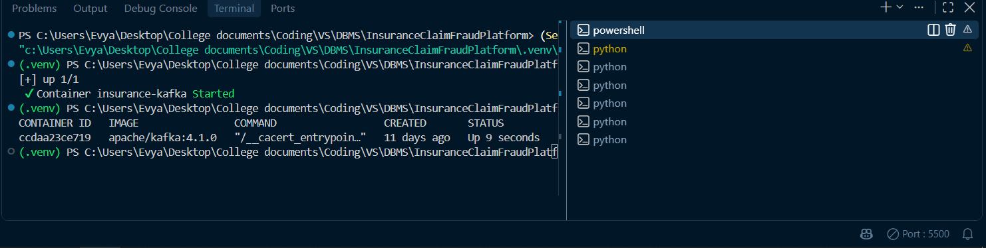
Figure 11: Kafka container started through Docker Compose and listed as running.
Connection details such as database names, the Mongo address, the Kafka bootstrap server and the Qdrant path are listed in a template file named .env.example, while the real values stay out of version control through the .gitignore file. The JWT secret is read from the environment in both the gateway and the Auth service, and it must be identical in the two places, otherwise every token would be rejected.

Running the Services and Interactive API Documentation
Each service is started with Uvicorn on its own port, and because each one is a FastAPI application, a Swagger page appears automatically at its /docs address. We used these pages constantly while developing, since they let us call an endpoint with a sample body before any frontend code existed. Figure 12 collects the pages for the Auth, Claim, Fraud, Notification and RAG services, followed by the gateway, whose lock icons mark the endpoints that need a token.
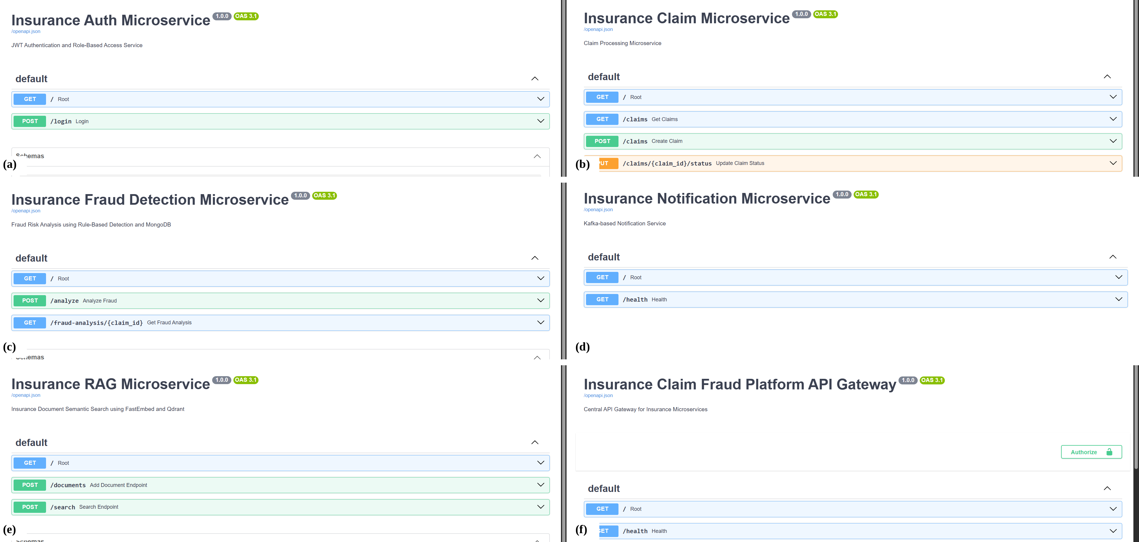
Figure 12: Swagger interfaces of (a) Auth, (b) Claim, (c) Fraud, (d) Notification, (e) RAG services and (f) the API gateway.

Frontend Behaviour
The frontend consists of two static pages written in plain HTML, CSS and JavaScript. The login page posts the credentials to the gateway, and on success it saves the token, username, role and customer identifier in local storage before redirecting to the dashboard. The dashboard reads the role at start-up and shows or hides whole sections accordingly: a customer sees only the claim form and a short notice, while staff see statistics, the claim table, the fraud analysis table and the policy knowledge assistant. Staff also get the extra Customer ID field, because they may file on behalf of someone else.
The summary tiles are calculated in the browser. The page requests the claim list once and counts the claims by status. For the risk tiles it then asks the gateway for the stored analysis of every claim, skips those that return 404 because they have never been analysed, and counts the remaining ones by level. This works well for the number of claims in our test data, but it does mean one request per claim, which we list as an improvement in Chapter 9.

Working Walkthrough
The complete working of the system can be followed through one example, the submission and decision of a single claim.
- The customer logs in. The gateway forwards the credentials to the Auth service, which returns a token valid for sixty minutes.
- The customer fills in the policy, claim type, amount, date and description and presses Submit Claim. The gateway confirms that the customer ID in the token matches the one in the request.
- The Claim service inserts the row with the status Pending, commits it, publishes the CLAIM_CREATED event and returns the new claim number.
- The Notification service receives the event from Kafka and prints it, simulating a message to the customer and the claims team.
- An officer or admin opens the dashboard, sees the new claim in the table and presses Analyze. The gateway forwards the amount and identifiers to the Fraud service, which scores the claim and stores the result in MongoDB.
- The staff member reads the score and reasons, then presses Process or Reject. The status is updated in PostgreSQL and the table refreshes.
- At any point the staff member can type a question into the policy knowledge assistant and read the closest passages.

Experiments and Testing

Test Setup
Testing was manual and scenario based. We ran PostgreSQL and MongoDB locally, started Kafka through Docker, ran the six FastAPI processes in separate terminals and opened the dashboard through Live Server. Three accounts were prepared, customer1, officer and admin, one for each role. Test data was entered through the form itself, so the claims visible in the screenshots, for instance vehicle accident and vehicle insurance claims with amounts between Rs. 25,000 and Rs. 1,00,000, are real rows created by these experiments. We also used the Swagger pages to call services directly whenever we wanted to separate a backend problem from a frontend one.

Functional Test Cases
Table 9 lists the scenarios we considered essential. The last column states where the behaviour can be seen in this report or, for error paths that we exercised through the API instead of the interface, which part of the code produces it.
Table 9: Functional test scenarios and expected outcomes
ID | Scenario | Expected outcome | Evidence
T1 | Customer logs in with valid credentials | Token issued, redirect to dashboard, role badge shows Customer | Figures 13 and 14
T2 | Login with a wrong password | 401 response with a generic invalid username or password message | Auth service login handler
T3 | Customer submits a claim for the own customer ID | Claim saved as Pending and the new claim number shown | Figure 14
T4 | Customer submits a claim for another customer ID | 403 response from the gateway | Gateway create_claim check
T5 | Customer requests the claim list | Only the claims of that customer are returned | Gateway get_claims filter
T6 | Admin presses Process on a pending claim | Status becomes Processed and the Process and Reject buttons disappear | Figures 16 and 17
T7 | Admin or officer analyses a claim | Alert with score, level and reasons, and a stored record | Figures 17 and 18
T8 | Claim created while Kafka is stopped | Claim still saved; the response notes that the notification failed | Claim service exception handler
T9 | Staff searches the knowledge base | Ranked passages with scores returned | Figure 19
T10 | Token expired or removed from storage | Dashboard clears storage and returns to the login page | Frontend handleAuthError

Fraud Rule Verification
Because the scorer is deterministic, its behaviour can be checked by hand. We chose inputs that sit on each side of every threshold and calculated the expected result before running it. Table 10 shows eight such cases. The case with an amount of exactly Rs. 1,50,000 is the most useful one, because it confirms that the fourth rule needs a strictly larger amount and the score stays at 65 instead of rising to 75. The last row confirms the default reason for claims where nothing fires.
Table 10: Hand-calculated fraud scores used to verify the rule engine
Case | Amount (Rs.) | Earlier claims | Days after start | Rules fired | Score | Level
C1 | 25,000 | 0 | 0 | R3 | 30 | Low
C2 | 85,000 | 0 | 0 | R1, R3 | 65 | Medium
C3 | 1,50,000 | 0 | 0 | R1, R3 | 65 | Medium
C4 | 2,00,000 | 0 | 0 | R1, R3, R4 | 75 | High
C5 | 40,000 | 3 | 30 | R2 | 25 | Low
C6 | 90,000 | 3 | 5 | R1, R2, R3 | 90 | High
C7 | 2,00,000 | 5 | 2 | R1 to R4 | 100 | High
C8 | 60,000 | 1 | 90 | None | 0 | Low (default reason)

Results and Discussion
This chapter presents the outputs of the running application. All screenshots were captured from our own system during testing, so the claim numbers and amounts are the genuine test records.

Login Page
Figure 13 shows the entry point of the platform. The page asks only for a username and a password, and it is the sole page that can be opened without a token. A successful login sends the user to the dashboard after a short confirmation message.
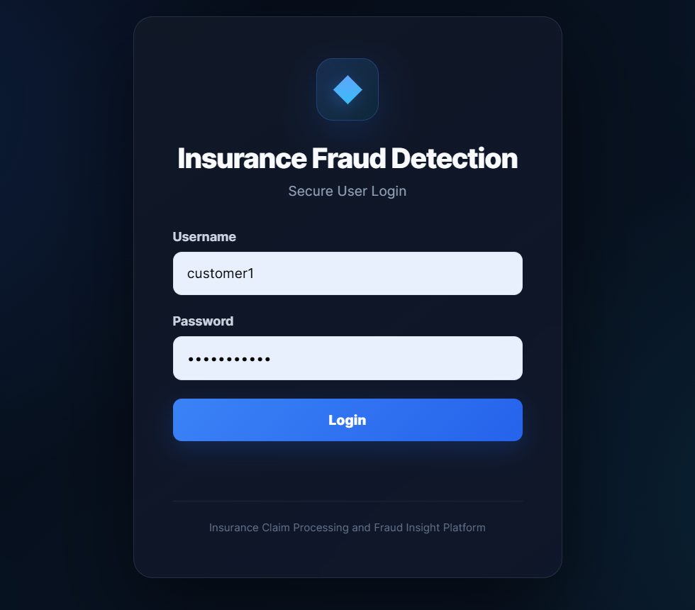
Figure 13: Secure login page of the Insurance Fraud Detection application.

Customer Claim Submission
Figure 14(a) shows the customer view after logging in as customer1. Only the claim form is available. The customer ID field is absent because the identifier is taken from the token. In the example the customer filled in policy 1, a vehicle repair claim of Rs. 1,00,000 dated 8 October 2026 and a short description. After submission the form is cleared and the green message in Figure 14(b) reports that claim 32 was created.
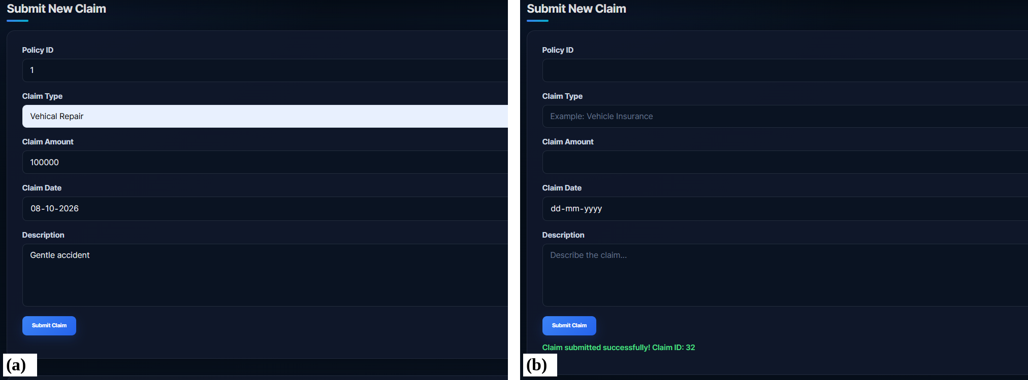
Figure 14: Customer dashboard: (a) a filled claim form and (b) the confirmation message after submission.

Administrator Dashboard
The administrator sees the statistics section first, shown in Figure 15. At the time of this capture the system held 22 claims, of which 7 were pending, 11 processed and none under review, which leaves 4 rejected claims. The three risk tiles show 0 high, 5 medium and 7 low risk analyses.
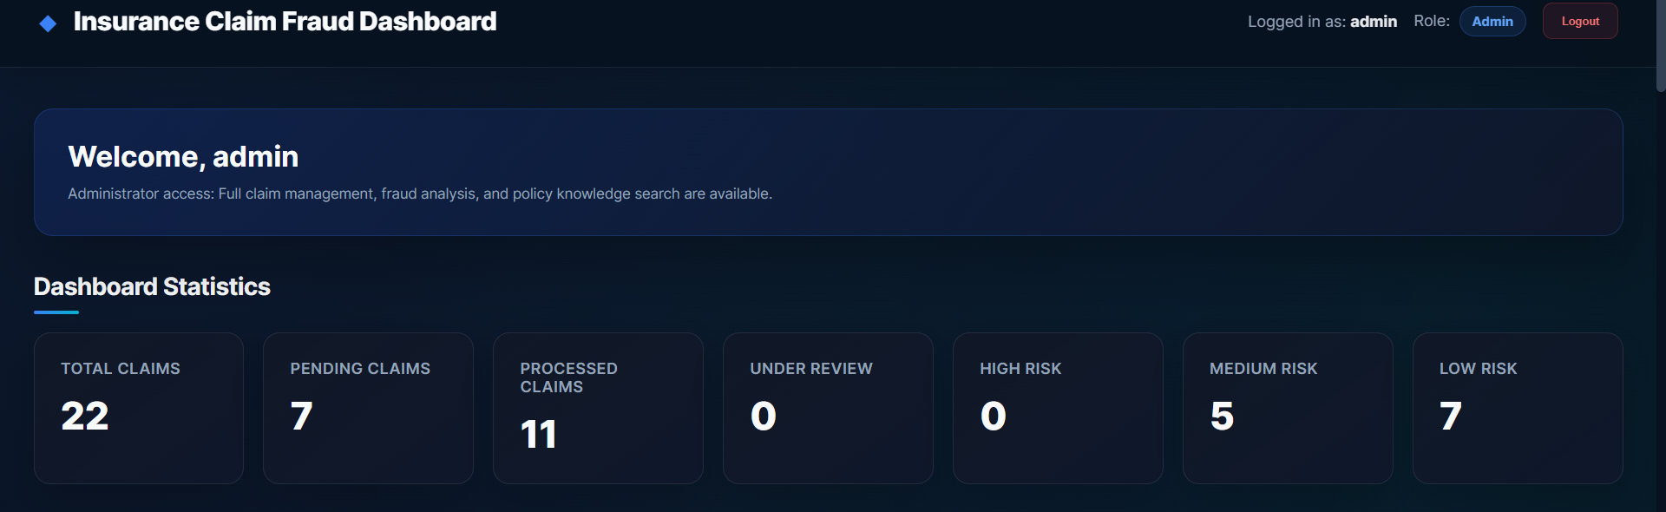
Figure 15: Administrator dashboard with claim and risk statistics.

Claim Management
Below the form, staff find the full claims table of Figure 16. Each row lists the claim number, customer, policy, claim type, amount, date and a colour-coded status. Pending rows offer Process, Reject and Analyze buttons, whereas rows with a final decision keep only Analyze, so a decided claim cannot be flipped by accident. The amounts are shown in Indian number format with the rupee sign.
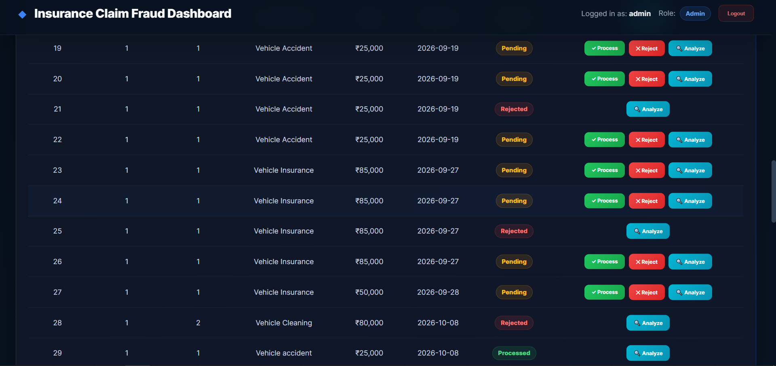
Figure 16: Claims table with status badges and action buttons for staff.
Figure 17 shows the feedback given by the interface. In panel (a) the browser reports that claim 32 has been processed successfully, and in panel (b) the fraud analysis for the same claim is displayed with its score of 65, the level Medium and the two reasons that were triggered.
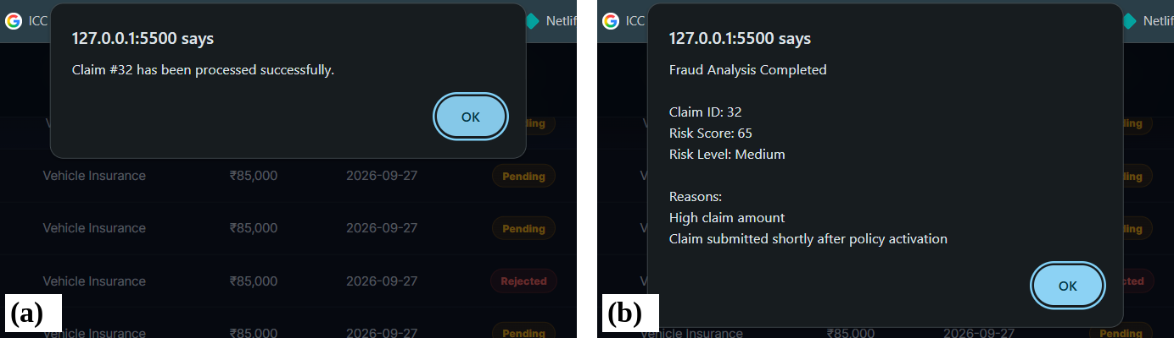
Figure 17: Feedback dialogs: (a) claim processed successfully and (b) fraud analysis result for claim 32.

Fraud Analysis Records
Every analysis is listed in a separate section, shown in Figure 18, with the score, a coloured level badge, the claim amount and the reasons. This is the view an officer would use to prioritise work, for example by looking first at the Medium and High rows. Table 11 repeats a selection of the rows in text form.
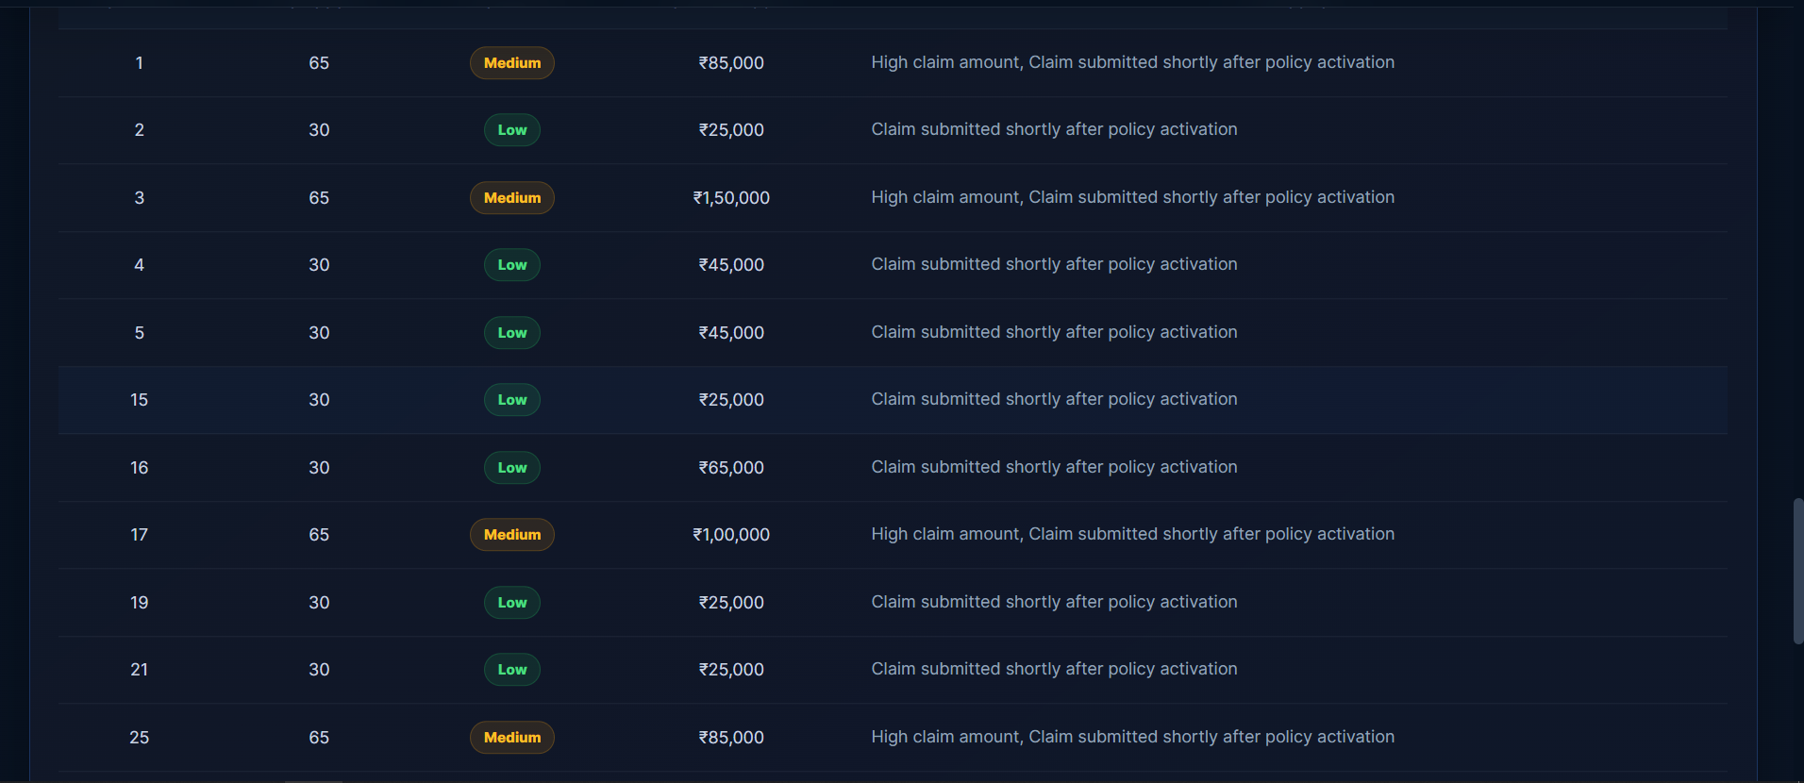
Figure 18: Stored fraud analysis records with score, risk level, amount and reasons.
Table 11: Selected fraud analysis results read from the dashboard
Claim | Amount (Rs.) | Score | Risk level | Reasons
1 | 85,000 | 65 | Medium | High claim amount; claim submitted shortly after policy activation
2 | 25,000 | 30 | Low | Claim submitted shortly after policy activation
3 | 1,50,000 | 65 | Medium | High claim amount; claim submitted shortly after policy activation
16 | 65,000 | 30 | Low | Claim submitted shortly after policy activation
17 | 1,00,000 | 65 | Medium | High claim amount; claim submitted shortly after policy activation
32 | 1,00,000 | 65 | Medium | High claim amount; claim submitted shortly after policy activation

Policy Knowledge Assistant
The last section of the staff dashboard, Figure 19, contains a multi-line search box with an example question about indicators of fraudulent vehicle claims. Pressing the button sends the text through the gateway to the RAG service and renders the returned passages with their scores underneath the form. Questions about documents required for a health claim or about the stages of claim processing are answered by the corresponding file in the knowledge base.
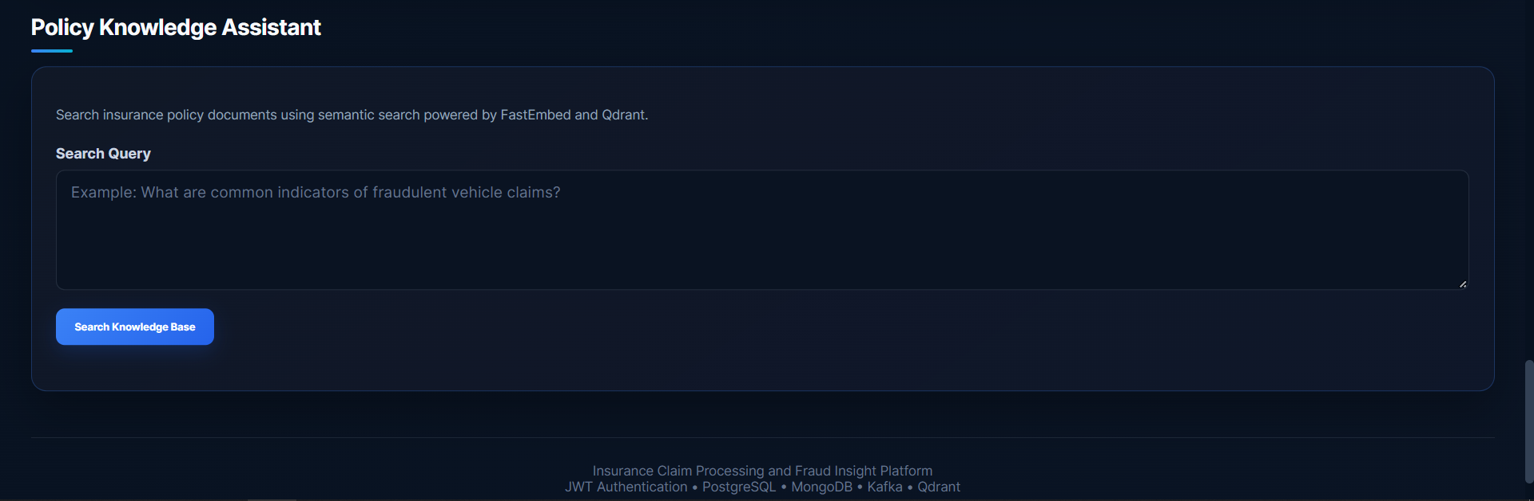
Figure 19: Policy Knowledge Assistant section for semantic search.

Claim Officer View
The claim officer sees almost the same page as the administrator, as in Figure 20, but the welcome text describes the officer's duties of submission, processing, rejection, fraud analysis and knowledge search. In this capture the risk tiles show a dash, which is the placeholder displayed until the fraud statistics have been loaded.
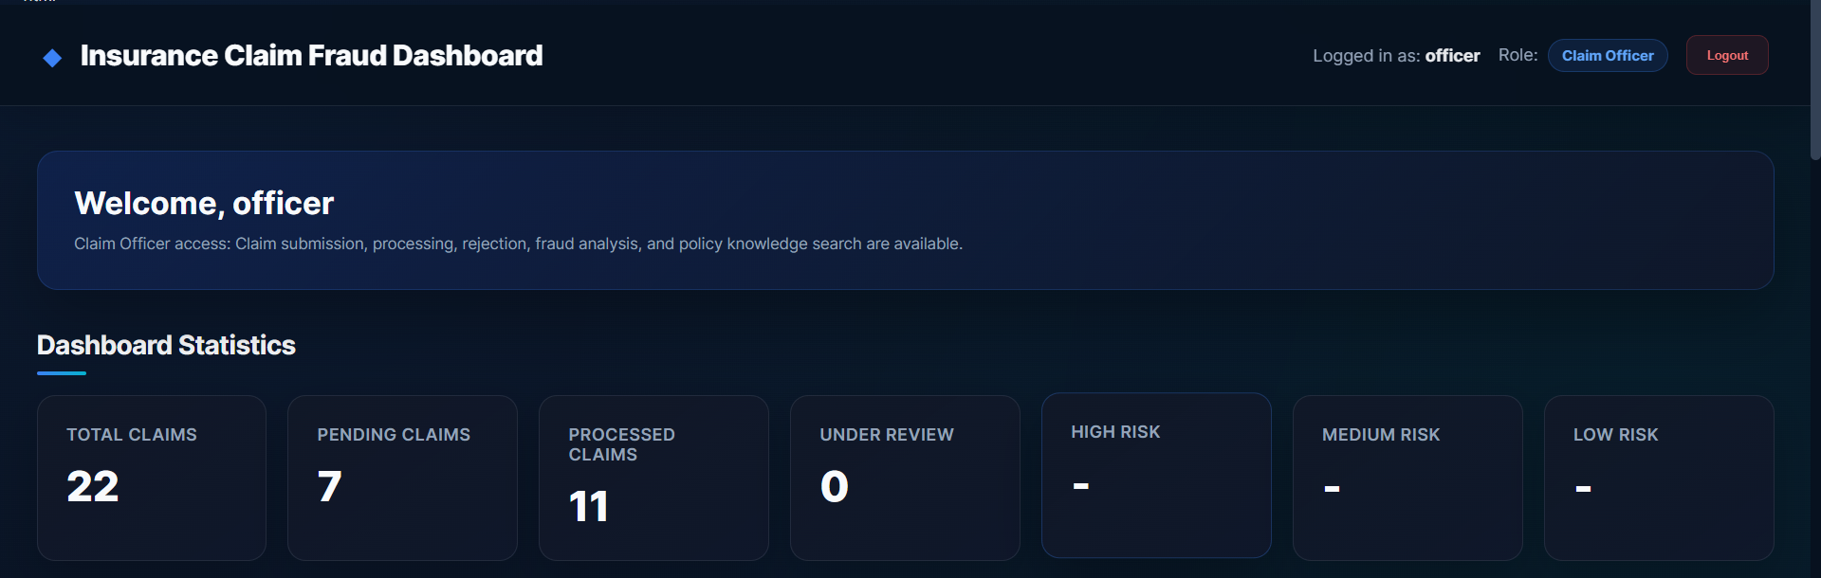
Figure 20: Claim officer dashboard.

Overall Statistics
Figure 21 redraws the numbers from the administrator snapshot as two charts. The left chart confirms that processed claims were the largest group at 11 of 22, with 7 still waiting for a decision. The right chart shows that all 12 analysed claims were Low or Medium and none was High.
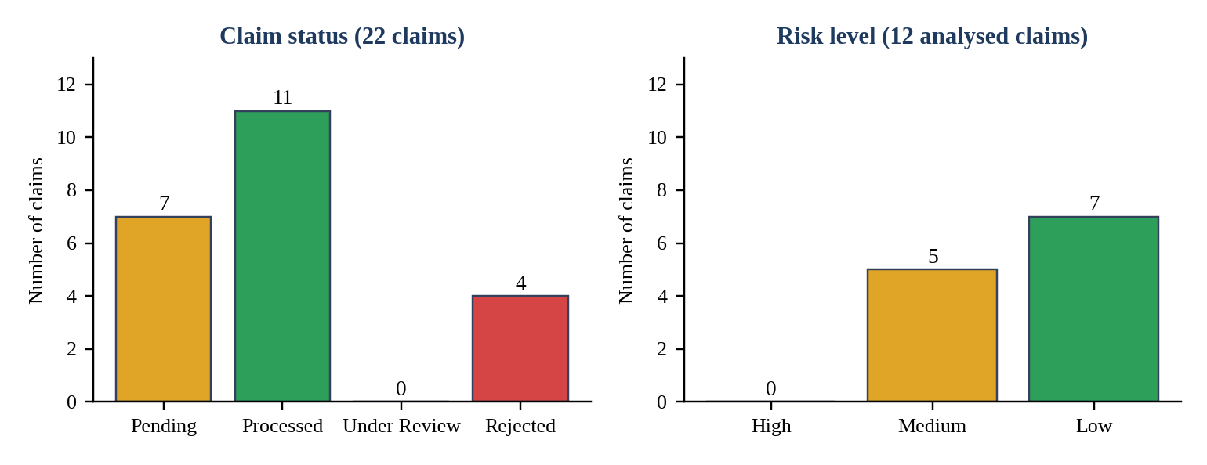
Figure 21: Claim status distribution and risk level distribution taken from the dashboard snapshot.

Discussion
Taken together, the results show that the main design goals were achieved. Roles see different pages, a claim travels from submission to a final decision, each analysis is stored together with an explanation, and the search section is able to return policy passages. Several observations deserve a frank comment. The scores in Table 11 only take the values 30 and 65, and the reason is visible in the dashboard code: when staff press Analyze, the page sends previous_claims and days_after_policy_start as zero, since the claim table does not carry that information. Rule R3 therefore fires every time, and the score depends mostly on the amount. A High result would appear only for amounts above Rs. 1,50,000, which explains why the High tile shows zero. The rule engine itself behaves correctly, as Table 10 confirms; what is missing is a data feed that computes the two values from the policies and claims tables.
To put these outcomes in context, Table 12 compares the way a claim is handled in a typical manual process with the way it is handled by the platform.
Table 12: Comparison between a manual claim process and the proposed platform
Aspect | Manual process | Proposed platform
Record keeping | Files, spreadsheets and e-mail threads | Single PostgreSQL schema with foreign keys between customers, policies and claims
Status tracking | Asked by phone or e-mail | Status visible on the dashboard and limited to four valid values
Fraud screening | Depends on the reviewer | Same four rules for every claim, with stored reasons
Access control | Shared folders | JWT tokens and three roles checked at the gateway
Notification | Manual messages | Kafka event published automatically on claim creation
Policy lookup | Keyword search in folders | Semantic search over embedded documents

A second observation concerns the gateway source. The routes for fraud analysis and for search and upload of documents are written twice, and the framework uses the first matching definition for a path, so the stricter later versions are never reached. For search, this means the endpoint is open to any logged-in user at the API level even though the dashboard hides the section from customers. We have kept the permission matrix in Table 4 as the intended behaviour and listed the clean-up as the first task for future work.

Conclusion and Future Work
We set out to build a claim processing backend that is understandable, divided into sensible parts and honest about its decisions. The platform that came out of the project accepts claims from authenticated customers, stores them relationally, lets staff screen them with an explainable score, records the screening in a flexible document store, announces new claims through Kafka and answers policy questions with semantic search. Equally important for us was the experience of choosing the right store for each kind of data and watching the pieces cooperate over the network. Details such as Kafka 4.x client compatibility, the token claim names and the mismatch in the frontend inputs taught us more about distributed backends than a single-process program would have.
The work is not finished. Table 13 collects the limitations we identified while testing, each paired with the improvement we would make next. Most of them are small and well defined, which in our view is a sign that the service boundaries are in the right place.
Table 13: Limitations observed during testing and the planned improvements
No. | Observation | Planned improvement
1 | Dashboard sends previous_claims and days_after_policy_start as zero, so rule R3 always fires | Compute both values from the claims and policies tables before calling the fraud service
2 | Gateway defines /fraud/analyze, /rag/search and /rag/documents twice | Remove the duplicates so that the intended role restrictions are the only ones active
3 | Database credentials and a fallback JWT secret appear in source files | Read all secrets from environment variables and refuse to start without them
4 | Notification consumer only prints events | Persist notifications and send e-mail or SMS; show them inside the dashboard
5 | Search returns passages but no composed answer | Add a language-model step that answers from the retrieved text and cites the source file
6 | Qdrant runs in embedded local mode | Run Qdrant as a server container so that several processes can share it
7 | Risk tiles need one request per claim | Add an aggregate statistics endpoint to the fraud service
8 | Rules are fixed and tests are manual | Add a machine-learning anomaly score beside the rules, plus automated tests and HTTPS

In summary, the Insurance Claim Processing and Fraud Insight Platform demonstrates that a student team can combine relational, document, streaming and vector technologies into a coherent application when each is given a clear job. We hope the structure of the code and of this report makes it easy for others to extend it.

References
- S. Viaene, R. A. Derrig, B. Baesens and G. Dedene, "A comparison of state-of-the-art classification techniques for expert automobile insurance claim fraud detection," Journal of Risk and Insurance, vol. 69, no. 3, pp. 373-421, 2002.
- E. F. Codd, "A relational model of data for large shared data banks," Communications of the ACM, vol. 13, no. 6, pp. 377-387, 1970.
- R. Elmasri and S. B. Navathe, Fundamentals of Database Systems, 7th ed. Pearson, 2016.
- R. T. Fielding, "Architectural styles and the design of network-based software architectures," Ph.D. dissertation, University of California, Irvine, 2000.
- S. Newman, Building Microservices: Designing Fine-Grained Systems, 2nd ed. O'Reilly Media, 2021.
- M. Jones, J. Bradley and N. Sakimura, "JSON Web Token (JWT)," RFC 7519, Internet Engineering Task Force, May 2015.
- R. S. Sandhu, E. J. Coyne, H. L. Feinstein and C. E. Youman, "Role-based access control models," IEEE Computer, vol. 29, no. 2, pp. 38-47, 1996.
- J. Kreps, N. Narkhede and J. Rao, "Kafka: a distributed messaging system for log processing," in Proc. NetDB Workshop, 2011.
- P. Lewis et al., "Retrieval-augmented generation for knowledge-intensive NLP tasks," in Advances in Neural Information Processing Systems, vol. 33, pp. 9459-9474, 2020.
- S. Xiao, Z. Liu, P. Zhang and N. Muennighoff, "C-Pack: packaged resources to advance general Chinese embedding," arXiv:2309.07597, 2023.
- FastAPI documentation. [Online]. Available: https://fastapi.tiangolo.com
- PostgreSQL Global Development Group, PostgreSQL documentation. [Online]. Available: https://www.postgresql.org/docs/
- MongoDB Inc., MongoDB Manual. [Online]. Available: https://www.mongodb.com/docs/manual/
- Apache Software Foundation, Apache Kafka documentation. [Online]. Available: https://kafka.apache.org/documentation/
- Qdrant documentation. [Online]. Available: https://qdrant.tech/documentation/
- FastEmbed documentation. [Online]. Available: https://qdrant.github.io/fastembed/
- Docker Inc., Docker Compose documentation. [Online]. Available: https://docs.docker.com/compose/

