Bond Girls Bail Bonds

# Pages

* Home
* Locate Inmate
* Locate Jail
* Locate Court
* Fugitives
* Contact Us

# Features

* Link to facebook
* Link to twitter
* Link to youtube
* Link to linkedIn

# Colors (3 Primary)

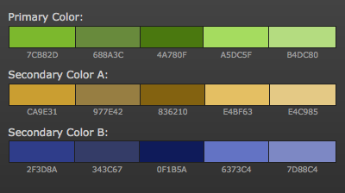

# Page Details

* Homepage: will have a primary header area that rotates with different company and service photos.
* Locate an inmate: will be a page with details how to locate an inmate including a link to the men’s central jail search.
* Locate Jail: Contact information of jails
* Fugitives: Photos and information of wanted people
* Contact Us: Contact information, contact form.

# SEO

* 3 Primary keywords (“bail bonds in los angeles”, “inmate search “, “la **bail bonds**”)
* Lower level keywords (“California bail bonds”,” what is bail bond”,” what are **bail bonds**”, “Hollywood bail bonds”,” bondsman”)

# Time

* This project will completed in 30 days

# Site size

* Width 1024px
* Height expandable