BACHELOR PAPER

Term paper submitted in partial fulfillment of the requirements for the degree of Bachelor of Science in Engineering at the University of Applied Sciences Technikum Wien - Degree Program Electronics and Business

**Working title**

Conducted from: Bernhard Erös

Personal identifier: 1810255057

1. evaluator: Alija Sabic, MSc.

Vienna, 2020-03-19

Declaration of Authenticity

“As author and creator of this work at hand, I confirm and acknowledge with my signature any relevant copyright regulations governed by creator and higher education acts (cf. copyright law and furthermore Statute on Studies Act Provisions / Examination Regulations of the UAS Technikum Wien within the framework of existing legislations).

I hereby declare, this thesis is my own personal work and any ideas of others or sources are used and cited accordingly. I am aware to face consequences declared by the head of the degree program, if I am not able to proof evidence, autonomy or independence or fraud to achieve a positive grade for this work (cf. Statute on Studies Act Provisions / Examination Regulations of the UAS Technikum Wien within the framework of existing legislations).

Furthermore, I declare this work has not been published to this date nor have I submitted it in this or any other form to an examination board. I assure this submitted version matches the version in the upload tool.”

|  |  |  |
| --- | --- | --- |
|  |  |  |
| Place, Date |  | Signature |

Abstract

Content Content Content Content Content Content Content Content Content Content Content Content Content Content Content Content Content Content Content Content Content Content Content Content Content Content Content Content Content Content Content Content Content Content Content Content Content Content Content

**Keywords:** smoke detector, Keyword2, Keyword3, Javascript, Tessel 2

Table of Contents

1 Introduction (3 pages) 6

1.1 Problem Definition (1/3 page) 7

1.2 Aim of this Work (1/3 page) 7

1.3 Personal Motivation (1/3 page) 7

1.4 Methodological Approach (1/3 page) 8

1.5 Structure of this Thesis (1/3 page) 8

2 Technical Fundamentals (10 pages) 9

2.1 Smoke detector types and principles (8 pages) 9

2.1.1 Factors affecting smoke detection 9

2.1.2 Ionization smoke detectors 10

2.1.3 Photoelectric smoke detectors 10

2.1.4 Heat detectors 11

2.1.5 Carbon Monoxide detectors 12

2.1.6 Multiple sensor detectors 12

2.1.7 Aspirating smoke detector systems 13

2.1.8 Linear detectors 15

2.1.9 Wireless smoke detectors 15

2.1.10 Smoke detectors for home use 16

3 Web Development (2 pages) 17

3.1 JavaScript 17

3.2 HTML5 17

3.3 CSS 17

3.4 HTTP 17

3.5 TCP/IP 17

3.6 Node.js 17

3.7 Node package manager 17

3.8 T2 Client 17

4 Specifications (1 page) 18

4.1 Functional Requirements 18

4.2 Nonfunctional Requirements 18

5 Design (2 pages) 19

5.1 Concept 19

5.2 Architecture 19

5.3 Hardware 19

5.3.1 Smoke detector 20

5.3.2 Tessel 2 20

6 Technical Implementation (9 pages) 21

6.1 Initial Setup for Tessel 2 21

6.2 Input and Output Detection 21

6.3 Smoke Alarm 21

6.4 Test Function 21

6.5 Html Configuration 21

6.6 CSS Configuration 21

6.7 Webserver Configuration 21

6.8 Processing on Tessel 2 22

6.9 Communication User Browser and Webserver 22

7 Results and Discussion (2 1/2 pages) 23

7.1 Market Situation 23

7.2 Costs 23

7.3 Security and Reliability 23

7.4 Future Advancements and Outlook 23

7.5 Conclusion (1/2 page) 23

8 Summary (1/2 page) 24

References 25

List of Figures 30

List of Tables 31

List of Abbreviations 32

# Introduction (3 pages)

With the introduction of smoke alarm detectors for commercial use in the early 1950’s [1] and for residential use around the 1970’s this market is still growing and interesting market to date [2]. First smoke detectors were used for the military facilities, warehouses or public buildings from the government in order to meet prevalent safety standards. They were not sold to the public until a significant price drop of smoke detectors due to technical developments were achieved. One of the most important developments was the introduction of solid-state electronics [3]. Namely diodes, transistors and integrated circuits, which replaced the previous technology with its cold cathode tubes or vacuum tubes. This allowed manufactures to reduce manufacturing and resource costs, to mass-produce these devices and sell them at reasonable prices to customers. From this moment on, the whole industry started to gain momentum and further developments in terms of detection of smoke, size of detectors, energy efficiency or to connect multiple detectors to fire alarm systems with steady connections to fire brigades. These allowed for a faster and reliable detection of fire and a prompt alerting of people in the building or structure these fire alarm systems were installed. For consumers smoke detectors which operated by batteries were introduced for easier installment and without the necessity of an expensive fire alarm system.

According to a survey of National Fire Protection Association (NFPA) almost every private household, at around 96 Percent, in the United States of America (USA)has smoke detectors installed in their homes [4] [5]. All these smoke detectors have one major disadvantage: the battery. These must be exchanged at certain intervals are renewal of the whole detector is advised according to manufacturer’s manuals to ensure proper functioning of the detector. In the European Union (EU) however, there is not such a dense distribution of smoke detectors in private households. This is due to higher and more uniform building codes across the EU and which focus heavily on fire prevention then fire detection. Every building according to its designated use must withstand a certain time against fire or fire safety facilities are implemented, whereas standards in the USA are lower or the they are not even adopted all [6]. This means a barely minimum fire safety requirements for new or existing buildings are met in the USA (most houses are built from wood because it is the cheapest resource in the USA). Fire safety regulations in Austria or Germany overachieve minimum fire safety standards of the EU. In Austria they are applied through several guidelines, e.g. “Österreichisches Institut für Bautechnik” (OIB) OIB Richtlinie 2 [7] and “Technische Richtlinie Vorbeugender Brandschutz” (TRVB) TRVB 122S [8]. In Germany there are similar guidelines, e.g. “Deutsches Institut für Normung“ (DIN) DIN 4102-1 and “European Norm” (EN)  
EN 13 501-1 [9].

Although there are many regulations to prevent fire, it is not totally impossible that fire occurs or ignites. If it does, annual statics [9] show around 400 people die from fire worldwide, but only one third dies in the consequence to fire, the other two thirds die in the case of smoke intoxication. 4000 people worldwide suffer long-term damage from burnings and around 1 Billion Euro of fire loss is accumulated worldwide in private households. These figures tell us most people die from smoke not from the actual fire itself. Many of these victims are surprised at night and do not recognize the smoke or fire while sleeping. To reduce the casualties of smoke intoxication almost every manufacturer of home smoke detectors has integrated or combined sensors for smoke / heat or carbon monoxide (CO), acoustic beepers or smart home implementations to receive notifications or ease maintenance [10]. For example, when there are several smoke detectors in every room of a house are installed, they create a mesh network. If there is an alarm, the detecting smoke detector transmits this signal to every other detector in the network and all acoustic beepers trigger at the same time to alert everyone in every room [11]. In Austria it is mandatory to install smoke detectors in habitable rooms or on exit paths in new or refurbished buildings since 2008 [7]. This does not imply that the latest and greatest smart home detectors installed in this new or refurbished buildings.

## Problem Definition (1/3 page)

Ideally, every private household should install smoke detectors in their homes, to protect themselves from fire and the even more dangerous smoke caused by fire. But most people think they are rather expensive, unreliable or are annoyed from changing batteries. This could lead to:

* losing their lifes from smoke intoxication
* damaging or losing their property in the case of fire without insurance covering it
* or treat safety or fire prevention slightly and do not care

Today’s home smoke detectors are well-engineered, reliable, more user friendly then people would think of.

## Aim of this Work (1/3 page)

The aim of this bachelor thesis is, to show how state of the art smoke detectors work and to point out the principles of different detections for smoke or fire. A comparison amongst these detectors builds a foundation to decide which type of detection is suited best for a prototype using the Tessel 2 microcontroller. A detection function for this prototype is implemented to detect smoke and fire reliably. Furthermore, a website displays relevant information and the current status of the associated sensor of the microcontroller.

## Personal Motivation (1/3 page)

The topic fire safety is a vital part of my life, since I work as a field engineer for fire alarm systems for one of Austria’s leading companies for around ten years. During my working hours I check, maintain, program or install all kinds of smoke detectors or various parts of our fire alarm systems for our diverse customers. Although there is a lot of routine work, because all parts work almost flawless, it is still a challenge for me to retain this high level of quality, our customers rely on. And this high reliability of our products made me curious how different detectors or parts of our fire alarm systems are constructed and work. Also, many lives were saved because of smoke detectors. In fact, fire deaths were reduced around 50 Percent since the 1970s [12]. Therefore, I would like to design an appropriate smoke detector prototype and a corresponding website. This shall help to engage myself even more with the topic fire safety and to gain in-depth knowledge of the technical fundamentals behind it.

## Methodological Approach (1/3 page)

At first, a theoretical research of current existing detecting methods, sensors and detectors for smoke and fire is conducted based on relevant literature and from hardware manufactures. In order to choose an appropriate approach for my smoke detector design it is necessary to understand and to highlight all different types of smoke detection. After this, the chosen microcontroller and proprietary modules are assembled and configured to accomplish suitable detection function. Then a website is programmed to showcase the function of the designed smoke detector, both functionally and visually appealing.

## Structure of this Thesis (1/3 page)

This thesis is structured in eight chapters. Chapter one focuses mainly on introductory and background information, my personal motivation and the aim of this bachelor thesis. It also gives an overview of the approach to achieve this aim.

In the second chapter technical fundamentals of different smoke detectors are described. Also, relevant information for home smoke detectors and regulations how they are used are mentioned. Chapter three briefly discusses a variety of web development related topics, since these are needed for the realization of a functioning prototype.

The fourth chapter determines the specifications which the design respectively the prototype must fulfill. In chapter five a concept for the realization is outlined and its architecture and used hardware is also described. The technical implementation and the necessary steps for a successful realization are shown in chapter six.

Chapter seven provides a verification of the design and shows if design specifications are met. It also covers supplementary information like market situation, costs, security and reliability and a future outlook.

The last chapter concludes with achievements, findings and which lessons were learned.

# Technical Fundamentals (10 pages)

This chapter covers and provides all relevant knowledge needed to understand underlying principles of smoke detection first. Then an overview which hardware was used to implement and realize a prototype design is presented. Furthermore, this chapter explains which software, protocols or standards where needed to apprehend interaction of each component for the prototype.

## Smoke detector types and principles (8 pages)

The following sections illustrate the variety of relevant state of the art smoke detector types and their principles of smoke detection. Based upon their description a suitable smoke detector is used for the prototype development.

### Factors affecting smoke detection

There are many different factors to be considered when smoke detectors are in use. But these four key factors [12] determine how well smoke is detected and these factors affect detection the most.

The first factor is smoke itself. Nor the amount of smoke emitted, or composition is not the same, depending which materials burns. Every material burns differently thus meaning the size of particles or smoke density change. Some materials produce larger particles when burned (e.g. plastics) or smoldering fires compared to flaming fires which emit smaller particles.

Another factor is smoke entrance resistance i.e. how easy or hard it is for smoke to permeate into a detection chamber. If this resistance is too high (e.g. geometry or structure of a detector, or filters are to narrow), this will affect the rate of smoke detection.

The rate of smoke buildup is factor three. Some materials burn faster than others based on their chemical structure itself [13]. Or for example smaller objects burn faster than larger objects (same material, same weight considered). Due to their increased surface area, more oxygen contributes to oxidation process leading to an increased combustion process [14].

The last factor to be considered is the low propagation velocity of smoke (unless there are no vents or air supply nearby or active). On one side this eases smoke permeating into a detector chamber. On another side this low velocity smoke could cool down and form larger particles i.e. there are less particles for detection and it takes smoke longer from the fire source to reach the detector.

With this comprehension in mind, smoke detectors have different sensitivities based on their varying detection mechanisms and scopes to detect smoke particles.

### Ionization smoke detectors

These type of smoke detectors were the first to be developed, although their principle was discovered accidently around the 1930s and they were granted license to distribute in the 1960s [16]. For detection a small amount of radioactive material, americium-241 (AM-241) is used. This material and two metal plates (one positively and negatively charged) are located inside the detection chamber shown below in Figure 1. The radioactive material is present in the form of a thin foil beneath both plates. When no smoke is present within the detection chamber, AM-241 ionizes air molecules to create a steady current flow between both plates. When smoke enters the chamber this interaction of ionization with the air is disrupted, because AM-241 interacts with smoke particles instead of air molecules thus resulting into a current drop.

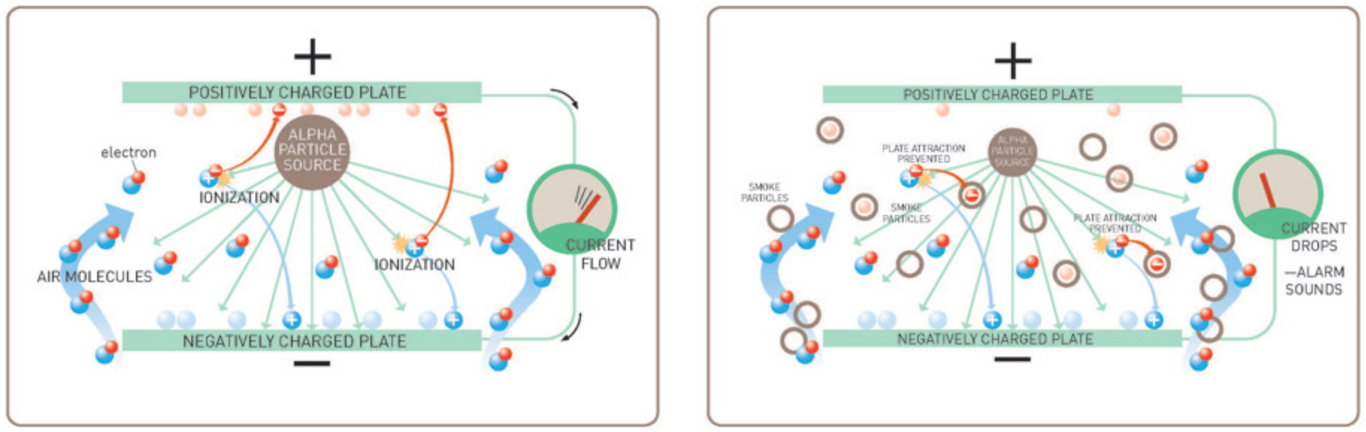

Figure 1: ionization principle [16]

Although radioactive material is used in these detectors, AM-241 is not dangerous (it only emits alpha radiation which represents a threat when this material gets in the body only) [16]. In Germany [17], Switzerland [18] or Austria [19] these type of detectors are used only for commercial or special use only. After approval they are allowed in areas, where photoelectric smoke detectors would not operate correctly or are explosion prone. Their distribution is restricted heavily in Europe compared to the USA or the United Kingdom (UK), when it comes to radiation protection laws and radioactive waste disposal.

### Photoelectric smoke detectors

These detectors work without a radioactive material inside their detection chamber. They work with a backscatter principle [20]. Inside an (obscured) detection chamber are an infrared (IR) emitter and IR receiver, positioned in an up to 90-degree angle, so both are not in line of sight depicted in Figure 2. When smoke particles are present in the chamber IR waves are backscattered from the particles onto the IR-Receiver. The voltage from the IR-receiver is constantly compared to a reference value. When enough IR waves are reflected onto the IR receiver its value changes due to increased incidence of IR waves. A comparator determines this difference and triggers an alarm signal.

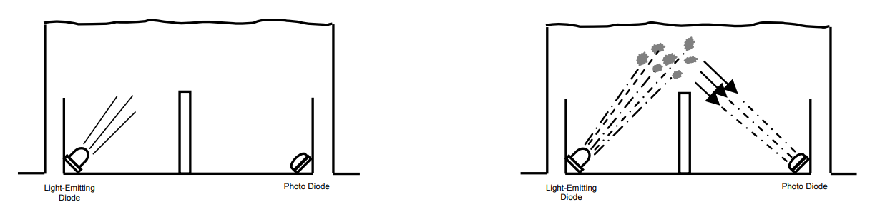

Figure 2: backscatter principe [21]

Photoelectric smoke detectors have an advantage being more sensitive to smoke from smoldering fires compared to ionization smoke detectors being more sensitive to smoke from flaming fires [20]. Typically, these detectors cover a protection area for around 113m2 which means a circular area with a diameter of 12 meters or radius of 6 meters. When other or smaller protection areas are covered these numbers are given in corresponding manufacturers datasheets. In Austria for example, required protection areas which must be covered securely by these detectors are prescribed in TRVB 123 [22]. Also, commercial distributed detectors can only operate properly until a certain height is reached, due to slow propagation velocity of smoke mentioned in Section 2.1.1. Fire tests for various manufacturers have shown, it is safe to mount these detectors up to 9 meters and alert correctly in the case of fire [22].

These type of smoke detectors are primarily used for commercial use in Europe, e.g. public buildings like schools, universities, occupancy accommodations, hospitals, office buildings etc. They are also available for residential use from different manufactures.

### Heat detectors

This type of detectors provide an alternative when ionization or photoelectric smoke detectors are improper to use, e.g. in kitchens, garages, etc. There are two principles to detect heat or temperature. The fixed temperature principle or the rate of rise principle shown in Figure 3. A fixed temperature heat detector uses an eutectic alloy as a heat sensitive element [23]. It changes its state from solid to liquid at a certain temperature, which triggers an alarm state. A rate of rise heat detector uses a thermistor specifically a negative temperature coefficient resistor (NTC). When temperature rises slowly this is ignored but if the value from NTC drops rapidly due to fire being present also an alarm state is triggered.

Heat is conducted slower in air than in solid objects or gases according to Fourier’s Law [24] and airs temperature gradient [25]. This must be considered whether a fixed temperature or rate of rise heat detector should be mounted in its designated installation site. These detectors cover a smaller protection area than photoelectric smoke detectors, their usual protection area is around 28m2 which means a circular area with a diameter of 6 meters or radius of 3 meters [22].

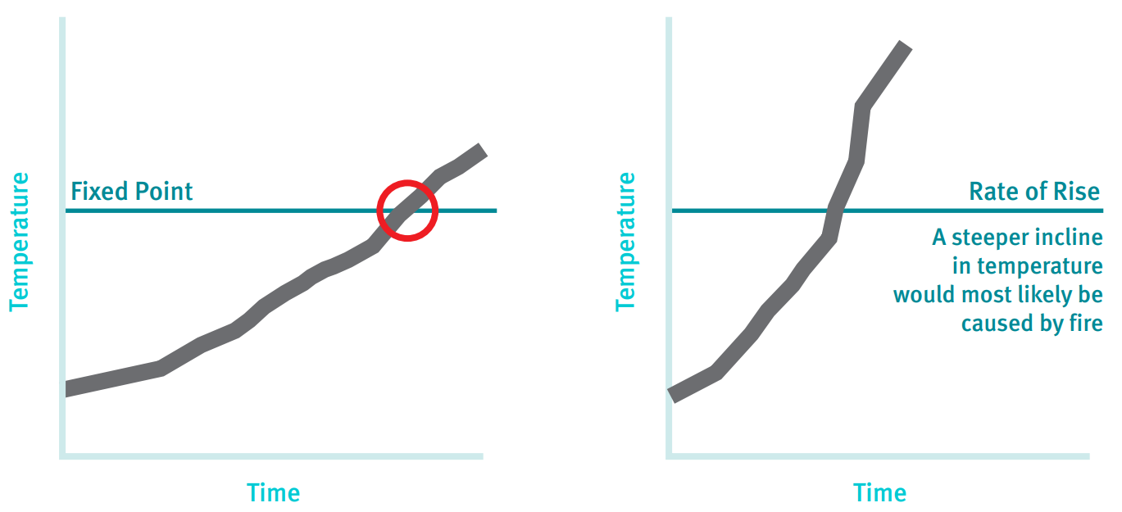

Figure 3: heat detector principles [20]

### Carbon Monoxide detectors

Carbon Monoxide (CO) is the most responsible gas [26] for all victims who die from fires worldwide as previously mentioned in Chapter 1. CO is emitted during combustion processes and is achromatic and odorless, which represents a threat for people. CO binds to hemoglobin in our blood and blocks oxygen transport which, ultimately leads to inner suffocation.

The most reliable method to detect CO is a biomimetic sensor [27]. These sensors mimic biological mechanisms that take place in our body. Such a biomimetic sensor in a CO detector reproduces the same effect CO has on hemoglobin. Inside of the sensor is a gel which changes color as it absorbs CO from surroundings. Another sensor detects this color change to trigger into an alarm state. The biomimetic sensor is designed to change its color at 400 ppm of CO.

Researches have shown that accumulated concentrations exceeding 400ppm in a few minutes are life threatening [26] [28]. If a detector detects such a high concentration or even slower ppm values at a slower rate of rise in the air, an alarm is triggered.

As of today, CO detectors should not replace conventional smoke detectors [21], mentioned in Sections 2.1.2 and 2.1.3. Although in the USA it is mandatory to install CO detectors in every home [29]. However, in Europe they are distributed for special purposes (mostly commercial use) or in combination with photoelectric detectors only [26]. Another thing to be considered is the sensors limited service life upto10 years [30].

### Multiple sensor detectors

These detectors combine detection methods previously mentioned in Sections 2.1.3 to 2.1.5 to enhance detection rate and to reduce false alarms, when different methods are combined. For commercial use it is common practice that, smoke detectors offer a combination of smoke and heat detection and their response characteristic is set via software tools when they are initially activated. This allows for more flexibility and an economic approach in manufacturing since only one detector needs to be produced and can be used individually.

In Austria however, it is mandatory to use only one response characteristic due to missing fire tests from manufactures that prove an enhanced detection rate when more than one response characteristic is evaluated [22]. Normally, these detectors are interconnected to fire alarm systems. Around 4000 detectors distributed on 16 loops could be linked up onto said system [31]. This is achieved due using an equivalent bus system Modbus [31] which resembles the European Installation Bus (EIB) / KNX standard. Also, different operating voltage levels e.g. from 7V to 31V [32] increase the number of detectors on one loop up to 256 elements. These fire alarm systems also work with various protocols like Building Automation and Control Networks (BACnet), Open Platform Communications (OPC) and provide a huge variety of actions when smoke or fire is detected [31] [33].

More recently companies also offer detectors for commercial use which can detect smoke, heat (both fixed and rate of rise temperature) and CO as well [34]. Although there are also companies who distribute multiple sensor detectors for private households which can detect smoke and CO [35] or smoke and heat [36] and offer integration into existing smart home networks. This gives customers more security and reliability but also higher costs per detector. These combined detectors are more or less state of the art, but single response characteristic detectors are more budget friendly and offer easier maintenance for consumers.

### Aspirating smoke detector systems

Aspirating smoke detector systems (ASD) work differently than regular smoke detectors although they use the same backscatter principle as described in Section 2.1.2. In fact, they comprise normally one or two highly sensitive photoelectric smoke detectors (Figure 4).

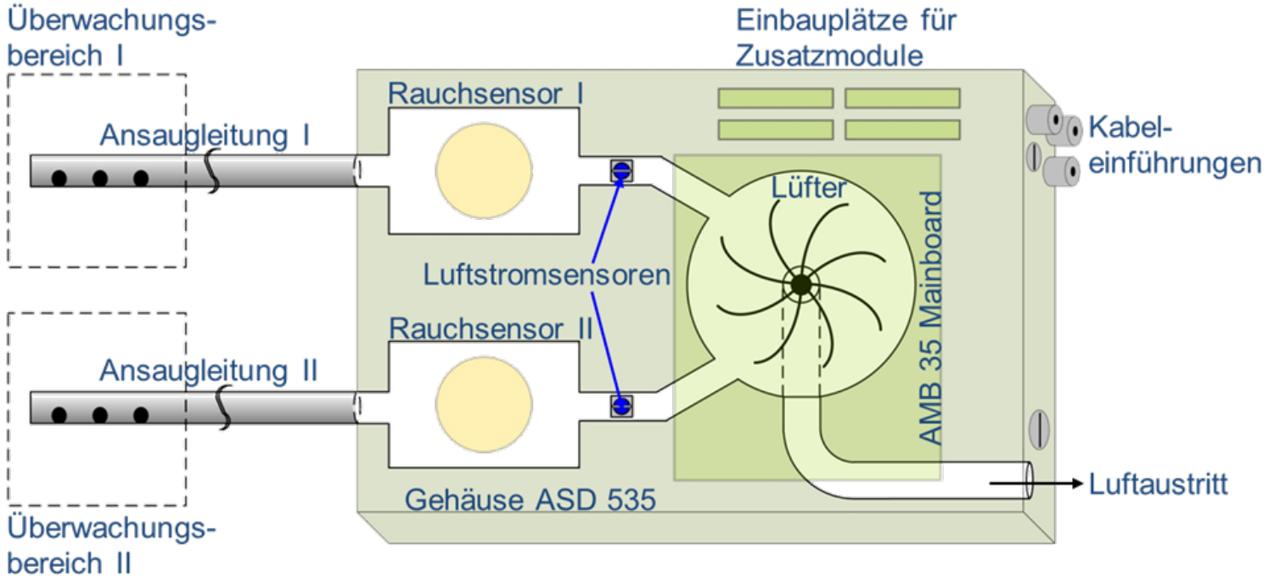

Figure 4: structure of aspirating smoke detector systems [37]

These systems aspirate air through one or two separate pipes (installed in the protection area) with aspiration holes at fixed distances. This is accomplished with a small ventilator inside the system. This stream of airflow is filtered first with filters which are mounted externally. This filtered airflow permeates the smoke detectors inside. If a predetermined alarm sensitivity is exceeded, an alarm signal is triggered from the system. These detectors are often equipped with autolearning functions to accommodate and adjust constantly to their surroundings.

ASDs are used where conventional smoke detectors cannot operate reliably. This occurs e.g. where these detectors could not work (too hot, too cold) or in areas where room height exceeds 9 meters like in high rise storage rooms, theatres, airports etc. They are also installed in clean and sterile rooms, server rooms and data centers. Basically, everywhere where sensitive and valuable electronic equipment needs protection and as early as possible detection in the event of fire. Also, one ASD could cover a much larger protection area than a single detector with up to 5760m2 [37]. Additionally, these systems can detect fire at much faster rates as depicted in Figure 5. They already sense particles when fire ignites, and pyrolysis just started.

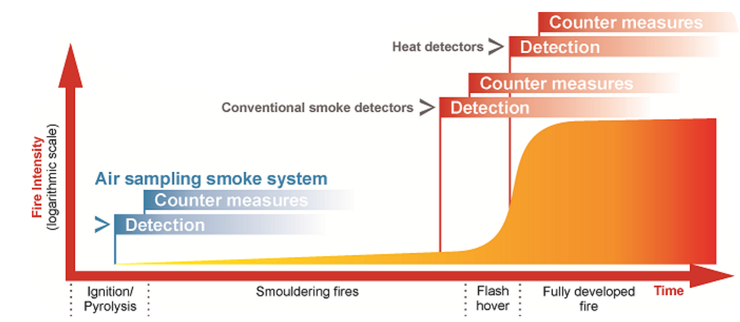

Figure 5: comparison of smoke detection rates [38]

For an even higher reliability and faster response rates Very Early Smoke Detection Apparatuses (VESDA) were developed around the 1970s in Australia. These operate with the nephelometer light scattering principle, which allows to detect even the smallest smoke concentrations [39]. Inside of this system is a tube with a light source, one inlet and outlet for air samples. For detection there are xenon or laser diodes with photo-diode receivers. These photo receivers measure the wavelengths of scattered light (red 700nm, green 550nm and blue (450nm) [40]. They are calibrated to detect a deviation of these wave lengths when aerosol or smoke particles are present.

To note almost every ASD is used for commercial purposes only and is not sold to personal households, due to their intended purpose, high costs and costly installation.

### Linear detectors

These detectors work with an obscuration principle [20]. An IR light beam is emitted from a transmitter and this light beam is received from a receiver on the other side of the protection are. When smoke particles or aerosols are in the air the receiver detects a reduction of signal strength and an alarm condition is met. There are two ways linear detectors are used. Either with a separate transmitter and receiver or with dual transmitter/receiver and a reflector as depicted in Figure 6.

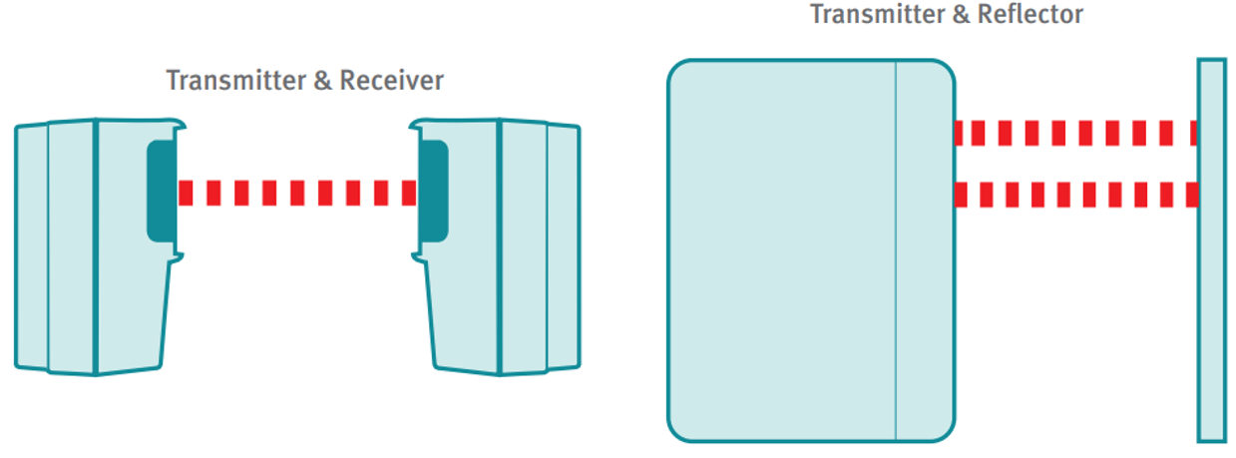

Figure 6: linear detectors [20]

Usually linear detectors are installed in exposed heights and unwanted obstructions e.g. flying birds, workers on hydraulic lifts need to be suppressed. Integrated algorithms can determine if fire or an unwanted obscuration took place. Furthermore, auto-realign functions ensure that transmitter and receiver are and stay in line of sight.

These detectors are used in large open areas, atriums, areas with monument protection (where smoke detector cannot be installed) or in areas where height exceeds 9 meters. They can be installed at a height up to 40 meters and their range can be up to 100 meters [20].

### Wireless smoke detectors

They utilize the same backscatter principle as photoelectric smoke detectors. Although each detector works independently of any wired connections and is battery powered. Usually they are connected in mesh networks to dedicated gateways (which are connected to a fire alarm system themselves). A certain range and as less obstruction as possible are criteria which need to be met. The network operates with two separate short-range device wave bands (SRD) with either 870 Mhz or 435 Mhz. In the case of an error, a channel switch on the main band is initiated first, then the wave band is changed automatically [41]. Inside these networks only a defined number of hops to transfer to a signal to the gateway are allowed to maintain standards defined in EN 54-1 [9].

This hop limitation reduces time to a minimum to transfer alarm states from an element to the gateway and allow as much as possible elements connected to one gateway. When nodes on one of the primary routes fail to transfer, there must at least exist one or more secondary routes to transfer the alarm condition as shown below in Figure 7.

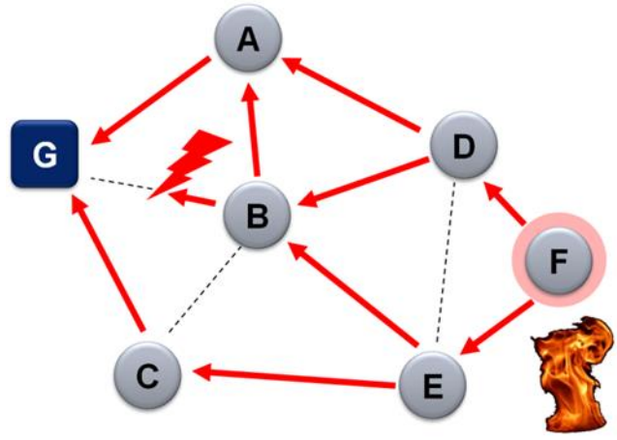

Figure 7: smoke detector mesh network [42]

Wireless smoke detectors are commercially used only in structures where building codes restrict wiring due to monument protection, e.g. historic buildings, museums.

### Smoke detectors for home use

For private usage smoke detectors are sold to customers wireless and battery powered exclusively. They are meant to work standalone or in combination with others to build up a mesh network (but not connected to a gateway mentioned in Section 2.1.9). They offer a wide variety in terms which detection principle is used. There are photoelectric but also more costly designs which offer multiple sensors for smoke and heat or smoke and CO previously described in Section 2.1.6. Depending on a customer’s budget they also provide an integration into their existing smart home network [35]. This allows notification to smartphone, simplified maintenance, current status of detectors is accessible or alarm forwarding among each element in a mesh network. The latter helps, when a detector is installed in every room and fire is detected in the basement for example, then every detector beeps to alert, shown below in Figure 8.

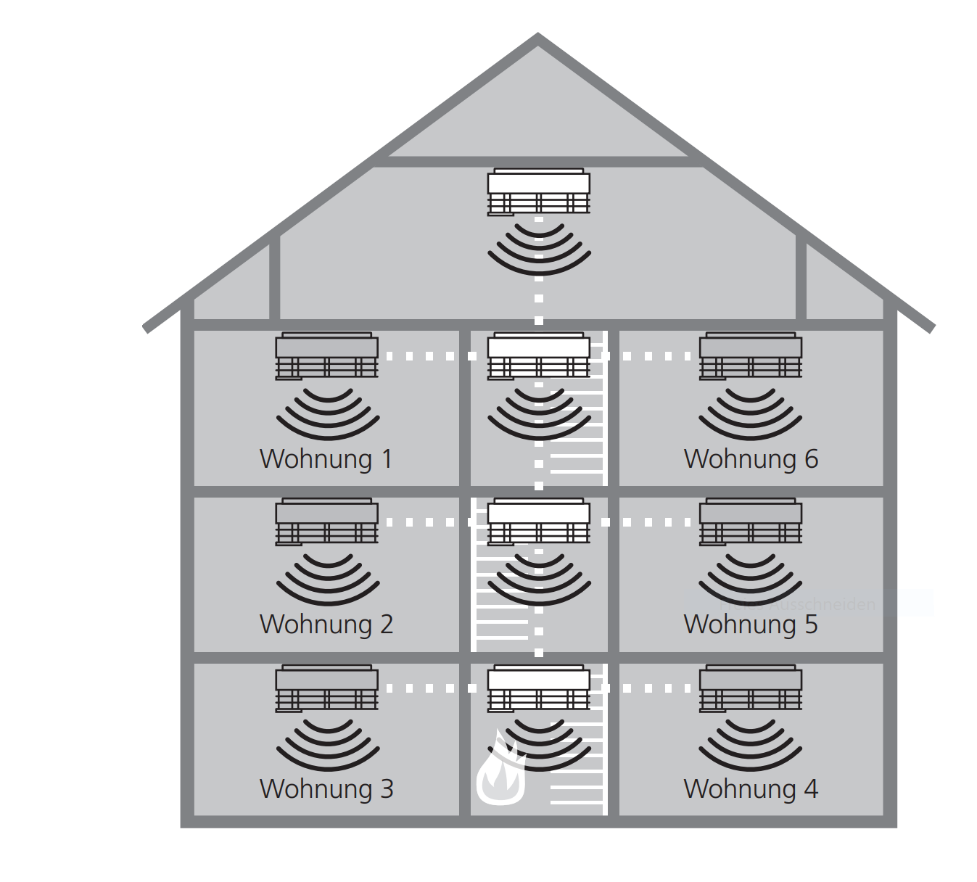

Figure 8: alarm forwarding of wireless smoke detectors [43]

# Web Development (2 pages)

## JavaScript

See reference from lecturer on webpage <https://eloquentjavascript.net/> namely chapter 11 asynchronous programming in JS

## HTML5

## CSS

## HTTP

See reference from lecturer on webpage hpbn.co chapter 11 http/1, chapter 12 http.2 and chapter 16 SSE Events

## TCP/IP

See reference from lecturer on webpage hpbn.co (building blocks of TCP) and lecture material from Zeitlhofer Thomas

## Node.js

See reference from lecturer on webpage <https://eloquentjavascript.net/> namely chapter 16 asynchronous programming in JS

## Node package manager

## Tessel 2 Client

# Specifications (1 page)

All given functions of a chosen smoke detector shall be implemented adequately into a design to a specific extent. These requirements are described in the subsequent sections. Functional requirements determine all necessary functions and the behavior the design is supposed to accomplish. All given resources or capabilities of each component should be used appropriately. Also, there are no additional functionalities designated for the realized system. Nonfunctional requirements describe the system quality and determine how well it is realized and implemented.

## Functional Requirements

* Transmission of a smoke detectors fire/smoke alarm signal to a user’s mobile web browser e.g. onto a smartphone or tablet with an interconnection over the Tessel 2 (T2) microcontroller
* Access to the smoke detector signals and functions shall be given via a webpage or appropriate framework
* Various states i.e. idle, alarm state shall be visible at any given time, when a present connection is established

## Nonfunctional Requirements

* The states for idle and alarm shall be visualized with colored backgrounds or tiles for easier readability
* When a status change occurs, the user shall not need to manually refresh the webpage or framework
* When no steady idle signal is coming from the smoke detector, regardless for whatever reason, a window or text box shall pop up, to notify the user a malfunction occurred

# Design (2 pages)

The following sections describe which components are used and how they work together to fulfill the defined functional and nonfunctional requirements, described in Chapter 4.

## Concept

The system is divided into three components. A hardware part, which is responsible for smoke detection and providing all relevant information and signals needed. The second part is a hardware/software component responsible for processing and transferring these information and signals. The third component is the user’s device displaying the interface. The structure of this system is depicted in Figure 9 to illustrate how these components, hardware and software and user device are linked.

## Architecture

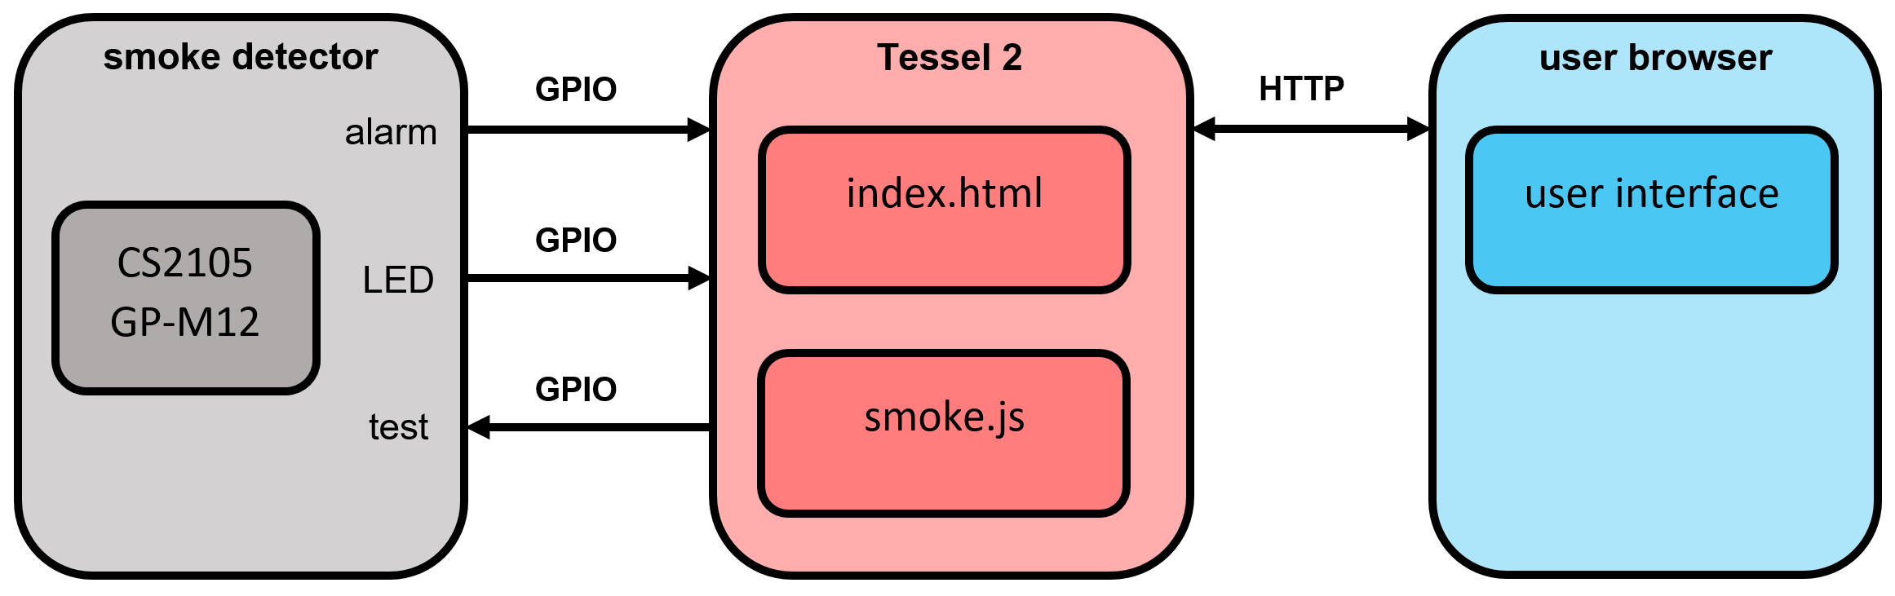

Figure 9: block diagram of design

The hardware part comprises a smoke detector. It is linked to the Tessel 2 via three separate connections. Two outputs, one when smoke is detected and a flash LED to indicate the smoke detector is in operation. There is also one input to use the smoke detectors built in test function. All outputs and inputs need further processing and are handled and evaluated from the T2. The T2 establishes a network connection, runs a JavaScript file to host a webserver and handle requests with an accompanied html webpage. A user can now access this webpage, to see current states (i.e. is there an alarm or to check if the smoke detector runs properly) or may use the test function.

## Hardware

The hardware, which was used, to design this prototype was a smoke detector from building center and the predetermined Tessel 2 microcontroller.

### Smoke detector

This smoke detector comes with an CS2105 GP-M12 Integrated Circuit (IC) on its printed circuit board (PCB) from manufacturer Semic, which is pin compatible to a better documented MC145012 IC [44]. This chip offers necessary outputs and inputs needed to realize a prototype. It provides an alarm input/output on pin 7, a test function on pin 16, acoustic feedback on pin 10, and a flash LED on 11 depicted in Figure 10 below. This detector runs on an integrated 9V-battery.

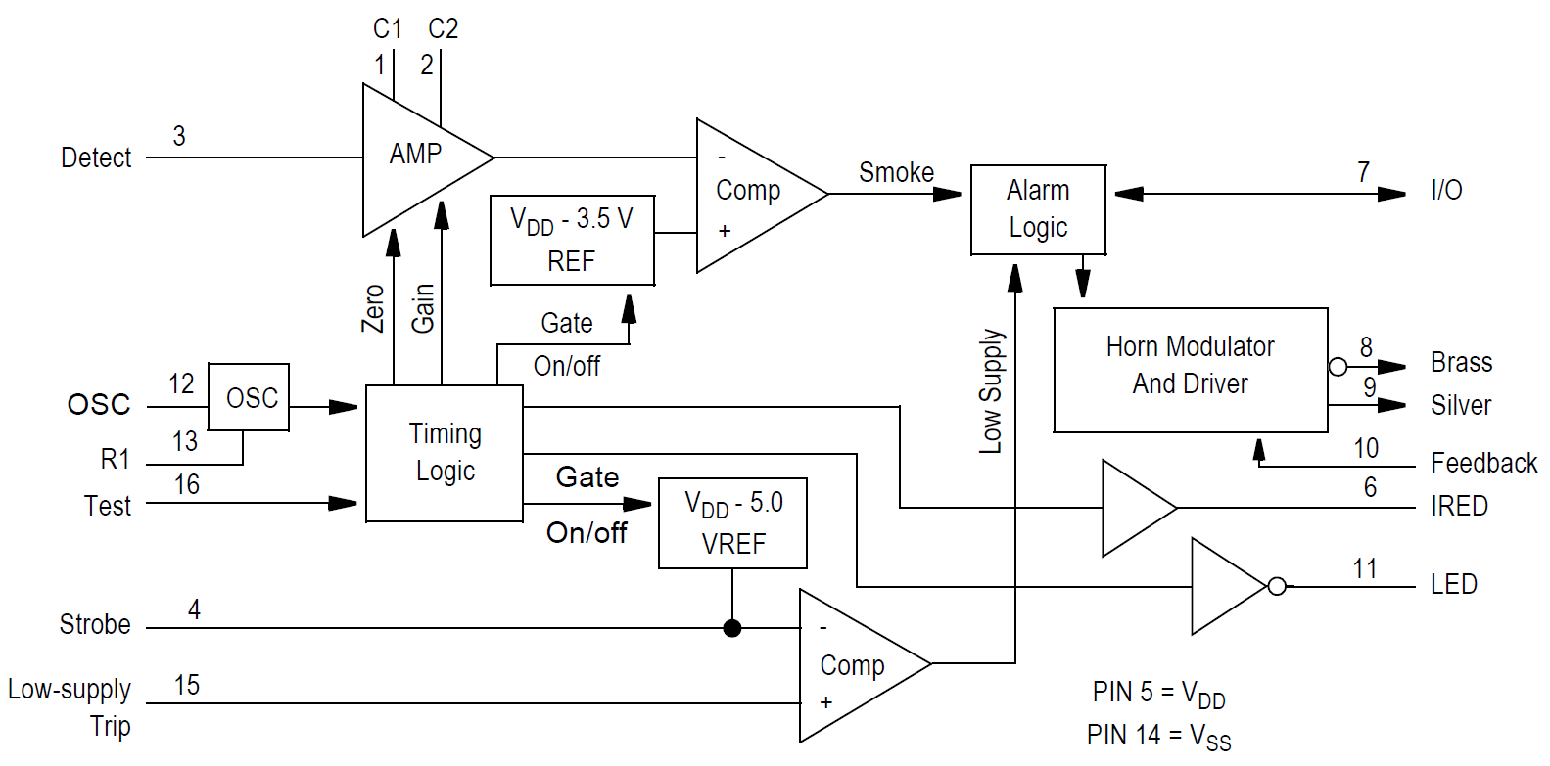

Figure 10: block diagram of CS2105 GP-M12 [44]

### Tessel 2

This board is based on a Wireless Fidelity (WiFi) router system on chip (SOC) Mediatek MT7620n running Linux via OPEN Wireless Router (OpenWRT) [45]. It also comes with an Atmel SAMD21 microcontroller [46]. Both build a processor/coprocessor architecture. The Mediatek runs user specific code, handles network connectivity via local and wireless area network (LAN)(WLAN) and universal serial bus (USB) and communicates with the microcontroller. This coprocessor handles low level Inputs and Outputs through two general purpose input and output (GPIO) banks which various modules could be attached for application specific inputs and outputs.

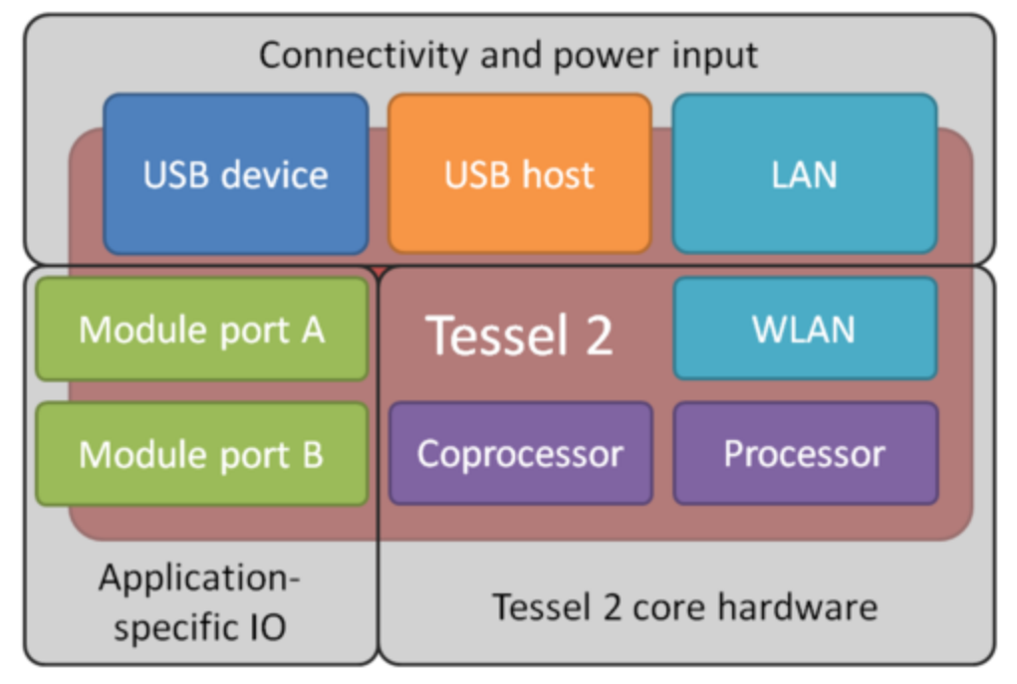

Figure 11: functional blocks of Tessel 2 [47]

# Technical Implementation (9 pages)

## Initial Setup for Tessel 2

Installation, setup, prerequisites, etc.

## Input and Output Detection

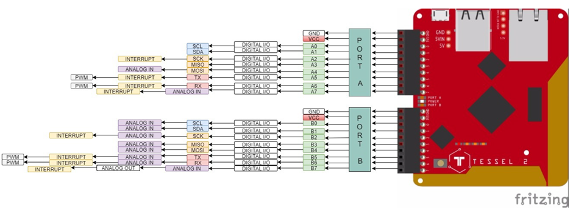

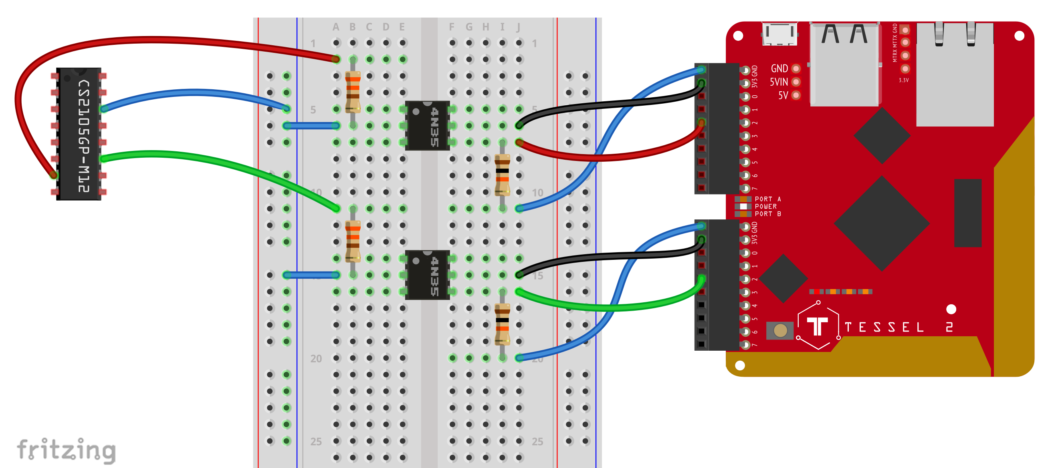

Pegel / GPIO Pins

## Smoke Alarm

respective .js file

## Test Function

respective .js file

## Html Configuration

static html file, embedded script within html file

## CSS Configuration

layout design, tessel 2 include file (needed for booting)

## Webserver Configuration

runs on tessel 2 , .js webserver file

## Processing on Tessel 2

.js webserver

## Communication User Browser and Webserver

get / response

# Results and Discussion (2 1/2 pages)

Verification of design and evaluation of design

## Market Situation

Current existing products with similar specifications and functions

## Costs

How expensive are similar products prescribed in 4.1

## Security and Reliability

How reliable are smoke detectors (specifically for end consumers). How secure is the integration into a smart home (are there threats or attack surfaces to do harm to a user’s smart home). How well does the implemented system meet certain requirements and national regulations?

## Future Advancements and Outlook

What could have been improved after finishing this work, which functions or feature could be implemented and improve performance or usability

## Conclusion (1/2 page)

What went well, what went bad, lessons learned

# Summary (1/2 page)

What was achieved

# References

|  |  |
| --- | --- |
| [1] | "How smoke detector is made," Advameg Inc., 2020. [Online]. Available: http://www.madehow.com/. [Accessed 02 02 2020]. |
| [2] | "Global Smoke Detector Industry," Global Industry Analysts, 2019. [Online]. Available: https://www.reportlinker.com/p05799669/Global-Smoke-Detector-Industry.html?utm_source=PRN. [Accessed 02 02 2020]. |
| [3] | D. Laws, "Who Invented The Transistor? -CHM," Computer History Museum, 04 12 2013. [Online]. Available: https://computerhistory.org/blog/who-invented-the-transistor/?key=who-invented-the-transistor. [Accessed 02 02 2020]. |
| [4] | M. Ahrens, "Smoke Alarm Executive Summary," 09 2015. [Online]. Available: https://www.nfpa.org/-/media/Files/News-and-Research/Fire-statistics-and-reports/Fact-sheets/SmokeAlarmsFactSheet.ashx?la=en. [Accessed 02 02 2020]. |
| [5] | C. Beyler and e. al., "Fire Science Reviews The Affordable Home Smoke Alarm," 2017. [Online]. Available: https://firesciencereviews-1springeropen-1com-10003428p0a2c.han.technikum-wien.at/articles/10.1186/s40038-016-0015-0. [Accessed 29 01 2020]. |
| [6] | International Code Council, "IFC - ICC," Internation Code Council Inc., 2018. [Online]. Available: https://www.iccsafe.org/products-and-services/i-codes/2018-i-codes/ifc/. [Accessed 02 02 2020]. |
| [7] | Österreichisches Institut für Bautechnik, "OIB Richtline 2 | OIB," 04 2019. [Online]. Available: https://www.oib.or.at/sites/default/files/richtlinie_2_12.04.19_0.pdf. [Accessed 02 02 2020]. |
| [8] | Österreichischer Bundesfeuerwehrverband , "TRVB-122-13-ohne-Anhang-3," 06 06 2013. [Online]. Available: https://www.bundesfeuerwehrverband.at/wp-content/uploads/2017/07/TRVB-122-13-ohne-Anhang-3.pdf. [Accessed 02 02 2020]. |
| [9] | A. Merschbacher, Brandschutzfibel, Planegg, Deutschland: Springer Vieweg, 2018. |
| [10] | E. Smith, "The Best Smoke Detectors Of 2020," reviews.org, 03 01 2020. [Online]. Available: https://www.reviews.org/safety/best-smoke-detectors/. [Accessed 29 01 2020]. |
| [11] | Hekatron Vertriebs GmbH, "produktinformation-genius-plus-und-genius-plus-x," Hekatron Vertriebs GmbH, 16 03 2018. [Online]. Available: https://www.hekatron-brandschutz.de/fileadmin/hekatron_elo/eloid/produktinformation-genius-plus-und-genius-plus-x_9708245.pdf. [Accessed 29 01 2020]. |
| [12] | M. J. Gollner, "Fire Technol (2016) 52," 13 06 2016. [Online]. Available: 1193. https://doi-1org-1000342kg0478.han.technikum-wien.at/10.1007/s10694-016-0606-2. [Accessed 29 01 2020]. |
| [13] | J. Fleming, "Smoke Detector Technlogy Research," The World Safety Foundation, 2010. [Online]. Available: https://de.scribd.com/document/14390291/Smoke-Detector-Technology-Research-Chief-Jay-Fleming. [Accessed 11 02 2020]. |
| [14] | Encyclopaedie Britannica In.c, "Combustion - Physical and chemical aspects of combustion," Encyclopaedie Britannica In.c, 2020. [Online]. Available: https://www.britannica.com/science/combustion/Physical-and-chemical-aspects-of-combustion. [Accessed 11 02 2020]. |
| [15] | J. W. e. al., Verbrennung - Physikalisch-Chemische Grundlagen, Modellierung, Berlin: Springer Berlin, 2001. |
| [16] | United States Nuclear Regularty Commission, "NRC Backgrounder of Smoke Detectors," United States Nuclear Regularty Commission, 22 05 2017. [Online]. Available: https://www.nrc.gov/reading-rm/doc-collections/fact-sheets/smoke-detectors.html. [Accessed 02 02 2020]. |
| [17] | Bundesamt für Strahlenschutz, "BfS - Ionisationsrauchmelder (IRM)," Bundesamt für Strahlenschutz, 07 06 2019. [Online]. Available: https://www.bfs.de/DE/themen/ion/anwendung-alltag/rauchmelder/rauchmelder_node.html. [Accessed 29 01 2020]. |
| [18] | K. Girschweiler, "Die Ionisationsrauchmelder müssen weg," Siemens Schweiz AG, [Online]. Available: https://www.siemens.ch/solutions/article/212. [Accessed 29 01 2020]. |
| [19] | Bundesministerium für Landwirtschaft, Regionen und Tourismus, "Bauartzulassungen," Bundesministerium für Landwirtschaft, Regionen und Tourismus, 07 01 2019. [Online]. Available: https://www.bmlrt.gv.at/umwelt/strahlen-atom/rechtsvorschriften/weitere-rechtliche-infos/bauart.html. [Accessed 29 01 2020]. |
| [20] | Hochiki Europe (UK) Ltd., "Understanding Different Fire Detection," [Online]. Available: https://www.hochikieurope.com/whitepapers/Applications.pdf. [Accessed 02 02 2020]. |
| [21] | Confederation of Fire Protection Associations Europe, "CFPA-E Guideline No 10:2008 F," Confederation of Fire Protection Associations Europe, 12 09 2008. [Online]. Available: http://cfpa-e.eu/wp-content/uploads/files/guidelines/CFPA_E_Guideline_No_10_2008.pdf. [Accessed 02 02 2020]. |
| [22] | Österreichischer Bundesfeuerwehrverband, "TRVB 123 / 11 (S) Brandmeldeanlagen," [Online]. Available: https://www.bundesfeuerwehrverband.at/produkt/trvb-123-11-s-brandmeldeanlagen/. [Accessed 17 02 2020]. |
| [23] | Firewize Holdings Pty Ltd., "Heat Detectors," Firewize Holdings Pty Ltd., [Online]. Available: http://firewize.com/learn/principle/heat-detectors. [Accessed 15 02 2020]. |
| [24] | T. W. Davies, "FOURIER'S LAW," Thermopedia TM, 14 02 2011. [Online]. Available: 10.1615/AtoZ.f.fourier_s_law. [Accessed 15 02 2020]. |
| [25] | O. Khayal, "Thermal conductivity values for various materials at 300K," 07 2017. [Online]. Available: https://www.researchgate.net/figure/1-Thermal-conductivity-values-for-various-materials-at-300-K_tbl1_318456109. [Accessed 15 02 2020]. |
| [26] | Hekatron Vertriebs GmbH, "Produktinformation CO-Brandmelder," [Online]. Available: https://www.hekatron-brandschutz.de/fileadmin/hekatron_elo/eloid/produktinformation-co-melder_12308530.pdf. [Accessed 29 01 2020]. |
| [27] | K. Toko, "Biomimetic Sensor Technology," *Measurement Science and Technology, Volume 12, Number 2,* 02 2001. |
| [28] | detectcarbonmonoxide.com, "CO Health Risks," detectcarbonmonoxide.com, [Online]. Available: https://www.detectcarbonmonoxide.com/co-health-risks/. [Accessed 16 02 2020]. |
| [29] | United States Environmental Protection Agency, United States Environmental Protection Agency, [Online]. Available: https://www.epa.gov/indoor-air-quality-iaq/what-about-carbon-monoxide-detectors. [Accessed 16 02 2020]. |
| [30] | Hekatron Vertriebs GmbH, "Katalog 2020 CO- und Rauchwarnmelder," Brühlmatten 9, 79295 Sulzburg, 2020. |
| [31] | Schrack Seconet AG, "Schrack Seconet Brandmeldesysteme," [Online]. Available: https://www.metrixsecurity.com/images/Products/fire%20detection/firealarm.pdf. [Accessed 17 02 2020]. |
| [32] | Hekatron Vertriebs GmbH, "Datenblatt Mehrfachsensormelder MTD 533X," 15 02 2013. [Online]. Available: https://www.brand-feuer.de/images/2/2f/Db_mtd_533x.pdf. [Accessed 17 02 2020]. |
| [33] | Hekatron Vertriebs GmbH, "Integral IP," Hekatron Vertriebs GmbH, [Online]. Available: https://www.hekatron-brandschutz.de/fileadmin/hekatron_elo/eloid/systemuebersicht-integral-ip_6118593.pdf. [Accessed 02 02 2020]. |
| [34] | Hekatron Vertriebs GmbH, "Prospekt Brandmelder," [Online]. Available: https://www.hekatron-brandschutz.de/fileadmin/hekatron_elo/eloid/prospekt-brandmelder_8549781.pdf. [Accessed 02 02 2020]. |
| [35] | Google LLC, "Nest Protect - Intelligenter Rauchmelder," [Online]. Available: https://store.google.com/product/nest_protect_2nd_gen_specs. [Accessed 17 02 2020]. |
| [36] | Abus August Bremicker Söhne KG, "Abus Rauchwarnmelder RWM450," [Online]. Available: https://www.abus.com/ger/Sicherheit-Zuhause/Brandschutz/Funk-Rauchmelder/RWM450-Funk. [Accessed 17 02 2020]. |
| [37] | Securiton AG, "SecuriRAS ASD aspirating smoke detectors," 05 2019. [Online]. Available: https://www.securiton.com/en/products/fire-detection/smoke-detection-systems/securiras-asd.html. [Accessed 17 02 2020]. |
| [38] | D. Allen, "Fire Protection Association Australia," 2017. [Online]. Available: http://www.fpaa.com.au/media/229743/d3-fp1-p8-allen.ppt.pdf. [Accessed 17 02 2020]. |
| [39] | P. B. C. C. P. e. a. Johnson, "Very Early Smoke Detection Apparatus (VESDA)," *Fire Science Reviews 6,* 2017. |
| [40] | Earth System Research Laboratory, "Aerosol Instrumentation - Nephelometer," U.S. Department of Commerce , [Online]. Available: https://www.esrl.noaa.gov/gmd/aero/instrumentation/neph_desc.html. [Accessed 19 02 2020]. |
| [41] | Siemens Building Technologies, "SWING Funk-Brandmeldesystem," 02 11 2018. [Online]. Available: https://www.downloads.siemens.com/download-center/Download.aspx?pos=download&fct=getasset&id1=A6V10381325. [Accessed 21 02 2020]. |
| [42] | Siemens AG, "SWING – Funk-Brandmelder," 13 07 2017. [Online]. Available: https://new.siemens.com/global/. [Accessed 26 02 2020]. |
| [43] | Hekatron Vertriebs GmbH, "Bedienungsanleitung Funkmodul Basis X Pro X," 18 11 2018. [Online]. Available: https://www.hekatron-brandschutz.de/. [Accessed 21 02 2020]. |
| [44] | NXP Freescale Semiconductor, "Photoelectric Smoke Detector IC," 11 2006. [Online]. Available: https://www.nxp.com/docs/en/data-sheet/MC145012.pdf. [Accessed 12 02 2020]. |
| [45] | Ralink, "OpenWRT Project MediaTek / Ralink," 16 10 2019. [Online]. Available: https://openwrt.org/docs/techref/hardware/soc/soc.mediatek. [Accessed 11 03 2020]. |
| [46] | Atmel, "Atmel-42181-SAM-D21 Datasheet," 2015. [Online]. Available: https://cdn.sparkfun.com/datasheets/Dev/Arduino/Boards/Atmel-42181-SAM-D21_Datasheet.pdf. [Accessed 11 03 2020]. |
| [47] | Tessel, "Tessel 2 Hardware Overview," Tessel, 2018. [Online]. Available: https://tessel.io/blog/113259439202/tessel-2-hardware-overview. [Accessed 11 03 2020]. |

# List of Figures

Figure 1: ionization principle [16] 10

Figure 2: backscatter principe [21] 11

Figure 3: heat detector principles [20] 12

Figure 4: structure of aspirating smoke detector systems [37] 13

Figure 5: comparison of smoke detection rates [38] 14

Figure 6: linear detectors [20] 15

Figure 7: smoke detector mesh network [42] 16

Figure 8: alarm forwarding of wireless smoke detectors [43] 16

Figure 9: block diagram of design 19

Figure 10: block diagram of CS2105 GP-M12 [44] 20

Figure 11: functional blocks of Tessel 2 [47] 20

# List of Tables

**Es konnten keine Einträge für ein Abbildungsverzeichnis gefunden werden.**

# List of Abbreviations

|  |  |
| --- | --- |
| AM-241 | Americium 241 |
| ASD | Aspirating Smoke Detector Systems |
| BACnet | Building Automation and Control Networks |
| CO | Carbon monoxide |
| DIN | Deutsches Institut für Normung |
| EIB | European Installation Bus |
| EN | European Norm |
| EU | European Union |
| GPIO | General Purpose Input Output |
| IC | Integrated Circuit |
| IR | Infrared |
| LAN | Local Area Network |
| NFPA | National Fire Protection Association |
| NTC | Negative Temperature Coefficient |
| OIB | Österreichisches Institut für Bautechnik |
| OPC | Open Platform Communications |
| OpenWRT | Open Wireless Router |
| PCB | Printed Circuit Board |
| SOC | System on Chip |
| SRD | Short Range Device |
| T2 | Tessel 2 |
| TRVB | Technische Richtline Vorbeugender Brandschutz |
| UK | United Kingdom |
| USA | United States of America |
| USB | Universal Serial Bus |
| VESDA | Very Early Smoke Detection Apparatuses |
| WiFi | Wireless Fidelity |
| WLAN | Wireless Area Network |
| XXX | XXX |
| XXX | XXX |
| XXX | XXX |
| XXX | XXX |
| XXX | XXX |
| XXX | XXX |
| XXX | XXX |
| XXX | XXX |
| XXX | XXX |
| XXX | XXX |
| XXX | XXX |
| XXX | XXX |
| XXX | XXX |
| XXX | XXX |
| XXX | XXX |
| XXX | XXX |
| XXX | XXX |
| XXX | XXX |
| XXX | XXX |
| XXX | XXX |
| XXX | XXX |
| XXX | XXX |
| XXX | XXX |

# 