Kids home characteristics/activity summary

Ethan Walker

Started 15 Jan 2020, Updated 15 Jan 2020

# Summary data for home characteristics

|  |  |  |  |  |  |  |  |
| --- | --- | --- | --- | --- | --- | --- | --- |
| area | winter_id | N | Mean Sqft | SD Sqft | Min Sqft | Median Sqft | Max Sqft |
| AK | 1 | 37 | 990.2 | 487.1 | 160 | 960.0 | 2500 |
| AK | 2 | 20 | 896.9 | 573.4 | 90 | 838.0 | 2760 |
| NN | 1 | 80 | 1137.2 | 1119.3 | 12 | 1065.0 | 8000 |
| NN | 2 | 47 | 1063.1 | 541.0 | 24 | 1024.0 | 2600 |
| WMT | 1 | 169 | 1910.4 | 885.7 | 540 | 1800.0 | 7500 |
| WMT | 2 | 128 | 2008.9 | 933.8 | 700 | 1943.5 | 7500 |

## , , = Duplex/Apt  
##   
##   
## AK NN WMT  
## 1 1 2 5  
## 2 1 2 2  
##   
## , , = House  
##   
##   
## AK NN WMT  
## 1 37 50 151  
## 2 28 27 112  
##   
## , , = Mobile Home  
##   
##   
## AK NN WMT  
## 1 0 29 20  
## 2 0 17 15  
##   
## , , = Other  
##   
##   
## AK NN WMT  
## 1 0 4 0  
## 2 0 1 0  
##   
## , , = NA  
##   
##   
## AK NN WMT  
## 1 0 1 0  
## 2 0 0 0

# Summary data for home activity

# Home characteristics summary plots

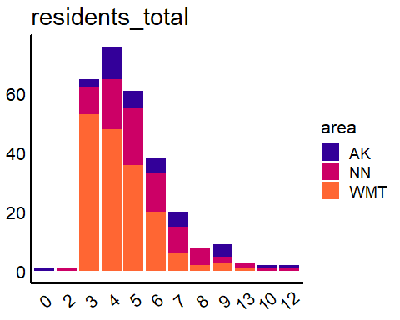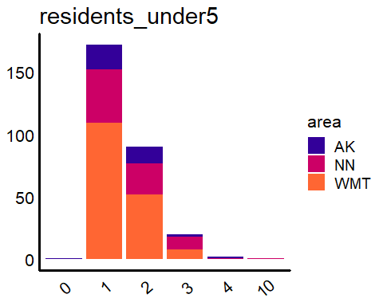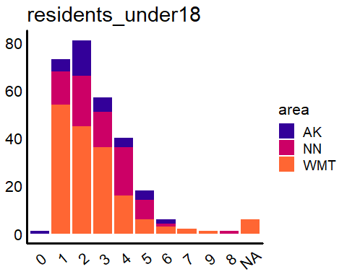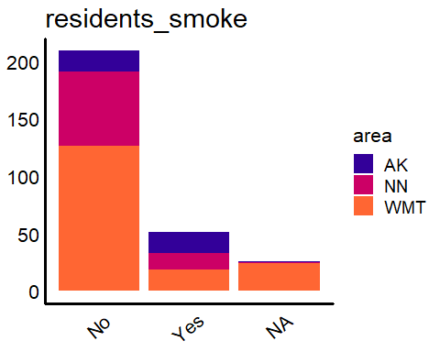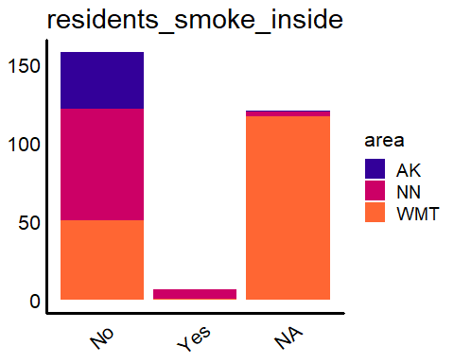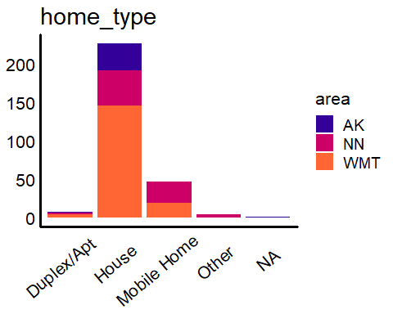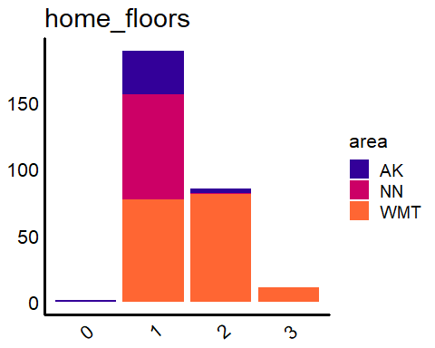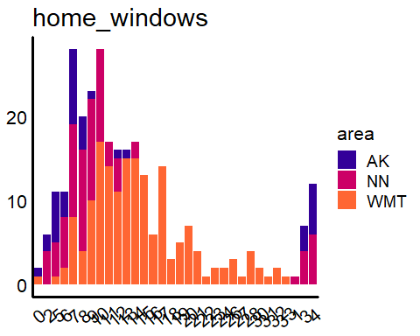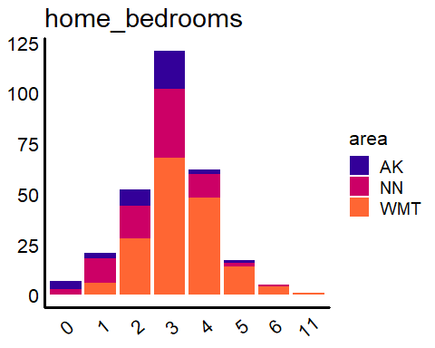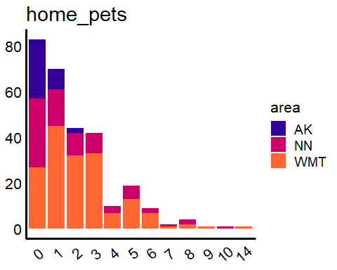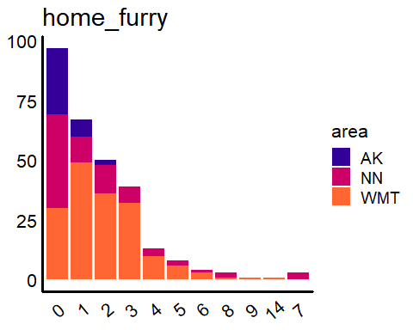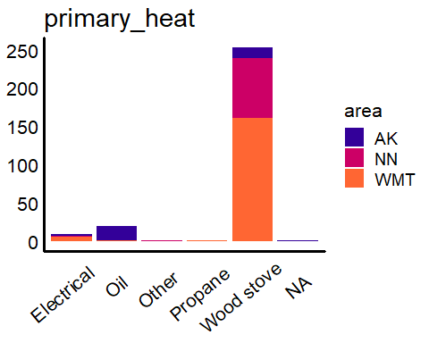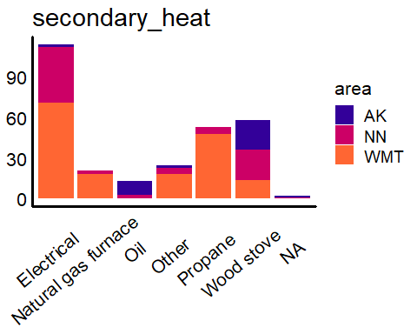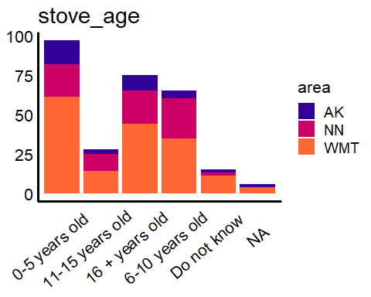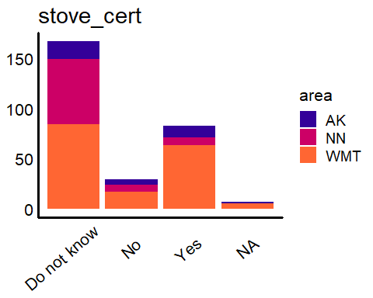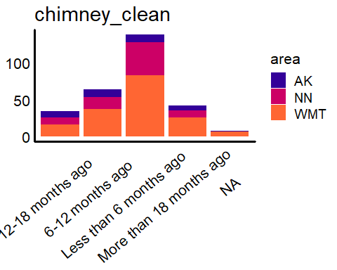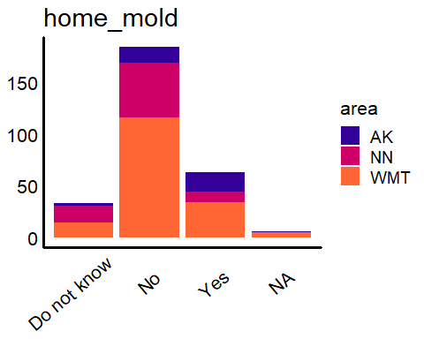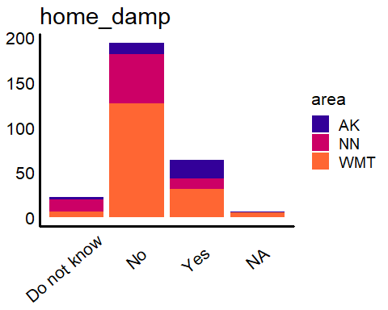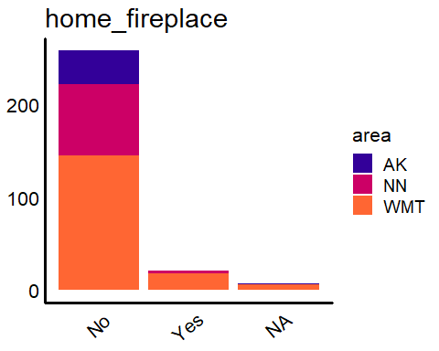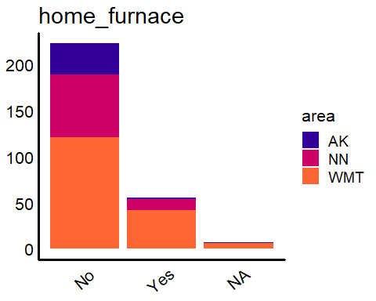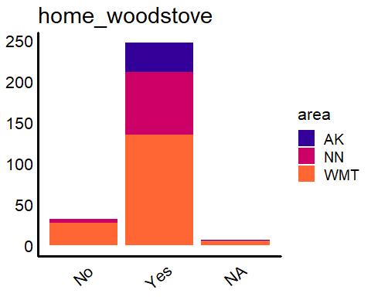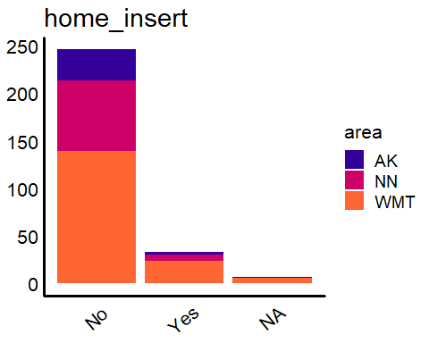

# Home activity summary plots

