PBHL621 data cleaning and visualization project

Ethan Walker

Feb 11th and 13th, 2020

# Try out what we’ve learned

Try to duplicate some summary statistics and plots using the code we have gone through together. Most of it we have gone through; a few things you might need to troubleshoot on your own.

## Load full dataset

## Clean the variables of interest

## Summarize the data to fill in the table

|  |  |  |  |
| --- | --- | --- | --- |
|  | Total (n=95) | Male (n=53) | Female (n=42) |
| Age  mean, sd, min, max |  |  |  |
| Age category – n (%)  0-5 years  6-10 years  11+ years  NA |  |  |  |
| Mother’s age  mean, sd, min, max |  |  |  |
| Language – n (%)  English  Spanish  French  NA |  |  |  |

## Make a plot to summarize the data:

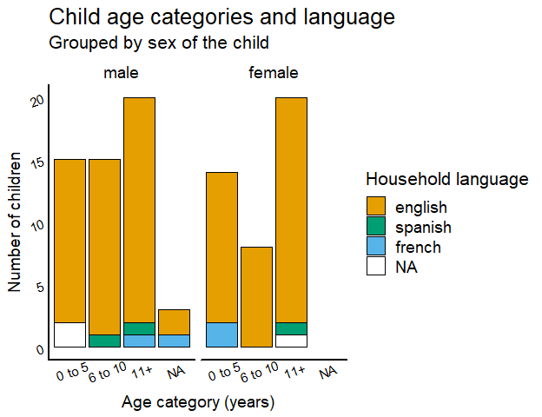

## Try another if you have time:

