* We have scanned the same soil, before rain (**br**), after rain (**ar**) and after a drying phase (**ad**).
* We have also separated pores into 2 main categories:

_cross : are pores that permit the drainages as they connect the soil surface to the below ground of the soil

_unc : are pores not connected to surface , they do not play major role in water transport but have importance for soil structure

* Here are some key parameters measured from CT images
  + **X.x Label.x ID.x:** identification of the pore/image
  + **Vol...mm³..x :** volume of each pore
  + **x.Cent..mm..x y.Cent..mm..x z.Cent..mm..x :** coordinated of the pore within the CT image
  + **Thickness..mm. SD.Thickness..mm. Max.Thickness..mm.** : thickness and diameter of each individual pore
  + **SA..mm².** : surface area of each individual pore

--------------------------------------------------

We have discriminated the pore into two different category linked to their potential role in fluid and gas transport.

* Un-Connected pores (_unc): pore isolated in the soil , not connect to the surface
* Crossing pores (_cross): pore crossing the upper layer of the soil from soil surface (atmosphere) to the below ground part undisturbed by the rainfall event.

For those different pores, we measured:

-The pore volume (mm³); pore Surface (mm²); thickness Mean (mm);

-The pores, included in each category, are also individually described.

The pore volume (mm³); porosity (mm³/mm; pore Surface (mm²); thickness Mean (mm); for the bulk soil within those volumes

**Soil upper layer**

**Below ground part of soil**

**Un-Connected pores (_unc)**

**Crossing pores (_cross)**

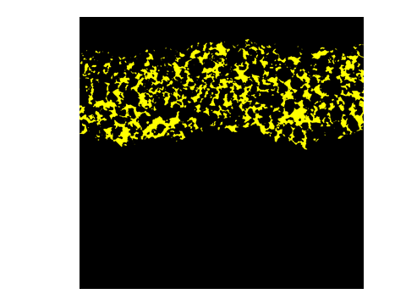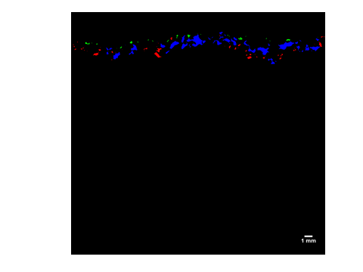

**Soil pore classified in different categories**: in yellow we represented the all pore from 0 to 400 voxels depth (=1cm), blue are for the connected pore (_cross) and the red pore are the unconnected pore (_unc).



**Soil pore classified in different categories plus the pores at the first centimetre (yellow) are shown overlapping with the original CT image in greyscale.**