Topic 6. Invisible analogies Reading 1, pp. 135-185
- Analogy-making: core of thinking
- Mental categories → result of series of analogies
- Categories’ halo: tool to understand new things, get new categories
(by extension/abstraction)
Analogies underlie comparison.
Physics: molecules – balls banging against each other
Biology: two strands of DNA – zipper
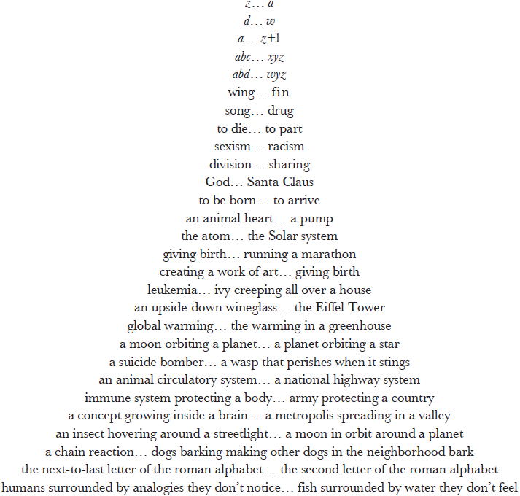
- Invisible analogies: analogies with no pre-existing verbal labels, non-lexicalized categories, lexical gaps. Expressible in words, the universal fabric of cognition
Mental lexicon → storehouse of labels
Semantic memory → storehouse of concepts
Label ≠ category
- Ad-hoc concepts/categories: Lawrence Barsalou
e.g. possible Christmas presents for one’s twelve-year-old
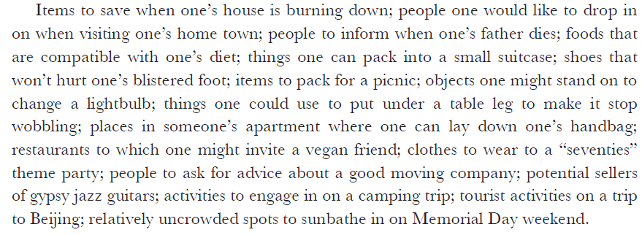 The existence of such categories is proof that categorization through analogy making is the core of thought.
- Stabilized ad-hoc concepts:
e.g. activities typical of camping trips, objects that could be useful for a picnic, objects that can comfortably be carried around in a small suitcase are categories that have a tendency to become very stable in the minds of those people who are fans of camping, of picnics, or of travelling.
- Deictic expressions
‘She was sitting right there!’
False on a literal level, true on an analogical level, minimum effort, maximum of simple analogies
- Gesture + ’there!’: analogies spotted within the current frame of reference – spontaneous creation of a new category (general/specific) (e.g. He was sitting right there!)
- Nodding + ’exactly’
‘me too’
I can recall a number of events sharing the exact conceptual skeleton of your story, so I can understand perfectly what you went through.
Mental fluidity in the passage from the first person’s frame of reference to the second person
- ‘that’ (p. 148)
a sudden and unusual change of status requires one to modify the way one writes a certain item, but for some time thereafter, the old habit keeps on taking over and as a result, one frequently writes the item in the outmoded way (p. 149)
By-product: generalizing a situation, a new abstract category ready to absorb new situations.
- ‘Unbelievable! I would have never been able to do that!’
(midway: very abstract – any heroic human act, very specific – the hospital situation)
Interpretation: striping off surface particulars, arriving at a true essence – skeleton core of the story. Relocating the core to own concrete experiences “Exactly the same thing happened to me”. Converting what people communicate into first-person experiences (own memories) – making analogies to link us with other people, to cope with new situations, to fulfil a psychological need. “Indeed, everyone, at every moment, is betting their very life on the validity of an enormous number of trivial, unconscious analogies whose existence they never suspect at all. Every act of thinking, no matter how small, relies on such analogies, and the tighter the analogy, the more unavoidable the conclusions it leads to would seem to be.” (p. 153).
- Memory triggering
- Someone dies
- Grand Canyon and the Temple in Karnak
How can distant, shadowy memory be rapidly and easily brought back to light?
Each person decides what a situation includes and doesn’t include. The decisions are on the fly and beyond consciousness. We continuously encode situations in memory along dimensions determining which future events will be able to remind us of these situations (both abstract and concrete dimensions → salient details and salient abstract characteristics).
- An event has more than one abstract structure depending on the frame of mind one is in when it is encountered.
Danny and the Grand Canyon: trivial side more fascinating than the main event (p. 162/163)
- Similarity is subjective
- Similarity is multidimensional
- Each person sees things in their own fashion. What is central and crucial for one being can be peripheral and trivial for others.
- Casting pearls before swine
- Idiosyncratic categories
- personal cognitive style
- Repertoire of lexicalized concepts (shared in a culture)
- Repertoire of own concepts (acquired/constructed over one’s lifetime’s viewing the world in one’s own way)
- Unlabeled, personal categories built on private experience (expressible in words)
Example: Patrick’s comic book hero experience
Nadine’s going out experience
Ilona’s ‘God is a sniper’ experience
- The role of emotions in evoking dormant experience: disillusionment
- subscripts ≠ exponents
- button 2 ≠ button 1
- Encoding of events
- perception through sensory organs
- perception through our concepts
Concepts would be different if senses were different; perception depends on our concepts (fillers for stimuli reaching our consciousness)
No perception without concepts
Encoding is conceptual (purely image-based processes would be insufficient)
Events are encoded (perceived, distilled, stored) in terms of prior concepts that we have acquired.
- Remindings
- Remindings condition our survival
- Remindings – encoding at such a high level of abstraction that the new and recalled events turn out to be identical (timeless essences)?
‘Instant pinpointing of timeless essences’ theory.
Theory rejected: unfamiliar categories do not allow to see deeply into situation involving them.
- Spotting the essence of something that one is already an expert in ≠ spotting the essence of something novel.
Abstraction ≠ deep abstraction
- The strictest form of literality doesn’t allow any resemblances to be noticed, thus excluding all thinking
- Spotting similarities in reminding depends on a number of separate, abstract, important aspects of the ‘old’ event perceived at the time it happened.
- For a current event to trigger the recall of a far-off-event that one hasn’t thought of for many years requires strong resemblances.
For this, some dimensions of the way we perceive the new and the old intention have to have sufficient flexibility beyond literal details. In reminding the two events don’t have to share exactly the same conceptual skeleton.

- Emergence of new categories
- “fauxthenticity” – foods and other objects
- Dog concepts (p. 179)
- Analogies connect mental representations
(only derivatively entities in the external world)
Mental bridge-building operation =
An act of categorization =
The making of an analogy =
The recognition of a correspondence between a newly-minted mental structure and an older one (the same mechanism for ‘cup’, ‘sour grapes’, ‘fauxthenticity’).

Follow-up exercise IV
Give your own example of invisible analogy

