# Environment & Occupancy Sensing

Please note that within this room, sensors have been deployed to enable monitoring of both the environment (temperature and light levels) and level of occupancy (door and chair cushion based sensors). The type of sensors deployed are shown below:

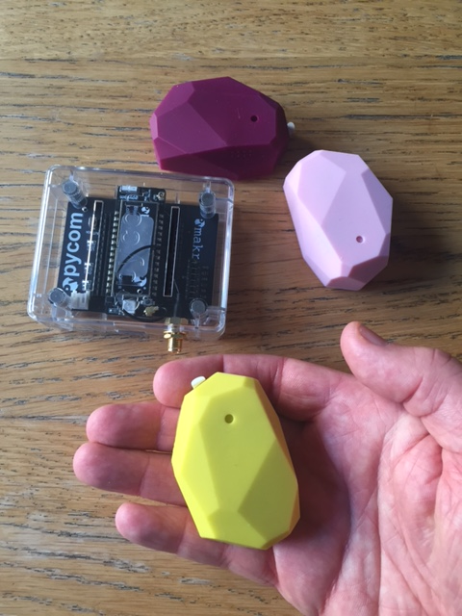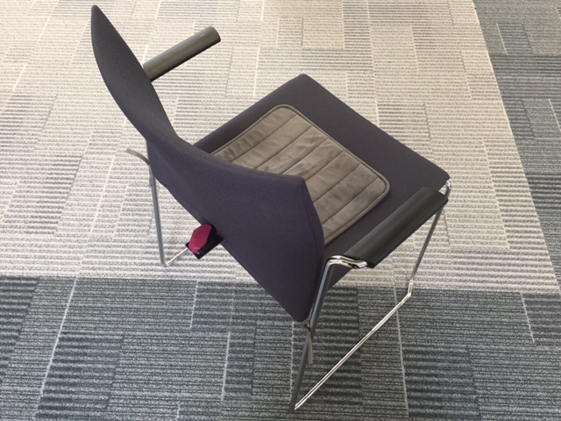

Please do not remove or unplug the sensors.

Please also note that no personal identifiers or personal identifying characteristics are being collected. The sensors used are not designed to identify who is in the room, only to determine the number of people present.

Further information about this project and the broader IoT initiative can be found at: <http://iot.ed.ac.uk/>

A full Privacy Impact Assessment has been carried out. If you have any concerns or other feedback regarding the this project, please contact the project manager: XXXXX