Trajectories of mental health among university staff and postgraduate students during the pandemic

Ewan Carr1*, Carolin Oetzmann2*, Katrina Davis2, …, Reza Razavi, and Matthew Hotopf.

1Biostatistics

2Psych Med.

* Contributed equally

## Funding/acknowledgements

This paper represents independent research part-funded by the National Institute for Health Research (NIHR) Maudsley Biomedical Research Centre at South London and Maudsley NHS Foundation Trust and King’s College London. The views expressed are those of the author(s) and not necessarily those of the NHS, the NIHR or the Department of Health and Social Care.

For OEM:

Authors should provide key messages under the following headings:

* What is already known about this subject?
* What are the new findings?
* How might this impact on policy or clinical practice in the foreseeable future?

Word count: up to 3,500

Structured abstract: up to 250 words; ‘Objectives’, ‘Methods’, ‘Results’, ‘Conclusions’

Tables/Illustrations: up to 5

References: up to 40

**Abstract**

|  |  |
| --- | --- |
| Objectives | Mental health declined in the early stages of the pandemic. |
| Methods | Longitudinal cohort study of staff and postgraduate students at London-based university in the United Kingdom. N participated in the baseline survey and N followed longitudinally.  Outcomes were.. We considered as exposures.. |
| Results | * General pattern of MH over time * Trajectory classes * Predictors of class membership * TVCs |
| Conclusions |  |

# Introduction

# Methods

## Data

* Baseline sample
* Longitudinal sample
* Included participants
* Time points

## Measures

* Outcomes
* Baseline covariates
* Time-varying covariates

Weights

## Statistical analyses

* Descriptives
* Growth mixture models
* Predictors of class membership
* Time-varying predictors

Software: R, Mplus

Code available on GitHub? (give link?)

# Results

## Cohort characteristics

The analytical sample included N participants, having removed…

Excluded participants tended to be…

Participants were… [describe sample]. Reference baseline paper?

Supplementary Table 1: Cohort characteristics

## Descriptive statistics

Figure/Table 1 presents weighted means for each outcome (GAD-7 and PHQ-9 score) at each survey period. This shows...

## Trajectories

Naming the classes:

|  |  |  |
| --- | --- | --- |
|  | GAD-7 | PHQ-9 |
| Class 1 | “High severity” | “High severity” |
| Class 2 | “With cases” |  |
| Class 3 | “Against cases” |  |
| Class 4 | “Low severity” | “Low severity” |

Figure 2:

A: Trajectory classes for GAD-7 total score

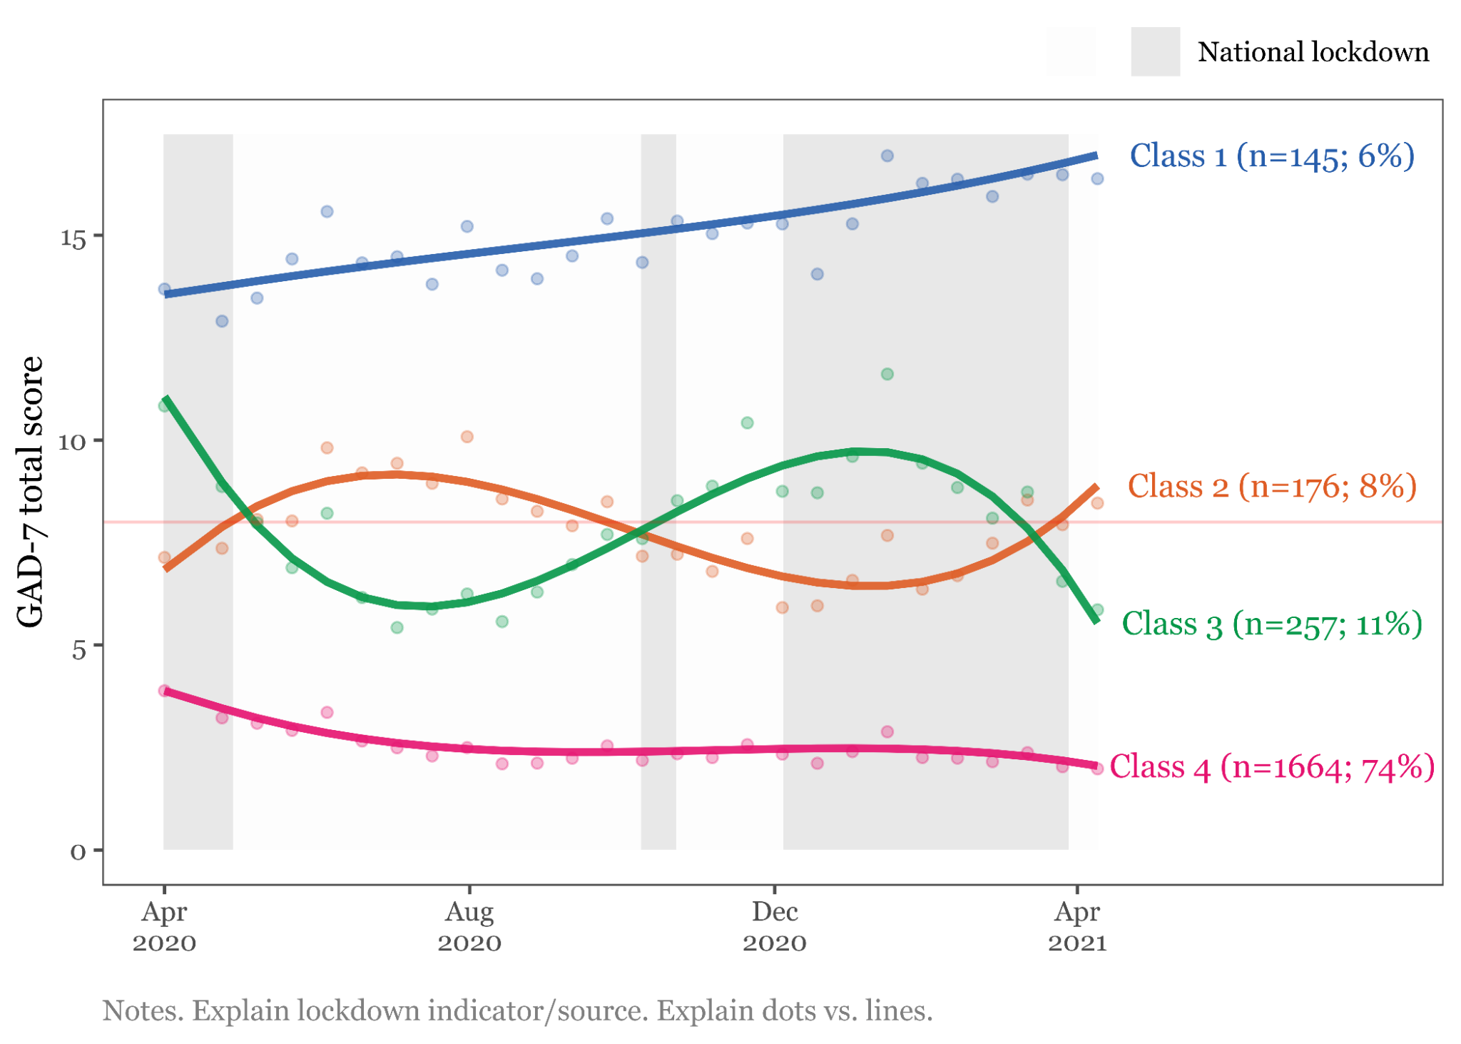

B: Trajectory classes for PHQ-9 total score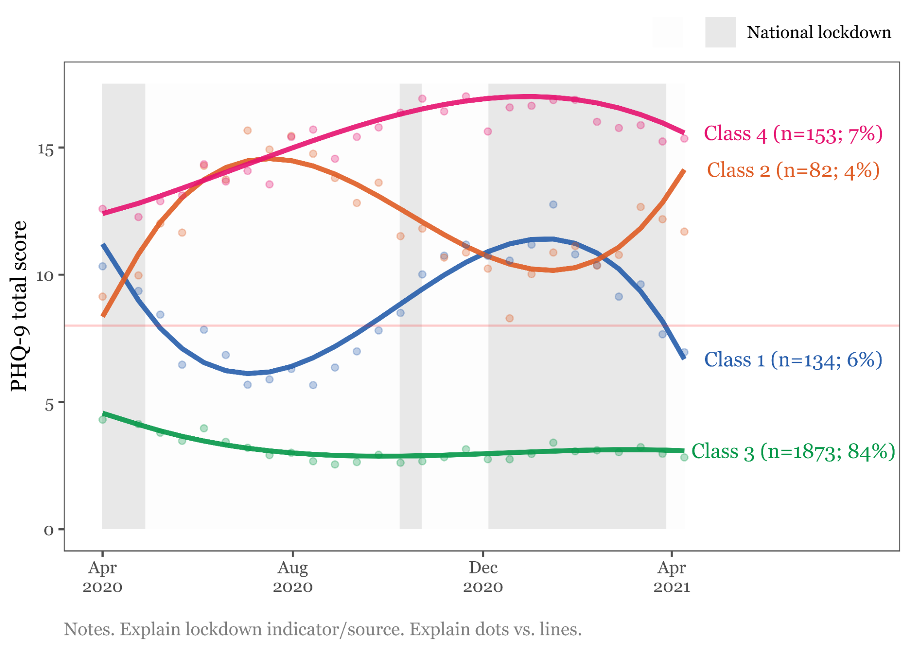

Figure 3: Odds ratios of baseline predictors of class membership

Supplementary Table 2: Odds ratios of baseline predictors of class membership

Figure 4: TVCs

## Interpretation

### GAD

* Older age => less likely to be in C1/C2/C3.

* Female sex ==> More likely to be in C1/C2/C3.

* Any children ==> less likely to be in C1/C2/C3, but attenuated after age/sex adjustment.

* Young children ==> more likely to be in C2 ('against cases'), after adjustment.

* Other caring role ==> More likely to be in C1/C2/C3.

* Chronic condition ==> more likely to be in C1 ('persistent high') and C3 ('with cases'), after adjustment.

* Ethnicity, compared to White:

- Asian and Black ==> C1 ('persistent high'), not reaching significance after adjustment.

- Asian ==> C3 ('with cases')

Key workers: no association

Living alone: no association

* Previous anxiety/depression ==> strongly associated with C1/C2/C3, after adjustment.

* Relationship status

- Single ==> more likely to be in C3 ('with cases'), after adjustment, compared to partnered.

* Renting:

* Associated with C3 ('with cases') but non-significant after adjustment.

* Staff role: no association, after adjustment for age.

* Role

- PGRs: no association, after adjustment.

- Research: no association, after adjustment.

- Teach: Less likely to be in C3 ('with cases').

* Shielding ==> C1 ('persistent high'), and C2 ('against cases')

### PHQ

* Older age => more likely to be in C1 ('with cases') and C4 ('high severity')

* Female sex ==> less likely to be in C3

* Prior anxiety ==> less likely to be C1 ('with cases').

* Prior depression

- ==> Less likely to be in C1 ('with cases')

- ==> More likely to be in C2 ('against cases') and C4 ('high severity')

* Relationship status

- Single ==> More likely to be in C2 ('against cases')

* Young children ==> Much less likely to be in C4 ('high severity')

No association:

* caring

* chronic

* ethnicity, but only because low N + big CIs

* Key workers

* Living alone

* Renting, after adjustment

* Role

* Shielding

# Conclusions

# References