Trajectories of mental health among university staff and postgraduate students during the pandemic

Ewan Carr1*, Carolin Oetzmann2*, Katrina Davis2, …, Reza Razavi, and Matthew Hotopf.

1Biostatistics

2Psych Med.

* Contributed equally

## Funding/acknowledgements

This paper represents independent research part-funded by the National Institute for Health Research (NIHR) Maudsley Biomedical Research Centre at South London and Maudsley NHS Foundation Trust and King’s College London. The views expressed are those of the author(s) and not necessarily those of the NHS, the NIHR or the Department of Health and Social Care.

For OEM:

Authors should provide key messages under the following headings:

* What is already known about this subject?
* What are the new findings?
* How might this impact on policy or clinical practice in the foreseeable future?

Word count: up to 3,500

Structured abstract: up to 250 words; ‘Objectives’, ‘Methods’, ‘Results’, ‘Conclusions’

Tables/Illustrations: up to 5

References: up to 40

**Abstract**

| Objectives | Mental health declined in the early stages of the pandemic. |
| --- | --- |
| Methods | Longitudinal cohort study of staff and postgraduate students at London-based university in the United Kingdom. N participated in the baseline survey and N followed longitudinally.  Outcomes were.. We considered as exposures.. |
| Results | * General pattern of MH over time * Trajectory classes * Predictors of class membership * TVCs |
| Conclusions |  |

# Introduction

The COVID-19 pandemic is a threat to wellbeing, not only from infection with the SARS-CoV-2 virus itself, but also indirectly through public health measures such as isolation and through enforced changes such as working from home and home schooling. The potential for mental health effects was highlighted early, and research challenges posed [[1]](https://www.zotero.org/google-docs/?MNVdpI). Subsequently there were reports from numerous research studies measuring symptoms of distress, depression and anxiety, with mixed methodological rigour and heterogeneous outcomes (Hotopf et al., 2020; Kohler, 2020; Lin et al., 2021). The consensus is that, on average, people in the early phase of the pandemic had significantly higher levels of symptoms, but that the impact was unevenly felt across the population (Bernardini et al., 2021; Robinson et al., 2021; Vindegaard & Benros, 2020). The implications of such analyses at one point in the pandemic are however fairly limited, since mental health is dynamic, and support needs are likely to be more indicated by the pattern of mental disorder symptoms over time as the pandemic disruption has continued. Longitudinal information that can identify the most vulnerable is therefore important for policy makers when planning for COVID-19 response and recovery (Boden et al., 2021; VanderWeele et al., 2019) . For working age employees, employers too have an interest in their health and wellbeing, since it is known that support from employers is also important for wellbeing, and it is likely to be important for confidence in dealing with a new-normal after the restrictive phase of the pandemic (Godderis & Luyten, 2020; Hotopf et al., 2020; Xiong et al., 2020) Therefore occupational cohorts may have an important role to play in informing employers about mental health among employees and where particular support may be needed[OC1] .

Universities are usually thought of as educators. However, they are also often large employers with diverse staff, not only academic and support staff to provide for students, but also early-career researchers (including postgraduate research students, PGRs), specialised technicians and advisors, and those supporting the facilities and buildings. [https://www.universitiesuk.ac.uk/policy-and-analysis/reports/Documents/2020/uuk-he-vision.pdf]. All of these people may have experienced the pandemic differently – their job role may play some part in this, but also other factors known to influence mental health in normal times, as well as factors specific to the pandemic (Boden et al., 2021).[OC2] [OC3]

King’s College London (KCL) is a large University, affiliated with the University of London, founded in 1829. On 23rd March 2020, KCL, like most other universities in the UK, had to shut its campuses to all but essential workers, and all teaching was moved online with most students in the UK being unable to return to their university campus until May 2021 [https://www.universitiesuk.ac.uk/news/Pages/uuk-response-to-government-update-on-student-returns-in-England.aspx],. Meanwhile, societal disruption continued with transitions in and out of lockdowns, increased caring responsibilities due to school closures for parents (citation), and continuing high workloads for key workers (citation).[OC4] In order to understand the impact this disruption has on employee wellbeing, the King’s College London Coronavirus Health and Experiences of Colleagues at King’s (KCL-CHECK) was designed.

KCL-CHECK is a King’s centric research platform designed to gauge employee concerns and to inform pandemic management, while also contributing to COVID-19 pandemic research with a large-scale occupational sample of staff and PGRs (full study protocol described in (Davis et al., 2020). Previous, publications from KCL-CHECK have reported on symptoms of depression and anxiety in early stages of the pandemic (late April-May 2020), finding a high prevalence of participants scoring above clinical cut-off on depression and anxiety questionnaires, particularly among young people (“baseline paper citation”). These results were consistent with other studies investigating the pattern of mental health in the UK since the start of the pandemic. For instance, (Ellwardt & Präg, 2021) reported that from April to September 2020, most people reported very low or low symptoms at all times, while others reported high levels or more dynamic symptoms throughout. As elsewhere, risk factors for mental disorder were important, as well as other pandemic related stressors. For example, being female and young were risk factors for higher symptoms, as was true pre-pandemic (“citation”); while living alone or living with young children which were not previously risk factors, were found to be important.

While KCL-CHECK is not a representative sample in the way (Ellwardt & Präg, 2021) is, it is able to look in particular detail at a large-scale occupational sample, from the same organisation, at a high temporal resolution, to provide for a better understanding of mental health trajectories in the workplace. Furthermore, the higher education sector is acknowledged to have room for improvement when it comes to the mental health of staff and postgraduate students, [https://www.universitiesuk.ac.uk/policy-and-analysis/reports/Documents/2020/uuk-stepchange-mhu.pdf]. As summarised above, the 2020-2021 period has been a challenging and uncertain time for staff and students at UK universities [https://www.universitiesuk.ac.uk/policy-and-analysis/reports/Documents/2020/uuk-he-vision.pdf] and indeed in other parts of the world (Besser et al., 2020; Gautam & Sharma, 2020; Odriozola-González et al., 2020). Therefore, longitudinal results from KCL CHECK will be of particular interest to occupational health clinicians, employers and managers in many settings where work has been disrupted by COVID-19.

Using KCL CHECK fortnightly surveys for a whole year, we report on depression and anxiety over the first year of the COVID-19 pandemic (April 2020 to April 2021). Furthermore, we address questions such as whether average scores increased or decreased over time, whether there were different trajectories over time and if so, what characteristics predicted these trajectories.

# Methods

## Data

Data were collected from staff and PGR students participating in the KCL CHECK longitudinal survey. Participants were invited via email to complete the baseline survey in April 2020. Those completing the baseline survey were also invited to participate in longitudinal surveys. All surveys were conducted online. Longitudinal surveys included shorter fortnightly questionnaires as well as longer questionnaires every two months. Between April 2020 and March 2021 there were 6 longer questionnaires and 21 fortnightly questionnaires (Please refer to Supplementary Table 1 for a full schedule). Of 2590 staff or PGR students responding to the baseline survey, 2508 agreed to participate in longitudinal follow-ups and are included in this analysis.

Administrative data on the demographic composition of staff and PGR student populations were obtained from centrally held administrative records. Aggregate information on age group, gender, and ethnicity were used to describe the representativeness of the survey compared to the target population and construct weights, as detailed below. Contextual data on the strictness of lockdown measures in the UK were obtained from the Oxford COVID-19 Government Response Tracker [[2]](https://www.zotero.org/google-docs/?ssoQQd).

## Measures

The outcomes were reports of symptoms associated with depression and anxiety measured using the Patient Health Questionnaire (PHQ-9) [[3]](https://www.zotero.org/google-docs/?5Js6oJ) and the Generalised Anxiety Disorder (GAD-7) [[4]](https://www.zotero.org/google-docs/?e86MZ6) scales, respectively. Where participants partially completed measures, up to two items were person-mean imputed for PHQ-9 and one for GAD-7 [[5]](https://www.zotero.org/google-docs/?MiYb0l). These outcomes were treated continuously, but…

We considered covariates measured at baseline as well as time-varying covariates measured repeatedly over time. All covariates were self-reported by participants in online surveys. Baseline covariates included factors previously linked to anxiety and depression and factors likely to be associated with increased vulnerability during the pandemic. These included demographic characteristics, health status, caring, and occupational role. Demographic variables included continuous age, gender, ethnicity, partnership status, living arrangements, and housing tenure. Gender was reported as ‘Female’, ‘Male’, ‘Other’, or ‘Prefer not to say’. Due to small cell counts (<0.5%), responses of ‘Other’ and ‘Prefer not to say’ were randomly allocated to ‘Female’ or ‘Male’, based on sample proportions. Ethnicity was coded into five categories following recommendations of the Office for National Statistics [[6]](https://www.zotero.org/google-docs/?lkLlLf) : White, Mixed, Asian (‘Asian’ or ‘Asian British’), Black (‘Black’, ‘African’, ‘Caribbean’, ‘Black British’) or Other (‘Other ethnic group’). Partnership status was categorised as ‘Single’, ‘Divorced, separated, widowed’, or ‘Civil partnership, married, cohabiting, non-cohabiting’. Living arrangements (“Which of the following best describes your current living arrangement?”) were dichotomised as ‘Living alone’ vs. ‘living with others.’ Housing tenure was dichotomised as any ‘renting’ category vs. all other categories.

Health status included self-reported chronic conditions (>1 condition vs. no conditions reported); whether the participant was ‘Currently shielding’ (defined as “a type of self-isolation, which involves not leaving your home for any reason for at least 12 weeks to reduce your risk of contracting COVID-19”); and prior diagnosis by health professional of (4) depression (‘Depression’) or anxiety disorder (‘Generalised anxiety disorder,’ ‘Panic attacks’ or ‘Post-traumatic stress disorder’).

Caring

Occupational role

Time-varying covariates included...

## Statistical analyses

The analyses were conducted in two parts.

We first described the cohort by presenting (i) baseline characteristics and (ii) weighted summaries of the outcomes at each follow-up survey. Outcomes were summarised overall and by gender and age group. We described the available sample at each survey (i.e. complete cases) and used weights to account for non-response, as detailed below.

Second, we used growth mixture models (GMM) to identify subgroups of participants with differing trajectories of anxiety and depression symptoms. GMMs are an extension of latent growth curve models (LGCMs) and are estimated within a structural equation modelling (SEM) framework [[7]](https://www.zotero.org/google-docs/?46GfVS). The LGCM allows us to model repeated measures of an observed variable (e.g. symptoms of anxiety) by using latent variables to represent the intercept (the initial level of the observed variable) and slope (the change over time). The GMM extends this model to allow identification of subgroups with different intercepts and slopes, reflecting differing trajectories of symptoms over time.

The GMM

variable over timeestimated within a stof structural equation model

Part 1: Descriptives

Part 2: Growth mixture models

* Descriptives
* Growth mixture models
* Predictors of class membership
* Time-varying predictors
* Weights

Software: R (packages), Mplus

Code available on GitHub? (give link?)

# Results

## Cohort characteristics

Of 2508 participants agreeing to longitudinal follow-up, the analytical sample included 2241 participants, having excluded 176 participants without follow-up information on PHQ-9 and GAD-7 and 91 missing information on baseline covariates. Excluded participants tended to be older (mean age = 39.6 vs. 38.3 years; p = 0.08) and were more likely to report female gender (70% vs. 60%; p < 0.001).

Compare

Table 1: Cohort characteristics (baseline only)

|  |  | **Count**  **n=2335** | **Weighted proportion** | **[CI]** |
| --- | --- | --- | --- | --- |
| Gender | Female | 1641 | 42% | [0.4, 0.4] |
| Male | 694 | 32% | [0.3, 0.3] |
| Age group | 16-34y | 967 | 44% | [0.4, 0.5] |
| 35-54y | 1032 | 43% | [0.4, 0.5] |
| 55+y | 336 | 13% | [0.1, 0.1] |
| Ethnicity | White | 1981 | 52% | [0.5, 0.5] |
| Black | 33 | 3% | [0.0, 0.0] |
| Asian | 166 | 11% | [0.1, 0.1] |
| Mixed | 92 | 3% | [0.0, 0.0] |
| Other | 59 | 5% | [0.0, 0.1] |
| NA | 4 | 27% | [0.2, 0.3] |
| Staff vs Students | Staff | 1932 | 61% | [0.6, 0.6] |
| Students | 403 | 13% | [0.1, 0.1] |
| Pre-existing MDD | YES | 533 | 16% | [0.1, 0.2] |
| NO | 1773 | 57% | [0.5, 0.6] |
| NA | 29 | 27% | [0.3, 0.3] |
| Pre-existing GAD | YES | 526 | 15% | [0.1, 0.2] |
| NO | 1780 | 58% | [0.6, 0.6] |
| NA | 29 | 27% | [0.3, 0.3] |
| Household members | Lives with others | 2071 | 65% | [0.6, 0.7] |
| Lives alone | 262 | 8% | [0.1, 0.1] |
| Missing | 2 | 27% | [0.2, 0.3] |
| Number of children living with | 0 | 1659 | 53% | [0.5, 0.6] |
| 1 | 289 | 9% | [0.1, 0.1] |
| 2 | 334 | 10% | [0.1, 0.1] |
| 3+ | 53 | 2% | [0.0, 0.0] |
| Participant is key worker | Not a key worker | 2012 | 64% | [0.6, 0.7] |
| Key worker | 323 | 10% | [0.1, 0.1] |

## Mental health over time, by age group and gender

Figure 1 presents the weighted mean scores for each outcome (GAD-7 and PHQ-9 score) at each survey period from April 2020 to April 2021. The figure shows that on average participants reported low levels of anxiety and depression (‘none’ or ‘mild’) over time. Symptoms were highest in April 2020 and decreased over the summer months when no lockdown measures were in place. However, scores increased again in December 2020 with rising case numbers and reinstated national lockdown measures (as indicated in grey).

To better understand these trends across demographic groups these trajectories were stratified by age group and gender. Males and females followed similar trajectories for both anxiety and depression, however, females presented with higher scores than males at each survey period. Meanwhile, when stratifying by age, younger individuals scored higher on both anxiety and depression than older participants, with 16–34-year-olds reporting ‘mild anxiety’ throughout the year, while 55+ year olds presented with no anxiety and depression over time.

Figure 1. Anxiety (GAD-7) and depression (PHQ-9) symptom trajectories over time stratified by age group and gender.

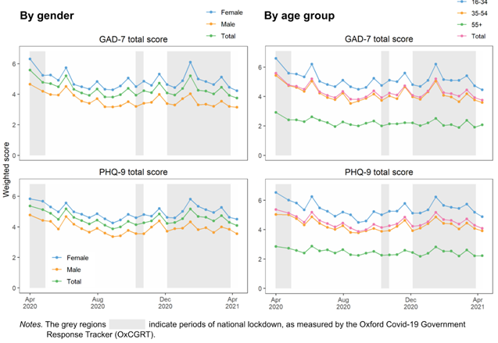

## Trajectories

Supplementary Table: Fit statistics for different N latent classes

Naming the classes:

|  | GAD-7 | PHQ-9 |
| --- | --- | --- |
| Class 1 | “High severity” | “High severity” |
| Class 2 | “With cases” |  |
| Class 3 | “Against cases” |  |
| Class 4 | “Low severity” | “Low severity” |

Figure 2

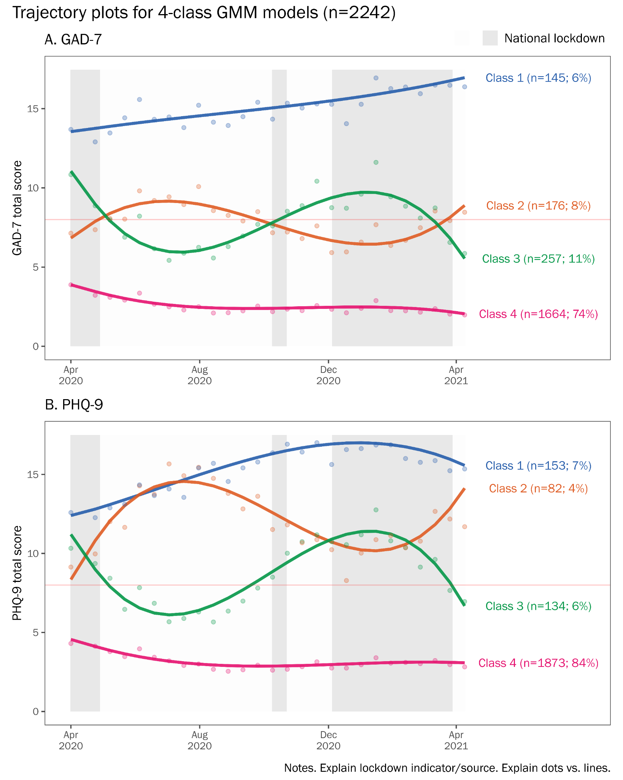

Figure 3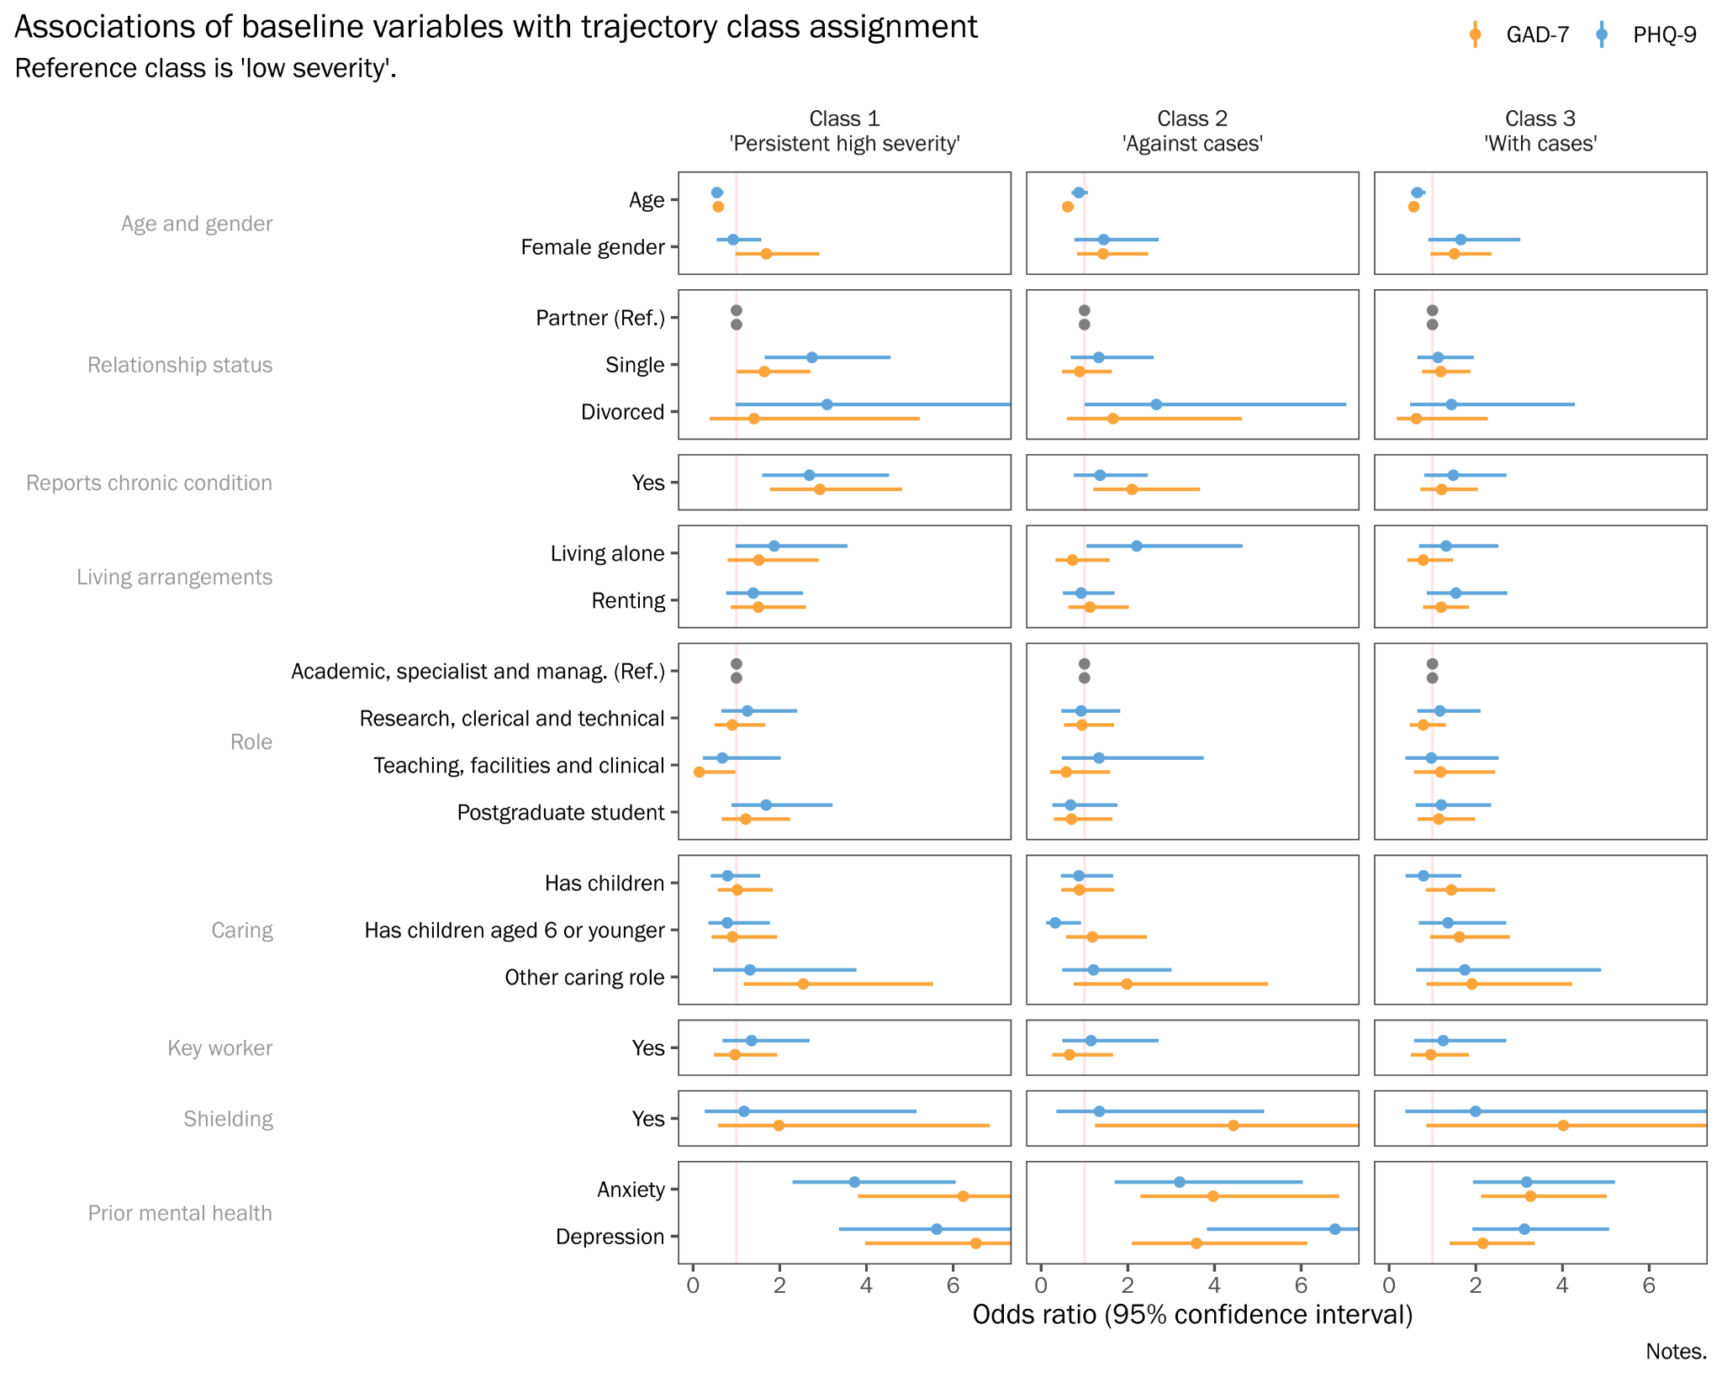

Supplementary Table 2: Odds ratios of baseline predictors of class membership

## Interpretation

### GAD

* Older age => less likely to be in C1/C2/C3.
* Female sex ==> More likely to be in C1/C2/C3.
* Any children ==> less likely to be in C1/C2/C3, but attenuated after age/sex adjustment.
* Young children ==> more likely to be in C2 ('against cases'), after adjustment.
* Other caring role ==> More likely to be in C1/C2/C3.
* Chronic condition ==> more likely to be in C1 ('persistent high') and C3 ('with cases'), after adjustment.
* Ethnicity, compared to White:
  + Asian and Black ==> C1 ('persistent high'), not reaching significance after adjustment.
  + Asian ==> C3 ('with cases')

Key workers: no association

Living alone: no association

* Previous anxiety/depression ==> strongly associated with C1/C2/C3, after adjustment.
* Relationship status
  + Single ==> more likely to be in C3 ('with cases'), after adjustment, compared to partnered.
* Renting:
  + Associated with C3 ('with cases') but non-significant after adjustment.
* Staff role: no association, after adjustment for age.
* Role
  + PGRs: no association, after adjustment.
  + Research: no association, after adjustment.
  + Teach: Less likely to be in C3 ('with cases').
* Shielding ==> C1 ('persistent high'), and C2 ('against cases')

### PHQ

* Older age => more likely to be in C1 ('with cases') and C4 ('high severity')
* Female sex ==> less likely to be in C3
* Prior anxiety ==> less likely to be C1 ('with cases').
* Prior depression
  + ==> Less likely to be in C1 ('with cases')
  + ==> More likely to be in C2 ('against cases') and C4 ('high severity')
* Relationship status
  + Single ==> More likely to be in C2 ('against cases')
* Young children ==> Much less likely to be in C4 ('high severity')

No association:

* caring
* chronic
* ethnicity, but only because low N + big CIs
* Key workers
* Living alone
* Renting, after adjustment
* Role
* Shielding

Figure 4: TVCs

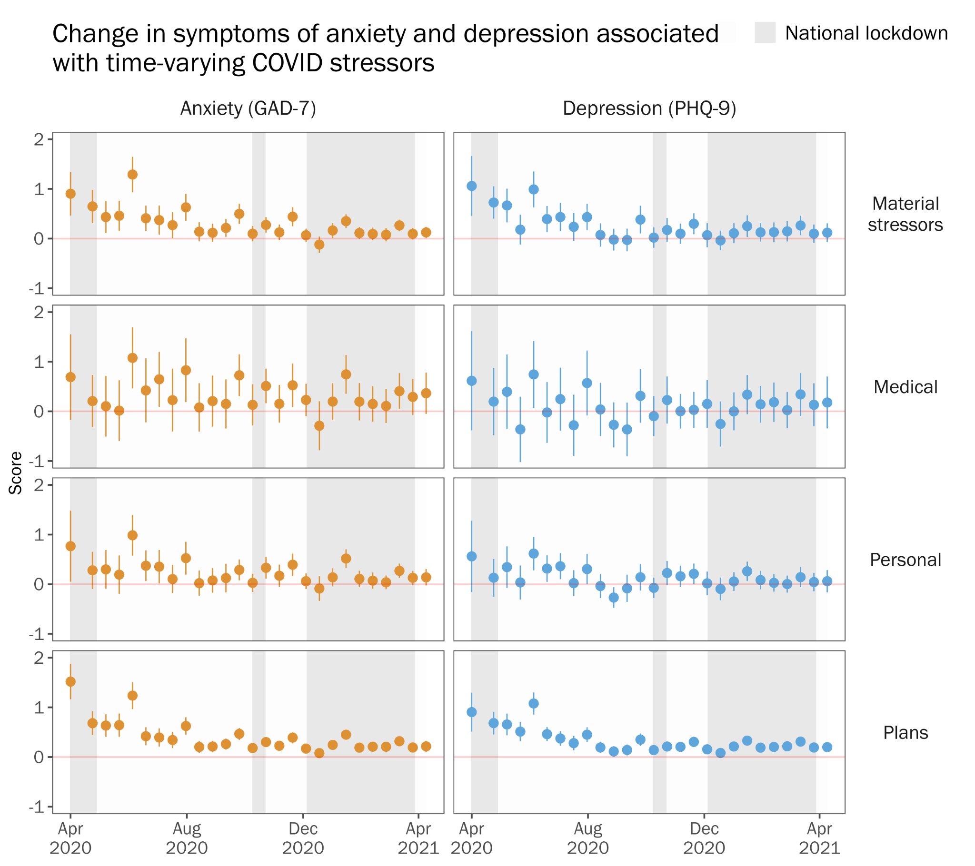

# Discussion

Key findings:

How does this compare?

* Ellwardt & Präg, 2021 --> showed that most people had very low (58%) or low (22%) symptoms at all times, but there was also a group who have high levels throughout (13%), and a group whose symptom levels are more dynamic (6%).

Policy/in context:

Strengths

Limitations

# Conclusions

1. Big MH impact of pandemic.
2. Most improved after April-June, but some did not.
3. Some highly responsive to changing pandemic circumstances.
   1. Age, gender.. Caring? Children?
4. COVID stressors had + impact during early stages, lessened over time...

Supplementary Materials

## Table S1. Schedule of follow-up assessment periods

| Date of follow-up assessment1 | | | Type of survey | Number responding | Response rate2 |
| --- | --- | --- | --- | --- | --- |
| 2020 | April | 15th | Two-monthly | 2241 | 100 |
|  | May | 8th | Fortnightly | 1772 | 79 |
|  |  | 22nd | Fortnightly | 1924 | 86 |
|  | June | 5th | Fortnightly | 1918 | 86 |
|  |  | 19th | Two-monthly | 1958 | 87 |
|  | July | 3rd | Fortnightly | 1927 | 86 |
|  |  | 17th | Fortnightly | 1812 | 81 |
|  |  | 31st | Fortnightly | 1759 | 78 |
|  | August | 14th | Two-monthly | 1641 | 73 |
|  |  | 28th | Fortnightly | 1741 | 78 |
|  | September | 11th | Fortnightly | 1757 | 78 |
|  |  | 25th | Fortnightly | 1773 | 79 |
|  | October | 9th | Two-monthly | 1664 | 74 |
|  |  | 23rd | Fortnightly | 1686 | 75 |
|  | November | 6th | Fortnightly | 1703 | 76 |
|  |  | 20th | Fortnightly | 1696 | 76 |
|  | December | 4th | Two-monthly | 1749 | 78 |
|  |  | 18th | Fortnightly | 1542 | 69 |
| 2021 | January | 1st | Fortnightly | 1564 | 70 |
|  |  | 15th | Fortnightly | 1661 | 74 |
|  |  | 29th | Two-monthly | 1662 | 74 |
|  | February | 12th | Fortnightly | 1607 | 72 |
|  |  | 26th | Fortnightly | 1625 | 73 |
|  | March | 12th | Fortnightly | 1598 | 71 |
|  |  | 26th | Two-monthly | 1554 | 69 |
|  | April | 9th | Fortnightly | 1492 | 67 |
|  |  | 23rd | Fortnightly | 1442 | 64 |

*Notes.*

1 Surveys were sent out in two batches over a two week period. This date represents the midpoint of the period.

2 Response rate (%) relative to the number of participants in the analytical who responded at baseline (n = 2241).

# References

[1 Hotopf M, Bullmore E, O’Connor RC, *et al.* The scope of mental health research in the COVID-19 Pandemic and its aftermath. *The British Journal of Psychiatry* 2020;:1–7.](https://www.zotero.org/google-docs/?DMllNz)

[2 Hale T, Angrist N, Goldszmidt R, *et al.* A global panel database of pandemic policies (Oxford COVID-19 Government Response Tracker). *Nat Hum Behav* 2021;**5**:529–38. doi:10.1038/s41562-021-01079-8](https://www.zotero.org/google-docs/?DMllNz)

[3 Kroenke K, Spitzer RL, Williams JB. The PHQ‐9: validity of a brief depression severity measure. *Journal of general internal medicine* 2001;**16**:606–13.](https://www.zotero.org/google-docs/?DMllNz)

[4 Spitzer RL, Kroenke K, Williams JBW, *et al.* A Brief Measure for Assessing Generalized Anxiety Disorder: The GAD-7. *Arch Intern Med* 2006;**166**:1092–7. doi:10.1001/archinte.166.10.1092](https://www.zotero.org/google-docs/?DMllNz)

[5 Downey RG, King CV. Missing Data in Likert Ratings: A Comparison of Replacement Methods. *The Journal of General Psychology* 1998;**125**:175–91. doi:10.1080/00221309809595542](https://www.zotero.org/google-docs/?DMllNz)

[6 ONS. Ethnic group, national identity and religion - Office for National Statistics. Ethnic group, national identity and religion. 2020.https://www.ons.gov.uk/methodology/classificationsandstandards/measuringequality/ethnicgroupnationalidentityandreligion#ethnic-group (accessed 10 Dec 2020).](https://www.zotero.org/google-docs/?DMllNz)

[7 Wickrama K, Lee TK, O’Neal CW, *et al. Higher-Order Growth Curves and Mixture Modeling with Mplus: A Practical Guide*. New York: : Routledge 2016. doi:10.4324/9781315642741](https://www.zotero.org/google-docs/?DMllNz)