Trajectories of mental health among university staff and postgraduate students during the pandemic

Ewan Carr1*, Carolin Oetzmann2*, Katrina Davis2, …, Reza Razavi, and Matthew Hotopf.

1Biostatistics

2Psych Med.

* Contributed equally

## Funding/acknowledgements

This paper represents independent research part-funded by the National Institute for Health Research (NIHR) Maudsley Biomedical Research Centre at South London and Maudsley NHS Foundation Trust and King’s College London. The views expressed are those of the author(s) and not necessarily those of the NHS, the NIHR or the Department of Health and Social Care.

*What is already known about this subject?*

*What are the new findings?*

*How might this impact on policy or clinical practice in the foreseeable future?*

Word count: up to 3,500

Structured abstract: up to 250 words; ‘Objectives’, ‘Methods’, ‘Results’, ‘Conclusions’

Tables/Illustrations: up to 5

References: up to 40

**Abstract**

| Background | The COVID-19 pandemic and subsequent containment measures have disrupted the social and working lives of many. Past studies have highlighted worsening mental health during the pandemic. However, many past studies have relied on infrequent follow-up with small sample sizes. This study fills this gap by drawing on fortnightly information for a large cohort. It describes differing trajectories of mental health between April 2020 and April 2021 and individual characteristics associated with these trajectory types. |
| --- | --- |
| Methods | KCL-CHECK is a longitudinal occupational cohort study at a large university in London, United Kingdom. Participants (n=2335) completed online questionnaires fortnightly between April 2020 and April 2021. Sociodemographic and clinical characteristics were measured at baseline. Symptoms of anxiety and depression were assessed (using PHQ-9 and GAD-7, respectively) repeatedly. Data were described using weighted statistics. Differing trajectories of mental health were identified using growth mixture models. |
| Results | [Summary of descriptive results].  We identified four trajectory types for anxiety and depression symptoms: 1) ‘Persistent high severity’; 2) ‘Varying symptoms, opposing cases’; 3) ‘Varying symptoms, in line with cases’; 4) ‘Persistent low severity’. Baseline characteristics such as younger age, female gender, caring responsibilities, and shielding were positively associated with higher severity trajectory types. Having young children at home was associated with the ‘Varying symptoms, opposing cases’ trajectory, which saw increasing levels of depressive symptoms as lockdown measures eased and national case numbers diminished. Similarly, living alone was also associated with ‘varying symptoms, opposing case numbers’ as well as increased odds of ‘high severity’ of depression symptoms. Other factors associated with high severity trajectory types included being single, and previous diagnosis of anxiety and depression. |
| Conclusions | These data highlight differing individual responses to the pandemic and underscore the need to consider individual circumstances when assessing and treating mental health during the pandemic. Aggregate trends in anxiety and depression can easily hide more substantial change experienced by subgroups. |

# Introduction

The COVID-19 pandemic is a threat to wellbeing, not only from infection with the SARS-CoV-2 virus itself, but also indirectly through public health measures such as social isolation and changes to home working and schooling. The potential impact of the pandemic on mental health was highlighted early in 2020 [[1]](https://www.zotero.org/google-docs/?MNVdpI). Since then, numerous studies have assessed symptoms of distress, depression and anxiety, with mixed methodological rigour and heterogeneous findings [[1–3]](https://www.zotero.org/google-docs/?54cQlJ). The consensus is that, on average, people in the early phases of the pandemic had significantly higher levels of symptoms, but that the impact was unevenly felt across the population [[4–6]](https://www.zotero.org/google-docs/?YqMiiL). However, insights from a single point in time are limited. Mental health is dynamic, and support needs are likely to reflect the pattern of mental disorder symptoms over time as the pandemic developed. Longitudinal assessments of mental health that can identify vulnerable groups are therefore important for policy makers when planning for COVID-19 response and recovery [[7,8]](https://www.zotero.org/google-docs/?byM1IW). Employers also play a central role. Support from employers is important for wellbeing, and it is likely to be important for confidence in navigating the ‘new normal’ after the more acute phases of the pandemic [[1,9,10]](https://www.zotero.org/google-docs/?NAy12m). Occupational cohorts are therefore needed to inform employers about mental health needs among their employees and where particular support may be needed.

Universities are usually thought of as educators. However, they are large employers comprising a variety of staff roles. This includes academic and support staff catering to students, but also early career researchers, specialised technicians and advisors, and those supporting the facilities or buildings [[11]](https://www.zotero.org/google-docs/?4EeAh7). Individual experiences of the pandemic, and the impact on mental health, are likely to vary across job roles. For example, between those who have regular contact with members of the public, vs. those who can work remotely most or all of the time. Besides job role, factors previously associated with poor mental health include younger age, [ref], female gender [ref], belonging to an ethnic minority group [ref], a history of mental disorder [ref], and caregiving responsibilities [ref]. In addition, recent studies have identified specific determinants of mental health that are caused or exacerbated by the pandemic [[7]](https://www.zotero.org/google-docs/?wtpZNl). These include having young children or children of school age at home [ref], living alone [ref], or being a key worker [ref].

King’s College London (KCL) is a large university with five campuses in central London, United Kingdom (UK). On 23rd March 2020, like most other universities in the UK, KCL closed its campuses to all but essential workers and moved all research and teaching online. Most students were unable to return to campus until May 2021 [[12]](https://www.zotero.org/google-docs/?P8mR4w). Meanwhile, societal disruption continued with transitions in and out of lockdowns, increased caring responsibilities due to school closures for parents [ref], and continuing high workloads for key workers [ref].[OC4]

The KCL-CHECK (King’s College London Coronavirus Health and Experiences of Colleagues at King’s) research platform was set up to understand the impact of the pandemic on employee wellbeing, gauge employee concerns, and to inform policy making within the university. It also contributes to research into the pandemic and provides a large-scale occupational sample of staff and PGRs [[13]](https://www.zotero.org/google-docs/?fl4yXL). We have previously reported on symptoms of depression and anxiety collected at the baseline questionnaire in April 2020 [ref; baseline paper]. We found a high prevalence of participants scoring above clinical cut-off on depression and anxiety questionnaires, particularly among young people (...) These results were consistent with other studies investigating the pattern of mental health in the UK since the start of the pandemic. For instance, (Ellwardt & Präg, 2021) reported that from April to September 2020, most people reported very low or low symptoms at all times, while others reported high levels or more dynamic symptoms throughout. This previous study identified younger age and female gender as important risk factors for higher severity symptoms of depression and anxiety, consistent with findings from before the pandemic [ref]. Living alone or with young children were also found to be important.

The aim of this study, building on findings from the baseline survey, was to describe patterns of mental health among staff and students between April 2020 and April 2021. We drew on fortnightly questionnaires collected throughout the year to describe (i) how average levels of anxiety or depression varied; (ii) subgroups with differing symptom trajectories. While the KCL-CHECK cohort is not nationally representative, we benefited from a large, well-defined occupational sample, high temporal resolution, and consistently high response rates. Our findings will inform a better understanding of mental health trajectories in the workplace. The higher education sector is acknowledged to have room for improvement when it comes to the mental health of staff and postgraduate students [[14]](https://www.zotero.org/google-docs/?AEh9bJ). As summarised above, the 2020-2021 period has been a challenging and uncertain time for staff and students at UK universities and indeed in other parts of the world [[15–17]](https://www.zotero.org/google-docs/?0cXNwX). Therefore, longitudinal results from KCL-CHECK will be of particular interest to occupational health clinicians, employers and managers in many settings where work has been disrupted by COVID-19.

# Methods

## Data

Data were collected from staff and PGR students participating in the KCL CHECK longitudinal survey. Participants were invited via email to complete the baseline survey in April 2020. Those completing the baseline survey were also invited to participate in longitudinal surveys. All surveys were conducted online. Longitudinal surveys included shorter fortnightly questionnaires as well as longer questionnaires every two months. Between April 2020 and March 2021 there were 6 longer questionnaires and 21 fortnightly questionnaires (Please refer to Supplementary Table 1 for a full schedule). Of 2590 staff or PGR students responding to the baseline survey, 2508 agreed to participate in longitudinal follow-ups and are included in this analysis.

Administrative data on the demographic composition of staff and PGR student populations were obtained from centrally held administrative records. Aggregate information on age group, gender, and ethnicity were used to describe the representativeness of the survey compared to the target population and construct weights, as detailed below. Contextual data on the strictness of lockdown measures in the UK were obtained from the Oxford COVID-19 Government Response Tracker [[18, p. 19]](https://www.zotero.org/google-docs/?ssoQQd).

## Measures

The outcomes were reports of symptoms associated with depression and anxiety measured using the Patient Health Questionnaire (PHQ-9) [[19]](https://www.zotero.org/google-docs/?5Js6oJ) and the Generalised Anxiety Disorder (GAD-7) [[20, p. 7]](https://www.zotero.org/google-docs/?e86MZ6) scales, respectively. Where participants partially completed measures, up to two items were person-mean imputed for PHQ-9 and one for GAD-7 [[21]](https://www.zotero.org/google-docs/?MiYb0l). In our analyses, these outcomes were treated continuously, but scores of 5-9 are typically labeled as ‘Mild anxiety’ or ‘Mild depression’ and scores ≥10 used to indicate ‘Probable anxiety’ or ‘Probable depression’ [[19,20]](https://www.zotero.org/google-docs/?SUfxQS).

We considered covariates self-reported by participants at baseline via an online questionnaire. Baseline covariates included factors previously linked to anxiety and depression and factors likely to be associated with increased vulnerability during the pandemic. These included demographic characteristics, health status, caring, and occupational role. Demographic variables included continuous age, gender, ethnicity, partnership status, living arrangements, and housing tenure. Gender was reported as ‘Female’, ‘Male’, ‘Other’, or ‘Prefer not to say’. Due to small cell counts (<0.5%), responses of ‘Other’ and ‘Prefer not to say’ were randomly allocated to ‘Female’ or ‘Male’, based on sample proportions. Ethnicity was coded into five categories following recommendations of the Office for National Statistics [[22]](https://www.zotero.org/google-docs/?lkLlLf) : White, Mixed, Asian (‘Asian’ or ‘Asian British’), Black (‘Black’, ‘African’, ‘Caribbean’, ‘Black British’) or Other (‘Other ethnic group’). Partnership status was categorised as ‘Single’, ‘Divorced, separated, widowed’, or ‘Civil partnership, married, cohabiting, non-cohabiting’. Living arrangements (“Which of the following best describes your current living arrangement?”) were dichotomised as ‘Living alone’ vs. ‘living with others.’ Housing tenure was dichotomised as any ‘renting’ category vs. all other categories.

Health status included self-reported chronic conditions (≥ one condition reported); whether the participant was ‘Currently shielding’ (defined as “a type of self-isolation, which involves not leaving your home for any reason for at least 12 weeks to reduce your risk of contracting COVID-19”); and prior diagnosis by health professional of (4) depression (‘Depression’) or anxiety disorder (‘Generalised anxiety disorder,’ ‘Panic attacks’ or ‘Post-traumatic stress disorder’). Caring roles included the number of children living at home (0, 1, 2, 3+), having children under the age of 6 (Yes/No), and whether the participant had any other caring responsibilities (“Do you have any other dependents or caring responsibilities?”; Yes/No). Occupational role was categorised as ‘Academic, specialist and management’, ‘Research, clerical and technical’, ‘Teaching, facilities and clerical’ or ‘PGR student’. These categories were chosen to reflect seniority and the degree of contact with the public. Finally, a binary variable indicated whether the respondent was in a key worker role (‘Are you currently fulfilling a ’key worker’ role as identified by the government?‘).

For visualisation purposes, information on the strictness of government lockdown policies was extracted from Oxford Covid-19 Government Response Tracker (OxCGRT; [[18]](https://www.zotero.org/google-docs/?2MLIox)). Periods of lockdown were defined as days where there was a national requirement to stay at home[1].

## Statistical analyses

The analyses were conducted in three parts.

We first described the cohort by presenting (i) baseline characteristics and (ii) weighted summaries of the outcomes at each follow-up survey. Outcomes were summarised overall and by gender and age group. We described the available sample at each survey (i.e. complete cases) and used weights to account for non-response, as detailed below.

Second, we used growth mixture models (GMM) to identify subgroups of participants with differing trajectories of anxiety and depression symptoms. GMMs are an extension of latent growth curve models (LGCMs) and are estimated within a structural equation modelling (SEM) framework [[23]](https://www.zotero.org/google-docs/?46GfVS). The LGCM allows us to model repeated measures of an observed variable (e.g. symptoms of anxiety) by using latent variables to represent the intercept (the initial level of the observed variable) and slope (the change over time). The GMM extends this model to allow identification of subgroups (‘latent classes’) with different intercepts and slopes, reflecting differing trajectories of symptoms over time. The GMM proceeds in two stages: (i) We first fit LGCMs to identify the most appropriate functional form of growth (e.g. linear, quadratic) for our data; (ii) We then fit GMMs with increasing numbers of latent classes and choose the optimal number of classes based on relative model fit and substantive interpretability. Model fit was assessed based on the AIC, sample size adjusted BIC [[24]](https://www.zotero.org/google-docs/?THzbEF), and the Lo-Mendell-Rubin test [[25,26]](https://www.zotero.org/google-docs/?ZQAmMX).

Third, we considered how covariates measured at baseline were associated with membership to trajectory classes using the R3STEP method in Mplus [[27]](https://www.zotero.org/google-docs/?LwgNUd). This used a multinomial logistic regression model to estimate how the odds of assignment to a particular trajectory class are associated with a unit change in each baseline predictor. We considered each covariate separately, adjusted for age and gender. Estimates are presented as odds ratios and 95% confidence intervals.

Descriptive statistics were calculated using R 4.1.0 (ref); GMM models were estimated using Mplus 8.4 using the *MplusAutomation* package (ref) for R. Survey weights were generated using the survey package for R (ref). All code for these analyses can be found on GitHub (<https://github.com/ewancarr/check-longitudinal>).

## Weighting

We derived a baseline weight to account for differences in age, gender, and ethnicity between the baseline cohort and the target population (all KCL staff and PGRs). In addition, a longitudinal weight was derived to account for differential non-response at longitudinal follow-up. Please refer to supplementary materials for details. Longitudinal descriptive summaries of each outcome were weighted using a combined weight (baseline weight x longitudinal weight). GMM models were weighted using the baseline weight only.

## Missing data

We excluded participants without any outcome data (7%) or missing information on baseline covariates (4%). Descriptive statistics were calculated based on the available sample at each time point.

# Results

## Cohort characteristics

Of 2508 participants agreeing to longitudinal follow-up, the analytical sample included 2241 participants, having excluded 176 participants without follow-up information on PHQ-9 and GAD-7 and 91 missing information on baseline covariates. Excluded participants tended to be older (mean age = 39.6 vs. 38.3 years; p = 0.08) and female (70% vs. 60%; p < 0.001).

**Table 1.** Cohort characteristics at baseline (n=2335)

|  |  | Count n=2335 | Weighted proportion | [CI] |
| --- | --- | --- | --- | --- |
| Gender | Female | 1581 | 57% | [0.54, 0.60] |
| Male | 660 | 43% | [0.40, 0.46] |
| Age group | 16-34y | 941 | 43% | [0.40, 0.46] |
| 35-54y | 979 | 43% | [0.41, 0.46] |
| 55+y | 321 | 14% | [0.12, 0.15] |
| Ethnicity | White | 1907 | 71% | [0.68, 0.74] |
| Black | 32 | 4% | [0.03, 0.06] |
| Asian | 156 | 14% | [0.12, 0.17] |
| Mixed | 90 | 5% | [0.04, 0.06] |
| Other | 56 | 6% | [0.04, 0.08] |
| Staff vs Students | Staff | 1851 | 82% | [0.80, 0.85] |
| Students | 390 | 18% | [0.15, 0.20] |
| Pre-existing MDD | YES | 519 | 22% | [0.20, 0.24] |
| NO | 1722 | 78% | [0.76, 0.80] |
| Pre-existing GAD | YES | 512 | 21% | [0.19, 0.23] |
| NO | 1729 | 79% | [0.77, 0.81] |
| Household members | Lives with others | 1991 | 88% | [0.87, 0.90] |
| Lives alone | 250 | 12% | [0.10, 0.13] |
| Number of children living with | 0 | 1600 | 72% | [0.70, 0.75] |
| 1 | 276 | 12% | [0.10, 0.14] |
| 2 | 316 | 14% | [0.12, 0.15] |
| 3+ | 49 | 2% | [0.01, 0.03] |
| Participant is keyworker | Not a keyworker | 1958 | 87% | [0.86, 0.89] |
| Keyworker | 283 | 13% | [0.11, 0.14] |

## Longitudinal descriptive statistics for symptoms of anxiety and depression

Figure 1 presents the weighted mean scores for each outcome (GAD-7 and PHQ-9 scores) at each survey period from April 2020 to April 2021. On average, participants reported low levels of anxiety and depression (scores consistent with ‘None’ or ‘Mild’ symptoms) over time. Symptoms were highest in April 2020 and decreased over the summer months when no lockdown measures were in place. However, scores increased again in December 2020 at a time of rising case numbers and reinstated national lockdown measures.

To better understand these trends across demographic groups these trajectories were stratified by age group and gender. Males and females followed similar trajectories for both anxiety and depression, however, females presented with higher scores than males at each survey period. Meanwhile, when stratifying by age, younger individuals scored higher on both anxiety and depression than older participants, with 16–34-year-olds reporting ‘mild anxiety’ throughout the year, while 55+ year olds presented with no anxiety and depression over time.

**Figure 1.** Anxiety (GAD-7) and depression (PHQ-9) symptom trajectories over time stratified by age group and gender

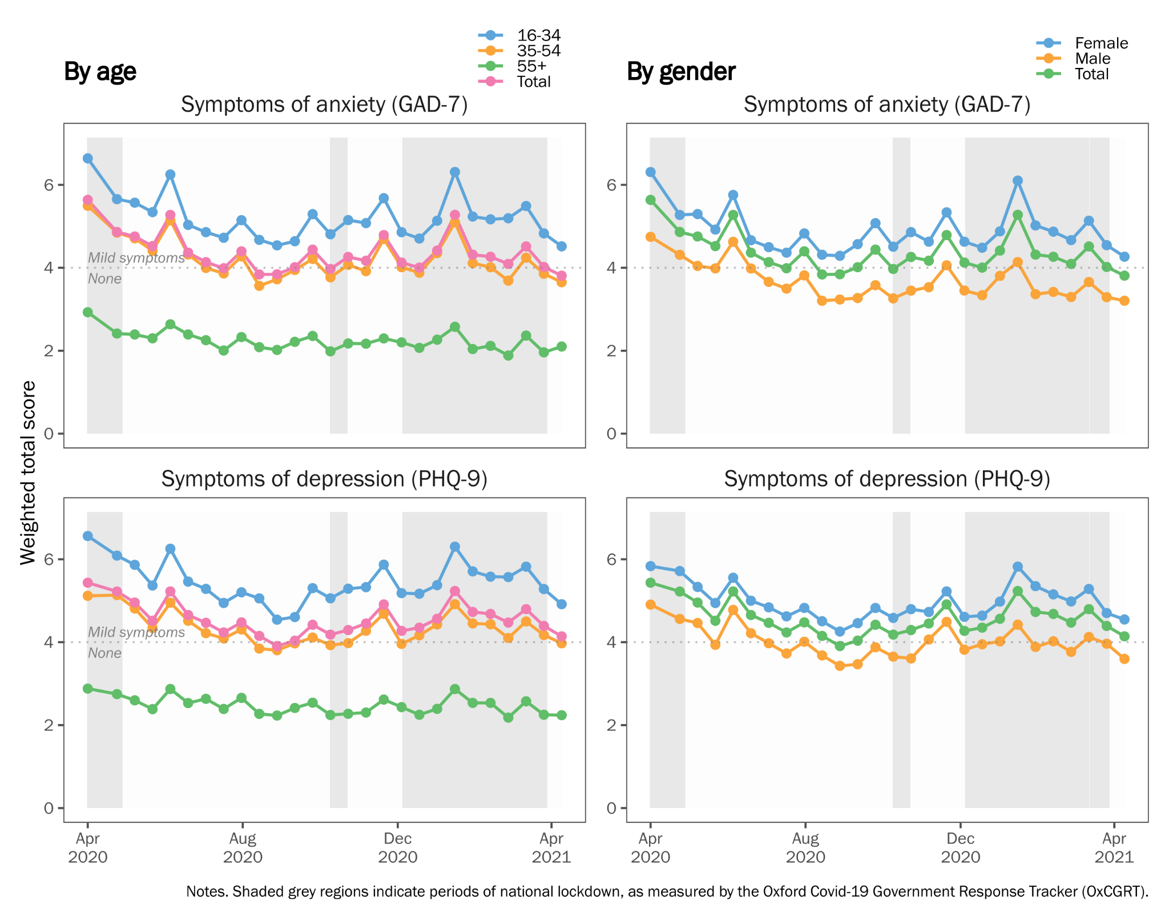

## Trajectories of anxiety and depression symptoms

Based on model fit and substantive interpretability, we chose a 4-class model for both anxiety and depression. While model fit could be improved by going beyond four classes (see Supplementary Table 2), this was at the expense of interpretability: additional classes tended to contain few participants and differed only quantitatively, not qualitatively, from the four classes described below.

The 4-class trajectories for symptoms of anxiety and depression are shown in Figure 2. This figure presents mean scores estimated by the model (solid line) alongside the observed data (points). For both outcomes, the four classes can be characterised as follows:

**Class 1:** *‘Persistent high severity symptoms’* (n = 145 (6%) and 153 (7%) for symptoms of anxiety and depression, respectively). This class reported scores consistent with ‘Probable’ anxiety and depression’ (>10) throughout the year. Mean scores increased consistently from April 2020, with the exception of depressive symptoms which started to decline in early 2021.

**Class 2:** *‘Varying symptoms, opposing cases’* (n = 176 (8%) and 82 (4%) for anxiety and depression, respectively). This class experienced fluctuating symptoms over the year, at and exceeding the threshold for ‘Probable’ anxiety and depression. Notably, for both anxiety and depression, this class reported symptoms that were at odds with the context of numbers of cases and hospitalisations in the UK. Between April and September 2020, as cases in the UK declined, this class experienced a worsening of symptoms of anxiety and depression. Similarly, with increasing cases in December 2020 and the return of national lockdown, this class experienced improving symptoms.

**Class 3:** *‘Varying symptoms, in line with cases’* (n = 257 (11%) and 134 (6%) for anxiety and depression, respectively). Like Class 2, this class experienced fluctuating symptoms throughout the year, but varied in line with case numbers in the UK. As cases declined during April to August 2020, this class experienced reductions in symptom severity; during the winter months, as cases rose, this class reported increasing levels of anxiety and depression.

**Class 4:** *‘Persistent low level symptoms’* (n = 1664 (74%) and 1873 (84%) for anxiety and depression, respectively). This class comprised the majority of respondents who reported lower symptoms throughout the year, at or below ‘Mild’ anxiety and depression. Symptoms for this group were highest in April 2020 but declined thereafter.

## Baseline predictors of trajectory class membership

To consider how participant characteristics at baseline were associated with different trajectory types, we used multinomial logistic regression (via the R3STEP method in Mplus) to estimate the odds of assignment to each class for a unit change in each covariate.

Figure 3 presents odds ratios for assignment to Classes 1 to 3. The majority class, Class 4 (‘Persistent low level symptoms’) was treated as the reference category. Each covariate was tested in a separate model, adjusted for age and gender. Age was scaled such that a one unit change represents a 10-year difference in age.

For anxiety, younger age and female gender were positively associated with assignment to one of the higher severity classes, compared to Class 4 (‘Low level symptoms’). A 10-year increase in age was associated with a two-fold reduction in the odds of assignment to the higher severity classes. Conversely, female gender was associated with increased odds (odds ratios (OR) = 1.43 to 1.67) of belonging to the higher severity classes, although not reaching thresholds for statistical significance. For depression, increased age was similarly associated with reduced odds of assignment to Classes 1 to 3, although associations for gender were reduced.

For both anxiety and depression, single respondents were more likely to be in Class 1 (‘Persistent high severity’), compared to those living in a partnership (OR = 1.65 and 2.74, respectively). For depression, living alone was associated with increased odds of assignment to Class 1 (‘Persistent high severity’; OR = 1.87) and Class 2 (‘Opposing cases’; OR = 2.21), compared to living with others. For anxiety, respondents with young children had increased odds of assignment to Class 3 (‘Varying in line with cases’), compared to the majority low severity class (OR = 1.62; 95% confidence intervals (CI): 0.95, 2.80). For depression, those with young children had reduced odds of assignment to Class 2 (‘Varying, opposing cases’; OR = 0.33; CI: 0.12, 0.92), indicating depressive symptoms increased as the strictness of lockdown measures and case numbers diminished.

For anxiety, having another caring role besides childcare was strongly associated with assignment to the higher severity classes (OR = 1.91 to 2.54), although reaching statistical significance only for Class 1 (‘Persistent high severity’). Shielding was also strongly associated with more severe symptoms of anxiety. Those shielding were twice as likely to be assigned to Class 1 (OR = 1.98; CI: 0.57, 6.84) and four times as likely to be assigned to the ‘varying symptoms’ Class 2 (OR = 4.44; CI: 1.24, 15.9) and Class 3 (OR = 4.02; CI: 0.86; 18.8). This indicates differential impacts of shielding, associated with worsening or improving symptoms of anxiety as lockdown measures eased and case numbers declined. Similar associations of shielding were not observed for depression.

Finally, a previous diagnosis of anxiety or depression was strongly associated with membership in all three higher severity classes (OR = 3.20 to 3.7 for anxiety; 3.1 to 6.8 for depression), compared to the ‘lower severity’ majority class.

**Figure 2.** Trajectory classes from 4-class GMM model for symptoms of anxiety and depression (n=2241).

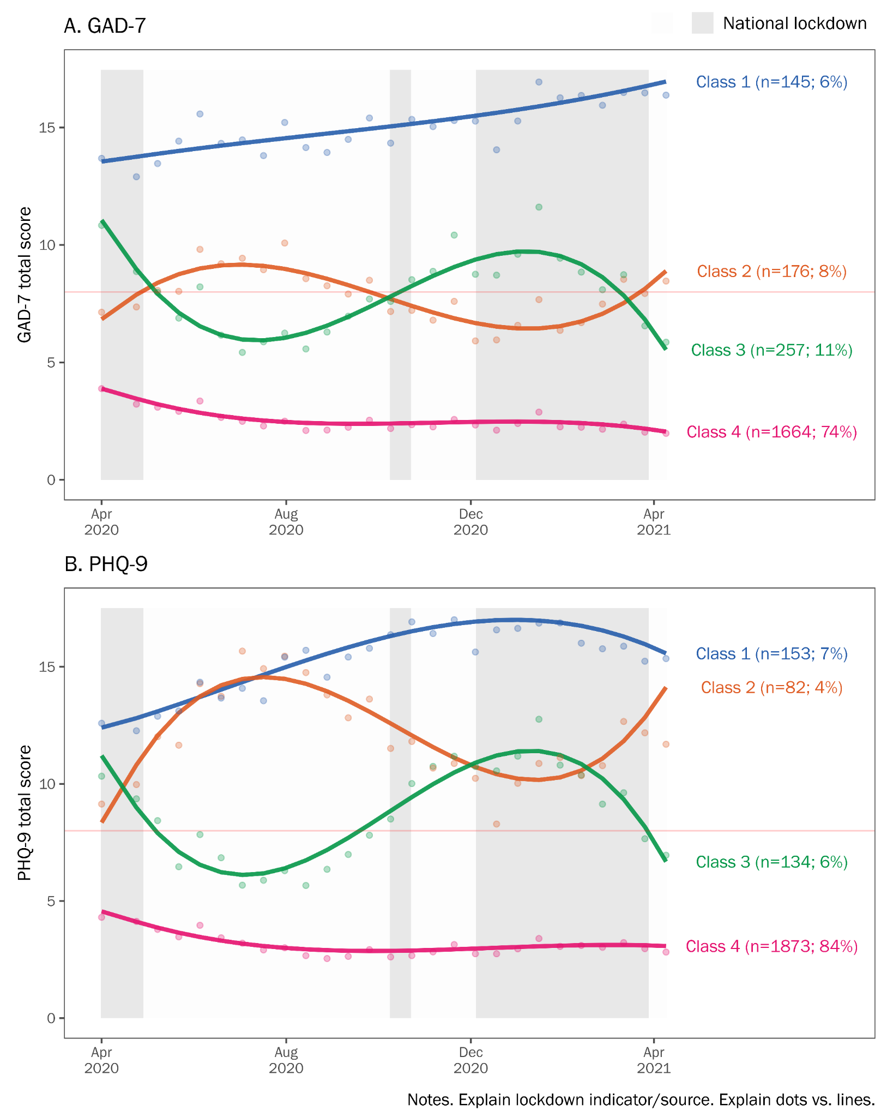

**Figure 3:** Associations of baseline variables with trajectory class assignment (n=2241)

*Reference class is ‘low severity’. Odds ratios also presented in Supplementary Table 2.*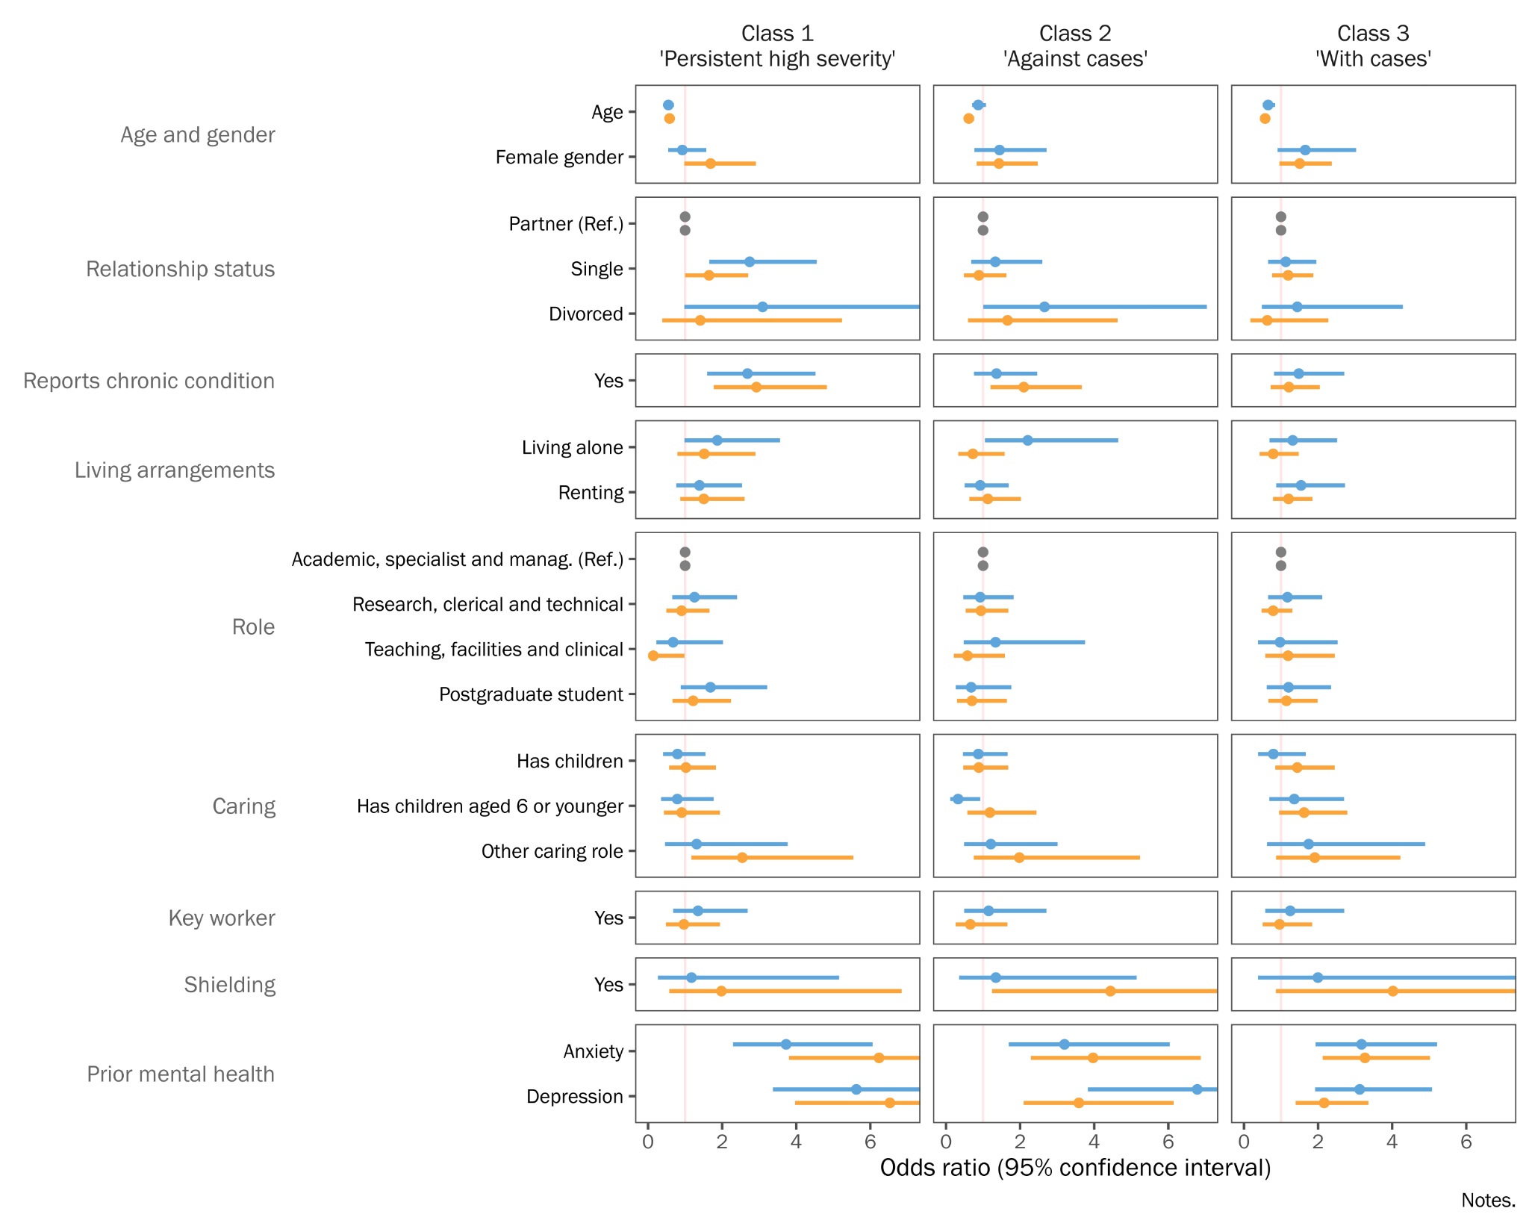

# Discussion

In a large, occupational cohort with fortnightly follow-up and high response rates, we described trajectories of anxiety and depression symptoms in the first year of the pandemic. We found EWAN CONTINUE HERE that anxiety and depressive symptoms were highest at the beginning of the pandemic and were in line with lockdown measures, easing during the summer months when lockdown measures relaxed and increasing again in December when cases rose, and lockdown measures were reinstated. These findings are similar to previous work conducted by the UCL social study [[28]](https://www.zotero.org/google-docs/?LKHvLl), which reported highest levels of anxiety and depression in the beginning of the pandemic and increased trends with lockdowns. However, on average participants reported low levels of anxiety and depression over time, results mirrored in work by (citation). Thus, a need was identified to try and understand if there are subgroups of participants with differing trajectories of anxiety and depression over time that are getting misrepresented in the aggregate trends.

Analysis of trajectories identified four subgroups’ participants with: (1) persistent high severity symptoms, (2) varying symptoms over time, that fluctuated in opposing direction to cases and hospitalisations in the UK, (3) varying symptoms fluctuating in line with cases and hospitalisations in the UK and (4) persistent low-level symptoms. These findings mirror those of previous studies indicating XX à Elwardt & Prag, Steptoe. Furthermore, these findings indicate that some participants are highly responsive to changes in pandemic circumstances (class 2 and 3), while others show persistent low or high severity symptoms (class 1 and 4). Here

How does this compare?

Policy/in context:

Strengths

* Our study differentiated by type of previous mental health condition (depression vs anxiety) while UCL SS (and a few others) just categorised by (yes - prev. MH diagnosis or no - prev. MH diagnosis).
* Focuses on a single large-scale cohort from the same organisation, suggesting that most participants received similar communications and workplace implications due to COVID-19
* High temporal resolution of MH surveys for 1 full year of follow-up

Limitations

* Low representativeness of minority ethnic groups and over-representation of females.
* Despite the high temporal resolution – important to consider the limitations of a cross-sectional study design. A risk that the study identifies general risk factors for developing MH symptoms (during a pandemic); rather than the specific impact COVID-19 had on MH symptoms (are not comparing to pre-pandemic levels).

# Conclusions

1. Big MH impact of pandemic.
2. Most improved after April-June, but some did not.
3. Some highly responsive to changing pandemic circumstances.
   1. Age, gender.. Caring? Children?
4. COVID stressors had + impact during early stages, lessened over time...

# Supplementary Materials

**Supplementary Table 1**: Schedule of follow-up assessment periods

| Date of follow-up assessment1 | | | Type of survey | Number responding | Response rate2 |
| --- | --- | --- | --- | --- | --- |
| 2020 | April | 15th | Two-monthly | 2241 | 100 |
|  | May | 8th | Fortnightly | 1772 | 79 |
|  |  | 22nd | Fortnightly | 1924 | 86 |
|  | June | 5th | Fortnightly | 1918 | 86 |
|  |  | 19th | Two-monthly | 1958 | 87 |
|  | July | 3rd | Fortnightly | 1927 | 86 |
|  |  | 17th | Fortnightly | 1812 | 81 |
|  |  | 31st | Fortnightly | 1759 | 78 |
|  | August | 14th | Two-monthly | 1641 | 73 |
|  |  | 28th | Fortnightly | 1741 | 78 |
|  | September | 11th | Fortnightly | 1757 | 78 |
|  |  | 25th | Fortnightly | 1773 | 79 |
|  | October | 9th | Two-monthly | 1664 | 74 |
|  |  | 23rd | Fortnightly | 1686 | 75 |
|  | November | 6th | Fortnightly | 1703 | 76 |
|  |  | 20th | Fortnightly | 1696 | 76 |
|  | December | 4th | Two-monthly | 1749 | 78 |
|  |  | 18th | Fortnightly | 1542 | 69 |
| 2021 | January | 1st | Fortnightly | 1564 | 70 |
|  |  | 15th | Fortnightly | 1661 | 74 |
|  |  | 29th | Two-monthly | 1662 | 74 |
|  | February | 12th | Fortnightly | 1607 | 72 |
|  |  | 26th | Fortnightly | 1625 | 73 |
|  | March | 12th | Fortnightly | 1598 | 71 |
|  |  | 26th | Two-monthly | 1554 | 69 |
|  | April | 9th | Fortnightly | 1492 | 67 |
|  |  | 23rd | Fortnightly | 1442 | 64 |

*Notes.*

1 Surveys were sent out in two batches over a two week period. This date represents the midpoint of the period.

2 Response rate (%) relative to the number of participants in the analytical who responded at baseline (n = 2241).

**Supplementary Table 2**: Model fit statistics for different numbers of latent classes; GMM models (n=2241)

| **Outcome** | **No. classes** | **-2LL**a | **Δ**b | **AIC** | **Δ**b | **aBIC**c | **Δ**b | **LMR p-value**d |
| --- | --- | --- | --- | --- | --- | --- | --- | --- |
| Anxiety (GAD-7) | 3 | 216537 | . | 216631 | . | 216750 | . | 0.63 |
| 4 | 216225 | -312 | 216329 | -302 | 216461 | -289 | 0.815 |
| 5 | 215980 | -245 | 216094 | -235 | 216239 | -222 | 0.374 |
| 6 | 215758 | -222 | 215882 | -212 | 216040 | -199 | 0.755 |
| 7 | 215541 | -217 | 215675 | -207 | 215845 | -195 | 0.738 |
| Depression (PHQ-9) | 3 | 216614 | . | 216708 | . | 216827 | . | 0.285 |
| 4 | 216264 | -350 | 216368 | -340 | 216500 | -327 | 0.757 |
| 5 | 215957 | -307 | 216071 | -297 | 216215 | -285 | 0.788 |
| 6 | 215686 | -271 | 215810 | -261 | 215967 | -248 | 0.759 |
| 7 | 215476 | -210 | 215610 | -200 | 215780 | -187 | 0.808 |

*Notes.*

a

b

c

d

# References

[1 Hotopf M, Bullmore E, O’Connor RC, *et al.* The scope of mental health research in the COVID-19 Pandemic and its aftermath. *The British Journal of Psychiatry* 2020;:1–7.](https://www.zotero.org/google-docs/?DMllNz)

[2 Kohler U. Survey Research Methods during the COVID-19 Crisis. *Survey Research Methods* 2020;**14**:93–4. doi:10.18148/srm/2020.v14i2.7769](https://www.zotero.org/google-docs/?DMllNz)

[3 Lin Y-H, Chen C-Y, Wu S-I. Efficiency and Quality of Data Collection Among Public Mental Health Surveys Conducted During the COVID-19 Pandemic: Systematic Review. *Journal of Medical Internet Research* 2021;**23**:e25118. doi:10.2196/25118](https://www.zotero.org/google-docs/?DMllNz)

[4 Bernardini F, Attademo L, Rotter M, *et al.* Social Determinants of Mental Health As Mediators and Moderators of the Mental Health Impacts of the COVID-19 Pandemic. *PS* 2021;**72**:598–601. doi:10.1176/appi.ps.202000393](https://www.zotero.org/google-docs/?DMllNz)

[5 Robinson E, Sutin AR, Daly M, *et al.* A systematic review and meta-analysis of longitudinal cohort studies comparing mental health before versus during the COVID-19 pandemic. *medRxiv* 2021;:2021.03.04.21252921. doi:10.1101/2021.03.04.21252921](https://www.zotero.org/google-docs/?DMllNz)

[6 Vindegaard N, Benros ME. COVID-19 pandemic and mental health consequences: Systematic review of the current evidence. *Brain, Behavior, and Immunity* 2020;**89**:531–42. doi:10.1016/j.bbi.2020.05.048](https://www.zotero.org/google-docs/?DMllNz)

[7 Boden M, Zimmerman L, Azevedo KJ, *et al.* Addressing the mental health impact of COVID-19 through population health. *Clinical Psychology Review* 2021;**85**:102006. doi:10.1016/j.cpr.2021.102006](https://www.zotero.org/google-docs/?DMllNz)

[8 Wei J, Hou R, Zhang X, *et al.* The association of late-life depression with all-cause and cardiovascular mortality among community-dwelling older adults: systematic review and meta-analysis. *The British Journal of Psychiatry* 2019;**215**:449–55. doi:10.1192/bjp.2019.74](https://www.zotero.org/google-docs/?DMllNz)

[9 Godderis L, Luyten J. Challenges and opportunities for occupational health and safety after the COVID-19 lockdowns. 2020.](https://www.zotero.org/google-docs/?DMllNz)

[10 Xiong J, Lipsitz O, Nasri F, *et al.* Impact of COVID-19 pandemic on mental health in the general population: A systematic review. *Journal of Affective Disorders* 2020.](https://www.zotero.org/google-docs/?DMllNz)

[11 Universities UK. Recovery, Skills, Knowledge and Opportunity. London: : Universities UK 2020. https://www.universitiesuk.ac.uk/policy-and-analysis/reports/Documents/2020/uuk-he-vision.pdf (accessed 2 Aug 2021).](https://www.zotero.org/google-docs/?DMllNz)

[12 Universities UK. Government decision on student returns in England “hugely disappointing for students.” 2021.https://www.universitiesuk.ac.uk/news/Pages/uuk-response-to-government-update-on-student-returns-in-England.aspx (accessed 18 Aug 2021).](https://www.zotero.org/google-docs/?DMllNz)

[13 Davis KAS, Stevelink SAM, Al-Chalabi A, *et al.* The King’s College London Coronavirus Health and Experiences of Colleagues at King’s Study (KCL CHECK) protocol paper: a platform for study of the effects of coronavirus pandemic on staff and postgraduate students. *medRxiv* 2020;:2020.06.16.20132456. doi:10.1101/2020.06.16.20132456](https://www.zotero.org/google-docs/?DMllNz)

[14 Universities UK. Stepchange: mentally healthy universities. 2020;:36.](https://www.zotero.org/google-docs/?DMllNz)

[15 Besser A, Lotem S, Zeigler-Hill V. Psychological Stress and Vocal Symptoms Among University Professors in Israel: Implications of the Shift to Online Synchronous Teaching During the COVID-19 Pandemic. *Journal of Voice* 2020;**0**. doi:10.1016/j.jvoice.2020.05.028](https://www.zotero.org/google-docs/?DMllNz)

[16 Gautam R, Sharma M. 2019-nCoV pandemic: A disruptive and stressful atmosphere for Indian academic fraternity. *Brain, Behavior, and Immunity* 2020;**88**:948–9. doi:10.1016/j.bbi.2020.04.025](https://www.zotero.org/google-docs/?DMllNz)

[17 Odriozola-González P, Planchuelo-Gómez Á, Irurtia MJ, *et al.* Psychological effects of the COVID-19 outbreak and lockdown among students and workers of a Spanish university. *Psychiatry Research* 2020;**290**:113108. doi:10.1016/j.psychres.2020.113108](https://www.zotero.org/google-docs/?DMllNz)

[18 Hale T, Angrist N, Goldszmidt R, *et al.* A global panel database of pandemic policies (Oxford COVID-19 Government Response Tracker). *Nat Hum Behav* 2021;**5**:529–38. doi:10.1038/s41562-021-01079-8](https://www.zotero.org/google-docs/?DMllNz)

[19 Kroenke K, Spitzer RL, Williams JB. The PHQ‐9: validity of a brief depression severity measure. *Journal of general internal medicine* 2001;**16**:606–13.](https://www.zotero.org/google-docs/?DMllNz)

[20 Spitzer RL, Kroenke K, Williams JBW, *et al.* A Brief Measure for Assessing Generalized Anxiety Disorder: The GAD-7. *Arch Intern Med* 2006;**166**:1092–7. doi:10.1001/archinte.166.10.1092](https://www.zotero.org/google-docs/?DMllNz)

[21 Downey RG, King CV. Missing Data in Likert Ratings: A Comparison of Replacement Methods. *The Journal of General Psychology* 1998;**125**:175–91. doi:10.1080/00221309809595542](https://www.zotero.org/google-docs/?DMllNz)

[22 ONS. Ethnic group, national identity and religion - Office for National Statistics. Ethnic group, national identity and religion. 2020.https://www.ons.gov.uk/methodology/classificationsandstandards/measuringequality/ethnicgroupnationalidentityandreligion#ethnic-group (accessed 10 Dec 2020).](https://www.zotero.org/google-docs/?DMllNz)

[23 Wickrama K, Lee TK, O’Neal CW, *et al. Higher-Order Growth Curves and Mixture Modeling with Mplus: A Practical Guide*. New York: : Routledge 2016. doi:10.4324/9781315642741](https://www.zotero.org/google-docs/?DMllNz)

[24 Sclove SL. Application of model-selection criteria to some problems in multivariate analysis. *Psychometrika* 1987;**52**:333–43. doi:10.1007/BF02294360](https://www.zotero.org/google-docs/?DMllNz)

[25 Lo Y, Mendell NR, Rubin DB. Testing the Number of Components in a Normal Mixture. *Biometrika* 2001;**88**:767–78.](https://www.zotero.org/google-docs/?DMllNz)

[26 Nylund KL, Asparouhov T, Muthén BO. Deciding on the Number of Classes in Latent Class Analysis and Growth Mixture Modeling: A Monte Carlo Simulation Study. *Structural Equation Modeling: A Multidisciplinary Journal* 2007;**14**:535–69. doi:10.1080/10705510701575396](https://www.zotero.org/google-docs/?DMllNz)

[27 Asparouhov T, Muthén B. Auxiliary Variables in Mixture Modeling: Three-Step Approaches Using Mplus. *Structural Equation Modeling: A Multidisciplinary Journal* 2014;**21**:329–41. doi:10.1080/10705511.2014.915181](https://www.zotero.org/google-docs/?DMllNz)

[28 Fancourt D, Feifei B, Hei Wan M, *et al.* Covid-19 Social Study: Results Release 36. London: : University College London 2021. https://b6bdcb03-332c-4ff9-8b9d-28f9c957493a.filesusr.com/ugd/3d9db5_93342fa7cccf45b194f8c6ec6c16e66f.pdf (accessed 18 Aug 2021).](https://www.zotero.org/google-docs/?DMllNz)

1. Defined as “not leaving house with exceptions for daily exercise, grocery shopping, and ‘essential’ trips” or “not leaving house with minimal exceptions (e.g., allowed to leave once a week, or only one person can leave at a time, etc.)”.