Trajectories of mental health among university staff and postgraduate students during the pandemic

Ewan Carr1*, Carolin Oetzmann2*, Katrina Davis2, Gabriella Bergin-Cartwright2, Grace Lavelle2, Daniel Leightley2, Kate Polling2,3, Sharon A.M. Stevelink2, Alice Wickersham2, …, Reza Razavi4, and Matthew Hotopf2,3

1 Department of Biostatistics and Health Informatics, Institute of Psychology, Psychiatry and Neuroscience, King’s College London, London, UK.

2 Department of Psychological Medicine, Institute of Psychology, Psychiatry and Neuroscience, King’s College London, London, UK.

3 South London and Maudsley NHS Foundation Trust, London, UK.

4 King’s College London School of Biomedical Engineering and Imaging Sciences, Faculty of Life Sciences and Medicine, London, United Kingdom.

5 ...

* Contributed equally

## Funding/acknowledgements

This paper represents independent research part-funded by the National Institute for Health Research (NIHR) Maudsley Biomedical Research Centre at South London and Maudsley NHS Foundation Trust and King’s College London. The views expressed are those of the author(s) and not necessarily those of the NHS, the NIHR or the Department of Health and Social Care.

What is already known about this subject?

* ...

What are the new findings?

* ...

How might this impact on policy or clinical practice in the foreseeable future?

* ...

**Abstract**

| Background | The COVID-19 pandemic and subsequent containment measures have disrupted the social and working lives of many. Past studies have highlighted worsening mental health due to the pandemic. However, many existing studies rely on infrequent follow-up and small sample sizes. This study fills this gap by drawing on fortnightly information for a large, occupational cohort. It describes differing trajectories of mental health between April 2020 and April 2021 and individual characteristics associated with these trajectory types. |
| --- | --- |
| Methods | KCL CHECK is a longitudinal occupational cohort study at a large university in London, United Kingdom. Participants (n=2335) completed online questionnaires fortnightly between April 2020 and April 2021. Sociodemographic and clinical characteristics were measured at baseline. Symptoms of anxiety and depression were assessed (using GAD-7 and PHQ-9 respectively) repeatedly. Data were described using weighted statistics. Differing trajectories of mental health were identified using growth mixture models. |
| Results | On average, participants reported low levels of anxiety and depression (scores consistent with ‘None’ or ‘Mild’ symptoms) throughout the year, with symptoms highest in April 2020 and decreasing over the summer months when no lockdown measures were in place. However, we observed more severe and variable symptoms among subgroups of participants. Four trajectory types for anxiety and depression were identified: 1) ‘Persistent high severity’; 2) ‘Varying symptoms, opposing cases’; 3) ‘Varying symptoms, in line with cases’; 4) ‘Persistent low severity’. Characteristics such as younger age, female gender, caring responsibilities, and shielding were positively associated with higher severity trajectory types. Both having young children at home and living alone were associated with the ‘varying symptoms, opposing cases’ trajectory, which saw increasing levels of anxiety and depressive symptoms as lockdown measures eased and national case numbers diminished. |
| Conclusions | These data highlight differing individual responses to the pandemic and underscore the need to consider individual circumstances when assessing and treating mental health. Aggregate trends in anxiety and depression can easily hide greater variation, and symptom severity, experienced by subgroups. |

# Introduction

The COVID-19 pandemic is a threat to wellbeing, not only from infection with the SARS-CoV-2 virus itself, but also indirectly through public health measures such as social isolation and changes to home working and schooling. The potential impact of the pandemic on mental health was highlighted early in 2020 [[1]](https://www.zotero.org/google-docs/?MNVdpI). Since then, numerous studies have assessed symptoms of distress, depression and anxiety, with mixed methodological rigour and heterogeneous findings [[1–3]](https://www.zotero.org/google-docs/?54cQlJ). The consensus is that, on average, people in the early phases of the pandemic had significantly higher levels of symptoms, but that the impact was unevenly felt across the population [[4–6]](https://www.zotero.org/google-docs/?YqMiiL). However, insights from a single point in time are limited. Mental health is dynamic, and support needs are likely to reflect the pattern of mental disorder symptoms over time as the pandemic developed and public health measures evolved. Longitudinal assessments of mental health that can identify vulnerable groups are therefore important for policy makers when planning for COVID-19 response and recovery [[7,8]](https://www.zotero.org/google-docs/?byM1IW). Employers also play a central role. Support from employers is important for wellbeing, and it is likely to be important for confidence in navigating the ‘new normal’ after the more acute phases of the pandemic [[1,9,10]](https://www.zotero.org/google-docs/?NAy12m). Occupational cohorts are therefore needed to inform employers about mental health needs among their employees and where particular support may be needed.

Universities are large employers comprising a variety of staff roles. This includes academic and support staff catering to students, but also early career researchers, specialised technicians and advisors, and those supporting the facilities [[11]](https://www.zotero.org/google-docs/?4EeAh7). Individual experiences of the pandemic, and the impact on mental health, are likely to vary across job roles. For example, between those who have regular contact with members of the public, vs. those who can work remotely most or all of the time. Besides job role, factors associated with poor mental health in populations prior to the pandemic include younger age, female gender, belonging to an ethnic minority group [[12]](https://www.zotero.org/google-docs/?kiLyOP), prior diagnosis of mental disorder, and caregiving responsibilities [[13]](https://www.zotero.org/google-docs/?07x5L6). In addition, recent studies have identified specific determinants of mental health that are caused or exacerbated by the pandemic. These include living alone, being a key worker, or having children at home due, particularly school age children due to increased caring responsibilities caused by school closures [[7]](https://www.zotero.org/google-docs/?nAmQW4).

King’s College London (KCL) is a large university with five campuses in central London, United Kingdom (UK). On 23rd March 2020, like most other universities in the UK, KCL closed its campuses to all but essential workers and moved all professional services, research and teaching online. Most students were unable to return to campus until May 2021 [[14]](https://www.zotero.org/google-docs/?P8mR4w). In April 2020 the university set up the “King’s College London Coronavirus Health and Experiences of Colleagues at King’s” (KCL CHECK) project to understand the impact of the pandemic on employee wellbeing and to inform policy making within the university. It also contributes to research into the pandemic and provides a large, well-defined occupational sample of staff and PGRs [[15]](https://www.zotero.org/google-docs/?fl4yXL). We have previously reported on symptoms of depression and anxiety collected at the baseline questionnaire in April 2020 [[16]](https://www.zotero.org/google-docs/?PvlL9K). This analysis found a high proportion of participants scoring above clinical cut-off on depression and anxiety questionnaires, particularly among young people (age < 25 years). Around 20% and 30% of staff and PGRs, respectively, met clinical thresholds for depression and anxiety. These results were consistent with other studies investigating the pattern of mental health in the UK since the start of the pandemic. For instance, Ellwardt and Präg [[17]](https://www.zotero.org/google-docs/?lLi0lO) reported that from April to September 2020, most people reported very low or low symptoms at all times, while others reported high levels or more dynamic symptoms throughout. This previous study identified younger age and female gender as important risk factors for higher severity symptoms of depression and anxiety, consistent with findings from before the pandemic [ref]. Living alone or with young children were also found to be important.

The aim of this study, building on findings from the baseline survey, was to describe patterns of mental health among staff and PGRs between April 2020 and April 2021. We drew on fortnightly questionnaires collected throughout the year to (i) describe how average levels of anxiety or depression varied; and (ii) identify subgroups with differing symptom trajectories. While the KCL CHECK cohort is not nationally representative, we benefited from a large, well-defined occupational sample, high temporal resolution, and consistently high response rates. Our findings will inform a better understanding of mental health trajectories in the workplace, and particularly the higher education sector. The higher education sector is acknowledged to have room for improvement when it comes to the mental health of staff and postgraduate students [[18]](https://www.zotero.org/google-docs/?AEh9bJ). As summarised above, the 2020-2021 period has been a challenging and uncertain time for staff and students at UK universities and indeed in other parts of the world [[19–21]](https://www.zotero.org/google-docs/?0cXNwX). Therefore, longitudinal results from KCL-CHECK will be of particular interest to occupational health clinicians, employers and managers in many settings where work has been disrupted by COVID-19.

# Methods

## Data

Data were collected from staff and PGR students participating in the KCL CHECK longitudinal survey. Participants were invited via email to complete the baseline survey in April 2020. Those completing the baseline survey were also invited to participate in longitudinal surveys. All surveys were conducted online. Longitudinal surveys included shorter fortnightly questionnaires as well as longer questionnaires every two months. Between April 2020 and March 2021 there were 6 longer questionnaires and 21 fortnightly questionnaires (Please refer to [Supplementary Table 1](https://docs.google.com/document/u/0/d/1FJ3wt83vQvQjNHqgvlp6k5-dlW6TZCbNOmFdCQr-WKw/edit) for a full schedule). Of 2590 staff or PGR students responding to the baseline survey, 2508 agreed to participate in longitudinal follow-ups and are included in this analysis.

Administrative data on the demographic composition of staff and PGR student populations were obtained from centrally held administrative records. Aggregate information on age group, gender, and ethnicity were used to describe the representativeness of the survey compared to the target population and construct weights, as detailed below. Contextual data on the strictness of lockdown measures in the UK were obtained from the Oxford COVID-19 Government Response Tracker [[22, p. 19]](https://www.zotero.org/google-docs/?ssoQQd).

## Measures

The outcomes were reports of symptoms associated with depression and anxiety measured using the Patient Health Questionnaire (PHQ-9) [[23]](https://www.zotero.org/google-docs/?5Js6oJ) and the Generalised Anxiety Disorder (GAD-7) [[24, p. 7]](https://www.zotero.org/google-docs/?e86MZ6) scales, respectively. Where participants partially completed measures, up to two items were person-mean imputed for PHQ-9 and one for GAD-7 [[25]](https://www.zotero.org/google-docs/?MiYb0l). In our analyses, these outcomes were treated continuously, but scores of 5-9 are typically labeled as ‘Mild anxiety’ or ‘Mild depression’ and scores ≥10 used to indicate ‘Probable anxiety’ or ‘Probable depression’ [[23,24]](https://www.zotero.org/google-docs/?SUfxQS).

We considered covariates self-reported by participants at baseline. These included factors previously linked to anxiety and depression as well as factors likely to be associated with increased vulnerability during the pandemic. These included (1) demographic characteristics (age, gender, ethnicity, partnership status, health status, caring role, and occupational role); (2) health status (chronic health conditions, shielding, previous mental health diagnosis), (3) caring roles (children at home, young children, other caring responsibilities); and (4) occupational role and key worker status. Please see [supplementary materials](https://docs.google.com/document/u/0/d/1FJ3wt83vQvQjNHqgvlp6k5-dlW6TZCbNOmFdCQr-WKw/edit) for details.

For visualisation purposes, information on the strictness of government lockdown policies was extracted from Oxford Covid-19 Government Response Tracker (OxCGRT; [[22]](https://www.zotero.org/google-docs/?2MLIox)). Periods of lockdown were defined as days where there was a national requirement to stay at home[1].

## Statistical analyses

The analyses were in four parts.

1. We first compared the analytical sample with excluded respondents using χ2 tests (categorical variables) and t-tests (continuous variables).
2. We then described the cohort by summarising (i) baseline characteristics and (ii) the two outcomes (GAD-7 anxiety and PHQ-9 depression) at each follow-up survey. Outcomes were summarised overall and by gender and age group.
3. Third, we used growth mixture models (GMM) to identify subgroups of participants with differing trajectories of anxiety and depression symptoms. GMMs are an extension of latent growth curve models (LGCMs) and are estimated within a structural equation modelling (SEM) framework [[26]](https://www.zotero.org/google-docs/?46GfVS). The LGCM allows us to model repeated measures of an observed variable (e.g. symptoms of anxiety) by using latent variables to represent the intercept (the initial level of the observed variable) and slope (the change over time). A GMM extends this model to allow identification of subgroups (‘latent classes’) with different intercepts and slopes, reflecting differing trajectories of symptoms over time. The GMM proceeds in two stages: (i) We first fit LGCMs to identify the most appropriate functional form of growth (e.g. linear, quadratic) for our data; (ii) We then fit GMMs with increasing numbers of latent classes and choose the optimal number of classes based on relative model fit and substantive interpretability. Modelling was conducted separately for anxiety symptoms and depression symptoms. Relative model fit was assessed based on the AIC, sample size adjusted BIC [[SABIC; 27]](https://www.zotero.org/google-docs/?THzbEF), and the Lo-Mendell-Rubin test [[28,29]](https://www.zotero.org/google-docs/?ZQAmMX). For AIC and SABIC, lower values indicated a better fit.
4. Fourth, we considered how covariates measured at baseline were associated with membership to trajectory classes using the R3STEP method in Mplus [[30]](https://www.zotero.org/google-docs/?LwgNUd). This used a multinomial logistic regression model to estimate how the odds of assignment to a particular trajectory class are associated with a unit change in each baseline predictor. We considered each covariate separately, adjusted for age and gender. Estimates are presented as odds ratios and 95% confidence intervals.

Descriptive statistics were calculated using R 4.1.0 [[31]](https://www.zotero.org/google-docs/?DKpQnF). GMM models were estimated using Mplus 8.4 using the *MplusAutomation* package [[32]](https://www.zotero.org/google-docs/?ydkaFw) for R. Survey weights were generated using the survey package for R [[33]](https://www.zotero.org/google-docs/?KoniYT). Code used in these analyses can be found online[2].

## Weighting

We derived two weights. A baseline weight adjusted for differences in age, gender, and ethnicity between the baseline cohort and the target population (all KCL staff and PGRs). A longitudinal weight adjusted for differential non-response at longitudinal follow-up. Please see [supplementary materials](https://docs.google.com/document/u/0/d/1FJ3wt83vQvQjNHqgvlp6k5-dlW6TZCbNOmFdCQr-WKw/edit) for details. Baseline statistics were weighted using the baseline weight only; longitudinal statistics were additionally weighted to account for non-response. GMM models were weighted with the baseline weight only, since these models retained all participants with at least one measurement of the outcome, and as such, were less affected by longitudinal non-response.

## Missing data

We excluded participants without any outcome data (7%) or missing information on baseline covariates (4%). Descriptive statistics were calculated based on the available sample at each time point. GMM models used full information maximum likelihood information (FIML) to retain all participants with at least one post-baseline measurement of the outcome [[34]](https://www.zotero.org/google-docs/?WlMCSi) .

# Results

## Cohort characteristics

Of 2508 participants agreeing to longitudinal follow-up, we excluded 176 participants without follow-up information on PHQ-9 and GAD-7 and 91 without information on baseline covariates. The analytical sample therefore included 2241 participants (1851 staff; 390 PGR students), representing 19% and 16% of all staff and PGR students at KCL, respectively. Excluded participants tended to be older (mean age = 39.6 vs. 38.3 years; p = 0.08) and female (70% vs. 60%; p < 0.001).

**Table 1.** Cohort characteristics at baseline (n=2335)

|  |  | Count | Weighted proportion | 95% confidence intervals |
| --- | --- | --- | --- | --- |
| Gender | Female | 1581 | 0.57 | [0.54, 0.60] |
| Male | 660 | 0.43 | [0.40, 0.46] |
| Age group | 16-34y | 941 | 0.43 | [0.40, 0.46] |
| 35-54y | 979 | 0.43 | [0.41, 0.46] |
| 55+y | 321 | 0.14 | [0.12, 0.15] |
| Ethnic group | White | 1907 | 0.71 | [0.68, 0.74] |
| Black | 32 | 0.04 | [0.03, 0.06] |
| Asian | 156 | 0.14 | [0.12, 0.17] |
| Mixed | 90 | 0.05 | [0.04, 0.06] |
| Other | 56 | 0.06 | [0.04, 0.08] |
| Role | Staff | 1851 | 0.82 | [0.80, 0.85] |
| Students | 390 | 0.18 | [0.15, 0.20] |
| Pre-existing MDD | | 519 | 0.22 | [0.20, 0.24] |
| Pre-existing GAD | | 512 | 0.21 | [0.19, 0.23] |
| Household members | Lives with others | 1991 | 0.88 | [0.87, 0.90] |
| Lives alone | 250 | 0.12 | [0.10, 0.13] |
| Number of children living with | 0 | 1600 | 0.72 | [0.70, 0.75] |
| 1 | 276 | 0.12 | [0.10, 0.14] |
| 2 | 316 | 0.14 | [0.12, 0.15] |
| 3+ | 49 | 0.02 | [0.01, 0.03] |
| Participant is keyworker | | 283 | 0.13 | [0.11, 0.14] |

**Figure 1.** Fortnightly mean scores for anxiety (GAD-7) and depression (PHQ-9) stratified by age group and gender (n=2241)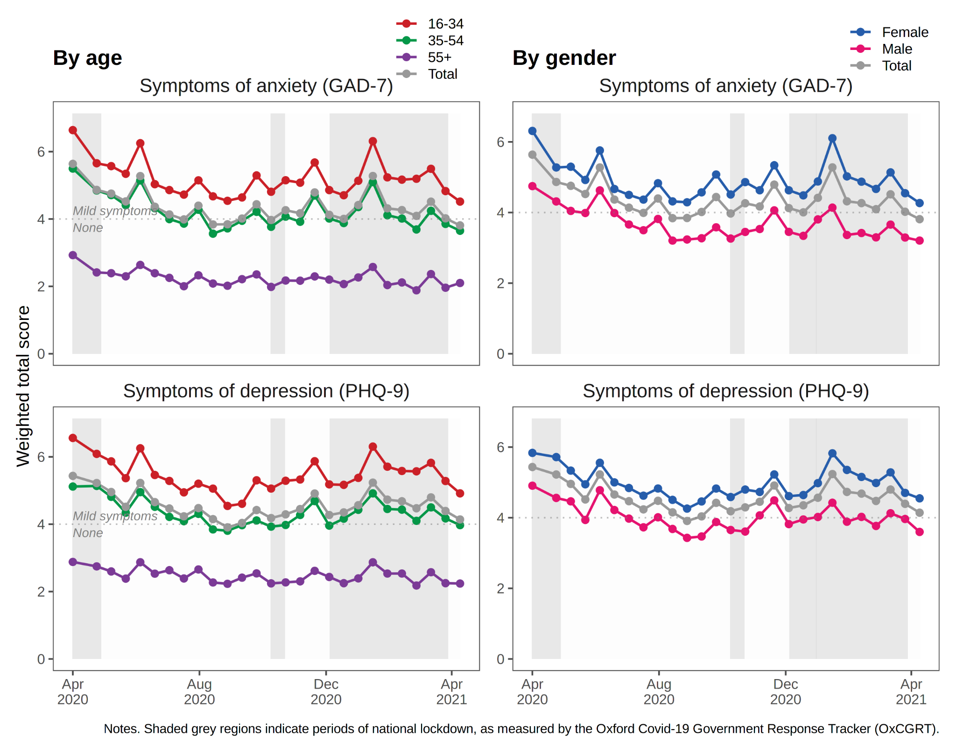

## Longitudinal trends in average levels of anxiety and depression

Figure 1 presents weighted mean scores for each outcome (GAD-7 anxiety and PHQ-9 depression) at each survey period between April 2020 and April 2021. On average, participants reported low levels of anxiety and depression (scores consistent with ‘None’ or ‘Mild’ symptoms) over time. Symptoms were highest in April 2020 and decreased over the summer months when no lockdown measures were in place. However, scores increased again in December 2020 at a time of rising case numbers and reinstated national lockdown measures.

To better understand these trends across demographic groups, these trajectories were stratified by age group and gender. When stratifying by age, younger individuals scored higher on both anxiety and depression than older participants, with 16–34-year-olds reporting ‘mild anxiety’ throughout the year, while 55+ year olds presented with no anxiety and depression over time. Males and females followed similar trajectories for both anxiety and depression, however, females presented with higher scores than males at each survey period.

## Trajectories of anxiety and depression symptoms

Based on model fit and substantive interpretability, we chose a 4-class model for both anxiety and depression. While model fit could be improved by going beyond four classes (see [Supplementary Table 2](https://docs.google.com/document/u/0/d/1FJ3wt83vQvQjNHqgvlp6k5-dlW6TZCbNOmFdCQr-WKw/edit)), this was at the expense of interpretability. Additional classes tended to differ only quantitatively, not qualitatively – that is, they indicated similar *types* of trajectory but at higher or lower severity, compared to the chosen four classes. The 4-class trajectories for symptoms of anxiety and depression are shown in Figure 2. This figure presents mean scores estimated by the model (solid line) alongside the observed data (points). For both outcomes, the four classes can be characterised as follows:

**Class 1:** *‘Persistent high severity symptoms’* (n = 145 (6%) and 153 (7%) for symptoms of anxiety and depression, respectively). This class reported scores consistent with ‘Probable’ anxiety and depression’ (>10) throughout the year. Mean scores increased consistently from April 2020, with the exception of depressive symptoms which started to decline in early 2021.

**Class 2:** *‘Varying symptoms, opposing national cases’* (n = 176 (8%) and 82 (4%) for anxiety and depression, respectively). This class experienced fluctuating symptoms over the year, at and exceeding the threshold for ‘Probable’ anxiety and depression. Notably, for both anxiety and depression, this class reported symptoms that were at odds with the national context of COVID-19 case numbers and hospitalisations in the UK. Between April and September 2020, as Covid cases in the UK declined, this class experienced a worsening of symptoms of anxiety and depression. Similarly, as national case numbers increased in December 2020 and lockdown measures returned, this class experienced improving symptoms.

**Class 3:** *‘Varying symptoms, in line with cases’* (n = 257 (11%) and 134 (6%) for anxiety and depression, respectively). Like Class 2, this class experienced fluctuating symptoms throughout the year, but varied in line with COVID case numbers in the UK. As COVID cases declined during April to August 2020, this class experienced reductions in symptom severity; during the winter months, as COVID cases rose, this class reported increasing levels of anxiety and depression.

**Class 4:** *‘Persistent low level symptoms’* (n = 1664 (74%) and 1873 (84%) for anxiety and depression, respectively). This class comprised the majority of respondents who reported lower symptoms throughout the year, at or below ‘Mild’ anxiety and depression. Symptoms for this group were highest in April 2020 but declined thereafter.

## Baseline predictors of trajectory class membership

To consider how participant characteristics at baseline were associated with different trajectory types, we used multinomial logistic regression (via the R3STEP method in Mplus) to estimate the odds of assignment to each class for a unit change in each covariate. Figure 3 presents odds ratios for assignment to Classes 1 to 3. The majority class, Class 4 (‘Persistent low level symptoms’) was treated as the reference category. Each covariate was tested in a separate model, adjusted for age and gender. Age was scaled such that a one unit change represents a 10-year difference in age.

For anxiety, younger age and female gender were positively associated with assignment to one of the higher or fluctuating severity classes, compared to Class 4 (‘Low level symptoms’). A 10-year increase in age was associated with a two-fold reduction in the odds of assignment to the higher severity classes. Conversely, female gender was associated with increased odds (odds ratios (OR) = 1.43 to 1.67) of belonging to the higher severity classes, although not reaching thresholds for statistical significance. For depression, increased age was similarly associated with reduced odds of assignment to Classes 1 to 3, although associations for gender were reduced.

For both anxiety and depression, single respondents were more likely to be in Class 1 (‘Persistent high severity’), compared to those living in a partnership (OR = 1.65 and 2.74, respectively). For depression, living alone was associated with increased odds of assignment to Class 1 (‘Persistent high severity’; OR = 1.87) and Class 2 (‘Opposing cases’; OR = 2.21), compared to living with others. For anxiety, respondents with young children had increased odds of assignment to Class 3 (‘Varying in line with cases’), compared to the majority low severity class (OR = 1.62; 95% confidence intervals (CI): 0.95, 2.80). For depression, those with young children had reduced odds of assignment to Class 2 (‘Varying, opposing cases’; OR = 0.33; CI: 0.12, 0.92), indicating depressive symptoms increased as the strictness of lockdown measures and case numbers diminished.

For anxiety, having another caring role besides childcare was strongly associated with assignment to the higher severity classes (OR = 1.91 to 2.54), although reaching statistical significance only for Class 1 (‘Persistent high severity’). Shielding was also strongly associated with more severe symptoms of anxiety. Those shielding were twice as likely to be assigned to Class 1 (OR = 1.98; CI: 0.57, 6.84) and four times as likely to be assigned to the ‘varying symptoms’ Class 2 (OR = 4.44; CI: 1.24, 15.9) and Class 3 (OR = 4.02; CI: 0.86, 18.8). This indicates differential impacts of shielding, associated with worsening or improving symptoms of anxiety as lockdown measures eased and case numbers declined. Similar associations of shielding were not observed for depression.

Finally, a previous diagnosis of anxiety or depression was strongly associated with membership in all three higher severity classes (OR = 3.20 to 3.7X for anxiety; 3.1X to 6.8X for depression), compared to the ‘lower severity’ majority class.

**Figure 2.** Trajectory classes from 4-class GMM model for symptoms of anxiety and depression (n=2241).

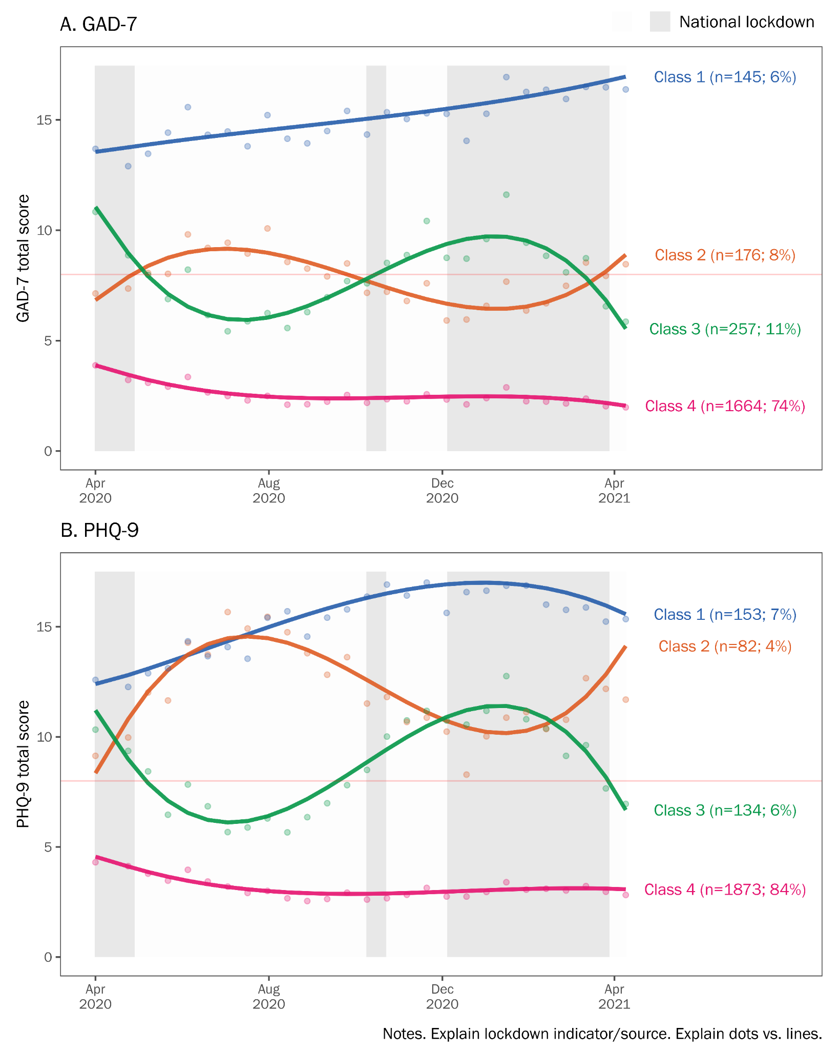

**Figure 3:** Associations of baseline variables with trajectory class assignment (n=2241)

Reference class is ‘low severity’. Odds ratios also presented in [Supplementary Table 2](https://docs.google.com/document/u/0/d/1FJ3wt83vQvQjNHqgvlp6k5-dlW6TZCbNOmFdCQr-WKw/edit).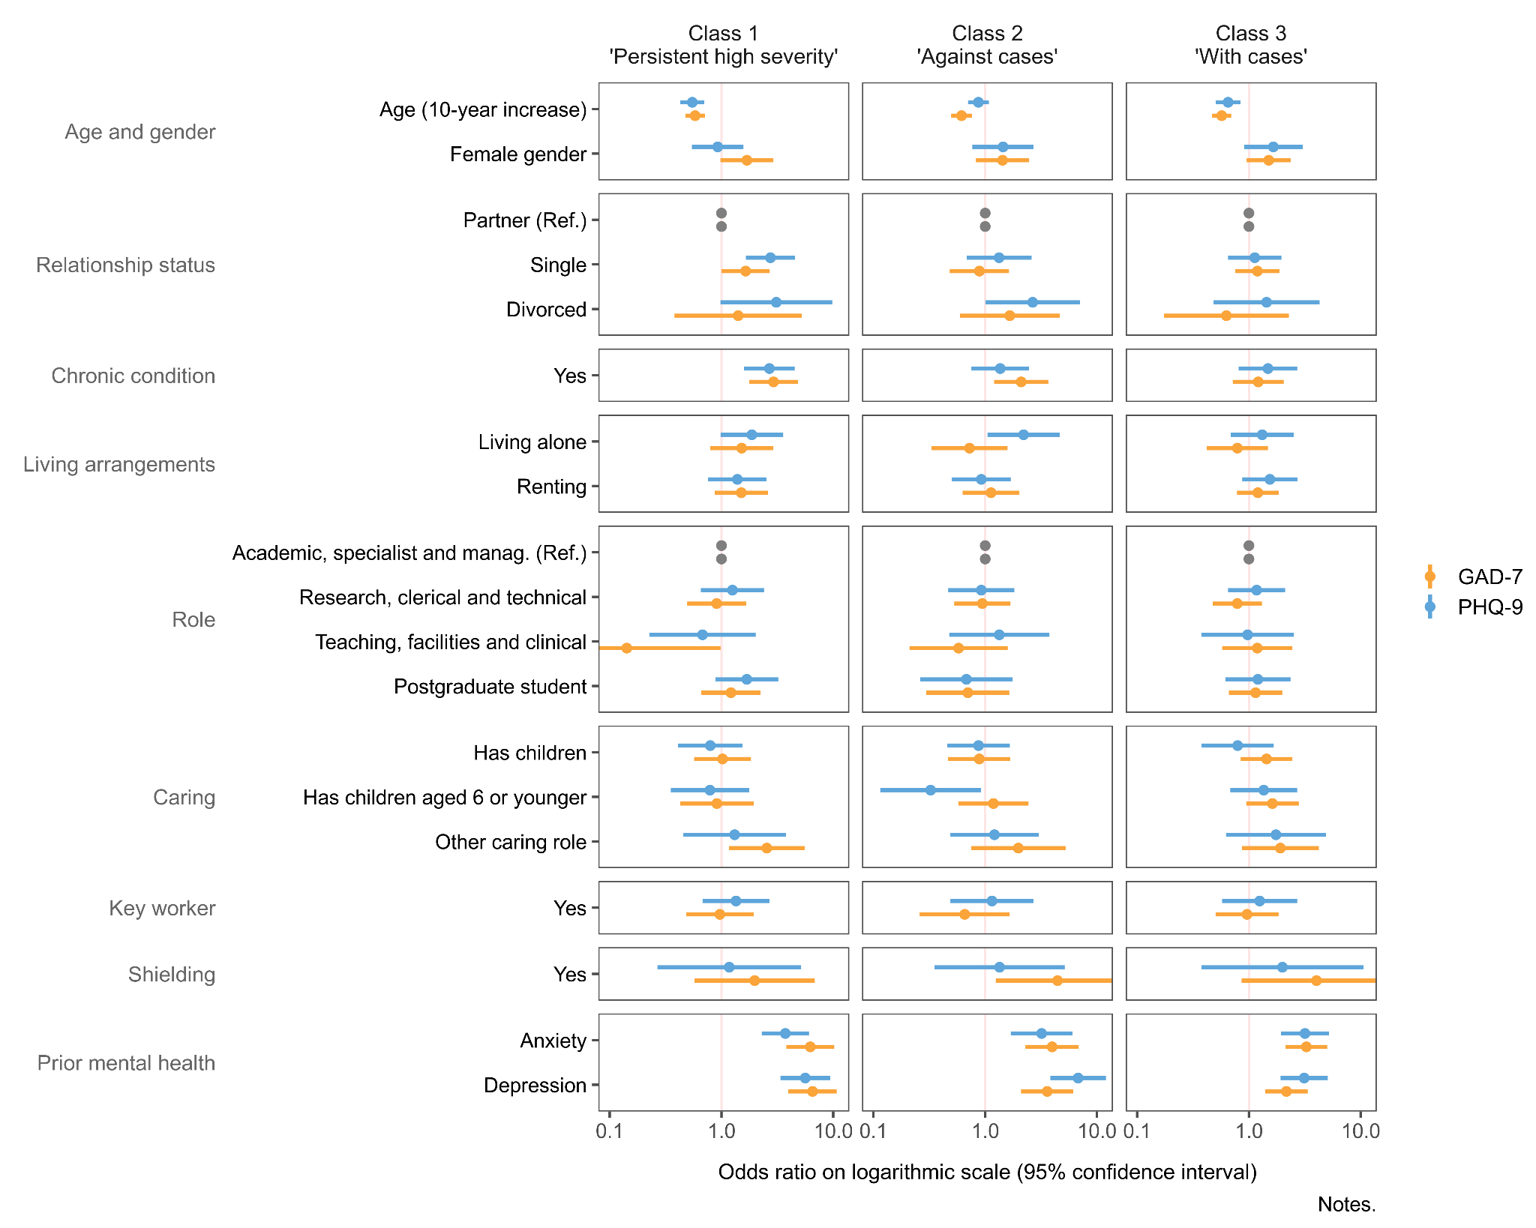

**Question for feedback:**

* The above figure omits ethnicity. There are very few participants in some ethnic groups, and consequently, we can’t really estimate the odds of class assignment by ethnicity. (The results are unstable with huge CIs. For example, OR = 12.1, 95% CI = 0.30, 326.23).
* How should we handle this?
  + **Option 1:** Omit ethnicity from the models, and explain why. (This isn’t good, because it looks as though we’re ignoring or overlooking ethnicity, despite measuring it in the survey).
  + **Option 2:** Include ethnicity in the models, but explain that the ORs aren’t interpretable.
  + **Option 3:** Include dummy variables for minority ethnic groups with sufficient sample size (i.e. Asian). This is likely even more problematic than leaving ethnicity out entirely.
* I’ve gone with Option 1 for now, but am open to other ideas.

# Discussion

In a large, occupational cohort with fortnightly follow-up and high response rates, we described trajectories of anxiety and depression symptoms in the first year of the COVID-19 pandemic (2020-2021) in the UK. We found that symptoms of anxiety and depression were highest at the start of the pandemic, eased over the summer months, and increased again in December. These fluctuations mirror national patterns of lockdown and numbers of cases and hospitalisations. While average levels of anxiety and depression were low throughout the year (scores consistent with ‘None’ or ‘Mild’ symptoms), these hid much greater variation among subgroups of respondents. Using growth mixture models, we identified four trajectory types for anxiety and depression. While most participants were assigned to the ‘persistent low-level symptoms’ trajectory class, others experienced more severe and variable symptoms. One group reported high severity symptoms throughout the year (‘persistent high severity’) whereas two groups reported fluctuating, moderate symptoms. Notably, these were in opposing directions. Some respondents reported reductions in symptom severity as lockdown measures eased, while at the same time, others experienced increasing anxiety and depression.

## Comparison with past studies

* Our findings are consistent with Pierce et al. [[35]](https://www.zotero.org/google-docs/?GCBgQr), who identified similar trajectories of mental health based on nationally representative surveys conducted before and during the pandemic. Based on the General Health Questionnaire (GHQ-12), their analysis identified five classes: a majority of respondents (77%) belonged to ‘Consistently good’ or ‘Consistently very good’ classes, whereas and a minority (4.1%) to a ‘Consistently very poor’ class. Like us, they also identified two classes with moderate symptoms that experienced opposing trajectories. One (‘Deteriorating’) saw worsening symptoms in the period from April to July, whereas another (‘Recovery’) saw improving symptoms. These classes mirror our ‘Varying symptoms’ classes. Importantly, whereas Pierce et al. incorporated data up until September 2020, our trajectories extended until April 2021. Our findings suggest that the ‘deterioration’ and ‘recovery’ trajectories identified by Pierce et al. may change direction again in December 2020, as case numbers rose and lockdown measures were reintroduced.
* Pierce et al. also considered demographic differences between their trajectory classes. Like us, they found... .
* To add: Knudsen et al. [[36]](https://www.zotero.org/google-docs/?7FXUtc).
  + Mental disorder among Norwegian adult population, based on psychiatric interviews.
  + They report a *reduction* in mental disorder prevalence between ‘pre-pandemic’ and during the pandemic; similar patterns with regards to age, gender, children, etc.
* Our findings are also consistent with previous work by the UCL Social Study [[37]](https://www.zotero.org/google-docs/?LKHvLl) that found levels of anxiety and depression to be highest at the start of the pandemic and trends that mirrored lockdown restrictions. Furthermore, when considering aggregate trends the identification of younger age and female gender as important risk factors for higher severity symptoms was consistent with previous findings [ref, ref].
* Previous work researching the heterogeneous nature of mental health during the first lockdown, April 2020 to September 2020, mirrored our findings with the largest class reporting continuously low level symptoms, while the other classes reported continuously high symptoms, symptoms that covaried with lockdown, or reported highest levels at the start of the pandemic [[17]](https://www.zotero.org/google-docs/?7DiDDt). However, one limitation in this previous work is that it builds the trajectory models of one lockdown and easing period, meanwhile the current study presents data across two lockdown and easing periods.
* Finally, when considering baseline covariates with class types, previous work found that more severe trajectories of anxiety and depression were associated with participants that were younger [ref], had pre-existing mental health [ref] and caring responsibilities [ref].

However, on average participants reported low levels of anxiety and depression over time, results mirrored in work by (citation). Thus, a need was identified to try and understand if there are subgroups of participants with differing trajectories of anxiety and depression over time that are getting misrepresented in the aggregate trends.

Analysis of trajectories identified four subgroups’ participants with: (1) persistent high severity symptoms, (2) varying symptoms over time, that fluctuated in opposing direction to cases and hospitalisations in the UK, (3) varying symptoms fluctuating in line with cases and hospitalisations in the UK and (4) persistent low-level symptoms. THow does this compare?

## Policy implications/results in context

This is still evolving, suggestions welcome, but key points are likely to include:

* Experiences of the pandemic, and the impact on mental health, are highly variable. It is therefore important to address the mental health needs of specific subgroups.
* Some respondents were highly responses to changes in the wider circumstances, such as lockdown measures or school closures. As university campuses resume in-person activities, these groups may need additional support.
  + We saw diverging trajectories classes. Some respondents reported improving symptoms as lockdown measures eased, other worsening (e.g. the ‘Varying symptoms, opposing cases’ trajectory class).
  + The pandemic will continue to be unpredictable. Individuals who were more affected (by uncertainty, by lockdown, or easing restrictions) will continue to need additional support.
  + Most immediately: the return to campus for staff and students from September 2021. The consequences for mental health of returning to work (or the prospect of returning) is likely to vary between individuals.
  + Higher education has room for improvement regarding the provision of mental health support to staff and students (i.e. connect up with this point from the Introduction).
* We could also have a point about improving online surveys.
  + Frequent data collection essential to understanding temporality of mental health in relation to the pandemic.
  + Detailed information on characteristics of the target population is needed to understand representativeness and generate sampling weights.
  + Even so, most surveys continue to (at times, severely) under-represent minority groups. Oversampling of under-represented groups would help, but this requires a sampling frame (and a probability sample). Most online surveys are convenience samples.
* [...]

## Strengths and limitations

Our study benefited from a large, well-defined sample that included nearly one quarter of KCL staff and PGR students. All participants were working or studying at KCL, and therefore, will have received similar communications from the university and experienced similar workplace policies. Follow-up information was collected fortnightly for 12 months and response rates remained high throughout the study. We drew on administrative data to describe and account for compositional differences between the sample and target population using sampling weights. We also derived longitudinal weights to account for non-response. Our use of latent growth curve modelling made efficient use of the available data and retained all participants with at least one follow-up assessment. We used previously validated measures of mental health and adjusted for several important confounders. In particular, our assessment of prior mental health differentiated between anxiety and depression, whereas similar studies have used a simpler measure of ‘previous mental health diagnosis’ [[37]](https://www.zotero.org/google-docs/?TgNS2c).

However, there are several limitations that readers should keep in mind when interpreting our results. First, although nearly one quarter of the target population participated in the survey, male gender and minority ethnic groups were under-represented in our sample. We derived sampling weights to account for differences between sample and population, but weights cannot make up for the missing experiences from smaller groups or intersectional groups that are present in very small numbers (such as non-binary gender and Black staff). Small numbers of respondents from ethnic minority groups also meant we were unable to assess how ethnicity was associated with trajectory class assignment. Second, occupational studies have previously been shown to report higher levels of psychological stress, compared to population studies [[38]](https://www.zotero.org/google-docs/?hRBe4l), which should also be considered when interpreting our results. Third, we lacked information on mental health among staff and PGR students from before the pandemic and cannot say how the observed trends or differences compare to previous years. Past studies have shown […] [[39]](https://www.zotero.org/google-docs/?1to5I1), therefore… .It is also important to stress that we identified variables associated with mental health during a pandemic, rather than specific causal effects of COVID-19 on mental health. Many of the observed risk factors are likely to have existed in 2019 and earlier [[3]](https://www.zotero.org/google-docs/?l2cjo9).

# Conclusions

Our findings highlight differing individual responses to the pandemic and underscore the need to consider individual circumstances when assessing and treating mental health. Aggregate trends in anxiety and depression can easily hide greater variation, and symptom severity, experienced by subgroups. As university campuses resume in-person activities it will be important to ensure vulnerable groups are adequately supported. This includes those likely to experience worsening mental health with easing restrictions as well as those with identified risk factors, such as having young children at home, other caring roles, a history of mental illness, or those who are shielding.

# References

[1 Hotopf M, Bullmore E, O’Connor RC, *et al.* The scope of mental health research in the COVID-19 Pandemic and its aftermath. *The British Journal of Psychiatry* 2020;:1–7.](https://www.zotero.org/google-docs/?DMllNz)

[2 Kohler U. Survey Research Methods during the COVID-19 Crisis. *Survey Research Methods* 2020;**14**:93–4. doi:10.18148/srm/2020.v14i2.7769](https://www.zotero.org/google-docs/?DMllNz)

[3 Lin Y-H, Chen C-Y, Wu S-I. Efficiency and Quality of Data Collection Among Public Mental Health Surveys Conducted During the COVID-19 Pandemic: Systematic Review. *Journal of Medical Internet Research* 2021;**23**:e25118. doi:10.2196/25118](https://www.zotero.org/google-docs/?DMllNz)

[4 Bernardini F, Attademo L, Rotter M, *et al.* Social Determinants of Mental Health As Mediators and Moderators of the Mental Health Impacts of the COVID-19 Pandemic. *PS* 2021;**72**:598–601. doi:10.1176/appi.ps.202000393](https://www.zotero.org/google-docs/?DMllNz)

[5 Robinson E, Sutin AR, Daly M, *et al.* A systematic review and meta-analysis of longitudinal cohort studies comparing mental health before versus during the COVID-19 pandemic. *medRxiv* 2021;:2021.03.04.21252921. doi:10.1101/2021.03.04.21252921](https://www.zotero.org/google-docs/?DMllNz)

[6 Vindegaard N, Benros ME. COVID-19 pandemic and mental health consequences: Systematic review of the current evidence. *Brain, Behavior, and Immunity* 2020;**89**:531–42. doi:10.1016/j.bbi.2020.05.048](https://www.zotero.org/google-docs/?DMllNz)

[7 Boden M, Zimmerman L, Azevedo KJ, *et al.* Addressing the mental health impact of COVID-19 through population health. *Clinical Psychology Review* 2021;**85**:102006. doi:10.1016/j.cpr.2021.102006](https://www.zotero.org/google-docs/?DMllNz)

[8 Wei J, Hou R, Zhang X, *et al.* The association of late-life depression with all-cause and cardiovascular mortality among community-dwelling older adults: systematic review and meta-analysis. *The British Journal of Psychiatry* 2019;**215**:449–55. doi:10.1192/bjp.2019.74](https://www.zotero.org/google-docs/?DMllNz)

[9 Godderis L, Luyten J. Challenges and opportunities for occupational health and safety after the COVID-19 lockdowns. 2020.](https://www.zotero.org/google-docs/?DMllNz)

[10 Xiong J, Lipsitz O, Nasri F, *et al.* Impact of COVID-19 pandemic on mental health in the general population: A systematic review. *Journal of Affective Disorders* 2020.](https://www.zotero.org/google-docs/?DMllNz)

[11 Universities UK. Recovery, Skills, Knowledge and Opportunity. London: : Universities UK 2020. https://www.universitiesuk.ac.uk/policy-and-analysis/reports/Documents/2020/uuk-he-vision.pdf (accessed 2 Aug 2021).](https://www.zotero.org/google-docs/?DMllNz)

[12 Rees R, Stokes G, Stansfield C, *et al. Prevalence of mental health disorders in adult minority ethnic populations in England: a systematic review*. 2016.](https://www.zotero.org/google-docs/?DMllNz)

[13 McManus S, Bebbington P, Jenkins R, *et al. Mental health and wellbeing in England: Adult Psychiatric Morbidity Survey 2014 : a survey carried out for NHS Digital by NatCen Social Research and the Department of Health Sciences, University of Leicester.* 2016.](https://www.zotero.org/google-docs/?DMllNz)

[14 Universities UK. Government decision on student returns in England “hugely disappointing for students.” 2021.https://www.universitiesuk.ac.uk/news/Pages/uuk-response-to-government-update-on-student-returns-in-England.aspx (accessed 18 Aug 2021).](https://www.zotero.org/google-docs/?DMllNz)

[15 Davis KAS, Stevelink SAM, Al-Chalabi A, *et al.* The King’s College London Coronavirus Health and Experiences of Colleagues at King’s Study (KCL CHECK) protocol paper: a platform for study of the effects of coronavirus pandemic on staff and postgraduate students. *medRxiv* 2020;:2020.06.16.20132456. doi:10.1101/2020.06.16.20132456](https://www.zotero.org/google-docs/?DMllNz)

[16 Carr E. Mental health among UK university staff and postgraduate students in the early stages of the COVID-19 pandemic. *Occupational and Environmental Medicine* 2021.](https://www.zotero.org/google-docs/?DMllNz)

[17 Ellwardt L, Präg P. Heterogeneous Mental Health Development During the COVID-19 Pandemic in the United Kingdom. *medRxiv* 2021;:2021.02.24.21251565. doi:10.1101/2021.02.24.21251565](https://www.zotero.org/google-docs/?DMllNz)

[18 Universities UK. Stepchange: mentally healthy universities. 2020;:36.](https://www.zotero.org/google-docs/?DMllNz)

[19 Besser A, Lotem S, Zeigler-Hill V. Psychological Stress and Vocal Symptoms Among University Professors in Israel: Implications of the Shift to Online Synchronous Teaching During the COVID-19 Pandemic. *Journal of Voice* 2020;**0**. doi:10.1016/j.jvoice.2020.05.028](https://www.zotero.org/google-docs/?DMllNz)

[20 Gautam R, Sharma M. 2019-nCoV pandemic: A disruptive and stressful atmosphere for Indian academic fraternity. *Brain, Behavior, and Immunity* 2020;**88**:948–9. doi:10.1016/j.bbi.2020.04.025](https://www.zotero.org/google-docs/?DMllNz)

[21 Odriozola-González P, Planchuelo-Gómez Á, Irurtia MJ, *et al.* Psychological effects of the COVID-19 outbreak and lockdown among students and workers of a Spanish university. *Psychiatry Research* 2020;**290**:113108. doi:10.1016/j.psychres.2020.113108](https://www.zotero.org/google-docs/?DMllNz)

[22 Hale T, Angrist N, Goldszmidt R, *et al.* A global panel database of pandemic policies (Oxford COVID-19 Government Response Tracker). *Nat Hum Behav* 2021;**5**:529–38. doi:10.1038/s41562-021-01079-8](https://www.zotero.org/google-docs/?DMllNz)

[23 Kroenke K, Spitzer RL, Williams JB. The PHQ‐9: validity of a brief depression severity measure. *Journal of general internal medicine* 2001;**16**:606–13.](https://www.zotero.org/google-docs/?DMllNz)

[24 Spitzer RL, Kroenke K, Williams JBW, *et al.* A Brief Measure for Assessing Generalized Anxiety Disorder: The GAD-7. *Arch Intern Med* 2006;**166**:1092–7. doi:10.1001/archinte.166.10.1092](https://www.zotero.org/google-docs/?DMllNz)

[25 Downey RG, King CV. Missing Data in Likert Ratings: A Comparison of Replacement Methods. *The Journal of General Psychology* 1998;**125**:175–91. doi:10.1080/00221309809595542](https://www.zotero.org/google-docs/?DMllNz)

[26 Wickrama K, Lee TK, O’Neal CW, *et al. Higher-Order Growth Curves and Mixture Modeling with Mplus: A Practical Guide*. New York: : Routledge 2016. doi:10.4324/9781315642741](https://www.zotero.org/google-docs/?DMllNz)

[27 Sclove SL. Application of model-selection criteria to some problems in multivariate analysis. *Psychometrika* 1987;**52**:333–43. doi:10.1007/BF02294360](https://www.zotero.org/google-docs/?DMllNz)

[28 Lo Y, Mendell NR, Rubin DB. Testing the Number of Components in a Normal Mixture. *Biometrika* 2001;**88**:767–78.](https://www.zotero.org/google-docs/?DMllNz)

[29 Nylund KL, Asparouhov T, Muthén BO. Deciding on the Number of Classes in Latent Class Analysis and Growth Mixture Modeling: A Monte Carlo Simulation Study. *Structural Equation Modeling: A Multidisciplinary Journal* 2007;**14**:535–69. doi:10.1080/10705510701575396](https://www.zotero.org/google-docs/?DMllNz)

[30 Asparouhov T, Muthén B. Auxiliary Variables in Mixture Modeling: Three-Step Approaches Using Mplus. *Structural Equation Modeling: A Multidisciplinary Journal* 2014;**21**:329–41. doi:10.1080/10705511.2014.915181](https://www.zotero.org/google-docs/?DMllNz)

[31 R Core Team. *R: A language and environment for statistical computing*. Vienna, Austria: 2020. https://www.R-project.org/](https://www.zotero.org/google-docs/?DMllNz)

[32 Hallquist MN, Wiley JF. MplusAutomation: An R Package for Facilitating Large-Scale Latent Variable Analyses in Mplus. *Structural Equation Modeling: A Multidisciplinary Journal* 2018;**0**:1–18. doi:10.1080/10705511.2017.1402334](https://www.zotero.org/google-docs/?DMllNz)

[33 Lumley T. Analysis of complex survey samples. *Journal of Statistical Software* 2004;**9**:1–19.](https://www.zotero.org/google-docs/?DMllNz)

[34 Enders CK, Bandalos DL. The Relative Performance of Full Information Maximum Likelihood Estimation for Missing Data in Structural Equation Models. *Structural Equation Modeling: A Multidisciplinary Journal* 2001;**8**:430–57. doi:10.1207/S15328007SEM0803_5](https://www.zotero.org/google-docs/?DMllNz)

[35 Pierce M, McManus S, Hope H, *et al.* Mental health responses to the COVID-19 pandemic: a latent class trajectory analysis using longitudinal UK data. *The Lancet Psychiatry* 2021;**8**:610–9. doi:10.1016/S2215-0366(21)00151-6](https://www.zotero.org/google-docs/?DMllNz)

[36 Knudsen AKS, Stene-Larsen K, Gustavson K, *et al.* Prevalence of mental disorders, suicidal ideation and suicides in the general population before and during the COVID-19 pandemic in Norway: A population-based repeated cross-sectional analysis. *The Lancet Regional Health - Europe* 2021;**4**:100071. doi:10.1016/j.lanepe.2021.100071](https://www.zotero.org/google-docs/?DMllNz)

[37 Fancourt D, Feifei B, Hei Wan M, *et al.* Covid-19 Social Study: Results Release 36. London: : University College London 2021. https://b6bdcb03-332c-4ff9-8b9d-28f9c957493a.filesusr.com/ugd/3d9db5_93342fa7cccf45b194f8c6ec6c16e66f.pdf (accessed 18 Aug 2021).](https://www.zotero.org/google-docs/?DMllNz)

[38 Goodwin L, Ben-Zion I, Fear NT, *et al.* Are Reports of Psychological Stress Higher in Occupational Studies? A Systematic Review across Occupational and Population Based Studies. *PLOS ONE* 2013;**8**:e78693. doi:10.1371/journal.pone.0078693](https://www.zotero.org/google-docs/?DMllNz)

[39 Pierce M, Hope H, Ford T, *et al.* Mental health before and during the COVID-19 pandemic: a longitudinal probability sample survey of the UK population. *The Lancet Psychiatry* Published Online First: 2020. doi:10.1016/S2215-0366(20)30308-4](https://www.zotero.org/google-docs/?DMllNz)

[40 ONS. Ethnic group, national identity and religion - Office for National Statistics. Ethnic group, national identity and religion. 2020.https://www.ons.gov.uk/methodology/classificationsandstandards/measuringequality/ethnicgroupnationalidentityandreligion#ethnic-group (accessed 10 Dec 2020).](https://www.zotero.org/google-docs/?DMllNz)

1. Defined as “not leaving house with exceptions for daily exercise, grocery shopping, and ‘essential’ trips” or “not leaving house with minimal exceptions (e.g., allowed to leave once a week, or only one person can leave at a time, etc.)”.
2. <https://github.com/ewancarr/check-longitudinal>