Trajectories of mental health among UK university staff and postgraduate students during the pandemic

Ewan Carr1*, Carolin Oetzmann2*, Katrina Davis2, Gabriella Bergin-Cartwright2, Grace Lavelle2, Daniel Leightley2, Kate Polling2,3, Sharon A.M. Stevelink2, Alice Wickersham2, …, Reza Razavi4, and Matthew Hotopf2,3

1 Department of Biostatistics and Health Informatics, Institute of Psychology, Psychiatry and Neuroscience, King’s College London, London, UK.

2 Department of Psychological Medicine, Institute of Psychology, Psychiatry and Neuroscience, King’s College London, London, UK.

3 South London and Maudsley NHS Foundation Trust, London, UK.

4 King’s College London School of Biomedical Engineering and Imaging Sciences, Faculty of Life Sciences and Medicine, London, United Kingdom.

* Contributed equally

## Funding/acknowledgements

This paper represents independent research part-funded by the National Institute for Health Research (NIHR) Maudsley Biomedical Research Centre at South London and Maudsley NHS Foundation Trust and King’s College London. The views expressed are those of the author(s) and not necessarily those of the NHS, the NIHR or the Department of Health and Social Care.

What is already known about this subject?

* Research among the general population into the impact of the pandemic on anxiety, depression, and other symptoms of distress have shown that, on average, people reported higher levels of symptoms in the early phases of the pandemic and discussed the public policy objectives needed to improve mental wellbeing. However, few studies have assessed the individual variation seen within these averages, particularly from an occupational cohort perspective, as employers play a key role in navigating the ‘new normal’.

What are the new findings?

* During the first year of the pandemic, on average, participants reported low levels of anxiety and depression, with symptoms improving when restrictions were lifted. However, when subgrouping the participants, it was observed that these data hide significant variability in symptom trajectories and how individuals vary with easing and tightening of restrictions.

How might this impact on policy or clinical practice in the foreseeable future?

* When considering the pandemic’s impact on mental health, and how to best provide support, employers, policymakers, and wellbeing managers across the higher educational sector (and beyond), need to account for the variability in experiences and wellbeing trajectories of their employees and will need to provide support in a variety of ways to accommodate the needs of each subgroup.

**Abstract**

| Background | The COVID-19 pandemic and subsequent containment measures have disrupted the social and working lives of many. Past studies have highlighted worsening mental health due to the pandemic. However, many existing studies rely on infrequent follow-up and small sample sizes. This study fills this gap by drawing on fortnightly information from a large, occupational cohort. It describes differing trajectories of mental health between April 2020 and April 2021 and individual characteristics associated with these trajectory types. |
| --- | --- |
| Methods | KCL CHECK is a longitudinal occupational cohort study at a large university in London, United Kingdom. Participants (n=2241) completed online questionnaires fortnightly between April 2020 and April 2021. Sociodemographic and clinical characteristics were measured at baseline. Symptoms of anxiety and depression were assessed (using GAD-7 and PHQ-9 respectively) repeatedly. Differing trajectories of mental health were identified using growth mixture models. |
| Results | On average, participants reported low levels of anxiety and depression (scores consistent with ‘None’ or ‘Mild’ symptoms) throughout the year, with symptoms highest in April 2020 and decreasing over the summer months when no lockdown measures were in place. However, we observed more severe and variable symptoms among subgroups of participants. Four trajectory types for anxiety and depression were identified: 1) ‘Persistent high severity’; 2) ‘Varying symptoms, opposing cases’; 3) ‘Varying symptoms, in line with cases’; 4) ‘Persistent low severity’. Characteristics such as younger age, female gender, caring responsibilities, and shielding were positively associated with higher severity trajectory types. Both having young children at home and living alone were associated with the ‘varying symptoms, opposing cases’ trajectory, which saw increasing levels of anxiety and depressive symptoms as lockdown measures eased and national case numbers diminished. |
| Conclusions | These data highlight differing individual responses to the pandemic and underscore the need to consider individual circumstances when assessing and treating mental health. Aggregate trends in anxiety and depression can easily hide greater variation, and symptom severity, experienced by subgroups. |

# Introduction

The COVID-19 pandemic is a threat to wellbeing, not only from infection with the SARS-CoV-2 virus itself, but also indirectly through public health measures such as social isolation and changes to home working and schooling. The potential impact of the pandemic on mental health was highlighted early in 2020 [[1]](https://www.zotero.org/google-docs/?MNVdpI). Since then, numerous studies have assessed symptoms of distress, depression and anxiety, with mixed methodological rigour and heterogeneous findings [[1–3]](https://www.zotero.org/google-docs/?54cQlJ). The consensus has been that, on average, people in the early phases of the pandemic reported significantly higher levels of symptoms, compared to before the pandemic, but that the impact on mental health was unevenly felt across the population [[4–6]](https://www.zotero.org/google-docs/?YqMiiL).

Insights from cross-sectional findings are limited. Mental health is dynamic and support needs to reflect individual experiences that evolve over time alongside the pandemic and public health response. Longitudinal assessments of mental health to identify vulnerable groups are therefore important for policy makers when planning for COVID-19 response and recovery [[7,8]](https://www.zotero.org/google-docs/?byM1IW). Support from employers is also important for wellbeing, and for confidence in navigating the ‘new normal’ after the more acute phases of the pandemic [[1,9,10]](https://www.zotero.org/google-docs/?NAy12m). Occupational cohorts are therefore needed to inform employers about mental health support needs among their employees.

Universities are large employers comprising a variety of staff roles. This includes academic and support staff catering to students, but also early career researchers, specialised technicians and advisors, and those supporting the facilities [[11]](https://www.zotero.org/google-docs/?4EeAh7). Individual experiences of the pandemic, and the impact on mental health, are likely to vary across job roles. For example, between those who have regular contact with members of the public, vs. those who can work remotely most or all of the time. Besides job role, factors associated with poor mental health in populations prior to the pandemic include younger age, female gender, belonging to an ethnic minority group [[12]](https://www.zotero.org/google-docs/?kiLyOP), prior diagnosis of mental disorder, and caregiving responsibilities [[13]](https://www.zotero.org/google-docs/?07x5L6). In addition, recent studies have identified specific determinants of mental health that are caused or exacerbated by the pandemic. These include living alone, being a key worker, or having children at home, particularly school age children affected by school closures [[7]](https://www.zotero.org/google-docs/?nAmQW4).

King’s College London (KCL) is a large university with five campuses in central London, United Kingdom (UK). On 23rd March 2020, KCL closed its campuses to all except essential workers and moved most activities online. In April 2020, the university set up the “King’s College London Coronavirus Health and Experiences of Colleagues at King’s” (KCL CHECK) project to understand the impact of the pandemic on staff and postgraduate research students (PGR) and inform policy making within the university [[14]](https://www.zotero.org/google-docs/?fl4yXL). We have previously reported on symptoms of depression and anxiety collected at the baseline questionnaire in April 2020 [[15]](https://www.zotero.org/google-docs/?PvlL9K). Consistent with other UK studies from this period, the baseline survey found around 1/5 staff and 1/3 PGRs to score above clinical cut-offs on depression and anxiety screening questionnaires. Ellwardt and Präg [[16]](https://www.zotero.org/google-docs/?lLi0lO) reported that from April to September 2020, most people reported very low or low symptoms at all times, while others reported high levels or more dynamic symptoms throughout. This previous study identified younger age and female gender as important risk factors for higher severity symptoms of depression and anxiety, consistent with findings from before the pandemic [[17]](https://www.zotero.org/google-docs/?mTGRdU). Living alone or with young children were also found to be important [[17,18]](https://www.zotero.org/google-docs/?JKHoWP).

The aim of this study, building on findings from the baseline survey, was to describe patterns of mental health among staff and PGRs between April 2020 and April 2021. We drew on fortnightly questionnaires collected throughout the year to (i) describe how average levels of anxiety or depression varied; and (ii) identify subgroups with differing symptom trajectories. While the KCL CHECK cohort is not nationally representative, we benefited from a large, well-defined occupational sample, high temporal resolution, and consistently high response rates. Our findings will inform a better understanding of mental health trajectories in the workplace, and particularly the higher education sector. The higher education sector is acknowledged to have room for improvement when it comes to the mental health of staff and postgraduate students [[19]](https://www.zotero.org/google-docs/?AEh9bJ). As summarised above, the 2020-2021 period has been a challenging and uncertain time for staff and students at UK universities and indeed in other parts of the world [[20–22]](https://www.zotero.org/google-docs/?0cXNwX). Therefore, longitudinal results from KCL-CHECK will be of particular interest to occupational health clinicians, employers and managers in many settings where work has been disrupted by COVID-19.

# Methods

## Data

Data were collected from staff and PGR students participating in the KCL CHECK longitudinal survey. Participants were invited via email to complete the baseline survey in April 2020. Those completing the baseline survey were also invited to participate in longitudinal surveys. All surveys were conducted online. Longitudinal surveys included shorter fortnightly questionnaires as well as longer questionnaires every two months. Between April 2020 and March 2021 there were 6 longer questionnaires and 21 fortnightly questionnaires (Please refer to [Supplementary Table 1](https://docs.google.com/document/u/0/d/1FJ3wt83vQvQjNHqgvlp6k5-dlW6TZCbNOmFdCQr-WKw/edit) for a full schedule). Of 2590 staff or PGR students responding to the baseline survey, 2508 agreed to participate in longitudinal follow-ups and are included in this analysis.

Administrative data on the demographic composition of staff and PGR student populations were obtained from centrally held administrative records. Aggregate information on age group, gender, and ethnicity were used to describe the representativeness of the survey compared to the target population and construct weights, as detailed below. Contextual data on the strictness of lockdown measures in the UK were obtained from the Oxford COVID-19 Government Response Tracker [[23]](https://www.zotero.org/google-docs/?ssoQQd).

## Measures

The outcomes were reports of symptoms associated with depression and anxiety measured using the Patient Health Questionnaire (PHQ-9) [[24]](https://www.zotero.org/google-docs/?5Js6oJ) and the Generalised Anxiety Disorder (GAD-7) [[25]](https://www.zotero.org/google-docs/?e86MZ6) scales, respectively. Where participants partially completed measures, up to two items were person-mean imputed for PHQ-9 and one for GAD-7 [[26]](https://www.zotero.org/google-docs/?MiYb0l). In our analyses, these outcomes were treated continuously, but scores of 5-9 are typically labeled as ‘Mild anxiety’ or ‘Mild depression’ and scores ≥10 used to indicate ‘Probable anxiety’ or ‘Probable depression’ [[24,25]](https://www.zotero.org/google-docs/?SUfxQS).

Covariates were self-reported by participants at baseline. These included factors previously linked to anxiety and depression, and factors likely to be associated with increased vulnerability during the pandemic: (1) demographic characteristics (age, gender, ethnicity, partnership status, health status, caring role, and occupational role); (2) health status (chronic health conditions, shielding, previous mental health diagnosis), (3) caring roles (children at home, young children, other caring responsibilities); and (4) occupational role and key worker status. Please see [supplementary materials](https://docs.google.com/document/u/0/d/1FJ3wt83vQvQjNHqgvlp6k5-dlW6TZCbNOmFdCQr-WKw/edit) for details. Ethnicity was used to describe the sample, but was omitted from regression models due to small numbers of participants in minority ethnic groups which would have produced unreliable estimates.

For visualisation purposes, information on the strictness of government lockdown policies was extracted from Oxford Covid-19 Government Response Tracker (OxCGRT; [[23]](https://www.zotero.org/google-docs/?2MLIox)). Periods of lockdown were defined as days where there was a national requirement to stay at home[1].

## Statistical analyses

The analyses were in four parts:

1. We first compared the analytical sample with excluded respondents using χ2 tests (categorical variables) and t-tests (continuous variables).
2. We then described the cohort by summarising (i) baseline characteristics and (ii) the two outcomes (GAD-7 anxiety and PHQ-9 depression) at each follow-up survey. Outcomes were summarised overall and by gender and age group.
3. Third, we used growth mixture models (GMM) to identify subgroups of participants with differing trajectories of anxiety and depression symptoms. GMMs are an extension of latent growth curve models (LGCMs) and are estimated within a structural equation modelling (SEM) framework [[27]](https://www.zotero.org/google-docs/?46GfVS). The LGCM allows us to model repeated measures of an observed variable (e.g. symptoms of anxiety) by using latent variables to represent the intercept (the initial level of the observed variable) and slope (the change over time). A GMM extends this model to allow identification of subgroups (‘latent classes’) with different intercepts and slopes, reflecting differing trajectories of symptoms over time. The GMM proceeds in two stages: (i) We first fit LGCMs to identify the most appropriate functional form of growth (e.g. linear, quadratic) for our data; (ii) We then fit GMMs with increasing numbers of latent classes and choose the optimal number of classes based on relative model fit and substantive interpretability. Modelling was conducted separately for anxiety symptoms and depression symptoms. Relative model fit was assessed based on the AIC, sample size adjusted BIC [[SABIC; 28]](https://www.zotero.org/google-docs/?THzbEF), and the Lo-Mendell-Rubin test [[29,30]](https://www.zotero.org/google-docs/?ZQAmMX). For AIC and SABIC, lower values indicated a better fit.
4. Fourth, we considered how covariates measured at baseline were associated with membership to trajectory classes using the R3STEP method in Mplus [[31]](https://www.zotero.org/google-docs/?LwgNUd). This used a multinomial logistic regression model to estimate how the odds of assignment to a particular trajectory class are associated with a unit change in each baseline predictor. We considered each covariate separately, adjusted for age and gender. Estimates are presented as odds ratios and 95% confidence intervals.

Descriptive statistics were calculated using R 4.1.0 [[32]](https://www.zotero.org/google-docs/?DKpQnF). GMM models were estimated using Mplus 8.4 using the *MplusAutomation* package [[33]](https://www.zotero.org/google-docs/?ydkaFw) for R. Survey weights were generated using the survey package for R [[34]](https://www.zotero.org/google-docs/?KoniYT). Code used in these analyses can be found online[2].

## Weighting

We derived two weights. A baseline weight adjusted for differences in age, gender, and ethnicity between the baseline cohort and the target population (all KCL staff and PGRs). A longitudinal weight adjusted for differential non-response at longitudinal follow-up. Please see [supplementary materials](https://docs.google.com/document/u/0/d/1FJ3wt83vQvQjNHqgvlp6k5-dlW6TZCbNOmFdCQr-WKw/edit) for details. Baseline statistics were weighted using the baseline weight only; longitudinal statistics were additionally weighted to account for non-response. GMM models were weighted with the baseline weight only, since these models retained all participants with at least one measurement of the outcome, and as such, were less affected by longitudinal non-response.

## Missing data

We excluded participants without any outcome data (7%) or missing information on baseline covariates (4%). Descriptive statistics were calculated based on the available sample at each time point. GMM models used full information maximum likelihood information (FIML) to retain all participants with at least one post-baseline measurement of the outcome [[35]](https://www.zotero.org/google-docs/?WlMCSi) .

# Results

## Cohort characteristics

Of 2508 participants agreeing to longitudinal follow-up, we excluded 176 participants without follow-up information on PHQ-9 and GAD-7 and 91 without information on baseline covariates. The analytical sample therefore included 2241 participants (1851 staff; 390 PGR students), representing 19% and 16% of all staff and PGR students at KCL, respectively. Excluded participants tended to be older (mean age = 39.6 vs. 38.3 years; p = 0.08) and female (70% vs. 60%; p < 0.001).

**Table 1.** Cohort characteristics at baseline (n=2241)

|  |  | Count | Weighted proportion | 95% confidence intervals |
| --- | --- | --- | --- | --- |
| Gender | Female | 1581 | 0.57 | [0.54, 0.60] |
| Male | 660 | 0.43 | [0.40, 0.46] |
| Age group | 16-34y | 941 | 0.43 | [0.40, 0.46] |
| 35-54y | 979 | 0.43 | [0.41, 0.46] |
| 55+y | 321 | 0.14 | [0.12, 0.15] |
| Ethnicity | White | 1907 | 0.71 | [0.68, 0.74] |
| Black | 32 | 0.04 | [0.03, 0.06] |
| Asian | 156 | 0.14 | [0.12, 0.17] |
| Mixed | 90 | 0.05 | [0.04, 0.06] |
| Other | 56 | 0.06 | [0.04, 0.08] |
| Role | Staff | 1851 | 0.82 | [0.80, 0.85] |
| Students | 390 | 0.18 | [0.15, 0.20] |
| Pre-existing MDD | | 519 | 0.22 | [0.20, 0.24] |
| Pre-existing GAD | | 512 | 0.21 | [0.19, 0.23] |
| Household members | Lives with others | 1991 | 0.88 | [0.87, 0.90] |
| Lives alone | 250 | 0.12 | [0.10, 0.13] |
| Number of children living with | 0 | 1600 | 0.72 | [0.70, 0.75] |
| 1 | 276 | 0.12 | [0.10, 0.14] |
| 2 | 316 | 0.14 | [0.12, 0.15] |
| 3+ | 49 | 0.02 | [0.01, 0.03] |
| Participant is keyworker | | 283 | 0.13 | [0.11, 0.14] |

Figure 1 presents weighted mean scores for each outcome (GAD-7 anxiety and PHQ-9 depression) at each survey period between April 2020 and April 2021. On average, participants reported low levels of anxiety and depression (scores consistent with ‘None’ or ‘Mild’ symptoms) over time. Symptoms were highest in April 2020 and decreased over the summer months when no lockdown measures were in place. However, scores increased again in December 2020 at a time of rising case numbers and reinstated national lockdown measures.Younger individuals scored higher on both anxiety and depression than older participants. Males and females followed similar trajectories for both anxiety and depression, however, females presented with higher scores than males at each survey period.

**Figure 1.** Fortnightly mean scores for anxiety (GAD-7) and depression (PHQ-9) stratified by age group and gender (n=2241)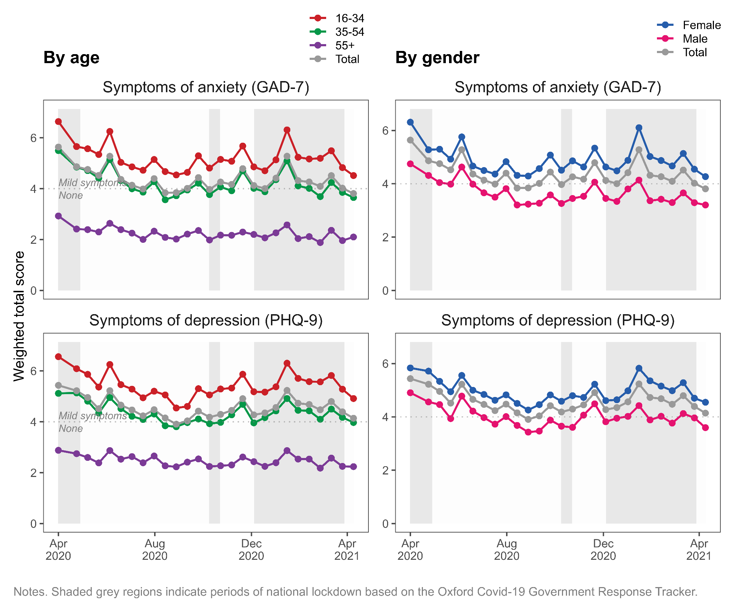

## Trajectories of anxiety and depression symptoms

Based on model fit and substantive interpretability, we chose a 4-class model for both anxiety and depression. While model fit could be improved by going beyond four classes (see [Supplementary Table 2](https://docs.google.com/document/u/0/d/1FJ3wt83vQvQjNHqgvlp6k5-dlW6TZCbNOmFdCQr-WKw/edit)), this was at the expense of interpretability. Additional classes tended to differ only quantitatively, not qualitatively – that is, they indicated similar *types* of trajectory but at higher or lower levels of severity, compared to the existing four classes. Figure 2 presents the 4-class trajectories for symptoms of anxiety and depression. For both outcomes, the four classes can be characterised as follows:

**Class 1:** *‘Persistent high severity symptoms’* (n=145 (6%) and 153 (7%) for symptoms of anxiety and depression, respectively). This class reported scores consistent with ‘Probable’ anxiety and depression’ (>10) throughout the year. Mean scores increased consistently from April 2020 onwards, with the exception of depressive symptoms which started to decline in early 2021.

**Class 2:** *‘Varying symptoms, opposing national cases’* (n=176 (8%) and 82 (4%) for anxiety and depression, respectively). This class experienced fluctuating symptoms over the year, meeting and exceeding thresholds for ‘Probable’ anxiety and depression. Notably, this class reported symptoms that ran counter to national COVID case numbers and hospitalisations. Between April and September 2020, as COVID cases in the UK declined, this class experienced a worsening of symptoms of anxiety and depression. Conversely, as UK case numbers rose in December 2020 and lockdown measures returned, this class experienced improving symptoms.

**Class 3:** *‘Varying symptoms, consistent with national cases’* (n=257 (11%) and 134 (6%) for anxiety and depression, respectively). Like Class 2, this class experienced fluctuating symptoms over the year, but these fluctuations mirrored changes in the number of COVID cases and hospitalisations in the UK. As COVID cases declined from April to August 2020, this class experienced reductions in symptom severity. During the winter months, as COVID cases in the UK rose, this class reported increasing symptoms of anxiety and depression.

**Class 4:** *‘Persistent low level symptoms’* (n=1664 (74%) and 1873 (84%) for anxiety and depression, respectively). This class comprised the majority of respondents who reported lower symptoms throughout the year, at or below ‘Mild’ anxiety and depression. Symptoms for this group were highest in April 2020 but declined thereafter.

## Baseline predictors of trajectory class membership

We used multinomial logistic regression to estimate the odds of assignment to each class for a unit change in each covariate. Figure 3 presents odds ratios for assignment to Classes 1 to 3, where Class 4 (‘Persistent low level symptoms’) was treated as the reference category. Each covariate was tested in a separate model, adjusted for age and gender. Age was scaled such that a one unit change represents a 10-year difference in age. These results are also presented in Supplementary Table 3.

For anxiety and depression, younger age and female gender were positively associated with assignment to one of the higher severity classes (‘persistent high severity’ or ‘varying’ symptoms), compared to Class 4 (‘low level symptoms’). For anxiety, a 10-year increase in age was associated with a two-fold reduction in the odds of assignment to a higher severity class; reduced odds were observed for depression. These associations reached statistical significance for most but not all classes. For anxiety and depression, single respondents were more likely to be in Class 1 (‘persistent high severity’), compared to those living in a partnership. For depression, living alone was associated with increased odds of assignment to Class 1 (‘persistent high severity’) and Class 2 (‘varying, opposing national cases’), compared to living with others. For anxiety, respondents with young children had increased odds of assignment to Class 3 (‘varying, consistent with national cases’), compared to the majority ‘low level symptoms’ class. For depression, those with young children had reduced odds of assignment to Class 2 (‘varying, opposing national cases’). This suggests that, compared to other respondents, those with young children were less likely to see an improvement in their depressive symptoms as lockdown measures eased and national case numbers diminished.

For anxiety, having another caring role besides childcare was associated with a two-fold increase in the odds of assignment to a higher severity class, although reaching statistical significance for ‘persistent high severity’ only. Shielding was also strongly associated with more severe symptoms of anxiety. Those shielding were twice as likely to be assigned to Class 1 (‘persistent high severity’) and four times as likely to be assigned to the ‘varying symptoms’ classes. This indicates differential impacts of shielding, associated with worsening or improving symptoms of anxiety as lockdown measures eased and case numbers declined. Similar associations of shielding were not observed for depression. Prior diagnosis of anxiety or depression was strongly associated with membership in all three higher severity classes, compared to the ‘low level symptoms’ majority class.

Class 4 (‘low level symptoms’) was the reference trajectory for all comparisons. For anxiety, ‘persistent high severity’ was associated with being younger, female, single, having a chronic condition, and having a caring role. ‘Varying, consistent with national cases’ was associated with being younger. ‘Varying, opposing national cases’ was associated with being younger, having a chronic condition, and shielding. All three trajectories were positively associated with having prior anxiety or depression.

For depression, ‘persistent high severity’ was positively associated with being younger, single, and having a chronic condition. ‘Varying, consistent with national cases’ was positively associated with being younger. ‘Varying, opposing national cases’ was associated with living alone, and not having children age 6 or under. All three trajectories were again positively associated with having prior anxiety or depression.

**Figure 2.** Trajectory classes from 4-class GMM model for symptoms of anxiety and depression (n=2241).

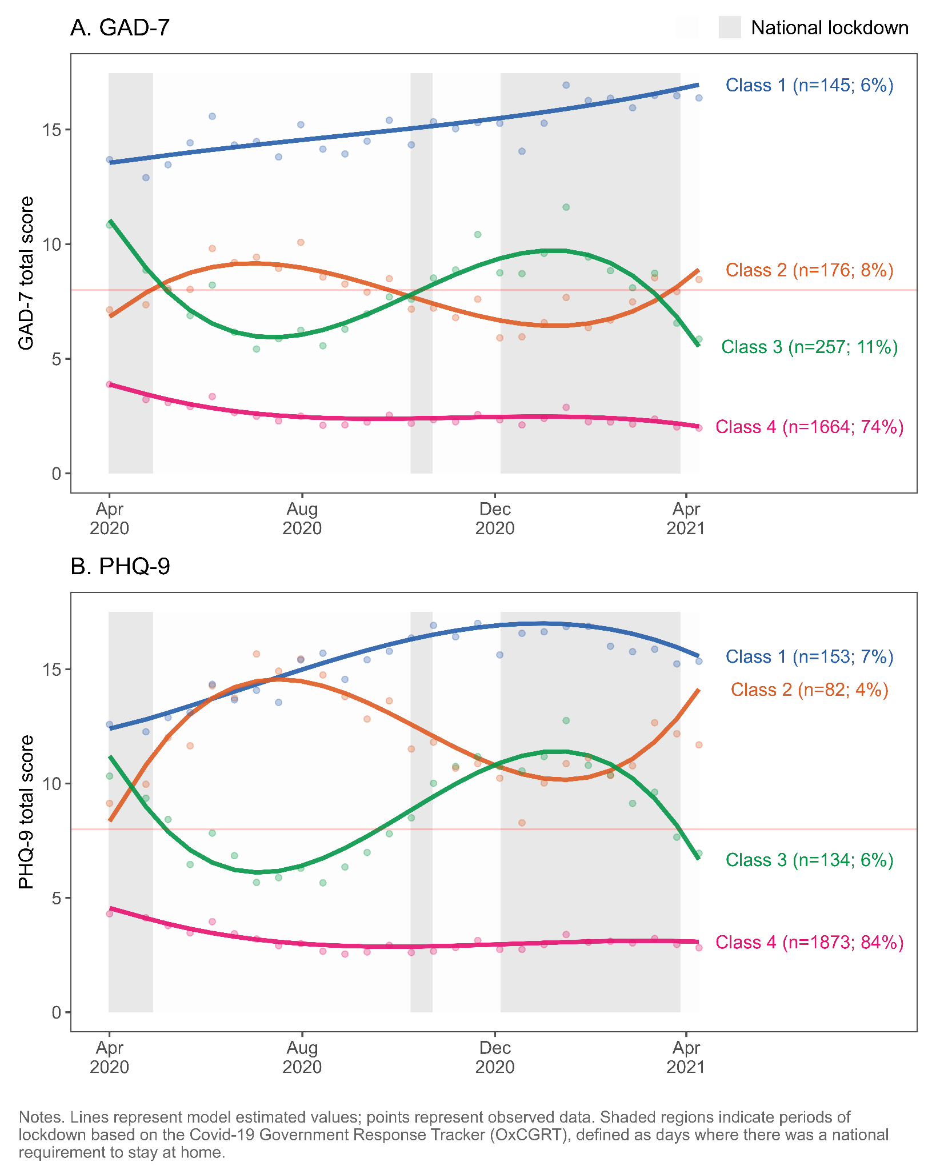

**Figure 3:** Associations of baseline variables with trajectory class assignment (n=2241)

Odds ratios representing odds of class assignment, compared to reference class of ‘Persistent low level symptoms’. Odds ratios also presented in [Supplementary Table 3](https://docs.google.com/document/u/0/d/1FJ3wt83vQvQjNHqgvlp6k5-dlW6TZCbNOmFdCQr-WKw/edit).

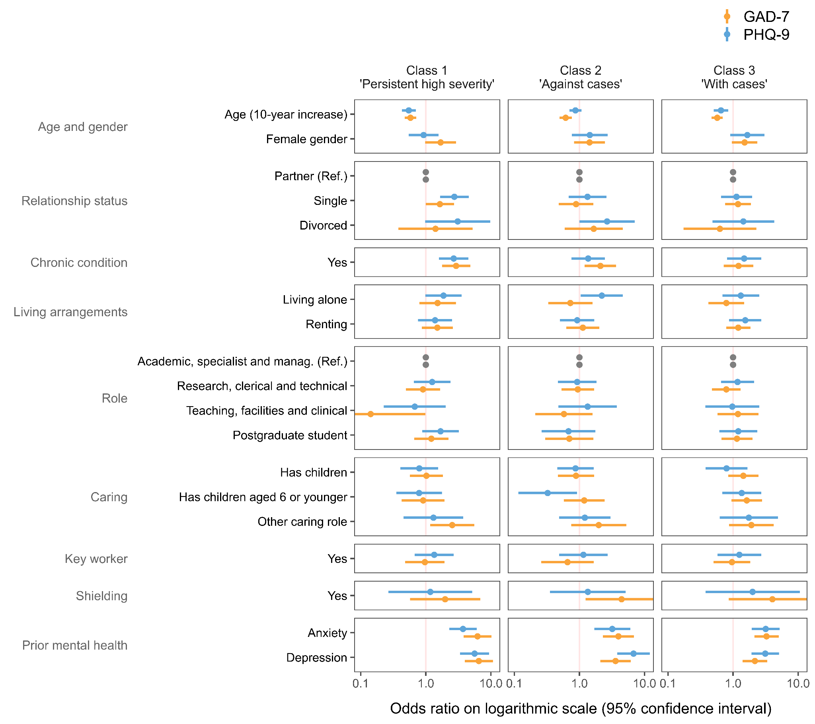

# Discussion

In a large, occupational cohort with fortnightly follow-up and high response rates, we described trajectories of anxiety and depression symptoms in the first year of the COVID-19 pandemic in the UK. We found that symptoms of anxiety and depression were highest at the start of the pandemic, eased over the summer months, and increased again in December. These fluctuations mirror national patterns of lockdown and numbers of cases and hospitalisations. While average levels of anxiety and depression were low throughout the year (scores consistent with ‘None’ or ‘Mild’ symptoms), these hid much greater variation among subgroups of respondents. Using growth mixture models, we identified four trajectory types for anxiety and depression. While most participants were assigned to the ‘persistent low-level symptoms’ trajectory class, others experienced more severe and variable symptoms. One group reported high severity symptoms throughout the year (‘persistent high severity’) whereas two groups reported fluctuating, moderate symptoms. Notably, these were in opposing directions. Some respondents reported reductions in symptom severity as lockdown measures eased, while at the same time, others experienced increasing anxiety and depression.

## Comparison with past studies

Our findings are consistent with several studies identifying trajectories of mental health in general population samples during the pandemic. Pierce et al. [[36]](https://www.zotero.org/google-docs/?GCBgQr) identified remarkably similar trajectories using the nationally representative UK Household Longitudinal Study (UKHLS). Based on the General Health Questionnaire (GHQ-12), they identified five classes: most respondents (77%) were assigned to ‘Consistently good’ or ‘Consistently very good’ classes, whereas a minority (4%) belonged to a ‘Consistently very poor’ class. Like us, they also identified two classes with moderate symptoms that experienced opposing trajectories, mirroring our ‘varying symptoms’ classes. One (‘Deteriorating’) saw worsening symptoms in the period from April to July, when national case numbers declined, whereas another (‘Recovery’) saw improving symptoms. Whereas Pierce et al. incorporated data until September 2020, our trajectories extended until April 2021. Our findings suggest that the ‘deterioration’ and ‘recovery’ trajectories identified in the UKHLS may have subsequently reversed course in December 2020 amidst worsening national circumstances. Consistent with our findings, Pierce et al. found more adverse trajectories associated with female gender, younger age, prior mental health condition, living alone, and shielding.

Our findings are also consistent with those from the UCL Social Study [[37]](https://www.zotero.org/google-docs/?XzPkhs), an online survey of over 70,000 respondents, that found levels of anxiety (GAD-7) and depression (PHQ-9) to be highest in April at the start of the pandemic, declining over the summer months, and increasing again from December 2020. They similarly found more severe symptoms those with younger age, female gender, and prior mental health diagnosis. Saunders et al. [[18]](https://www.zotero.org/google-docs/?JGX7oc) used information for 21,938 adults in England who participated in the UCL Social Study between March and July 2020. They identified four trajectory classes for symptoms of anxiety (GAD-7) and depression (PHQ-9). As in our study, most respondents were assigned to a ‘low symptom severity’ class (approx. 70%) whereas a smaller proportion experienced moderate or severe symptoms (between 6% and 17%). These classes are similar to our ‘persistent low level’ and ‘persistent high level’ classes, respectively. A fourth class experienced symptoms that worsened during national lockdown but improved after lockdown measures were eased. This latter class mirrors our ‘Varying symptoms, opposing national cases’ class – that experienced worsening symptoms during lockdown when case numbers declined. Saunders et al. found lower severity trajectories to be associated with older age, whereas moderate or severe trajectories were associated with female gender, low income, living alone, and reporting physical and mental health conditions.

From outside the UK, Knudsen et al. [[38]](https://www.zotero.org/google-docs/?7FXUtc) conducted a repeated cross-sectional analysis of mental disorders among Norwegian adults from January to September 2020 using psychiatric interviews. Unlike the majority of studies during this period, they found a reduction in the prevalence of mental disorders from pre-pandemic period (January to March 2020) to the first pandemic period (March to May 2020), from 15.3% to 8.7%. One proposed explanation for this conflicting result is the use of diagnostic clinical interviews rather than the online, self-reported questionnaires used in the present study and many others. The latter may be more sensitive to short-term fluctuations in symptoms that, while considerable, do not meet thresholds for clinical relevance. Another explanation is the Norwegian context, with lower rates of transmission, fewer hospitalisations and deaths, and a stronger safety net through the welfare state or pandemic-specific monetary support.

In the United States, Riehm et al. [[39]](https://www.zotero.org/google-docs/?pTkY4r) drew on a nationally representative cohort of 6,901 adults who responded on 10 occasions between March and August 2020. They found that the predicted probability of self-reporting mental distress increased in March and April, declined between May and June, and remained stable until August. As elsewhere, younger age and female gender were associated with greater likelihood of mental distress.

## Policy implications

Our findings must be considered within the context of higher education, a sector that has previously acknowledged a deficiency in supporting the mental health of its staff and postgraduate students [[19]](https://www.zotero.org/google-docs/?7qAGfa). Challenges in this sector are likely to have been exacerbated by the strains of the pandemic [[40]](https://www.zotero.org/google-docs/?ExZmDW) and create a renewed need for action to improve mental health support for staff and students in higher education. However, as our results demonstrate, individual experiences of the pandemic are highly variable. Some experienced persistent severe symptoms, other persistent low level symptoms, and others still experienced fluctuating symptoms over the year. There is no single trajectory type and averages tend to hide considerable inter-individual variation. Support policies need to address the particular needs and challenges of specific subgroups. For example, some respondents experienced worsening symptoms alongside changes in the wider context of the pandemic, such as lockdown measures and school closures. Policies could usefully support these individuals might be required to provide additional support as many university campuses resumed in-person activities in September 2021. Furthermore, we identified a distinction across these sensitive participants with some reporting improved symptoms as lockdown eased and others worsening symptoms, a key distinction to acknowledge in policy measures. Here, it is of particular importance to highlight the latter group, as this directionality might seem counterintuitive and thus can be easily overlooked when it comes to policy to help employees/students return to in-person activities.

Additionally, it is critical to note that the pandemic will continue to be unpredictable moving forward, emphasizing the need to offer continuous support to those most sensitive to environmental changes. For example, the findings suggest that those shielding were more likely to have varying symptoms and show sensitivity to changes in COVID policy. This provides helpful guidance for employers as they can predict that shielding employees are going to be particularly sensitive to changes going forward and can plan support accordingly. However, the directionality is unclear (if their symptoms will improve or worsen with these changes), thus requiring high flexibility in the type of support being offered.

Finally, the current findings regarding the variability of mental health over time has given further credence to the importance of frequent data collection in understanding the temporality of mental health. Detailed information on characteristics of the target population is needed to understand representativeness and generate sampling weights. However, here it is important to acknowledge that despite high volumes of data collected, most surveys continue to under-represent minority groups, thus while mental health on large cohorts was at the forefront of research, future policy and recommendations should be made to ensure inclusion of under-represented groups.

* [...]

## Strengths and limitations

Our study benefited from a large, well-defined sample that included nearly one quarter of KCL staff and PGR students. All participants were working or studying at KCL at baseline, and therefore, are likely to have received similar communications from the university and experienced similar workplace policies. Follow-up information was collected fortnightly for 12 months and response rates remained high throughout the study. We drew on administrative data to describe and account for compositional differences between the sample and target population using sampling weights. We also derived longitudinal weights to account for non-response. Our use of latent growth curve modelling made efficient use of the available data and retained all participants with at least one follow-up assessment. We used previously validated measures of mental health and adjusted for several important confounders. In particular, our assessment of prior mental health differentiated between anxiety and depression, whereas similar studies have used a simpler measure of ‘previous mental health diagnosis’ [[37]](https://www.zotero.org/google-docs/?TgNS2c).

However, there are several limitations. First, although nearly one quarter of the target population participated in the survey, male gender and racial and ethnic minority groups were under-represented in our sample. We derived sampling weights to account for differences between sample and population, but weights cannot make up for the missing experiences from smaller groups or intersectional groups that are present in very small numbers (such as non-binary gender and Black staff). Small numbers of respondents from ethnic minority groups also meant we were unable to assess how ethnicity was associated with trajectory class assignment.

Second, occupational studies have previously been shown to report higher levels of psychological stress, compared to population studies [[41]](https://www.zotero.org/google-docs/?hRBe4l). which should also be considered when interpreting our results. Third, related to this, our study captures a single occupational cohort at a large London university. They may not reflect patterns at other higher education institutions and cannot be generalised to the general population. Respondents had more years of education and higher socioeconomic position, compared to the general population. The healthy worker effect [[42]](https://www.zotero.org/google-docs/?mgYtPD) may also play a role: our sample consists of current employees and PGR students who may be better off, in terms of mental health, than those on leave or not working. Fourth, symptoms of anxiety and depression were measured with the self-report GAD-7 and PHQ-9 questionnaires, respectively. Gold standard diagnosis of psychiatric diagnosis is via clinical interview. While the PHQ-9 and GAD-7 are validated and widely used [[24,25, p. 7]](https://www.zotero.org/google-docs/?y3xkqw), we are not aware of any studies validating these scales for use during a global pandemic. During extremely adverse events such as pandemic and lockdown, it is not known how questionnaire scores relate to clinical disorder.

Fifth, we lacked information on mental health among staff and PGR students from before the pandemic and cannot say how the observed trends or differences compare to previous years. Recent studies have shown mental health reporting during the pandemic to differ markedly from the pre-pandemic period [[43]](https://www.zotero.org/google-docs/?e3MQqZ). Some observations may be specific to the particular, and unprecedented, circumstances facing the UK and higher education sector in 2020/21. It is also important to stress that we identified variables associated with mental health during a pandemic, rather than specific causal effects of COVID-19 on mental health. Many of the observed risk factors are likely to have existed in 2019 and earlier [[3]](https://www.zotero.org/google-docs/?l2cjo9).

# Conclusions

Our findings highlight differing individual responses to the pandemic and underscore the need to consider individual circumstances when assessing and treating mental health. Aggregate trends in anxiety and depression can easily hide greater variation, and symptom severity, experienced by subgroups. As university campuses resume in-person activities it will be important to ensure vulnerable groups are adequately supported. This includes those likely to experience worsening mental health with easing restrictions as well as those with identified risk factors, such as having young children at home, other caring roles, a history of mental illness, or those who are shielding.

# 

# References

[1 Hotopf M, Bullmore E, O’Connor RC, *et al.* The scope of mental health research in the COVID-19 Pandemic and its aftermath. *The British Journal of Psychiatry* 2020;:1–7.](https://www.zotero.org/google-docs/?DMllNz)

[2 Kohler U. Survey Research Methods during the COVID-19 Crisis. *Survey Research Methods* 2020;**14**:93–4. doi:10.18148/srm/2020.v14i2.7769](https://www.zotero.org/google-docs/?DMllNz)

[3 Lin Y-H, Chen C-Y, Wu S-I. Efficiency and Quality of Data Collection Among Public Mental Health Surveys Conducted During the COVID-19 Pandemic: Systematic Review. *Journal of Medical Internet Research* 2021;**23**:e25118. doi:10.2196/25118](https://www.zotero.org/google-docs/?DMllNz)

[4 Bernardini F, Attademo L, Rotter M, *et al.* Social Determinants of Mental Health As Mediators and Moderators of the Mental Health Impacts of the COVID-19 Pandemic. *PS* 2021;**72**:598–601. doi:10.1176/appi.ps.202000393](https://www.zotero.org/google-docs/?DMllNz)

[5 Robinson E, Sutin AR, Daly M, *et al.* A systematic review and meta-analysis of longitudinal cohort studies comparing mental health before versus during the COVID-19 pandemic. *medRxiv* 2021;:2021.03.04.21252921. doi:10.1101/2021.03.04.21252921](https://www.zotero.org/google-docs/?DMllNz)

[6 Vindegaard N, Benros ME. COVID-19 pandemic and mental health consequences: Systematic review of the current evidence. *Brain, Behavior, and Immunity* 2020;**89**:531–42. doi:10.1016/j.bbi.2020.05.048](https://www.zotero.org/google-docs/?DMllNz)

[7 Boden M, Zimmerman L, Azevedo KJ, *et al.* Addressing the mental health impact of COVID-19 through population health. *Clinical Psychology Review* 2021;**85**:102006. doi:10.1016/j.cpr.2021.102006](https://www.zotero.org/google-docs/?DMllNz)

[8 Wei J, Hou R, Zhang X, *et al.* The association of late-life depression with all-cause and cardiovascular mortality among community-dwelling older adults: systematic review and meta-analysis. *The British Journal of Psychiatry* 2019;**215**:449–55. doi:10.1192/bjp.2019.74](https://www.zotero.org/google-docs/?DMllNz)

[9 Godderis L, Luyten J. Challenges and opportunities for occupational health and safety after the COVID-19 lockdowns. 2020.](https://www.zotero.org/google-docs/?DMllNz)

[10 Xiong J, Lipsitz O, Nasri F, *et al.* Impact of COVID-19 pandemic on mental health in the general population: A systematic review. *Journal of Affective Disorders* 2020.](https://www.zotero.org/google-docs/?DMllNz)

[11 Universities UK. Recovery, Skills, Knowledge and Opportunity. London: : Universities UK 2020. https://www.universitiesuk.ac.uk/policy-and-analysis/reports/Documents/2020/uuk-he-vision.pdf (accessed 2 Aug 2021).](https://www.zotero.org/google-docs/?DMllNz)

[12 Rees R, Stokes G, Stansfield C, *et al. Prevalence of mental health disorders in adult minority ethnic populations in England: a systematic review*. 2016.](https://www.zotero.org/google-docs/?DMllNz)

[13 McManus S, Bebbington P, Jenkins R, *et al. Mental health and wellbeing in England: Adult Psychiatric Morbidity Survey 2014 : a survey carried out for NHS Digital by NatCen Social Research and the Department of Health Sciences, University of Leicester.* 2016.](https://www.zotero.org/google-docs/?DMllNz)

[14 Davis KAS, Stevelink SAM, Al-Chalabi A, *et al.* The King’s College London Coronavirus Health and Experiences of Colleagues at King’s Study (KCL CHECK) protocol paper: a platform for study of the effects of coronavirus pandemic on staff and postgraduate students. *medRxiv* 2020;:2020.06.16.20132456. doi:10.1101/2020.06.16.20132456](https://www.zotero.org/google-docs/?DMllNz)

[15 Carr E. Mental health among UK university staff and postgraduate students in the early stages of the COVID-19 pandemic. *Occupational and Environmental Medicine* 2021.](https://www.zotero.org/google-docs/?DMllNz)

[16 Ellwardt L, Präg P. Heterogeneous Mental Health Development During the COVID-19 Pandemic in the United Kingdom. *medRxiv* 2021;:2021.02.24.21251565. doi:10.1101/2021.02.24.21251565](https://www.zotero.org/google-docs/?DMllNz)

[17 Aknin L, Neve J-ED, Dunn E, *et al.* Mental Health During the First Year of the COVID-19 Pandemic: A Review and Recommendations for Moving Forward. Perspectives on Psychological Science. 2021;**(Forthcoming).** doi:10.31234/osf.io/zw93g](https://www.zotero.org/google-docs/?DMllNz)

[18 Saunders R, Buckman JEJ, Fonagy P, *et al.* Understanding different trajectories of mental health across the general population during the COVID-19 pandemic. *Psychological Medicine* undefined/ed;:1–9. doi:10.1017/S0033291721000957](https://www.zotero.org/google-docs/?DMllNz)

[19 Universities UK. Stepchange: mentally healthy universities. 2020;:36.](https://www.zotero.org/google-docs/?DMllNz)

[20 Besser A, Lotem S, Zeigler-Hill V. Psychological Stress and Vocal Symptoms Among University Professors in Israel: Implications of the Shift to Online Synchronous Teaching During the COVID-19 Pandemic. *Journal of Voice* 2020;**0**. doi:10.1016/j.jvoice.2020.05.028](https://www.zotero.org/google-docs/?DMllNz)

[21 Gautam R, Sharma M. 2019-nCoV pandemic: A disruptive and stressful atmosphere for Indian academic fraternity. *Brain, Behavior, and Immunity* 2020;**88**:948–9. doi:10.1016/j.bbi.2020.04.025](https://www.zotero.org/google-docs/?DMllNz)

[22 Odriozola-González P, Planchuelo-Gómez Á, Irurtia MJ, *et al.* Psychological effects of the COVID-19 outbreak and lockdown among students and workers of a Spanish university. *Psychiatry Research* 2020;**290**:113108. doi:10.1016/j.psychres.2020.113108](https://www.zotero.org/google-docs/?DMllNz)

[23 Hale T, Angrist N, Goldszmidt R, *et al.* A global panel database of pandemic policies (Oxford COVID-19 Government Response Tracker). *Nat Hum Behav* 2021;**5**:529–38. doi:10.1038/s41562-021-01079-8](https://www.zotero.org/google-docs/?DMllNz)

[24 Kroenke K, Spitzer RL, Williams JB. The PHQ‐9: validity of a brief depression severity measure. *Journal of general internal medicine* 2001;**16**:606–13.](https://www.zotero.org/google-docs/?DMllNz)

[25 Spitzer RL, Kroenke K, Williams JBW, *et al.* A Brief Measure for Assessing Generalized Anxiety Disorder: The GAD-7. *Arch Intern Med* 2006;**166**:1092–7. doi:10.1001/archinte.166.10.1092](https://www.zotero.org/google-docs/?DMllNz)

[26 Downey RG, King CV. Missing Data in Likert Ratings: A Comparison of Replacement Methods. *The Journal of General Psychology* 1998;**125**:175–91. doi:10.1080/00221309809595542](https://www.zotero.org/google-docs/?DMllNz)

[27 Wickrama K, Lee TK, O’Neal CW, *et al. Higher-Order Growth Curves and Mixture Modeling with Mplus: A Practical Guide*. New York: : Routledge 2016. doi:10.4324/9781315642741](https://www.zotero.org/google-docs/?DMllNz)

[28 Sclove SL. Application of model-selection criteria to some problems in multivariate analysis. *Psychometrika* 1987;**52**:333–43. doi:10.1007/BF02294360](https://www.zotero.org/google-docs/?DMllNz)

[29 Lo Y, Mendell NR, Rubin DB. Testing the Number of Components in a Normal Mixture. *Biometrika* 2001;**88**:767–78.](https://www.zotero.org/google-docs/?DMllNz)

[30 Nylund KL, Asparouhov T, Muthén BO. Deciding on the Number of Classes in Latent Class Analysis and Growth Mixture Modeling: A Monte Carlo Simulation Study. *Structural Equation Modeling: A Multidisciplinary Journal* 2007;**14**:535–69. doi:10.1080/10705510701575396](https://www.zotero.org/google-docs/?DMllNz)

[31 Asparouhov T, Muthén B. Auxiliary Variables in Mixture Modeling: Three-Step Approaches Using Mplus. *Structural Equation Modeling: A Multidisciplinary Journal* 2014;**21**:329–41. doi:10.1080/10705511.2014.915181](https://www.zotero.org/google-docs/?DMllNz)

[32 R Core Team. *R: A language and environment for statistical computing*. Vienna, Austria: 2020. https://www.R-project.org/](https://www.zotero.org/google-docs/?DMllNz)

[33 Hallquist MN, Wiley JF. MplusAutomation: An R Package for Facilitating Large-Scale Latent Variable Analyses in Mplus. *Structural Equation Modeling: A Multidisciplinary Journal* 2018;**0**:1–18. doi:10.1080/10705511.2017.1402334](https://www.zotero.org/google-docs/?DMllNz)

[34 Lumley T. Analysis of complex survey samples. *Journal of Statistical Software* 2004;**9**:1–19.](https://www.zotero.org/google-docs/?DMllNz)

[35 Enders CK, Bandalos DL. The Relative Performance of Full Information Maximum Likelihood Estimation for Missing Data in Structural Equation Models. *Structural Equation Modeling: A Multidisciplinary Journal* 2001;**8**:430–57. doi:10.1207/S15328007SEM0803_5](https://www.zotero.org/google-docs/?DMllNz)

[36 Pierce M, McManus S, Hope H, *et al.* Mental health responses to the COVID-19 pandemic: a latent class trajectory analysis using longitudinal UK data. *The Lancet Psychiatry* 2021;**8**:610–9. doi:10.1016/S2215-0366(21)00151-6](https://www.zotero.org/google-docs/?DMllNz)

[37 Fancourt D, Feifei B, Hei Wan M, *et al.* Covid-19 Social Study: Results Release 36. London: : University College London 2021. https://b6bdcb03-332c-4ff9-8b9d-28f9c957493a.filesusr.com/ugd/3d9db5_93342fa7cccf45b194f8c6ec6c16e66f.pdf (accessed 18 Aug 2021).](https://www.zotero.org/google-docs/?DMllNz)

[38 Knudsen AKS, Stene-Larsen K, Gustavson K, *et al.* Prevalence of mental disorders, suicidal ideation and suicides in the general population before and during the COVID-19 pandemic in Norway: A population-based repeated cross-sectional analysis. *The Lancet Regional Health - Europe* 2021;**4**:100071. doi:10.1016/j.lanepe.2021.100071](https://www.zotero.org/google-docs/?DMllNz)

[39 Riehm KE, Holingue C, Smail EJ, *et al.* Trajectories of Mental Distress Among U.S. Adults During the COVID-19 Pandemic. *Annals of Behavioral Medicine* 2021;**55**:93–102. doi:10.1093/abm/kaaa126](https://www.zotero.org/google-docs/?DMllNz)

[40 Holmes EA, O’Connor RC, Perry VH, *et al.* Multidisciplinary research priorities for the COVID-19 pandemic: a call for action for mental health science. *The Lancet Psychiatry* 2020.](https://www.zotero.org/google-docs/?DMllNz)

[41 Goodwin L, Ben-Zion I, Fear NT, *et al.* Are Reports of Psychological Stress Higher in Occupational Studies? A Systematic Review across Occupational and Population Based Studies. *PLOS ONE* 2013;**8**:e78693. doi:10.1371/journal.pone.0078693](https://www.zotero.org/google-docs/?DMllNz)

[42 Li C-Y, Sung F-C. A review of the healthy worker effect in occupational epidemiology. *Occup Med* 1999;**49**:225–9. doi:10.1093/occmed/49.4.225](https://www.zotero.org/google-docs/?DMllNz)

[43 Pierce M, Hope H, Ford T, *et al.* Mental health before and during the COVID-19 pandemic: a longitudinal probability sample survey of the UK population. *The Lancet Psychiatry* Published Online First: 2020. doi:10.1016/S2215-0366(20)30308-4](https://www.zotero.org/google-docs/?DMllNz)

1. Defined as “not leaving house with exceptions for daily exercise, grocery shopping, and ‘essential’ trips” or “not leaving house with minimal exceptions (e.g., allowed to leave once a week, or only one person can leave at a time, etc.)”.
2. <https://github.com/ewancarr/check-longitudinal>