Trajectories of mental health among UK university staff and postgraduate students during the pandemic

Ewan Carr1*, Carolin Oetzmann2*, Katrina Davis2, Gabriella Bergin-Cartwright2, Grace Lavelle2, Daniel Leightley2, Kate Polling2,3, Sharon A.M. Stevelink2, Alice Wickersham2, Valentina Vitiello, Reza Razavi4, and Matthew Hotopf2,3

1 Department of Biostatistics and Health Informatics, Institute of Psychology, Psychiatry and Neuroscience, King’s College London, London, UK.

2 Department of Psychological Medicine, Institute of Psychology, Psychiatry and Neuroscience, King’s College London, London, UK.

3 South London and Maudsley NHS Foundation Trust, London, UK.

4 King’s College London School of Biomedical Engineering and Imaging Sciences, Faculty of Life Sciences and Medicine, London, United Kingdom.

* Contributed equally

## Funding/acknowledgements

This paper represents independent research part-funded by the National Institute for Health Research (NIHR) Maudsley Biomedical Research Centre at South London and Maudsley NHS Foundation Trust and King’s College London. The views expressed are those of the author(s) and not necessarily those of the NHS, the NIHR or the Department of Health and Social Care.

What is already known about this subject?

* Research among the general population into the impact of the pandemic on anxiety, depression, and other symptoms of distress have shown that, on average, people reported higher levels of symptoms in the early phases of the pandemic. However, few studies have assessed individual variation amongst these averages, particularly from an occupational cohort perspective. Employers play a key role in navigating the ‘new normal’.

What are the new findings?

* During the first year of the pandemic, on average, participants reported low levels of anxiety and depression, with symptoms improving when restrictions were lifted. However, these averages hide significant variability within subgroups of participants. In addition to subgroups experiencing persistent high or low severity symptoms, two further subgroups experienced symptoms that fluctuated in line with the easing and tightening of national lockdown restrictions.

How might this impact on policy or clinical practice in the foreseeable future?

* When considering the mental health impact of the pandemic and how best to support staff and students, there is a need for policymakers, employers, and wellbeing managers across the higher education sector to account for variability in experiences and provide support that accommodates the particular needs of each subgroup.

**Abstract**

| Background | The COVID-19 pandemic and subsequent containment measures have disrupted the social and working lives of many. Past studies have highlighted worsening mental health due to the pandemic. However, many existing studies rely on infrequent follow-up and small sample sizes. This study fills this gap by drawing on fortnightly assessments from a large, occupational cohort. It describes differing trajectories of mental health between April 2020 and April 2021 and individual characteristics associated with these trajectory types. |
| --- | --- |
| Methods | KCL CHECK is a longitudinal occupational cohort study at a large university in London, United Kingdom. Participants (n=2241) completed online questionnaires fortnightly between April 2020 and April 2021. Sociodemographic and clinical characteristics were measured at baseline. Symptoms of anxiety and depression were assessed (using GAD-7 and PHQ-9 respectively) repeatedly. Differing trajectories of mental health were identified using growth mixture models. |
| Results | On average, participants reported low levels of anxiety and depression (scores consistent with ‘None’ or ‘Mild’ symptoms) throughout the year, with symptoms highest in April 2020 and decreasing over the summer months when no lockdown measures were in place. However, we observed more severe and variable symptoms among subgroups of participants. Four trajectory types for anxiety and depression were identified: 1) ‘Persistent high severity’; 2) ‘Varying symptoms, opposing national cases’; 3) ‘Varying symptoms, consistent with national cases’; 4) ‘Persistent low severity’. Characteristics such as younger age, female gender, caring responsibilities, and shielding were positively associated with higher severity trajectory types. Both having young children at home and living alone were associated with the ‘varying symptoms, opposing cases’ trajectory, which saw increasing levels of anxiety and depressive symptoms as lockdown measures eased and national case numbers diminished. |
| Conclusions | These data highlight differing individual responses to the pandemic and underscore the need to consider individual circumstances when assessing and treating mental health. Aggregate trends in anxiety and depression can easily hide greater variation, and symptom severity, experienced by subgroups. |

# 

# Introduction

The COVID-19 pandemic is a threat to wellbeing, not only from infection with the SARS-CoV-2 virus itself, but also indirectly through public health measures such as social isolation and changes to home working and schooling. The potential impact of the pandemic on mental health was highlighted early in 2020 [[1]](https://www.zotero.org/google-docs/?MNVdpI). Since then, numerous studies have assessed symptoms of distress, depression and anxiety, with mixed methodological rigour and heterogeneous findings [[1–3]](https://www.zotero.org/google-docs/?54cQlJ). The consensus has been that, on average, people in the early phases of the pandemic reported significantly higher levels of symptoms, compared to before the pandemic, but that the impact on mental health was unevenly felt across the population [[4–6]](https://www.zotero.org/google-docs/?YqMiiL).

Insights from a single point in time are limited. Mental health is dynamic and support needs to reflect individual experiences that evolve alongside the pandemic and public health response. Longitudinal assessments of mental health to identify vulnerable groups are therefore important for policy makers when planning for COVID-19 response and recovery [[7,8]](https://www.zotero.org/google-docs/?byM1IW). Support from employers is also important for wellbeing when navigating the ‘new normal’ after the more acute phases of the pandemic [[1,9,10]](https://www.zotero.org/google-docs/?NAy12m).

Universities are large employers comprising a variety of staff roles. This includes academic and support staff catering to students, but also early career researchers, specialised technicians and advisors, and those supporting the facilities [[11]](https://www.zotero.org/google-docs/?4EeAh7). Individual experiences of the pandemic, and the impact on mental health, are likely to vary across job roles. For example, between those who have regular contact with members of the public, vs. those who can work remotely most or all of the time. Besides job role, factors associated with poor mental health in populations prior to the pandemic include younger age, female gender, belonging to an ethnic minority group [[12]](https://www.zotero.org/google-docs/?kiLyOP), prior diagnosis of mental disorder, and caregiving responsibilities [[13]](https://www.zotero.org/google-docs/?07x5L6). In addition, recent studies have identified specific determinants of mental health that are caused or exacerbated by the pandemic. These include living alone, being a key worker, or having children at home, particularly school age children who are affected by school closures [[7]](https://www.zotero.org/google-docs/?nAmQW4).

King’s College London (KCL) is a large university with five campuses in central London, United Kingdom (UK). On 23rd March 2020, KCL closed its campuses to all except essential workers and moved most activities online. In April 2020, the university set up the “King’s College London Coronavirus Health and Experiences of Colleagues at King’s” (KCL CHECK) project to understand the impact of the pandemic on staff and postgraduate research students (PGR) and inform policy making within the university [[14]](https://www.zotero.org/google-docs/?fl4yXL). We have previously reported on symptoms of depression and anxiety collected at the baseline questionnaire in April 2020 [[15]](https://www.zotero.org/google-docs/?PvlL9K). Consistent with other UK studies from this period, the baseline survey found around 20% of staff and 30% PGRs to score above clinical cut-offs on depression and anxiety screening questionnaires.

Building on findings from the baseline survey, the present study aimed to describe patterns of mental health among staff and PGRs between April 2020 and April 2021. We drew on fortnightly questionnaires collected throughout the year to (i) describe how average levels of anxiety or depression varied; and (ii) identify subgroups with differing symptom trajectories. Our findings will inform a better understanding of mental health trajectories in the workplace, and particularly the higher education sector.

# Methods

## Data

Data were collected from staff and PGR students participating in the KCL CHECK longitudinal survey. Participants were invited via email to complete the baseline survey in April 2020. Those completing the baseline survey were also invited to participate in longitudinal surveys. All surveys were conducted online. Longitudinal surveys included shorter fortnightly questionnaires as well as longer questionnaires every two months. Between April 2020 and March 2021 there were 6 longer questionnaires and 21 fortnightly questionnaires (Please refer to Supplementary Table 1 for a full schedule). Of 2590 staff and PGR students responding to the baseline survey, 2508 agreed to participate in longitudinal follow-ups and are included in this analysis.

Administrative data on the demographic composition of staff and PGR student populations were obtained from centrally held administrative records. Aggregate information on age group, gender, and ethnicity were used to describe the representativeness of the survey compared to the target population and construct weights, as detailed below. Contextual data on the strictness of lockdown measures in the UK were obtained from the Oxford COVID-19 Government Response Tracker [[16]](https://www.zotero.org/google-docs/?ssoQQd).

## Measures

The outcomes were reports of symptoms associated with depression and anxiety measured using the Patient Health Questionnaire (PHQ-9) [[17]](https://www.zotero.org/google-docs/?5Js6oJ) and the Generalised Anxiety Disorder (GAD-7) [[18]](https://www.zotero.org/google-docs/?e86MZ6) scales, respectively. Where participants partially completed measures, up to two items were person-mean imputed for PHQ-9 and one for GAD-7 [[19]](https://www.zotero.org/google-docs/?MiYb0l). In our analyses these outcomes were treated continuously, but scores of 5-9 are typically labeled as ‘Mild anxiety’ or ‘Mild depression’ and scores ≥10 used to indicate ‘Probable anxiety’ or ‘Probable depression’ [[17,18]](https://www.zotero.org/google-docs/?SUfxQS).

Covariates were self-reported by participants at baseline. These included factors previously linked to anxiety and depression as well as factors likely to be associated with increased vulnerability during the pandemic: (1) demographic characteristics (age, gender, ethnicity, partnership status, health status, caring role, and occupational role); (2) health status (chronic health conditions, shielding, previous mental health diagnosis), (3) caring roles (children at home, young children, other caring responsibilities); and (4) occupational role and key worker status. Please see supplementary materials for details. Ethnicity was used to describe the sample, but was omitted from regression models due to small numbers of participants in minority ethnic groups which would have produced unreliable estimates.

For visualisation purposes, information on the strictness of government lockdown policies was extracted from Oxford Covid-19 Government Response Tracker (OxCGRT; [[16]](https://www.zotero.org/google-docs/?2MLIox)). Periods of lockdown were defined as days where there was a national requirement to stay at home[1].

## Statistical analyses

The analyses were in four parts:

1. We compared the analytical sample with excluded respondents using χ2 tests (categorical variables) and t-tests (continuous variables).
2. We described the cohort by summarising (i) baseline characteristics and (ii) the two outcomes (GAD-7 anxiety and PHQ-9 depression) at each follow-up survey. Outcomes were summarised overall and by gender and age group.
3. We used growth mixture models (GMMs) to identify subgroups of participants with differing trajectories of anxiety and depression symptoms. GMMs are an extension of latent growth curve models (LGCMs) and are estimated within a structural equation modelling (SEM) framework [[20]](https://www.zotero.org/google-docs/?46GfVS). The LGCM allows us to model repeated measures of an observed variable (e.g. symptoms of anxiety) by using latent variables to represent the intercept (the initial level of the observed variable) and slope (the change over time). A GMM extends this model to allow identification of subgroups (‘latent classes’) with different intercepts and slopes, reflecting differing trajectories of symptoms over time. The GMM proceeds in two stages: (i) We first fit LGCMs to identify the most appropriate functional form of growth (e.g. linear, quadratic) for our data; (ii) We then fit GMMs with increasing numbers of latent classes and choose the optimal number of classes based on relative model fit and substantive interpretability. Modelling was conducted separately for anxiety symptoms and depression symptoms. Relative model fit was assessed based on the AIC, sample size adjusted BIC [[SABIC; 21]](https://www.zotero.org/google-docs/?THzbEF), and the Lo-Mendell-Rubin test [[22,23]](https://www.zotero.org/google-docs/?ZQAmMX). For AIC and SABIC, lower values indicated a better fit.
4. Fourth, we considered how covariates measured at baseline were associated with membership to trajectory classes using the R3STEP method in Mplus [[24]](https://www.zotero.org/google-docs/?LwgNUd). This used a multinomial logistic regression model to estimate how the odds of assignment to a particular trajectory class are associated with a unit change in each baseline predictor. We considered each covariate separately, adjusted for age and gender. Estimates are presented as odds ratios and 95% confidence intervals.

Descriptive statistics were calculated using R 4.1.0 [[25]](https://www.zotero.org/google-docs/?DKpQnF). GMM models were estimated using Mplus 8.4 using the *MplusAutomation* package [[26]](https://www.zotero.org/google-docs/?ydkaFw) for R. Survey weights were generated using the survey package for R [[27]](https://www.zotero.org/google-docs/?KoniYT). All code used in these analyses can be found online[2].

## Weighting

We derived two weights. A baseline weight adjusted for differences in age, gender, and ethnicity between the baseline cohort and the target population (all KCL staff and PGRs). A longitudinal weight adjusted for differential non-response at longitudinal follow-up. Please see supplementary materials for details. Baseline statistics and GMM models were weighted using the baseline weight only; longitudinal statistics were additionally weighted to account for non-response.

## Missing data

We excluded participants without any outcome data (7%) or missing information on baseline covariates (4%). Descriptive statistics were calculated based on the available sample at each time point. GMM models used full information maximum likelihood information (FIML) to retain all participants with at least one post-baseline measurement of the outcome [[28]](https://www.zotero.org/google-docs/?WlMCSi) .

# Results

## Cohort characteristics

Of 2508 participants agreeing to longitudinal follow-up, we excluded 176 participants without follow-up information on PHQ-9 and GAD-7 and 91 without information on baseline covariates. The analytical sample therefore included 2241 participants (1851 staff; 390 PGR students), representing 19% and 16% of all staff and PGR students at KCL, respectively. Excluded participants tended to be older (mean age = 39.6 vs. 38.3 years; p = 0.08) and female (70% vs. 60%; p < 0.001).

**Table 1.** Cohort characteristics at baseline (n=2241)

|  |  | Count | Weighted proportion | 95% confidence intervals |
| --- | --- | --- | --- | --- |
| Gender | Female | 1581 | 0.57 | [0.54, 0.60] |
| Male | 660 | 0.43 | [0.40, 0.46] |
| Age group | 16-34 | 941 | 0.43 | [0.40, 0.46] |
| 35-54 | 979 | 0.43 | [0.41, 0.46] |
| 55+ | 321 | 0.14 | [0.12, 0.15] |
| Ethnicity | White | 1907 | 0.71 | [0.68, 0.74] |
| Black | 32 | 0.04 | [0.03, 0.06] |
| Asian | 156 | 0.14 | [0.12, 0.17] |
| Mixed | 90 | 0.05 | [0.04, 0.06] |
| Other | 56 | 0.06 | [0.04, 0.08] |
| Role | Staff | 1851 | 0.82 | [0.80, 0.85] |
| PGR students | 390 | 0.18 | [0.15, 0.20] |
| Pre-existing major depressive disorder (MDD) | | 519 | 0.22 | [0.20, 0.24] |
| Pre-existing generalised anxiety disorder (GAD) | | 512 | 0.21 | [0.19, 0.23] |
| Living alone | | 250 | 0.12 | [0.10, 0.13] |
| Number of children living with | 0 | 1600 | 0.72 | [0.70, 0.75] |
| 1 | 276 | 0.12 | [0.10, 0.14] |
| 2 | 316 | 0.14 | [0.12, 0.15] |
| 3+ | 49 | 0.02 | [0.01, 0.03] |
| Participant is keyworker | | 283 | 0.13 | [0.11, 0.14] |

Figure 1 presents weighted mean scores for each outcome (GAD-7 anxiety and PHQ-9 depression) at each survey period between April 2020 and April 2021. On average, participants reported low levels of anxiety and depression (scores consistent with ‘None’ or ‘Mild’ symptoms) over time. Symptoms were highest in April 2020, decreased over the summer months, and increased again in December 2020 at a time of rising case numbers and reinstated national lockdown measures. When stratifying by age, younger individuals scored higher on both anxiety and depression than older participants. On average, males and females reported similar levels of anxiety and depression throughout the year, but females presented with higher scores at each survey period.

**Figure 1.** Fortnightly mean scores for anxiety (GAD-7) and depression (PHQ-9) stratified by age group and gender (n=2241)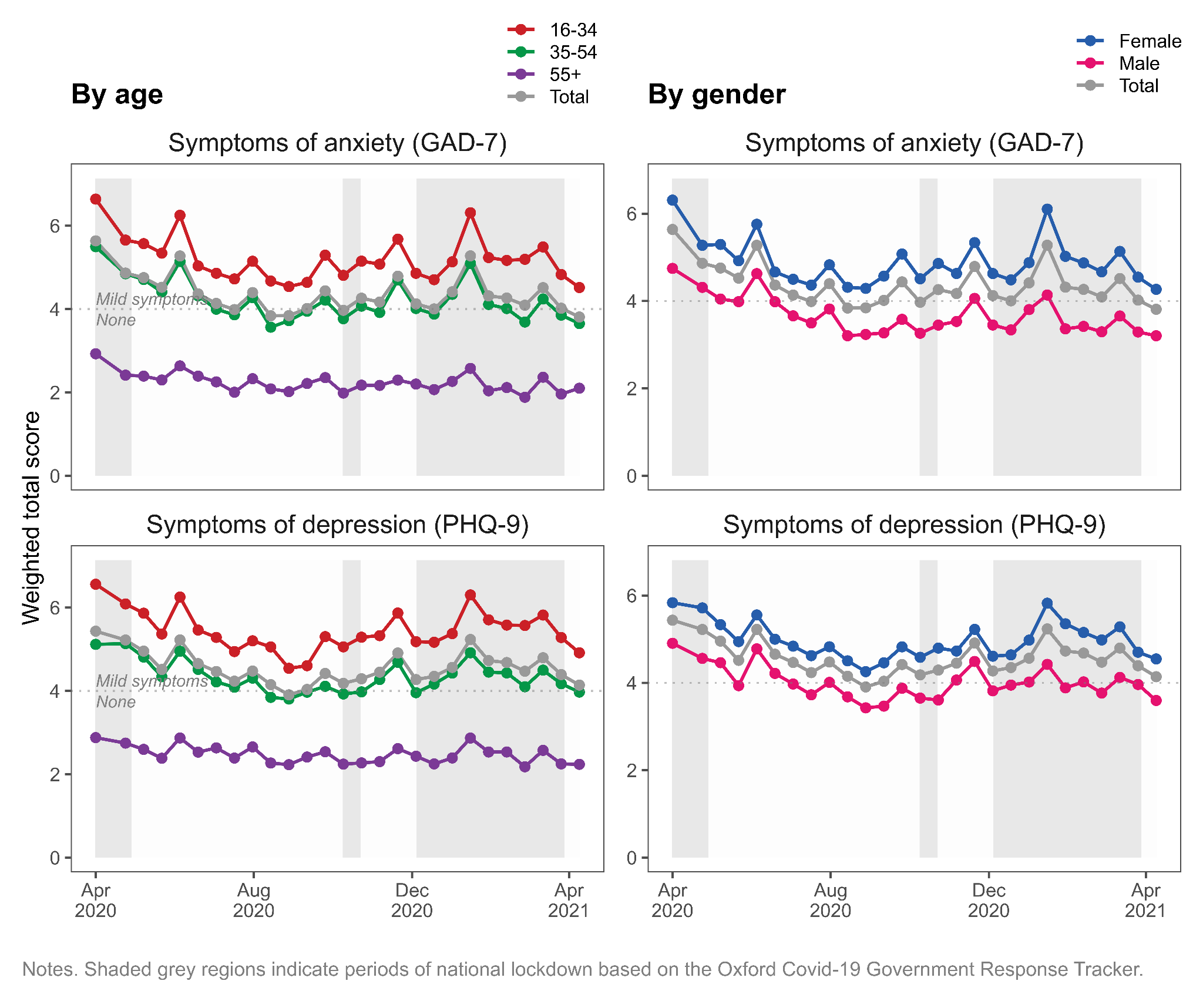

## 

## Trajectories of anxiety and depression symptoms

Based on model fit and substantive interpretability, we chose a 4-class model for both anxiety and depression. While model fit could be improved by going beyond four classes (see Supplementary Table 2), this was at the expense of interpretability. Additional classes indicated similar typesof trajectory but at higher or lower levels of severity, compared to the existing four classes. Figure 2 presents the 4-class trajectories for symptoms of anxiety and depression. For both outcomes, the four classes can be characterised as follows:

**Class 1:** *‘Persistent high severity symptoms’* (n=145 (6%) and 153 (7%) for symptoms of anxiety and depression, respectively). This class reported scores consistent with ‘Probable’ anxiety and depression’ (>10) throughout the year. Mean scores increased consistently from April 2020 onwards, with the exception of depressive symptoms which started to decline in early 2021.

**Class 2:** *‘Varying symptoms, opposing national cases’* (n=176 (8%) and 82 (4%) for anxiety and depression, respectively). This class experienced fluctuating symptoms over the year, meeting and exceeding thresholds for ‘Probable’ anxiety and depression. Notably, this class reported symptoms that ran counter to national COVID case numbers and hospitalisations. Between April and September 2020, as COVID cases in the UK declined, this class experienced a worsening of symptoms of anxiety and depression. Conversely, as UK case numbers rose in December 2020 and lockdown measures returned, this class experienced improving symptoms.

**Class 3:** *‘Varying symptoms, consistent with national cases’* (n=257 (11%) and 134 (6%) for anxiety and depression, respectively). Like Class 2, this class experienced fluctuating symptoms over the year, but these fluctuations mirrored changes in the number of COVID cases and hospitalisations in the UK. As COVID cases declined from April to August 2020, this class experienced reductions in symptom severity. During the winter months, as COVID cases in the UK rose, this class reported increasing symptoms of anxiety and depression.

**Class 4:** *‘Persistent low severity symptoms’* (n=1664 (74%) and 1873 (84%) for anxiety and depression, respectively). This class comprised the majority of respondents who reported lower symptoms throughout the year, at or below ‘Mild’ anxiety and depression. Symptoms for this group were highest in April 2020 but declined thereafter.

## Baseline predictors of trajectory class membership

We used multinomial logistic regression to estimate the odds of assignment to each class for a unit change in each covariate. Figure 3 presents odds ratios for assignment to Classes 1 to 3, where Class 4 (‘Persistent low severity’) was treated as the reference category. Each covariate was tested in a separate model, adjusted for age and gender. Age was scaled such that a one unit change represents a 10-year difference in age. These results are also presented in Supplementary Table 3.

For anxiety, ‘persistent high severity’ symptoms were associated with being younger, female, single, having a chronic condition, and having a caring role. ‘Varying, opposing national cases’ was associated with being younger, having a chronic condition, and shielding. ‘Varying, consistent with national cases’ was associated with being younger and female, although the latter did not reach statistical significance. All three trajectories were positively associated with having prior anxiety or depression, compared to the reference ‘persistent high severity’ class.

For depression, ‘persistent high severity’ was positively associated with being younger, single, and having a chronic condition. ‘Varying, opposing national cases’ was associated with being divorced, living alone, and not having children aged 6 or under. All three trajectories were again positively associated with having prior anxiety or depression. ‘Varying, consistent with national cases’ was positively associated with being younger.

**Figure 2.** Trajectory classes from 4-class GMM model for symptoms of anxiety and depression (n=2241).

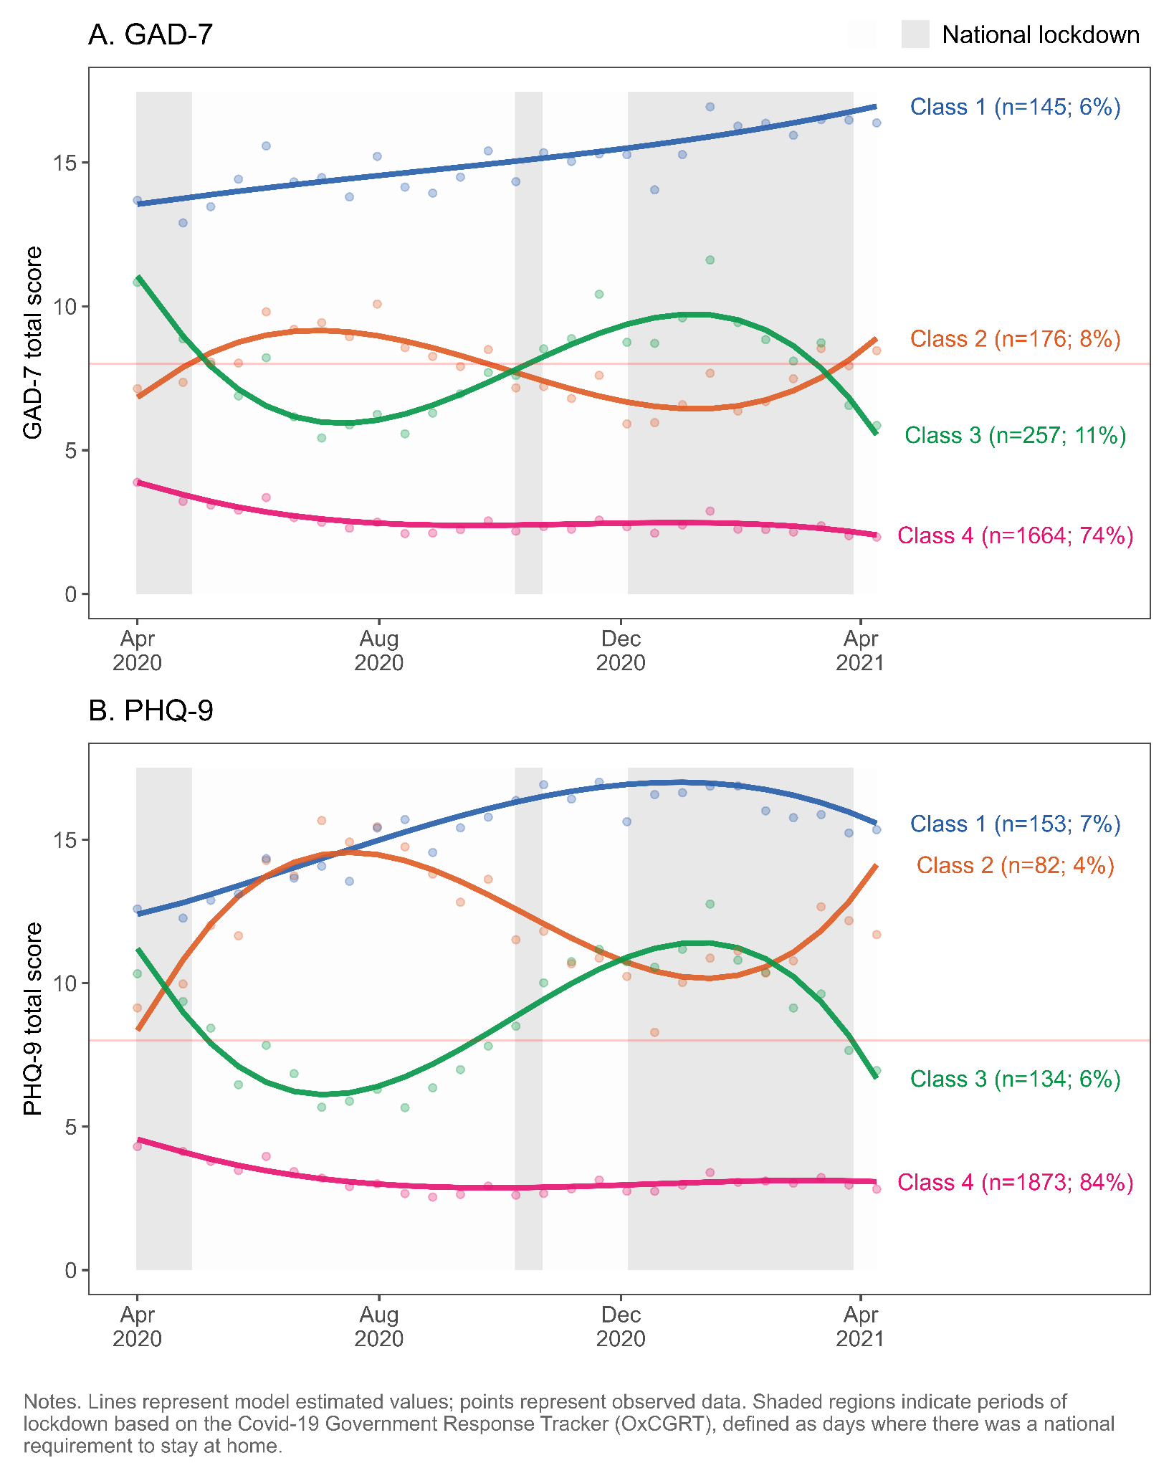

**Figure 3:** Associations of baseline variables with trajectory class assignment (n=2241)

Odds ratios representing odds of class assignment, compared to reference class of ‘Persistent low severity’. Odds ratios also presented in Supplementary Table 3.

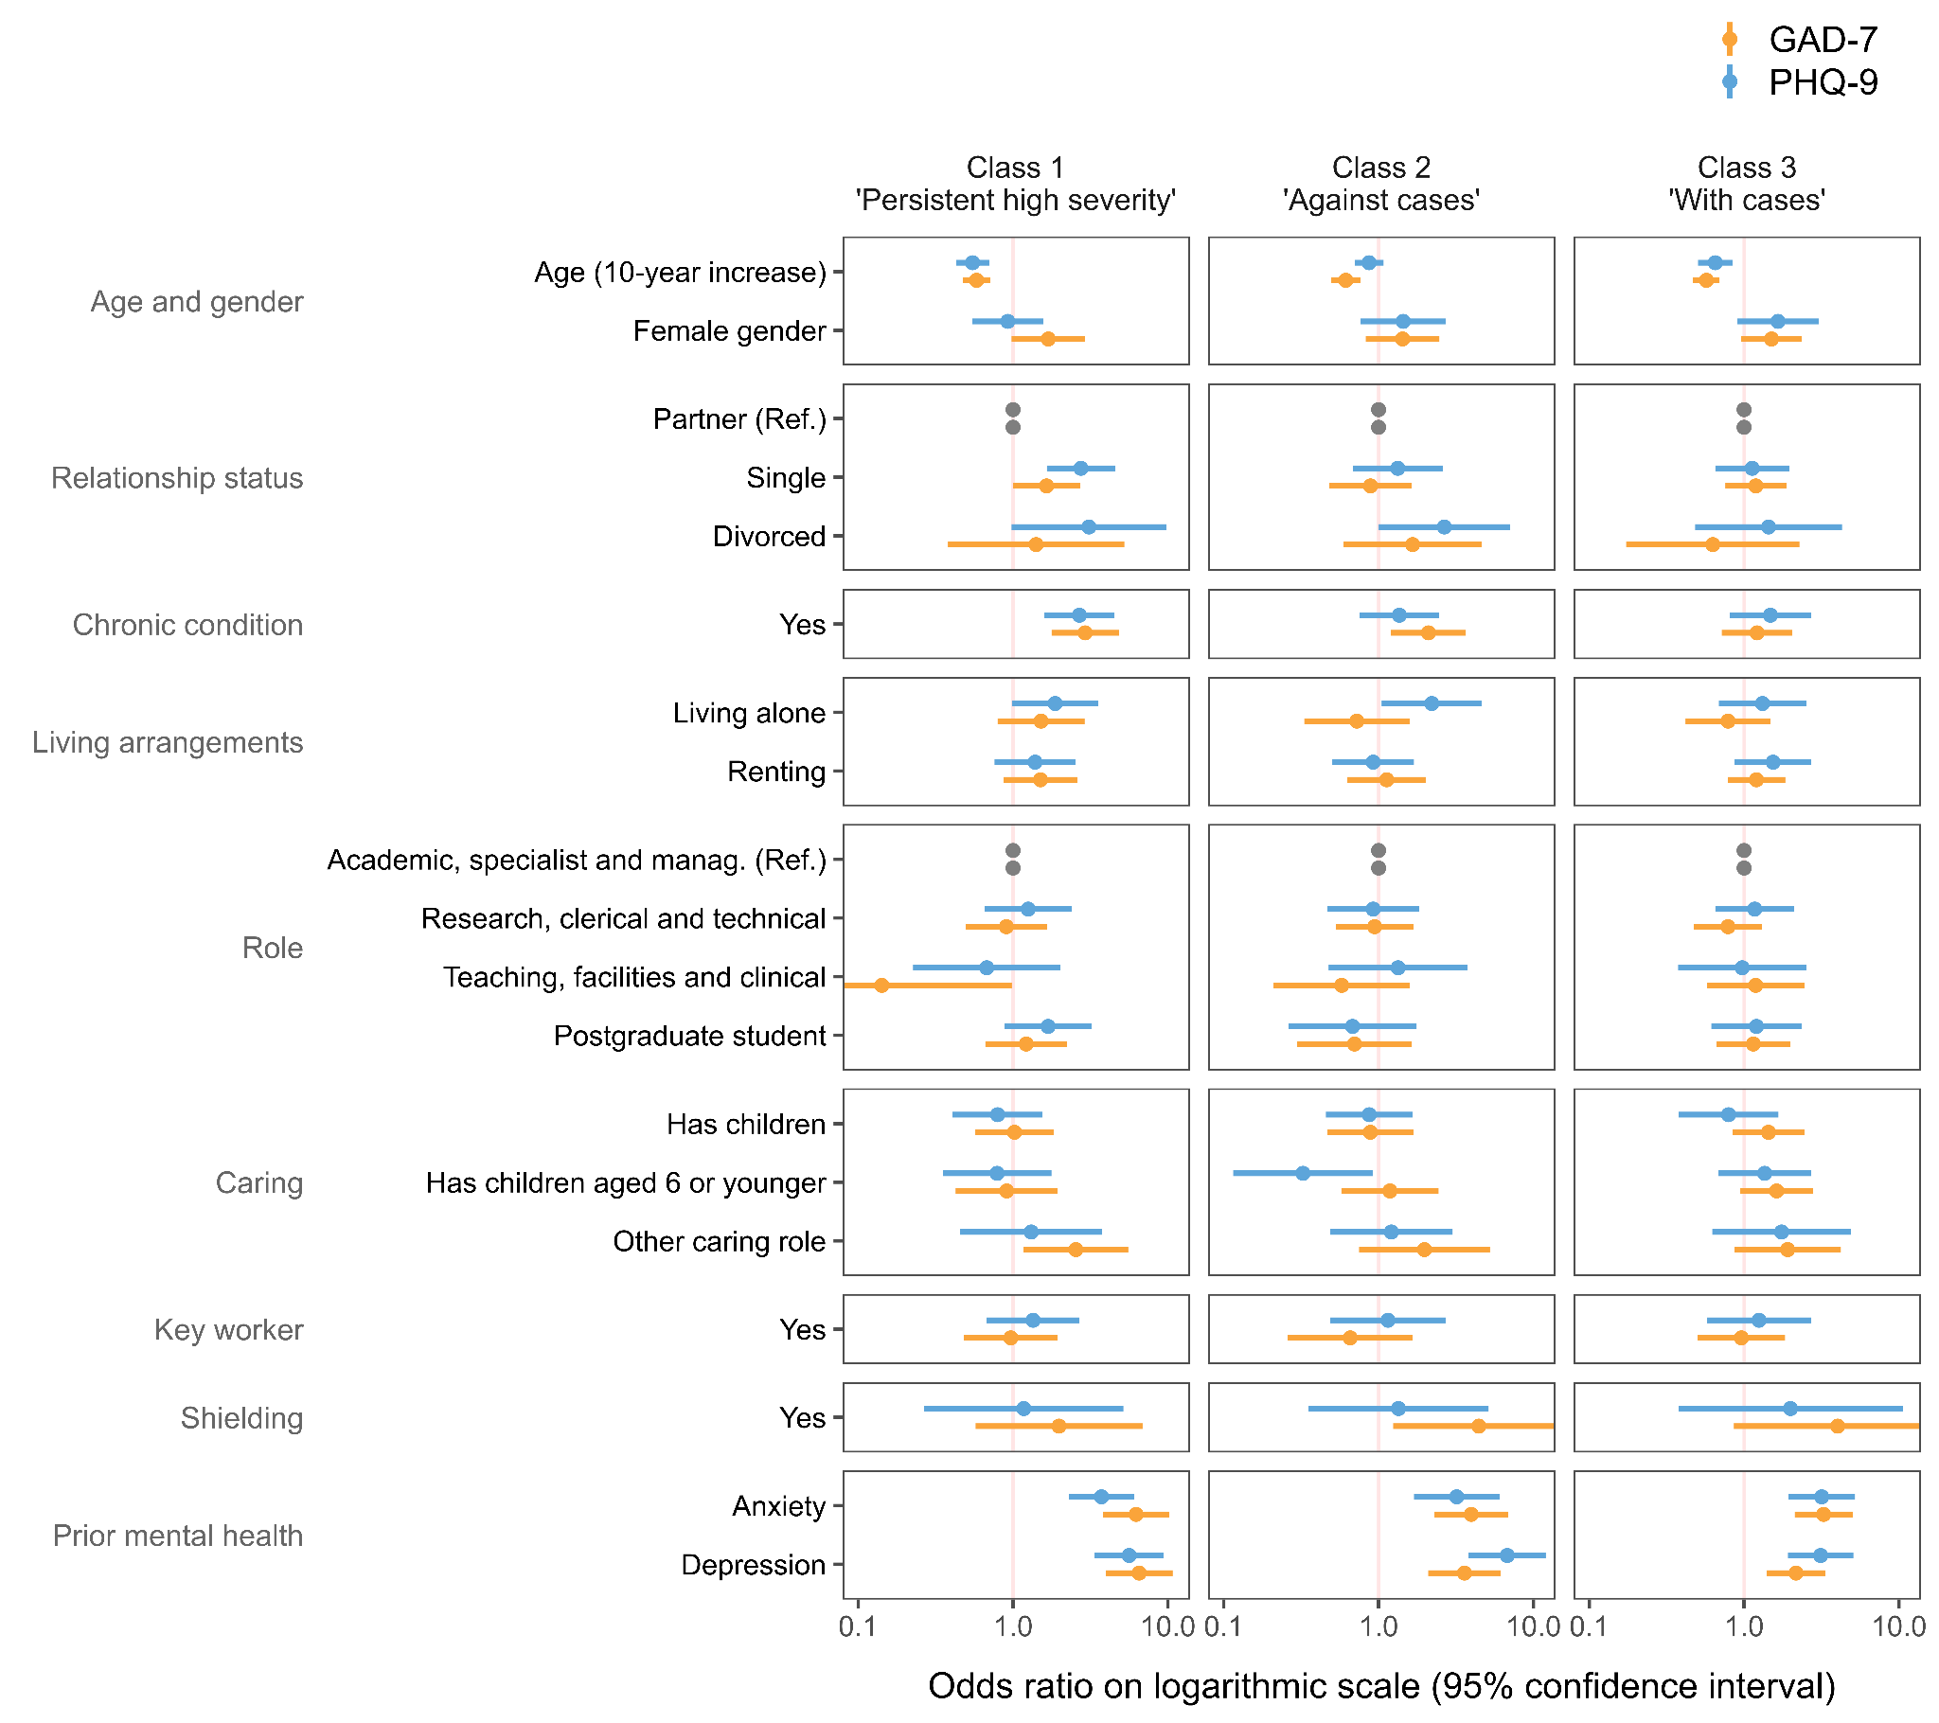

# Discussion

In a large, occupational cohort with fortnightly follow-up and high response rates, we described trajectories of anxiety and depression symptoms in the first year of the COVID-19 pandemic in the UK. Symptoms of anxiety and depression were highest at the start of the pandemic, eased over the summer months, and increased again in December. These fluctuations mirrored national patterns of lockdown and case numbers. While average levels of anxiety and depression were low throughout the year (scores consistent with ‘None’ or ‘Mild’ symptoms), these hid much greater variation among subgroups of respondents. Using growth mixture models, we identified four trajectory types for anxiety and depression. While most participants were assigned to the ‘persistent low-level symptoms’ trajectory class, others experienced more severe and variable symptoms. One group reported high severity symptoms throughout the year (‘persistent high severity’) whereas two groups reported fluctuating, moderate symptoms. Notably, these were in opposing directions. Some respondents reported reductions in symptom severity as lockdown measures eased, while at the same time, others experienced increasing anxiety and depression.

## Comparison with past studies

Our findings are consistent with several studies identifying trajectories of mental health in general population samples during the pandemic. Pierce et al. [[29]](https://www.zotero.org/google-docs/?GCBgQr) identified remarkably similar trajectories using the nationally representative UK Household Longitudinal Study (UKHLS). Based on the General Health Questionnaire (GHQ-12), they identified five classes: most respondents (77%) were assigned to ‘Consistently good’ or ‘Consistently very good’ classes, whereas a minority (4%) belonged to a ‘Consistently very poor’ class. Like us, they also identified two classes with moderate symptoms that experienced opposing trajectories, mirroring our ‘varying symptoms’ classes. One (‘Deteriorating’) saw worsening symptoms in the period from April to July, when national case numbers declined, whereas another (‘Recovery’) saw improving symptoms. Whereas Pierce et al. incorporated data until September 2020, our trajectories extended until April 2021. Our findings suggest that the ‘deterioration’ and ‘recovery’ trajectories identified in the UKHLS may have subsequently reversed course in December 2020 amidst worsening national circumstances. Consistent with our findings, Pierce et al. found more adverse trajectories to be associated with female gender, younger age, prior mental health condition, living alone, and shielding.

Our findings are also consistent with those from the UCL Social Study [[30]](https://www.zotero.org/google-docs/?XzPkhs), an online survey of over 70,000 respondents, that found levels of anxiety (GAD-7) and depression (PHQ-9) to be highest in April at the start of the pandemic, declining over the summer months, and increasing again from December 2020. They similarly found more severe symptoms those with younger age, female gender, and prior mental health diagnosis. Saunders et al. [[31]](https://www.zotero.org/google-docs/?JGX7oc) used information for 21,938 adults in England who participated in the UCL Social Study between March and July 2020. They identified four trajectory classes for symptoms of anxiety (GAD-7) and depression (PHQ-9). As in our study, most respondents were assigned to a ‘low symptom severity’ class (approx. 70%) whereas a smaller proportion experienced moderate or severe symptoms (between 6% and 17%). These classes are similar to our ‘persistent low level’ and ‘persistent high level’ classes, respectively. A fourth class experienced symptoms that worsened during national lockdown but improved after lockdown measures were eased. This latter class mirrors our ‘Varying symptoms, opposing national cases’ class – that experienced worsening symptoms during lockdown when case numbers declined. Saunders et al. found lower severity trajectories to be associated with older age, whereas moderate or severe trajectories were associated with female gender, low income, living alone, and reporting physical and mental health conditions.

## Policy implications

Our findings should be considered within the context of higher education, a sector that has previously acknowledged the need to support the mental health of its staff and postgraduate students [[32]](https://www.zotero.org/google-docs/?7qAGfa). Challenges in this sector are likely to have been exacerbated by the strains of the pandemic [[33]](https://www.zotero.org/google-docs/?ExZmDW) and create a renewed need for action to improve mental health support for staff and students. However, as our results highlight, individual experiences of the pandemic are heterogeneous and average trends will hide considerable inter-individual variation. Thus, policies must reflect the diverse needs of each subgroup and policies that help individuals in one group might not help individuals in another. For example, we found that amidst easing lockdown and falling national case numbers, some respondents reported improving symptoms while others reported worsening symptoms. The latter group is particularly relevant, since this directionality (i.e. worsening symptoms amids ‘improving’ national circumstances) might seem counterintuitive and thus easily overlooked when designing policies to help staff and students resume in-person activities.

Another example is the finding that shielding respondents were more likely to have varying symptoms and showed sensitivity to changes in COVID policy. This provides helpful guidance for employers as they can predict that shielding employees are going to be particularly sensitive to future changes. However, the directionality is unclear (if their symptoms will improve or worsen with these changes), thus requiring high flexibility in the type of support being offered.

Finally, the current findings regarding the variability of mental health over time has given further credence to the importance of frequent data collection in understanding the temporality of mental health. Detailed information on characteristics of the target population is needed to understand representativeness and generate sampling weights. However, many surveys under-represent minority groups or misrepresent the target population. Thus future policy and recommendations should be inclusive of under-represented groups.

## Strengths and limitations

Our study benefited from a large, well-defined sample that included one fifth of KCL staff and PGR students. All participants were working or studying at KCL at baseline, and therefore, are likely to have received similar communications from the university and experienced similar workplace policies. Follow-up information was collected fortnightly for 12 months and response rates remained high throughout the study. We used administrative data to describe and account for compositional differences between the sample and target population using sampling weights. We also derived longitudinal weights to account for non-response. Our use of latent growth curve modelling made efficient use of the available data and retained all participants with at least one follow-up assessment. We used validated measures of mental health and adjusted for several important confounders. In particular, our assessment of prior mental health differentiated between anxiety and depression, whereas similar studies have used a simpler measure of ‘previous mental health diagnosis’ [[30]](https://www.zotero.org/google-docs/?TgNS2c).

However, there are several limitations. First, although one fifth of the target population participated in the survey, male gender and racial and minority ethnic groups were under-represented. We derived weights to account for differences between sample and population, but these cannot make up for the missing experiences from smaller, intersectional groups that are present in very small numbers. Small numbers from minority ethnic groups also prevented us from assessing associations with class assignment. Second, occupational studies have been shown to report higher levels of psychological stress, compared to population studies [[34]](https://www.zotero.org/google-docs/?hRBe4l). Our study captures a single occupational cohort at a large London university, which may not reflect patterns in other workplaces. Respondents had more years of education and higher socioeconomic position compared to the general population. There will also be a healthy worker effect [[35]](https://www.zotero.org/google-docs/?fHFopm) since employees and PGR students are, by definition, well enough to work.

Third, while the GAD-7 and PHQ-9 questionnaires are widely used and have been validated for the general population [[17,18]](https://www.zotero.org/google-docs/?MmLONF), studies validating these scales for use in a global pandemic are yet to be published. During extremely adverse events such as pandemic and lockdown, it is not known how questionnaire scores relate to clinical disorder. Fourth, we lacked information on mental health among staff and PGR students from before the pandemic and cannot say how the observed trends or differences compare to previous years. Recent studies have shown mental health reporting during the pandemic to differ markedly from the pre-pandemic period [[36]](https://www.zotero.org/google-docs/?KPRW0n). It is also important to stress that we identified variables associated with mental health during a pandemic, rather than specific causal effects of COVID-19 on mental health. Many of the observed risk factors are likely to have existed in 2019 and earlier [[5]](https://www.zotero.org/google-docs/?UyJlb1).

# Conclusions

Our findings highlight differing individual responses to the pandemic and underscore the need to consider individual circumstances when assessing and treating mental health. Aggregate trends in anxiety and depression can easily hide greater variation, and symptom severity, experienced by subgroups. As university campuses resume in-person activities it will be important to ensure vulnerable groups are adequately supported. This includes those likely to experience worsening mental health with easing restrictions as well as those with identified risk factors, such as having young children at home, other caring roles, a history of mental illness, or those who are shielding.

# 

# References

[1 Hotopf M, Bullmore E, O’Connor RC, *et al.* The scope of mental health research in the COVID-19 Pandemic and its aftermath. *The British Journal of Psychiatry* 2020;:1–7.](https://www.zotero.org/google-docs/?DMllNz)

[2 Kohler U. Survey Research Methods during the COVID-19 Crisis. *Survey Research Methods* 2020;**14**:93–4. doi:10.18148/srm/2020.v14i2.7769](https://www.zotero.org/google-docs/?DMllNz)

[3 Lin Y-H, Chen C-Y, Wu S-I. Efficiency and Quality of Data Collection Among Public Mental Health Surveys Conducted During the COVID-19 Pandemic: Systematic Review. *Journal of Medical Internet Research* 2021;**23**:e25118. doi:10.2196/25118](https://www.zotero.org/google-docs/?DMllNz)

[4 Bernardini F, Attademo L, Rotter M, *et al.* Social Determinants of Mental Health As Mediators and Moderators of the Mental Health Impacts of the COVID-19 Pandemic. *PS* 2021;**72**:598–601. doi:10.1176/appi.ps.202000393](https://www.zotero.org/google-docs/?DMllNz)

[5 Robinson E, Sutin AR, Daly M, *et al.* A systematic review and meta-analysis of longitudinal cohort studies comparing mental health before versus during the COVID-19 pandemic. *medRxiv* 2021;:2021.03.04.21252921. doi:10.1101/2021.03.04.21252921](https://www.zotero.org/google-docs/?DMllNz)

[6 Vindegaard N, Benros ME. COVID-19 pandemic and mental health consequences: Systematic review of the current evidence. *Brain, Behavior, and Immunity* 2020;**89**:531–42. doi:10.1016/j.bbi.2020.05.048](https://www.zotero.org/google-docs/?DMllNz)

[7 Boden M, Zimmerman L, Azevedo KJ, *et al.* Addressing the mental health impact of COVID-19 through population health. *Clinical Psychology Review* 2021;**85**:102006. doi:10.1016/j.cpr.2021.102006](https://www.zotero.org/google-docs/?DMllNz)

[8 Wei J, Hou R, Zhang X, *et al.* The association of late-life depression with all-cause and cardiovascular mortality among community-dwelling older adults: systematic review and meta-analysis. *The British Journal of Psychiatry* 2019;**215**:449–55. doi:10.1192/bjp.2019.74](https://www.zotero.org/google-docs/?DMllNz)

[9 Godderis L, Luyten J. Challenges and opportunities for occupational health and safety after the COVID-19 lockdowns. 2020.](https://www.zotero.org/google-docs/?DMllNz)

[10 Xiong J, Lipsitz O, Nasri F, *et al.* Impact of COVID-19 pandemic on mental health in the general population: A systematic review. *Journal of Affective Disorders* 2020.](https://www.zotero.org/google-docs/?DMllNz)

[11 Universities UK. Recovery, Skills, Knowledge and Opportunity. London: : Universities UK 2020. https://www.universitiesuk.ac.uk/policy-and-analysis/reports/Documents/2020/uuk-he-vision.pdf (accessed 2 Aug 2021).](https://www.zotero.org/google-docs/?DMllNz)

[12 Rees R, Stokes G, Stansfield C, *et al. Prevalence of mental health disorders in adult minority ethnic populations in England: a systematic review*. 2016.](https://www.zotero.org/google-docs/?DMllNz)

[13 McManus S, Bebbington P, Jenkins R, *et al. Mental health and wellbeing in England: Adult Psychiatric Morbidity Survey 2014 : a survey carried out for NHS Digital by NatCen Social Research and the Department of Health Sciences, University of Leicester.* 2016.](https://www.zotero.org/google-docs/?DMllNz)

[14 Davis KAS, Stevelink SAM, Al-Chalabi A, *et al.* The King’s College London Coronavirus Health and Experiences of Colleagues at King’s Study (KCL CHECK) protocol paper: a platform for study of the effects of coronavirus pandemic on staff and postgraduate students. *medRxiv* 2020;:2020.06.16.20132456. doi:10.1101/2020.06.16.20132456](https://www.zotero.org/google-docs/?DMllNz)

[15 Carr E. Mental health among UK university staff and postgraduate students in the early stages of the COVID-19 pandemic. *Occupational and Environmental Medicine* 2021.](https://www.zotero.org/google-docs/?DMllNz)

[16 Hale T, Angrist N, Goldszmidt R, *et al.* A global panel database of pandemic policies (Oxford COVID-19 Government Response Tracker). *Nat Hum Behav* 2021;**5**:529–38. doi:10.1038/s41562-021-01079-8](https://www.zotero.org/google-docs/?DMllNz)

[17 Kroenke K, Spitzer RL, Williams JB. The PHQ‐9: validity of a brief depression severity measure. *Journal of general internal medicine* 2001;**16**:606–13.](https://www.zotero.org/google-docs/?DMllNz)

[18 Spitzer RL, Kroenke K, Williams JBW, *et al.* A Brief Measure for Assessing Generalized Anxiety Disorder: The GAD-7. *Arch Intern Med* 2006;**166**:1092–7. doi:10.1001/archinte.166.10.1092](https://www.zotero.org/google-docs/?DMllNz)

[19 Downey RG, King CV. Missing Data in Likert Ratings: A Comparison of Replacement Methods. *The Journal of General Psychology* 1998;**125**:175–91. doi:10.1080/00221309809595542](https://www.zotero.org/google-docs/?DMllNz)

[20 Wickrama K, Lee TK, O’Neal CW, *et al. Higher-Order Growth Curves and Mixture Modeling with Mplus: A Practical Guide*. New York: : Routledge 2016. doi:10.4324/9781315642741](https://www.zotero.org/google-docs/?DMllNz)

[21 Sclove SL. Application of model-selection criteria to some problems in multivariate analysis. *Psychometrika* 1987;**52**:333–43. doi:10.1007/BF02294360](https://www.zotero.org/google-docs/?DMllNz)

[22 Lo Y, Mendell NR, Rubin DB. Testing the Number of Components in a Normal Mixture. *Biometrika* 2001;**88**:767–78.](https://www.zotero.org/google-docs/?DMllNz)

[23 Nylund KL, Asparouhov T, Muthén BO. Deciding on the Number of Classes in Latent Class Analysis and Growth Mixture Modeling: A Monte Carlo Simulation Study. *Structural Equation Modeling: A Multidisciplinary Journal* 2007;**14**:535–69. doi:10.1080/10705510701575396](https://www.zotero.org/google-docs/?DMllNz)

[24 Asparouhov T, Muthén B. Auxiliary Variables in Mixture Modeling: Three-Step Approaches Using Mplus. *Structural Equation Modeling: A Multidisciplinary Journal* 2014;**21**:329–41. doi:10.1080/10705511.2014.915181](https://www.zotero.org/google-docs/?DMllNz)

[25 R Core Team. *R: A language and environment for statistical computing*. Vienna, Austria: 2020. https://www.R-project.org/](https://www.zotero.org/google-docs/?DMllNz)

[26 Hallquist MN, Wiley JF. MplusAutomation: An R Package for Facilitating Large-Scale Latent Variable Analyses in Mplus. *Structural Equation Modeling: A Multidisciplinary Journal* 2018;**0**:1–18. doi:10.1080/10705511.2017.1402334](https://www.zotero.org/google-docs/?DMllNz)

[27 Lumley T. Analysis of complex survey samples. *Journal of Statistical Software* 2004;**9**:1–19.](https://www.zotero.org/google-docs/?DMllNz)

[28 Enders CK, Bandalos DL. The Relative Performance of Full Information Maximum Likelihood Estimation for Missing Data in Structural Equation Models. *Structural Equation Modeling: A Multidisciplinary Journal* 2001;**8**:430–57. doi:10.1207/S15328007SEM0803_5](https://www.zotero.org/google-docs/?DMllNz)

[29 Pierce M, McManus S, Hope H, *et al.* Mental health responses to the COVID-19 pandemic: a latent class trajectory analysis using longitudinal UK data. *The Lancet Psychiatry* 2021;**8**:610–9. doi:10.1016/S2215-0366(21)00151-6](https://www.zotero.org/google-docs/?DMllNz)

[30 Fancourt D, Feifei B, Hei Wan M, *et al.* Covid-19 Social Study: Results Release 36. London: : University College London 2021. https://b6bdcb03-332c-4ff9-8b9d-28f9c957493a.filesusr.com/ugd/3d9db5_93342fa7cccf45b194f8c6ec6c16e66f.pdf (accessed 18 Aug 2021).](https://www.zotero.org/google-docs/?DMllNz)

[31 Saunders R, Buckman JEJ, Fonagy P, *et al.* Understanding different trajectories of mental health across the general population during the COVID-19 pandemic. *Psychological Medicine* undefined/ed;:1–9. doi:10.1017/S0033291721000957](https://www.zotero.org/google-docs/?DMllNz)

[32 Universities UK. Stepchange: mentally healthy universities. 2020;:36.](https://www.zotero.org/google-docs/?DMllNz)

[33 Holmes EA, O’Connor RC, Perry VH, *et al.* Multidisciplinary research priorities for the COVID-19 pandemic: a call for action for mental health science. *The Lancet Psychiatry* 2020.](https://www.zotero.org/google-docs/?DMllNz)

[34 Goodwin L, Ben-Zion I, Fear NT, *et al.* Are Reports of Psychological Stress Higher in Occupational Studies? A Systematic Review across Occupational and Population Based Studies. *PLOS ONE* 2013;**8**:e78693. doi:10.1371/journal.pone.0078693](https://www.zotero.org/google-docs/?DMllNz)

[35 Li C-Y, Sung F-C. A review of the healthy worker effect in occupational epidemiology. *Occup Med* 1999;**49**:225–9. doi:10.1093/occmed/49.4.225](https://www.zotero.org/google-docs/?DMllNz)

[36 Pierce M, Hope H, Ford T, *et al.* Mental health before and during the COVID-19 pandemic: a longitudinal probability sample survey of the UK population. *The Lancet Psychiatry* Published Online First: 2020. doi:10.1016/S2215-0366(20)30308-4](https://www.zotero.org/google-docs/?DMllNz)

1. Defined as “not leaving house with exceptions for daily exercise, grocery shopping, and ‘essential’ trips” or “not leaving house with minimal exceptions (e.g., allowed to leave once a week, or only one person can leave at a time, etc.)”.
2. <https://github.com/ewancarr/check-longitudinal>