Lab Report

Lab Title: Spectrum Estimation of Multimedia Signals

Name: William Ewanchuk

Student ID: 1692036

Section: D51

Date Lab Performed: November 15, 2024

**Question 1: Audio File Information**

*First Few Words of the Song:*

I love to love, I love to love you,

So much I wanna share and do, wohohoh

I love to love, I love to love you,

I wanna find a way to you

**(b)** *MATLAB Code to Read the Audio File*

**Sampling Rate:** Fs = 22050 Hz

**Matrix Size of x:** 400000 X 1 = size(x)

**Bit-Rate Calculation:** Bit-Rate = Bit-Depth × Sampling Rate

**Bit-Rate (bits/sec):** 7.0560 X 10^10 Bits/sec

**Duration of Audio Signal (seconds):** 18.1406

**Question 2: Spectrum Estimation Using DFT**

1. *MATLAB Code to Calculate the Discrete Fourier Transform*

**(b) Values of X[0], X[1], and X[2]**

**X[0]:** -16.0625

**X[1]:** 0.077856 -0.64057j

**X[2]:** 3.1697 -1.6708j

*(c) MATLAB Code to Scale the Coefficients*

*(d) MATLAB Code to Plot the Magnitude Spectrum in dB*

**(e) Comments on the Magnitude Spectrum**

*Comments:*

* Most of the signal's energy is concentrated in the lower frequency range, particularly below 2 kHz. This indicates that the audio signal predominantly contains low-frequency components, which is typical of music or speech signals.
* The magnitude decreases significantly after approximately 2 kHz, showing a decline in the strength of higher frequency components. This is expected, as higher frequencies usually carry less energy in natural audio signals.
* A noticeable peak appears around 3, which most likely represents the tonal noise that could be heard throughout the sound clip, which was most likely the 3 kHz peak as there were no surrounding frequency peaks in the plot.

**Question 3: Power Spectrum Using pwelch**

1. *MATLAB Code to Generate the Power Spectral Density Plot*

**(b) Frequency Range with Most Energy**

*Frequency Range with Top 20 dB Energy:* 0.043066 kHz to 3.0146 kHz

* From the plot, the signal's energy is concentrated in the range 0–3 kHz.
* This is where the highest peaks occur, indicating that most of the power is within this frequency range.

**(c) Frequency of Tonal Noise**

*Frequency of Annoying Tonal Noise:* 3.01465kHz

* From the plot, the signal's energy is concentrated in the range 0–3 kHz.
* This is where the highest peaks occur, indicating that most of the power is within this frequency range.

**Question 4: Spectrum of a 2-D Image**

*Image with Visual Artifacts*

**(a) Comments on the Image Quality**

*Comments:*

* The observed grid-like pattern in the image, resembling a 'picnic table' with gridded lines, appears to be an intentional distortion introduced into the signal. This pattern may correspond to a high-frequency modulation, or a deliberate **spatial filter** applied to the image. The periodic nature of the grid leads to repetitive structures in the image, which can be observed in both the visual domain and the frequency domain.
* The grid-like pattern observed in the image is a result of periodic noise introduced into the spatial domain. This periodicity corresponds to distinct high-frequency components in the Fourier spectrum. In the spatial domain, the grid lines appear as horizontal and vertical patterns that repeat across the image. In the frequency domain, these periodic structures manifest as distinct peaks at specific frequencies in the 2D spectrum. These peaks indicate the presence of energy concentrated at those spatial frequencies, directly caused by the repetitive grid pattern in the image.

*MATLAB Code to Display and Analyze Image*

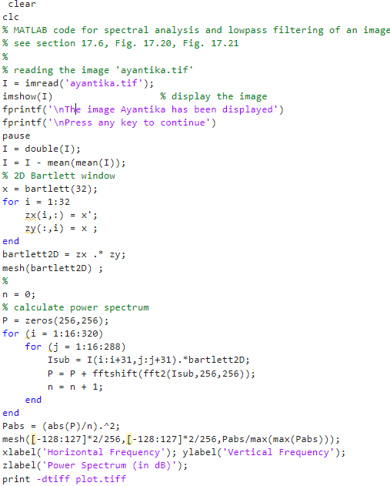

1. *Observations from the Spectrum Plot*

*Normalized Frequency Ranges:*

* Horizontal Frequency Range: [-1 , 1] cycles per pixel
* Vertical Frequency Range: [-1, 1] cycles per pixel

These ranges correspond to the spatial frequencies in the 2D Fourier domain after the Fourier Transform is performed, and the frequency resolution is determined by the size of the 256x256 pixellated grid. This is a normalized frequency scale, where 0 corresponds to the DC (low frequency) component, and the highest frequencies are represented by the edges of the plot.

**(d) 2-D Frequencies of Noise Peaks**

*Noise Peaks Frequencies:*

* [0.523438, 0]
* [-0.523438, 0]
* [0, 0.523438]
* [0, -0.523438]

The periodic grid pattern in the spatial domain directly corresponds to these frequencies, with the spacing between the grid lines determining the frequency values. Specifically, the closer the grid lines are to each other, the higher the spatial frequency. The symmetry of the frequency peaks (positive and negative) reflects the Fourier transform's properties, indicating that the same frequency content exists in both directions visually.

