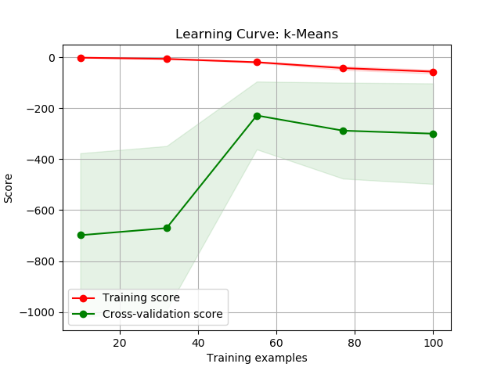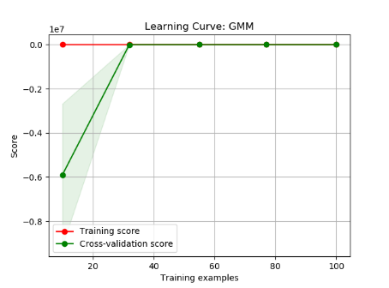

**K-means Clustering – Iris Dataset**

|  |  |  |
| --- | --- | --- |
| Number of Clusters (k) | Average Silhouette Score | Computation Time (s) |
| 2 | 0.681046169211746 | 0.012734415468326654 |
| 3 | 0.5528190123564091 | 0.029036258562866735 |
| 4 | 0.4980505049972866 | 0.029844457052465856 |
| 5 | 0.4887488870931048 | 0.03492919624095947 |
| 6 | 0.3678464984712235 | 0.0373326346812366 |
| 7 | 0.3588294450965675 | 0.048418917627579106 |

**Expectation Maximization – Iris Dataset** *Table 3*

|  |  |  |  |
| --- | --- | --- | --- |
| Number of Clusters | Log Likelihood Lower Bound | Converged? | Runtime |
| 2 | -1.429031363973205 | Yes | 0.005925025838021084 |
| 3 | -1.2014746139064725 | Yes | 0.05119260406701587 |
| 4 | -1.10093144880453 | Yes | 0.028726660712138585 |
| 6 | -0.8059522525664535 | Yes | 0.022368268406526948 |
| 8 | -0.7368557739239782 | Yes | 0.0884444894227201 |
| 10 | -0.3526845027903988 | Yes | 0.08137768927871125 |

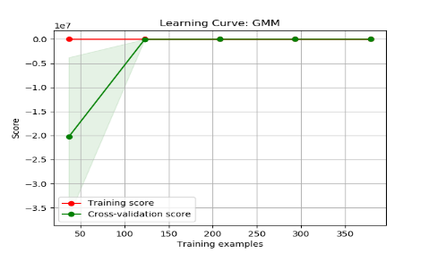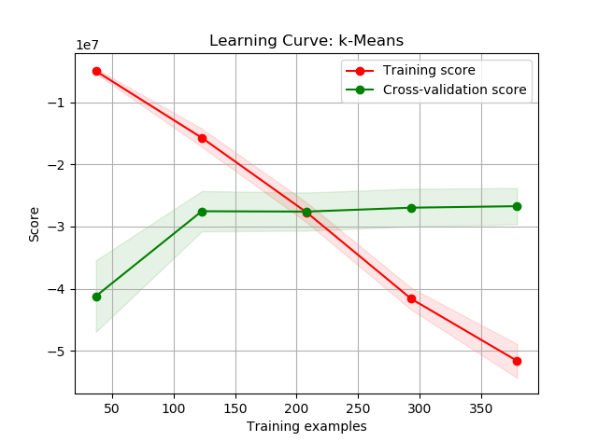

**K-means Clustering – Breast Cancer Dataset**

|  |  |  |
| --- | --- | --- |
| Number of Clusters (k) | Average Silhouette Score | Computation Time (s) |
| 2 | 0.6972646156059464 | 0.03430330081380539 |
| 3 | 0.6660201620263426 | 0.06269250692099249 |
| 4 | 0.5334614737117133 | 0.1113413309251925 |
| 5 | 0.5102292997907839 | 0.10151283332457695 |
| 6 | 0.4857922435948332 | 0.11805410345857581 |
| 7 | 0.4676241057484445 | 0.1423726972778283 |
| 8 | 0.46824565183432526 | 0.08221691807680997 |

**Expectation Maximization – Breast Cancer Dataset**

|  |  |  |  |
| --- | --- | --- | --- |
| Number of Clusters | Log Likelihood Lower Bound | Converged? | Runtime |
| 2 | 39.045730470889744 | Yes | 0.026338737426113486 |
| 3 | 40.78222702448428 | Yes | 0.03384031450628133 |
| 4 | 42.66317965563292 | Yes | 0.10076986900625795 |
| 6 | 45.059190044923525 | Yes | 0.05604849473031326 |
| 8 | 47.043968167914336 | Yes | 0.12968341680368778 |
| 10 | 48.448060139207946 | Yes | 0.14303561750490212 |
| 12 | 50.73155858605159 | Yes | 0.0965233007644386 |

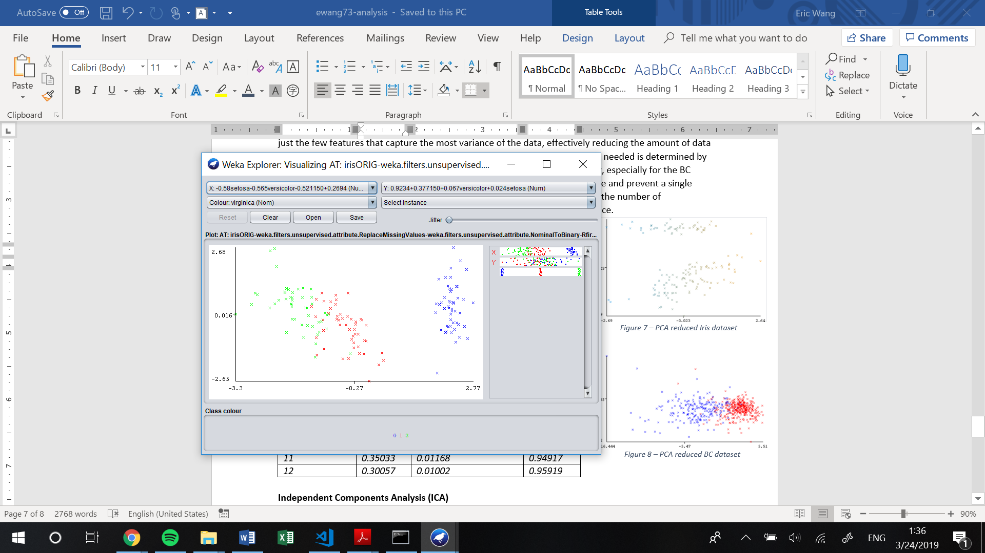iris pca

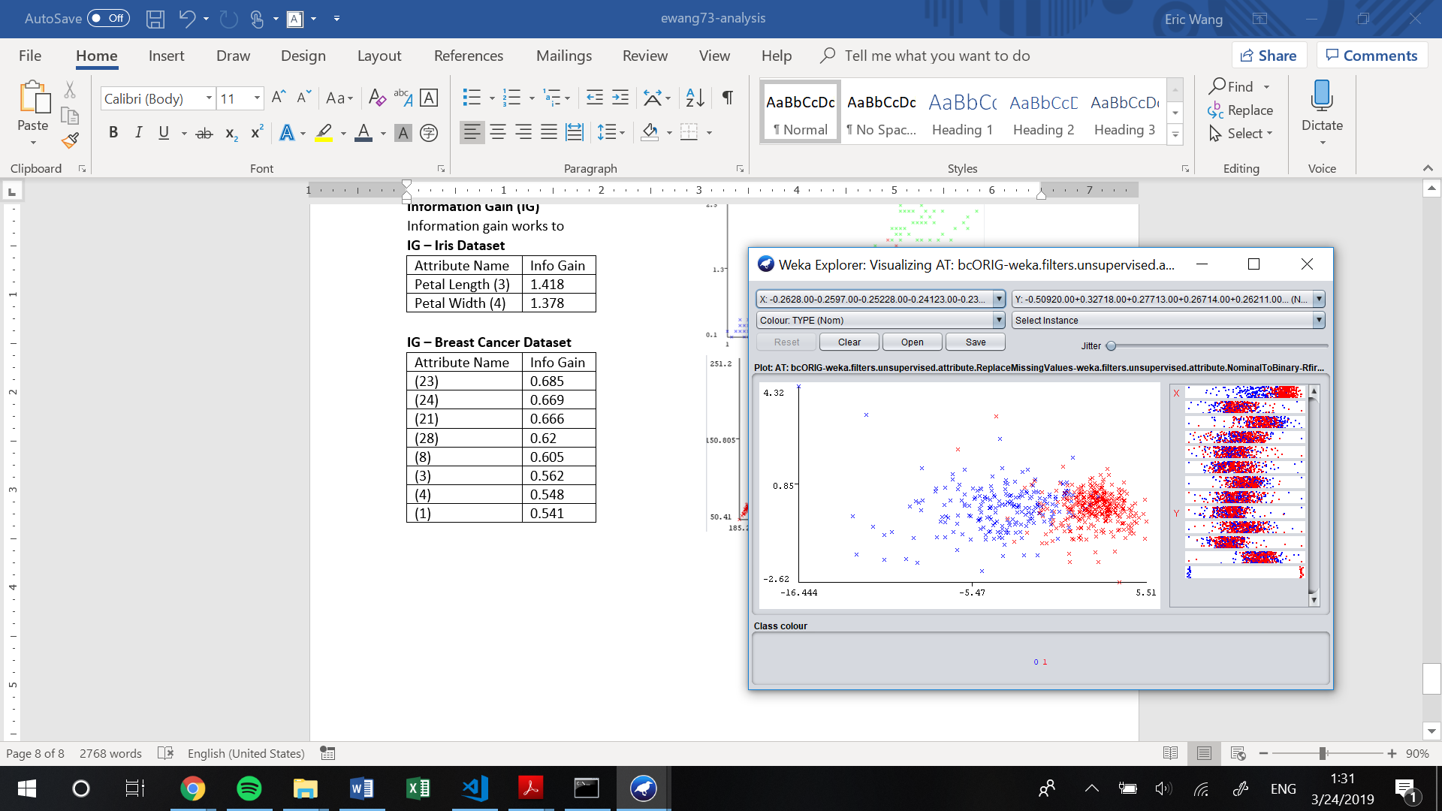bc pca

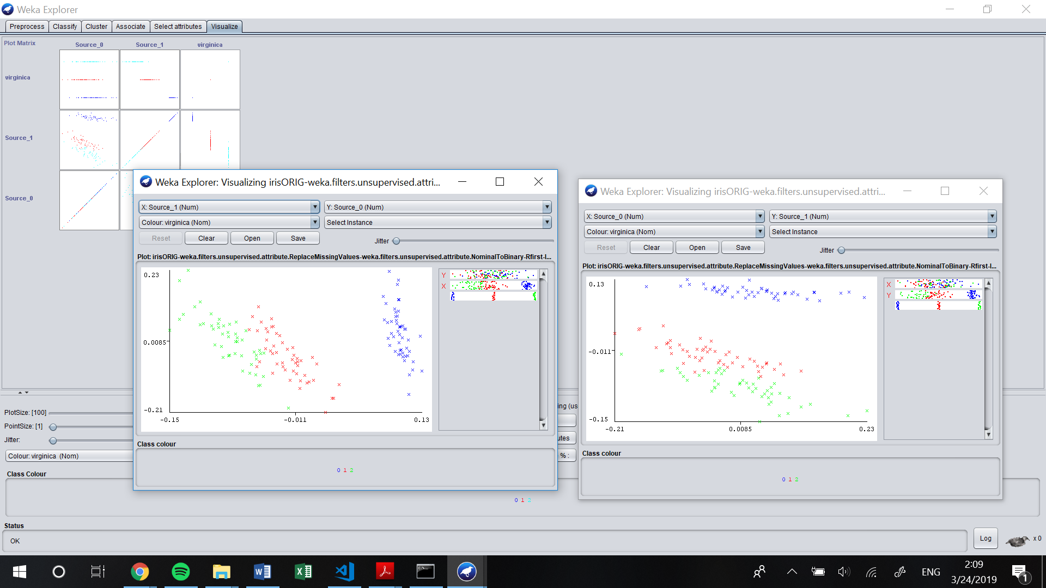Iris ica

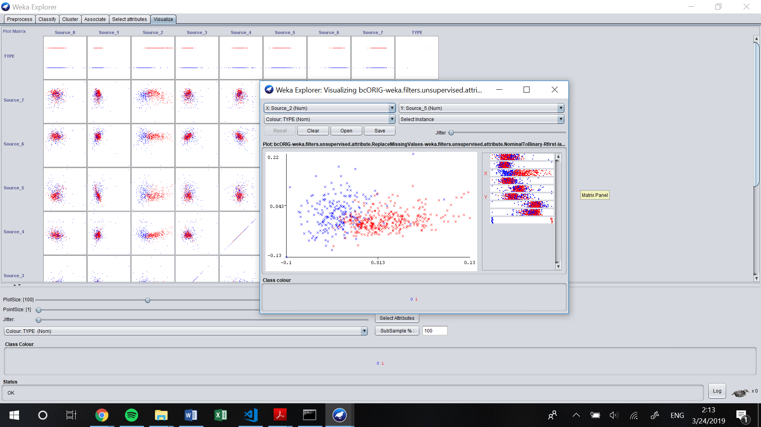Bc ica

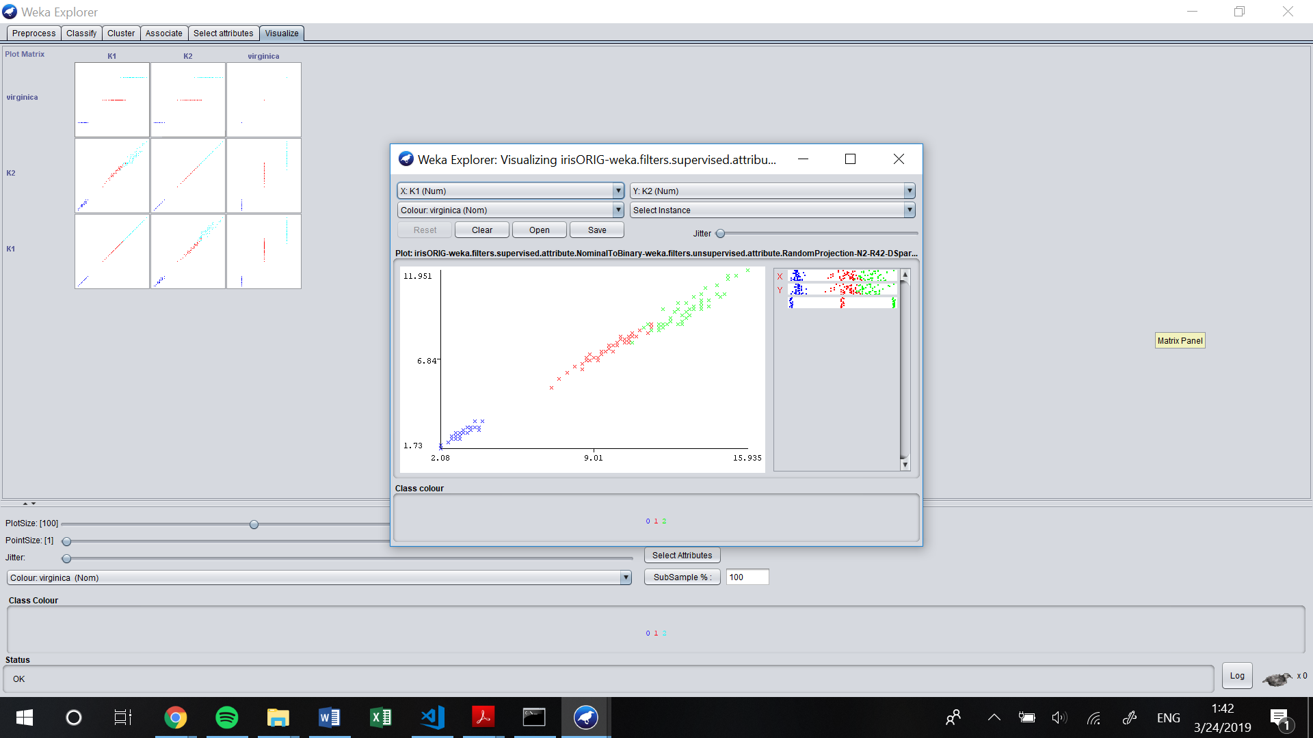Iris rp

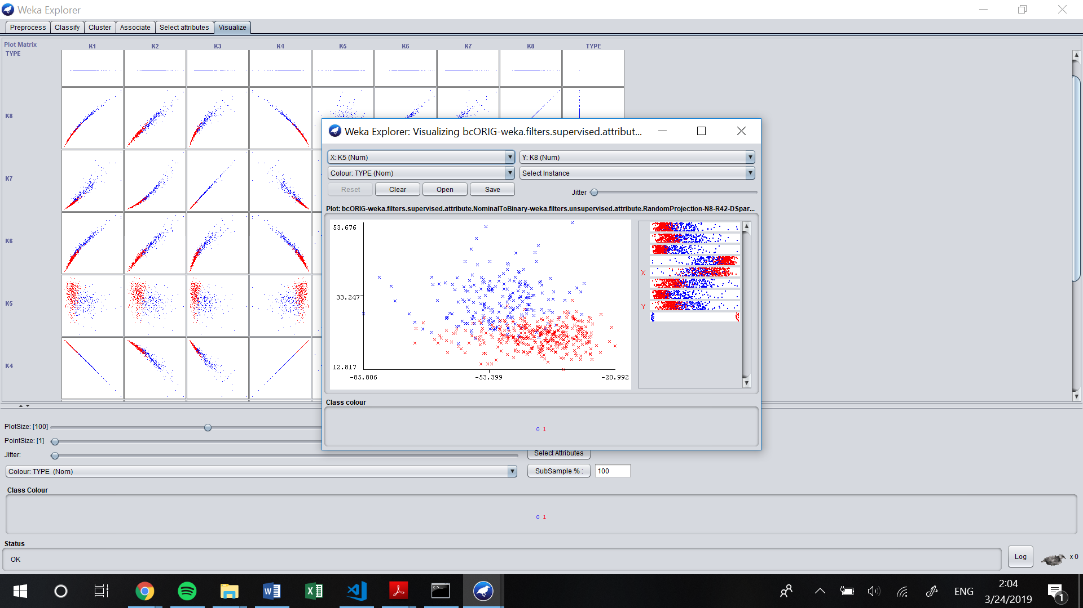Bc rp

Iris ig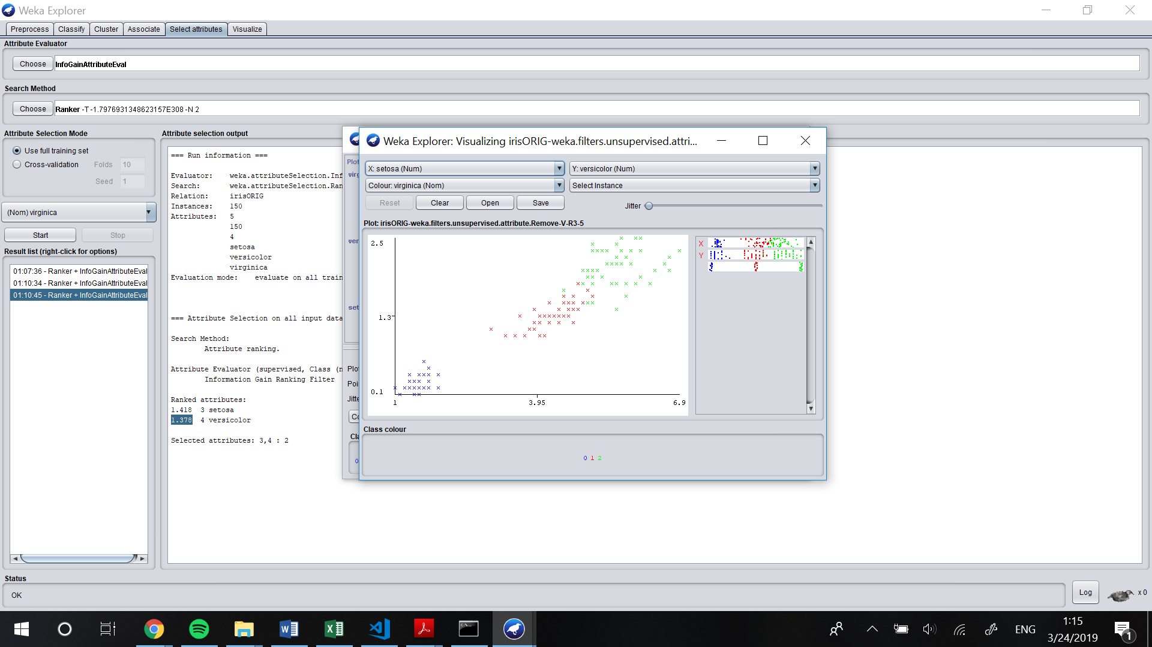

Bc ig