Game Physics - Assignment Report
Ewan McGrath – K00204708

For this assignment we were tasked with creating a small 3D scene using the Bullet Physics engine and OpenGL. I decided I was going to create a Pachinko machine of sorts, as I think having the balls fall down through the gaps is an interesting display of physics.
To accomplish this, I took the code from chapter seven of the book we were given, and I changed a few things, and added some code.
First to create the Pachinko-esque game I changed the box you spawn with right mouse click to a sphere; To mimic the balls found in a Pochinko machine.
Next, I added some struts coming out of a large wall in specific places (these are the struts in white) to act as a starting location for the balls to fall down towards. Then, I added another set of struts on the wall to separate out the balls more. Finally, I added areas for the balls to fall into, separated by small walls.
After that, I added the spawn points for the balls, as using the mouse was somewhat tedious. I added five spawn points for variety and changed the colours of the balls for each spawn, so you could see where they all ended up down below in the boxes. I set the spawn points using a switch statement.
The last thing I did on the scene was create random spawn points for the rest of the struts (these are the struts in black), as adding ~100 struts or so would be too tedious, and it also adds some ‘replayability’. I did this using a simple for loop and randomizing the X and Y positions between four different points.
The last thing I did was edit the camera settings a small bit, so you could get a better view of the balls falling and view everything a lot more closely.

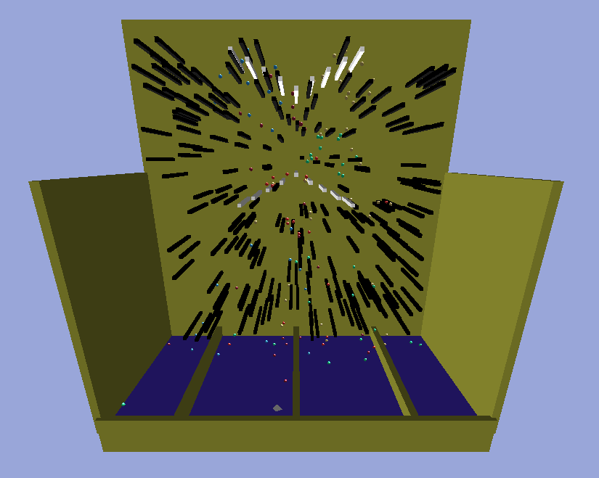
Figure 1 - Example of assignment running

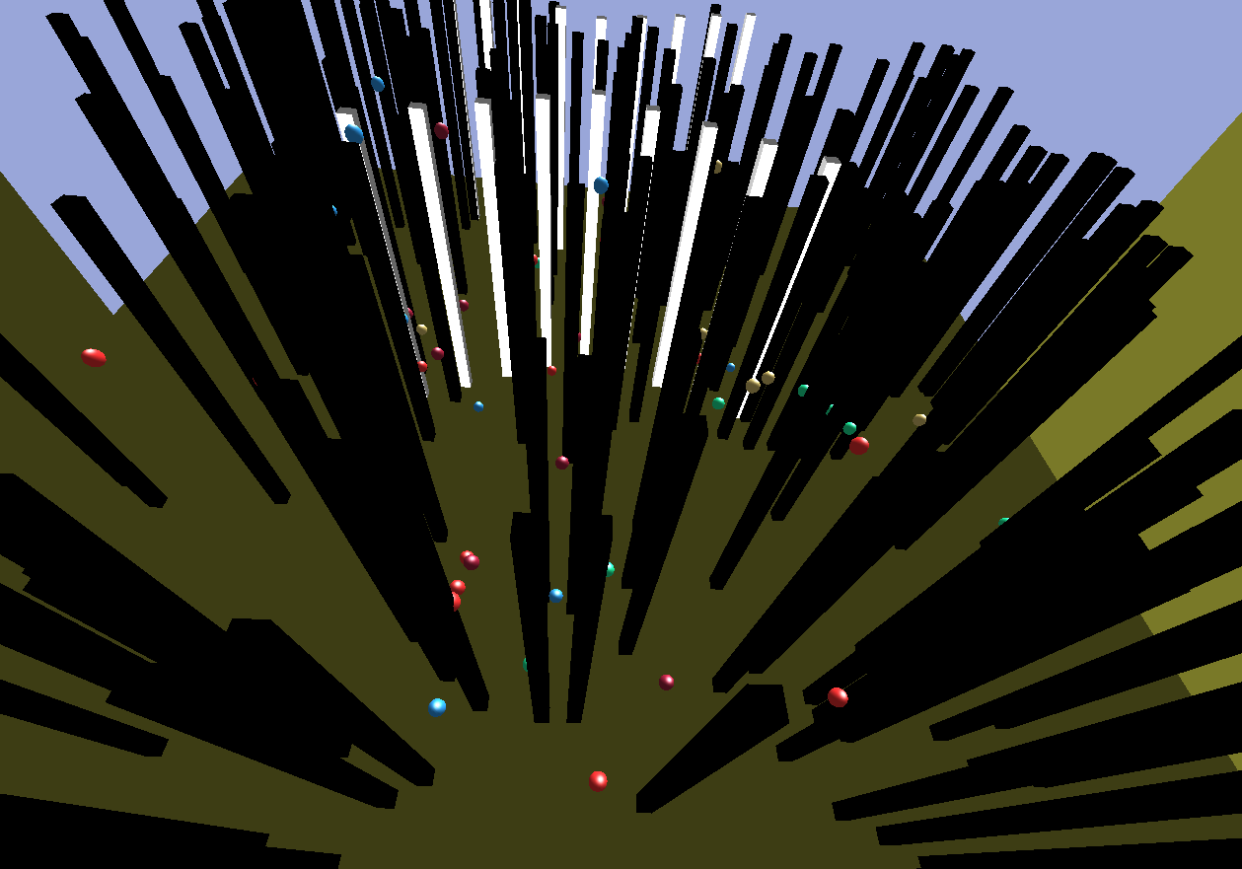
Figure 2 - Second example of assignment running

