[Online LaTeX Equation Editor (lagrida.com)](https://latexeditor.lagrida.com/)

**Total Elements(1)**

\Large \sum_{\small t=1}^{\small n}\normalsize \Large [C_{\small t,Diamond} \normalsize + \Large C_{\small t,Square}]

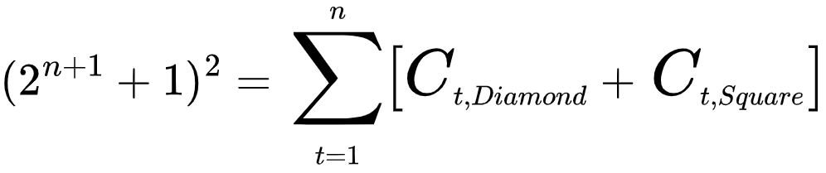

**Total Elements(2)**

\Large \sum_{\small t=1}^{\small n}\normalsize 2^{\small2t-2} \normalsize + 2^{\small2t-1}\normalsize + 2^{\small t}

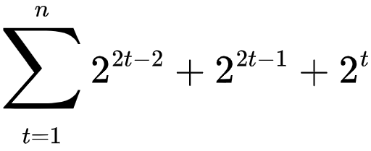

**Total Diamond**

\Large C_{\tiny D,t} \normalsize = 2^{\small2(t-1)}

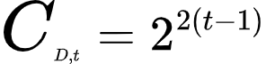

**Total Square(1)**

\Large C_{\tiny S,t} \normalsize = [2^{\small(t-1)}\normalsize+1][2^{\small(t-1)}\normalsize] + [2^{\small(t-1)}\normalsize][2^{\small(t-1)}\normalsize+1]



**Total Square(2)**

\Large C_{\small S,t} \normalsize = 2^{\small(2t-1)}\normalsize + 2^{\small t}

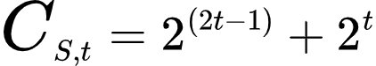

**Target Cells (Diamond)**

\tiny \begin{bmatrix}

\normalsize [a_{\tiny D,t}\normalsize m_{\tiny t}\normalsize][b_{\tiny D,t}\normalsize m_{\tiny t}\normalsize] & & \normalsize[ a_{\tiny D,t}\normalsize m_{\tiny t}\normalsize][(b_{\tiny D,t}\normalsize +1)m_{\tiny t}\normalsize] \\ \\ \\

& \huge [ a_{\small D,t}\huge m_{\small t}\huge+e_{\small t}\huge][b_{\small D,t}\huge m_{\small t}\huge+e_{\small t}\huge] & \\ \\ \\

\normalsize [(a_{\tiny D,t}\normalsize +1)m_{\tiny t}\normalsize][b_{\tiny D,t}\normalsize m_{\tiny t}\normalsize] & & \normalsize [(a_{\tiny D,t}\normalsize +1)m_{\tiny t}\normalsize][(b_{\tiny D,t}\normalsize +1)m_{\tiny t}\normalsize]

\end{bmatrix}

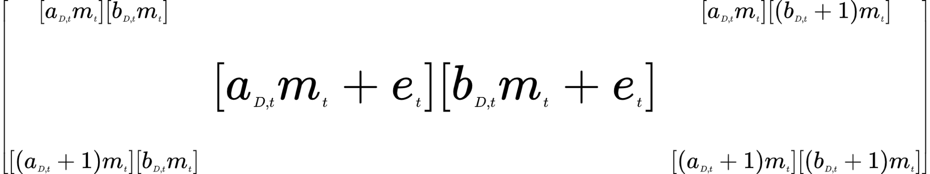

**Target Cells (Square) (a rows, b cols)**

\tiny \begin{bmatrix}

& \normalsize [a_{\tiny S,t} m_{\tiny t}\normalsize][b_{\tiny S,t} m_{\tiny t}\normalsize ] & \\ \\ \\

\normalsize [a_{\tiny S,t} m_{\tiny t}\normalsize +e_{\tiny t}\normalsize ][b_{\tiny S,t} m_{\tiny t}\normalsize -e_{\tiny t}\normalsize ] \ \ \ \ & \huge [a_{\small S,t} m_{\small t}\huge +e_{\small t}\huge ][b_{\small S,t} m_{\small t}\huge] & \ \ \ \ \normalsize [a_{\tiny S,t} m_{\tiny t}\normalsize +e_{\tiny t}\normalsize ][b_{\tiny S,t} m_{\tiny t}\normalsize +e_{\tiny t}\normalsize ] \\ \\ \\

& \normalsize [(a_{\tiny S,t} +1)m_{\tiny t}\normalsize ][b_{\tiny S,t} m_{\tiny t}\normalsize ] &

\end{bmatrix}

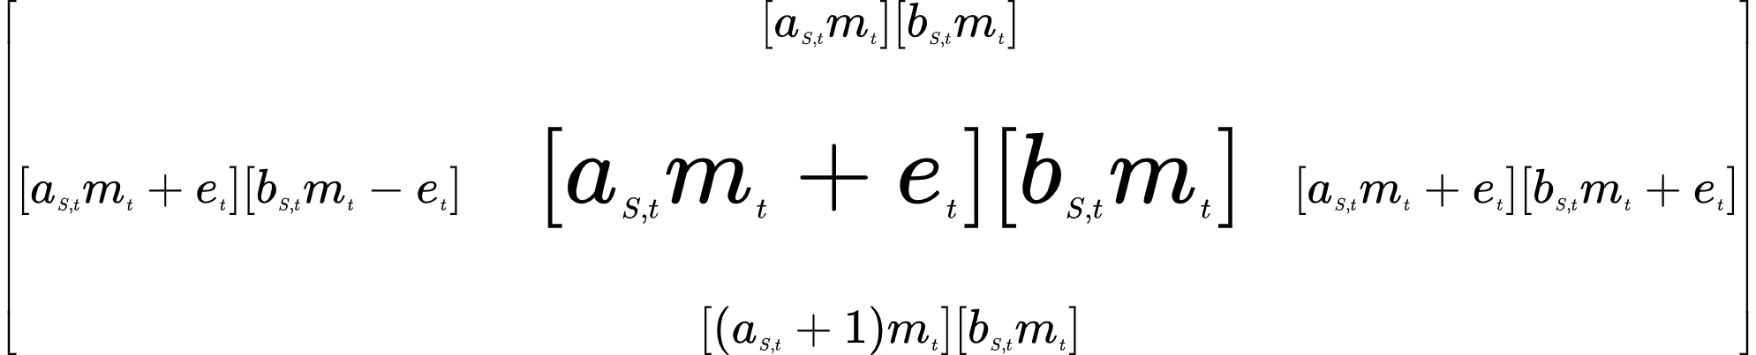

**Target Cells (Square) (a cols, b rows)**

\tiny \begin{bmatrix}

& \normalsize [b_{\tiny S,t} m_{\tiny t}\normalsize -e_{\tiny t}\normalsize ][a_{\tiny S,t} m_{\tiny t}\normalsize +e_{\tiny t}\normalsize] & \\ \\ \\

\normalsize [b_{\tiny S,t} m_{\tiny t}\normalsize][a_{\tiny S,t} m_{\tiny t}\normalsize ] \ \ \ \ & \huge [b_{\small S,t} m_{\small t}\huge ][a_{\small S,t} m_{\small t}\huge +e_{\small t}\huge] & \ \ \ \ \normalsize [b_{\tiny S,t} m_{\tiny t}\normalsize ][(a_{\tiny S,t}+1) m_{\tiny t}\normalsize ] \\ \\ \\

& \normalsize [b_{\tiny S,t} m_{\tiny t}\normalsize +e_{\tiny t}\normalsize ][a_{\tiny S,t} m_{\tiny t}\normalsize +e_{\tiny t}\normalsize] &

\end{bmatrix}

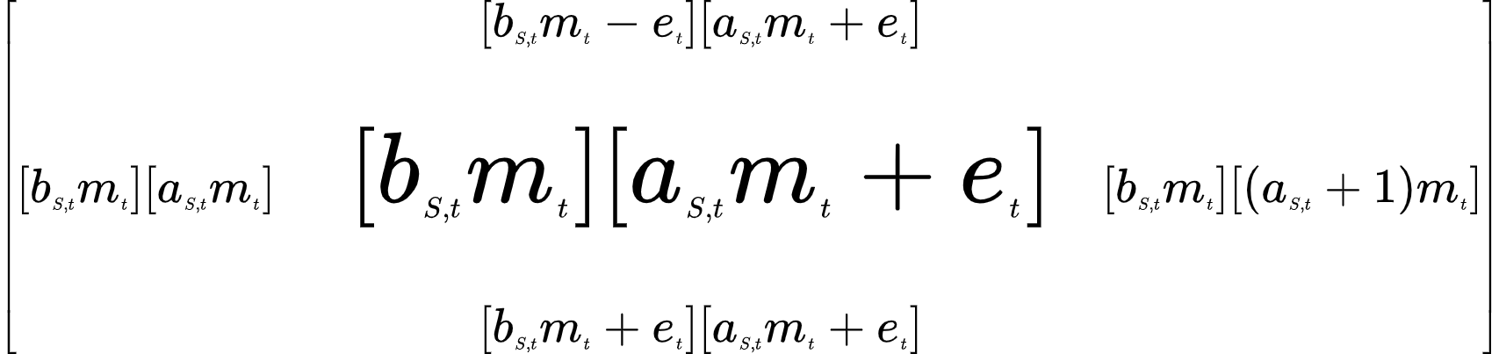

**a range (Diamond)**

a_{\tiny D,t}\normalsize = [0,1,\tiny ...\normalsize,\small \sqrt{ \normalsize C_{\tiny D,t}} \normalsize]

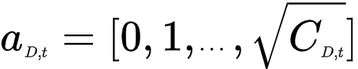

**b range (Diamond)**

b_{\tiny D,t}\normalsize = [0,1,\tiny ...\normalsize,\small \sqrt{ \normalsize C_{\tiny D,t}} \normalsize]

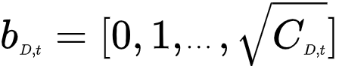

**a range (Square)**

a_{\tiny S,t}\normalsize = [0,1,\tiny ...\normalsize , \normalsize 2^{\small(t-1)}\small - \normalsize1]



**b range (Square)**

b_{\tiny S,t}\normalsize = [0,1,\tiny ...\normalsize , \normalsize 2^{\small(t-1)}\normalsize]



**t range**

t = 1,2,\tiny ...\normalsize n



**d**

d = 2^{\small n}\small + \normalsize 1



**m**

m_{\small t} \normalsize = \frac{d-1}{t}

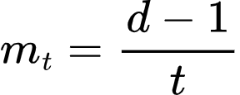

**e**

e_{\small t} \normalsize = \frac{m_{\small t}}{2}

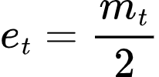

z = \frac{x - \mu}{\sigma}

Cov(X,Y)=\sum_{i=1}^{n}\frac{(X_i-\overline{X})(Y_{i}-\overline{Y})}{n-1}

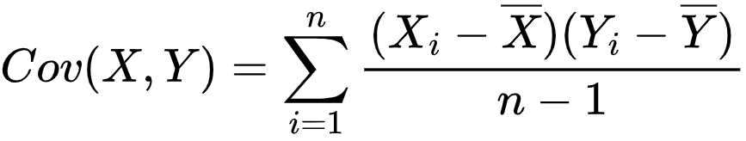

\begin{bmatrix}

Cov(x,x) &Cov(x,y)  & Cov(x,z) \\

 Cov(y,x)&Cov(y,y)  & Cov(y,z) \\

 Cov(z,x)& Cov(z,y) & Cov(z,z)

\end{bmatrix}

