**PILAR COLLEGE OF ZAMBOANGA CITY, INC.**

R.T. Lim Boulevard, Zamboanga City

**HIGHER EDUCATION DEPARTMENT**

A.Y. 2024-2025

**ACTIVITY PLAN**

**ACTIVITY: E-SPORTS TOURNAMENT**

**VENUE:** Mother Ignacia Gymnasium/Social Hall/ComLab

**DATE:** September 29-30, 2024

**TIME:** 7:00am to 4:00pm

**RATIONALE:**

The competitive play of various digital games (esports) has gained considerable popularity. E-sports also brings social interaction for students who are not good at getting along with others.  From a social standpoint, the e-sports community encourages teamwork, which will end up helping students adapt to society after graduation. It also teaches students sportsmanship and how to respect opponents even in a defeat. How to deal with failure and frustration is a lesson that everyone should learn as early as possible in their life.

As e-sports start to be considered as high-potential career options, it’s imperative to understand the importance of building up a pipeline for self-development (or career development) for student players on campus. By creating an e-sports-focused community in schools, students can connect their passion with their academic and personal goals, creating a well-nurtured environment for students to learn, improve in, and embrace different aspects of e-sports. From tournaments, teams, clubs, and scrims to coaches, team leaders and sponsors, these elements within an e-sports community will help establish a structured pipeline for students to learn, grow and develop.

A. OBJECTIVES

Cultivating students’ soft skills, such as teamwork, good sportsmanship, strategic thinking, and leadership.

Increased academic and social engagement

Developing Strong Team-based Problem-Solving Skills

Boosting students’ healthy competitive mind set and feedback reception

B. VALUES INTEGRATION

a. Core Values: Excellence

b. Related Values:

Improve collaboration, friendship and sportsmanship between students by creating a sense of community.

Brings social interaction for students who are not good at getting along with others.

C. PERSON INVOLVED

Faculty & Staff

Students

Event Manager

D. GENERAL RULES

1. Participants must be at the 25 minutes before the game starts.

2. There should be one entry/game per color team (excluded CODM: BATTLE ROYALE).

3. Each participant is required to read, understand, and agree to these rules and any other applicable tournament rules prior to, and as a condition to, participating in the tournament. *(See attachments “Code of Conduct” on the next page)*

4. Violation of these Rules or any other applicable rules may subject a Participant to discipline, including, but not limited to forfeiture of match, prizes, and imposition of fines and disqualification from the tournament.

E. ACTIVITY – E-Sports Tournament

- FPS: Counter Strike

- MOBA: DOTA 2

- FG: Street Fighter 6  
 - SG: Tetris battle

- Mobile Legends  
 - Call of Duty: Multiplayer and Battle Royale

*(Please see the Tournament Rules on the next page)*

F. MATERIALS

1. PC/Laptop/Mobile phones

2. Projector

3. White Screen

4. Criteria, Paper, Pens

G. REMINDERS

1. All participants must be well informed about the activity.

2. No outsiders and alumni are allowed to train the participants in each contest.

3. The participants will only be allowed to join if with Parent’s Consent.

4. The Tournament manager should inform the participants all the rules, conduct and guidelines before the game.

H. OTHER PROVISION

1. The internet connection must be provided by the institution. If in case, there will be slow connection, the players should have a backup internet data or connection.

2. Players must provide their own peripherals to be use during tournament.

3. The location of the E-SPORTS will be held in front of the ITRC office upon permission and approval of the Mr. James Tabangan.

4. If the location is approved, the event organizer will help Mr. James to set up other necessary equipment/tools to be use in the tournament.

**PILAR COLLEGE OF ZAMBOANGA CITY, INC.**

R.T. Lim Boulevard, Zamboanga City

**HIGHER EDUCATION DEPARTMENT**

A.Y. 2024-2025

**“E-SPORTS TOURNAMENT 2024”**

**CODES OF CONDUCT**

The below Code of Conduct applies to all Players at all levels of the competition. The tournament organizer reserves the right to levy penalties, sanction or disqualify any player at its discretion. Any conduct not outlined below is captured in the Leagues & Intramurals Code of Conduct.

**PLAYER BEHAVIOR**

* Competitor must conduct themselves in a reasonable manner, maintaining an appropriate demeanor with other players and tournament administrators. These requirements apply to both offline and online, including conduct on social media platforms and activity on live streams. All Players are expected to adhere to these standards of sportsmanship.
* Players are always expected to behave at their best. Unfair conduct may include, but is not limited to, hacking, exploiting, ringing and intentional disconnection. Players are expected to showcase good sportsmanship and fair play. Any unsportsmanlike conduct or toxic behavior will be addressed with a heavy hand by the administrators. The tournament administration maintains the sole judgement for violations of these rules.
* Players cannot use obscene gestures, profanities and/or discrimination comments in game chat, lobby chat, or live interviews. This includes abbreviations and/or obscure references. League Administrators reserve the right to enforce this at their own discretion. These rules also apply for forums, emails, personal messages and League channels.

**DURING THE TOURNAMENT**

* Players must conduct themselves in a reasonable manner, maintaining an appropriate demeanor with spectators, members of the press, tournament administrators, and others
* These requirements apply to both offline and online, including social media conduct. All players are expected to adhere to the standards of good sportsmanship always.
* Players must refrain from using vulgar or offensive languages.
* Abusive behavior, including harassment and threats are prohibited.
* Physical abuse, fighting or any threatening action or language, directed at any player, spectator, official or any other person are prohibited.
* Any action that interferes with play of a game, including but not limited to purposely disconnecting or abuse of in-game pausing, is prohibited and can result in match forfeiture and/or disqualification from the competition.
* All Players must not disclose any confidential information provided by the tournament organizer or any of its affiliates to any other people or groups of people, including via social media.

**COLLUSION POLICY**

Collusion is defined as any agreement between two or more players to disadvantage other players in the Competition. Collusion between Players is strictly prohibited. Any Player determined by the tournament organizer at any phase of the EST 2023 to be engaging in Collusion will be removed from the competition.

Examples of collusion include, but are not limited to:

* Intentionally losing a match for any reason.
* Playing on behalf of another competitor, including using a secondary account, to aid them.
* Any form of match-fixing.

**PENALTIES**

Violation of any part of these Official Rules will, at the Tournament organizer's election, result in (a) sanction(s) and/or (b) loss of winner status. All Players must follow the tournament organizer's directions. All decisions and rulings of the tournament organizer are final and binding. The Tournament organizer reserves the right to sanction any Player in competition at any level, at any time for any reason. Sanctions may include, in no order, the following:

* Warning
* Reprimand
* Forfeiture of single match
* Forfeiture of all matches
* Loss of awards (including prize money and other paid expenses)
* Disqualification from the EST 2024

**PILAR COLLEGE OF ZAMBOANGA CITY, INC.**

R.T. Lim Boulevard, Zamboanga City

**HIGHER EDUCATION DEPARTMENT**

A.Y. 2024-2025

**E-SPORTS 2024: MOBILE LEGENDS TOURNAMENT**

TOURNAMENT STRUCTURE:

1. Tournament is open to all-male, or all-female, or mixed teams.

2. Qualifying Stage is Single Round Robin (Point System).

3. The tournament will implement a 10-hero ban, where the first banning will determine through a toss coin.

4. Qualifying stage will be a best-of-3 series.

5. Playoffs stage will be a best-of-3 series

6. Battle for Third will be a best-of-3 series.

7. Finals will be a best-of-5 series

POINTING SYSTEM:

Points: 2-0 series = 3 points

1-1series = 1 point

0-2 series = 0 points

PLAYER REQUIREMENTS:

1. A player can only join one team.

2. Players must be available during tournament dates.

3. Players must be a bona fide student of PCZC

4. Players must be currently enrolled in the school year (2024-2025)

TEAM REQUIREMENTS:

1. A team must consist of the following members:

- 5 main players (required)

- 1-2 reserved players (optional)

- 1 coach/player-coach (optional)

2. Once nominated/registered, regular/reserved players cannot be replaced throughout the event.

SCHEDULES / TIMING OF MATCHES:

1. The tournament is an Online Tournament.

2. Players will be advised of schedule and timing of matches thru their registered email address.

3. Only Tournament Director can alter schedule and timing of matches.

GENERAL CONDUCT:

1. Players are expected to conduct themselves and compete with the spirit of sportsmanship, maintaining a friendly and polite demeanor in activities involving other participants.

2. The organizer has the right to apply penalties, disqualify and dismiss any registered player from the tournament, at their discretion, at any stage of the tournament.

3. Cheating doesn’t need to be successful to qualify as a violation. Conspiring to cheat is already a violation and will lead to an automatic disqualification for all conspirators.

Examples of cheating includes, but are not limited to:

- Ghosting

- Account Sharing

- Piloting

OTHER DETAILED RULES & TECHNICAL ASPECTS:

1. All participants will be advised of other rules or technical aspects of tournament prior to start of competitions.

TOURNAMENT MATCHES:

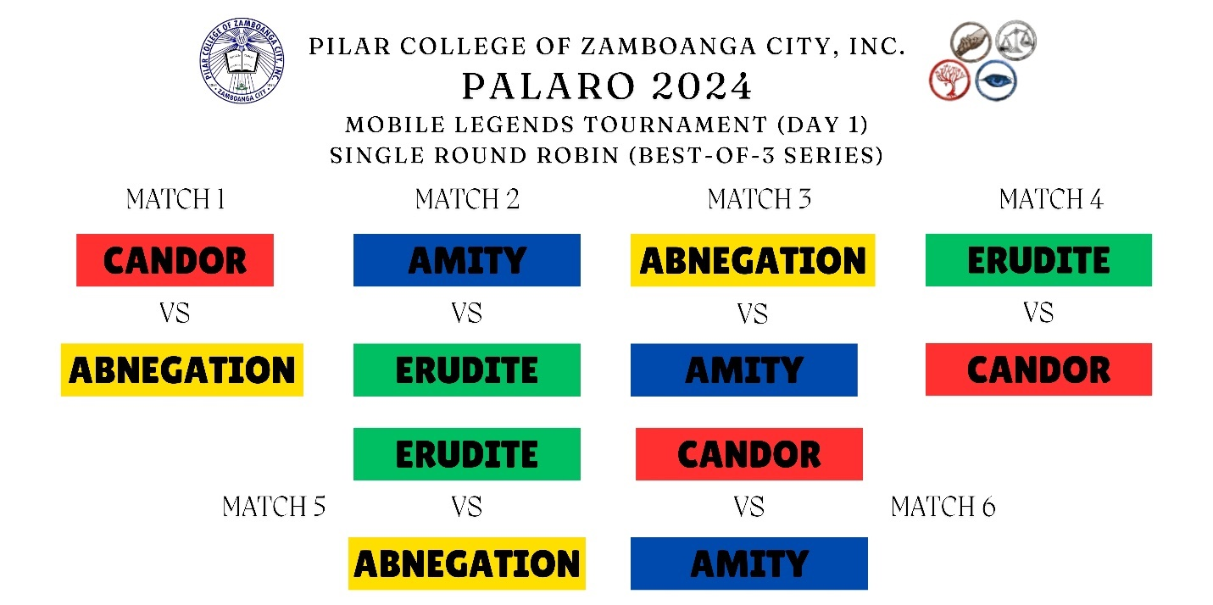

TOURNAMENT BRACKET:

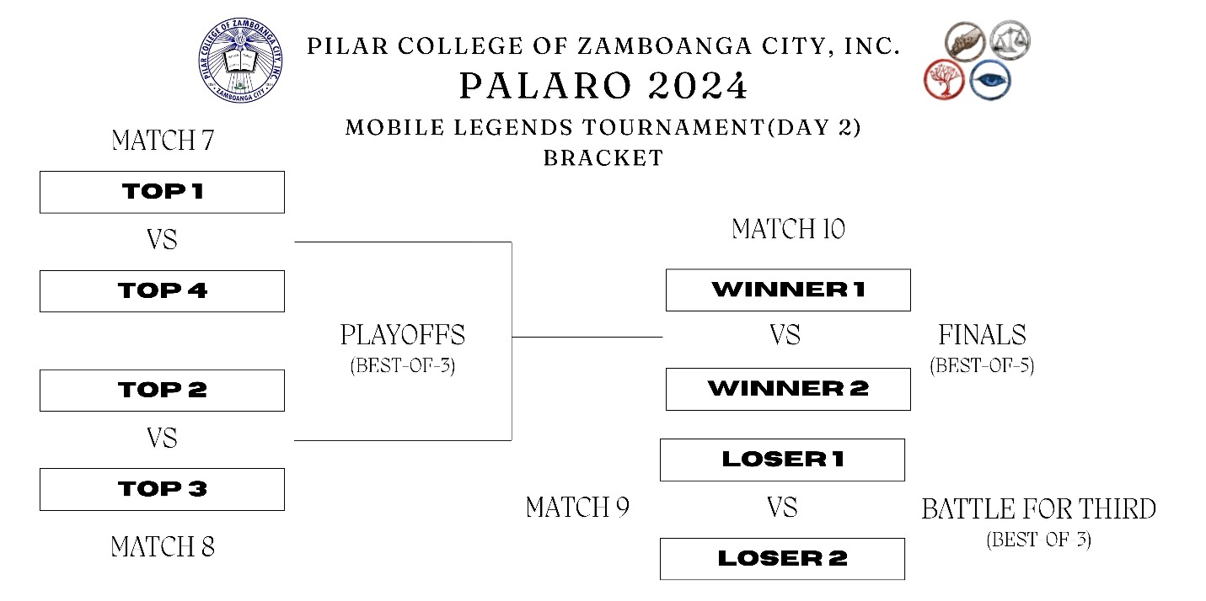

**PILAR COLLEGE OF ZAMBOANGA CITY, INC.**

R.T. Lim Boulevard, Zamboanga City

**HIGHER EDUCATION DEPARTMENT**

A.Y. 2024-2025

**E-SPORTS 2024: CALL OF DUTY: MULTIPLAYER TOURNAMENT**

TOURNAMENT STRUCTURE:

1. Tournament is open to all-male, or all-female, or mixed teams.

2. Qualifying Stage is Single Round Robin (Point System).

3. The multiplayer tournament will have 3 rounds (Search and Destroy, Domination, and Hardpoints).

4. Qualifying stage will be a best-of-3 series.

5. Playoffs stage will be a best-of-3 series

6. Battle for Third will be a best-of-3 series.

7. Finals will be a best-of-5 series

POINTING SYSTEM:

Points: 2-0 series = 3 points

1-1series = 1 point

0-2 series = 0 points

PLAYER REQUIREMENTS:

1. A player can only join one team.

2. Players must be available during tournament dates.

3. Players must be a bona fide student of PCZC

4. Players must be currently enrolled in the school year (2024-2025)

TEAM REQUIREMENTS:

1. A team must consist of the following members:

- 5 main players (required)

- 1 or 2 reserve player (optional)

- 1 coach/player-coach (optional)

2. Each color team must only have 1 entry.

3. Once nominated/registered, regular/reserved players cannot be replaced throughout the event.

SCHEDULES / TIMING OF MATCHES:

1. The tournament is an Online Tournament.

2. Players will be advised of schedule and timing of matches thru their registered email address.

3. Only Tournament Director can alter schedule and timing of matches.

GENERAL CONDUCT:

1. Players are expected to conduct themselves and compete with the spirit of sportsmanship, maintaining a friendly and polite demeanor in activities involving other participants.

2. The organizer has the right to apply penalties, disqualify and dismiss any registered player from the tournament, at their discretion, at any stage of the tournament.

3. Cheating doesn’t need to be successful to qualify as a violation. Conspiring to cheat is already a violation and will lead to an automatic disqualification for all conspirators.

Examples of cheating includes, but are not limited to:

- Ghosting

- Account Sharing

- Piloting

OTHER DETAILED RULES & TECHNICAL ASPECTS:

1. All participants will be advised of other rules or technical aspects of tournament prior to start of competitions.

MAP POOL:

**Hardpoint:** Slums, Summit, Shoothouse, Crash, Raid, Nuketown

**Search and Destroy:** Tunisia, Hackney Yard, Standoff, Terminal

**Domination:** Firing Range, Standoff, Nuketown

SCORESTREAKS ALLOWED:

- UAV

- COUNTER UAV

- SHOCK RC

- HUNTER KILLER DRONE

- PREDATOR MISSILE

- ADVANCE UAV

- SENTRY GUN

BANNED UNITS:

OPERATORS:

- K9- units

- Shadow Blade

- Ballistic Shield

- Gravity Vortex

- Bull Charge

- H.I.V.E

PRIMARY WEAPONS:

- NA- 45

- Striker

- HS2126

- JAK- 12

- Echo

- LK24

- Argus

- R9

- RPD

SECONDARY WEAPONS:

- Kilobolt

- Crossbow

- Launchers

- Rytec

PERKS:

- Akimbo

- Martyrdom

TACTICAL AND LETHAL ACTIVITY:

- Heartbeat Sensor

- Gas Grenade

- Flashbang

- Flashdrone

- Storm Ball

- Trip Mine

- Thermite

- Molotov

- EMP

- Cluster

TOURNAMENT MATCHES:

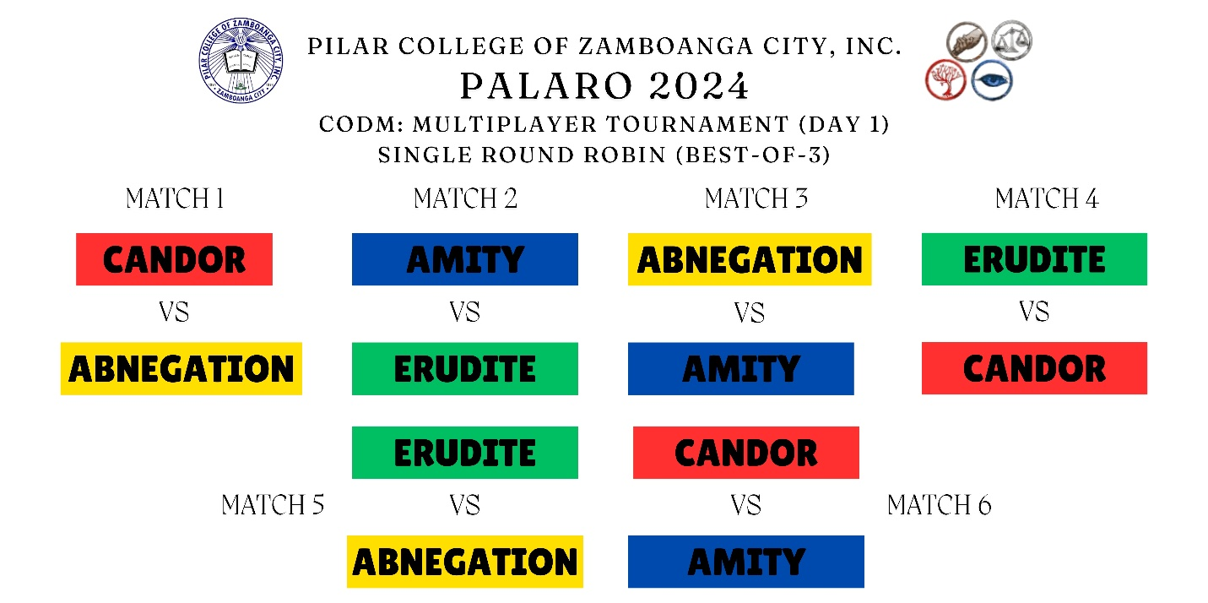

TOURNAMENT BRACKET:

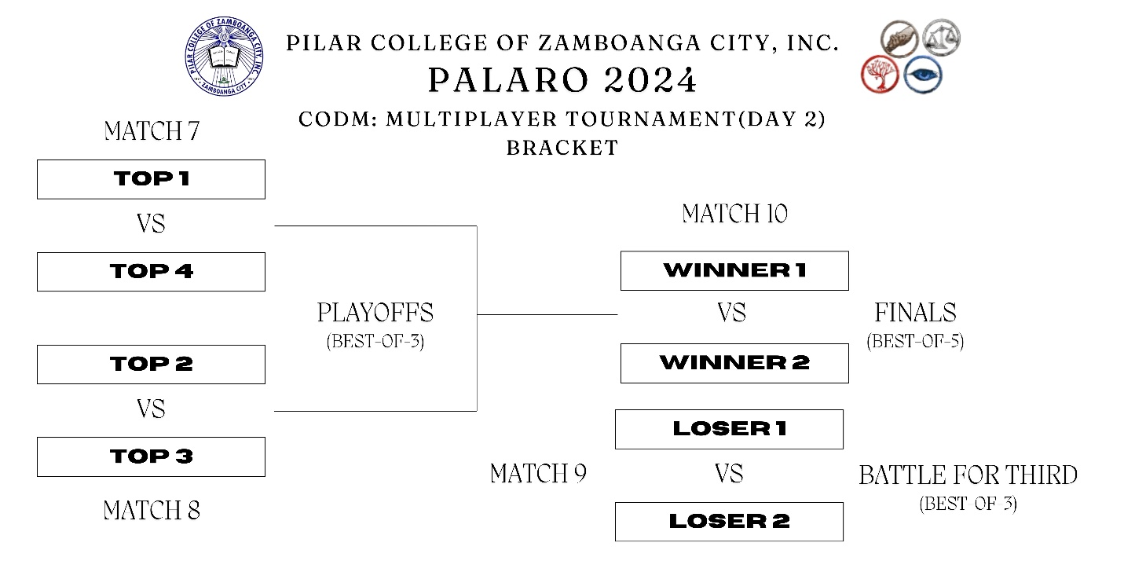

**PILAR COLLEGE OF ZAMBOANGA CITY, INC.**

R.T. Lim Boulevard, Zamboanga City

**HIGHER EDUCATION DEPARTMENT**

A.Y. 2024-2025

**E-SPORTS 2024: CALL OF DUTY: BATTLE ROYALE TOURNAMENT**

TOURNAMENT STRUCTURE:

1. Tournament is open to all-male, or all-female, or mixed teams.

2. The tournament will be a pointing system.

3. The map will be in Isolated.

4. The game will be played in 3 rounds.

POINTING SYSTEM:

Points: KILLS:

1 kill = 2 points

PLACE:

1st place = 50 points

2nd place = 45 points

3rd place = 40 points

4th place = 35 points

5th place = 30 points

6th place = 25 points

7th place = 20 points

8th place = 15 points

PLAYER REQUIREMENTS:

1. A player can only join one team.

2. Players must be available during tournament dates.

3. Players must be a bona fide student of PCZC

4. Players must be currently enrolled in the school year (2024-2025)

TEAM REQUIREMENTS:

1. A team must consist of the following members:

- 4 main players (required)

2. Each color team must only have 1 or 2 entries.

3. Once nominated/registered, regular/reserved players cannot be replaced throughout the event.

4. The name of the team should be based on the color name team. (Ex: First team: CAN, Second Team: DOR)

SCHEDULES / TIMING OF MATCHES:

1. The tournament is an Online Tournament.

2. Players will be advised of schedule and timing of matches thru their registered email address.

3. Only Tournament Director can alter schedule and timing of matches.

GENERAL CONDUCT:

1. Players are expected to conduct themselves and compete with the spirit of sportsmanship, maintaining a friendly and polite demeanor in activities involving other participants.

2. The organizer has the right to apply penalties, disqualify and dismiss any registered player from the tournament, at their discretion, at any stage of the tournament.

3. Cheating doesn’t need to be successful to qualify as a violation. Conspiring to cheat is already a violation and will lead to an automatic disqualification for all conspirators.

Examples of cheating includes, but are not limited to:

- Ghosting

- Account Sharing

- Piloting

OTHER DETAILED RULES & TECHNICAL ASPECTS:

1. All participants will be advised of other rules or technical aspects of tournament prior to start of competitions.

POINTING SYSTEM FORMAT:

|  |  |  |  |  |  |  |  |  |
| --- | --- | --- | --- | --- | --- | --- | --- | --- |
| TEAM NAME | ROUND 1 | | ROUND 2 | | ROUND 3 | | TOTAL | RANK |
|  | PLACE | KILLS | PLACE | KILLS | PLACE | KILLS |  |  |
| ERU |  |  |  |  |  |  |  |  |
| DITE |  |  |  |  |  |  |  |  |
| CAN |  |  |  |  |  |  |  |  |
| DOR |  |  |  |  |  |  |  |  |
| AMI |  |  |  |  |  |  |  |  |
| TY |  |  |  |  |  |  |  |  |
| ABNE |  |  |  |  |  |  |  |  |
| GATION |  |  |  |  |  |  |  |  |

**PILAR COLLEGE OF ZAMBOANGA CITY, INC.**

R.T. Lim Boulevard, Zamboanga City

**HIGHER EDUCATION DEPARTMENT**

A.Y. 2024-2025

**E-SPORTS 2024: COUNTER STRIKE TOURNAMENT**

TOURNAMENT STRUCTURE:

1. Tournament is open to all-male, or all-female, or mixed teams.

2. Qualifying Stage is Single Round Robin (Pointing system).

3. Semi-Finals will be a single elimination.

4. Qualifying stage will be Best-of-1.

5. Semi-Finals will be Best-of-1.

6. Battle for Third will be Best-of-1.

7. Finals will be Best-of-3.

8. The game mode will be competitive.

9. It will be a 30 rounds per match (15 rounds per side).

10. Map will be *de_dust II*.

11. The starting money will be $10,000

POINTING SYSTEM:

Points: 2-0 series = 3 points

1-1series = 1 point

0-2 series = 0 points

MATCH RULES:

1. The Pause rule will be implemented.

2. 2 tactical pauses for each team (30 seconds pause).

3. Technical pause will be allowed in case of issues; a maximum of 5 minutes.

PLAYER REQUIREMENTS:

1. A player can only join one team.

2. Players must be available during tournament dates.

3. Players must be a bona fide student of PCZC

4. Players must be currently enrolled in the school year (2024-2025)

TEAM REQUIREMENTS:

1. A team must consist of the following members:

- 5 main players (required)

- 1 reserved players (optional)

- 1 coach/player-coach (optional)

2. Once nominated/registered, regular/reserved players cannot be replaced throughout the event.

SCHEDULES / TIMING OF MATCHES:

1. The tournament is an Online Tournament.

2. Players will be advised of schedule and timing of matches thru their registered email address.

3. Only Tournament Director can alter schedule and timing of matches.

GENERAL CONDUCT:

1. Players are expected to conduct themselves and compete with the spirit of sportsmanship, maintaining a friendly and polite demeanor in activities involving other participants.

2. The organizer has the right to apply penalties, disqualify and dismiss any registered player from the tournament, at their discretion, at any stage of the tournament.

3. Cheating doesn’t need to be successful to qualify as a violation. Conspiring to cheat is already a violation and will lead to an automatic disqualification for all conspirators.

Examples of cheating includes, but are not limited to:

- Ghosting

- Account Sharing

- Piloting

OTHER DETAILED RULES & TECHNICAL ASPECTS:

1. All participants will be advised of other rules or technical aspects of tournament prior to start of competitions.

2. No tea bagging.

3. No spray painting after a kill.

TOURNAMENT MATCHES:

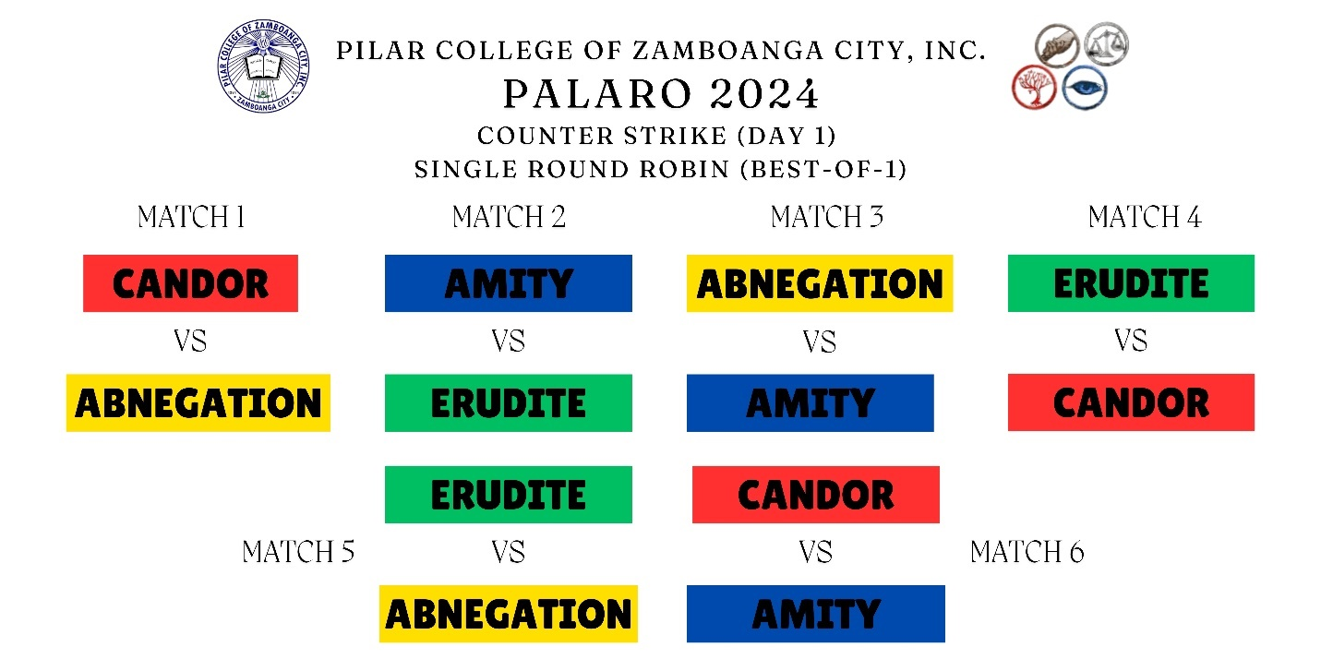

TOURNAMENT BRACKET:

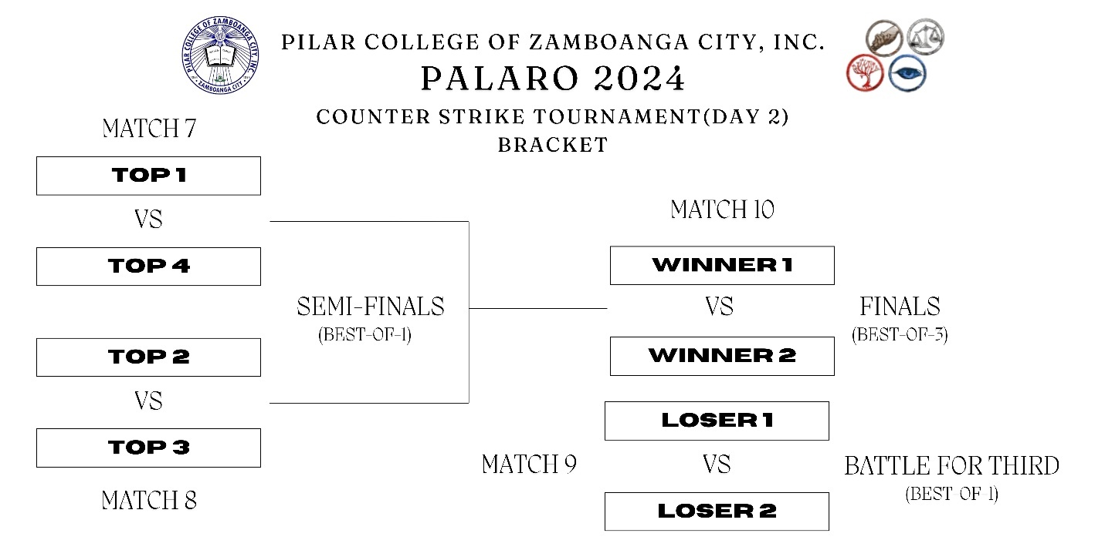

**PILAR COLLEGE OF ZAMBOANGA CITY, INC.**

R.T. Lim Boulevard, Zamboanga City

**HIGHER EDUCATION DEPARTMENT**

A.Y. 2024-2025

**E-SPORTS 2024: MOBA: DOTA 2 TOURNAMENT**

TOURNAMENT STRUCTURE:

1. Tournament is open to all-male, or all-female, or mixed teams.

2. Single Round Robin (Pointing system).

3. Main Stage and Finals will be a single elimination.

4. Group stage will be Best-of-1.

5. Main stage will be Best-of-3.

6. Battle for Third will be Best-of-3.

6. Finals will be Best-of-5.

7. The game will be Captain’s Mode.

POINTING SYSTEM:

Points: 2-0 series = 3 points

1-1series = 1 point

0-2 series = 0 points

MATCH RULES:

1. The Pause rule will be implemented.

2. 2 tactical pauses for each team (30 seconds pause).

3. Technical paused will be allowed in case of issues; a maximum of 5 minutes.

PLAYER REQUIREMENTS:

1. A player can only join one team.

2. Players must be available during tournament dates.

3. Players must be a bona fide student of PCZC

4. Players must be currently enrolled in the school year (2024-2025)

TEAM REQUIREMENTS:

1. A team must consist of the following members:

- 5 main players (required)

- 1 reserved players (optional)

- 1 coach/player-coach (optional)

2. Once nominated/registered, regular/reserved players cannot be replaced throughout the event.

SCHEDULES / TIMING OF MATCHES:

1. The tournament is an Online Tournament.

2. Players will be advised of schedule and timing of matches thru their registered email address.

3. Only Tournament Director can alter schedule and timing of matches.

GENERAL CONDUCT:

1. Players are expected to conduct themselves and compete with the spirit of sportsmanship, maintaining a friendly and polite demeanor in activities involving other participants.

2. The organizer has the right to apply penalties, disqualify and dismiss any registered player from the tournament, at their discretion, at any stage of the tournament.

3. Cheating doesn’t need to be successful to qualify as a violation. Conspiring to cheat is already a violation and will lead to an automatic disqualification for all conspirators.

Examples of cheating includes, but are not limited to:

- Ghosting

- Account Sharing

- Piloting

OTHER DETAILED RULES & TECHNICAL ASPECTS:

1. All participants will be advised of other rules or technical aspects of tournament prior to start of competitions.

TOURNAMENT MATCHES: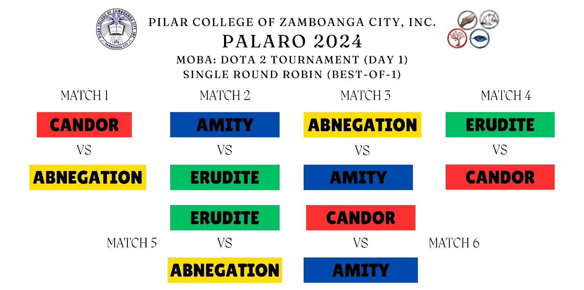

TOURNAMENT BRACKET:

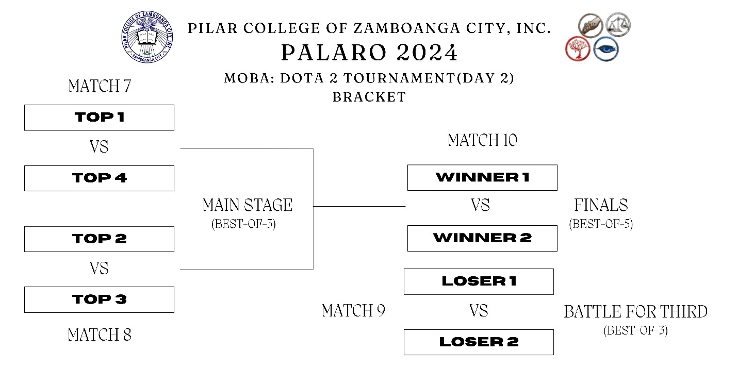

**PILAR COLLEGE OF ZAMBOANGA CITY, INC.**

R.T. Lim Boulevard, Zamboanga City

**HIGHER EDUCATION DEPARTMENT**

A.Y. 2024-2025

**E-SPORTS 2024: SG: TETRIS BATTLE TOURNAMENT**

TOURNAMENT STRUCTURE:

1. Tournament is open to all-male, or all-female, or mixed teams.

2. Qualifying Stage is Single Round Robin (Point System)

3. Qualifying stage will be a Best-of-3.

4. Playoffs stage will be a Best-of-3.

5. Battle for Third will be Best-of-3.

6. Finals will be a Best-of-5.

POINTING SYSTEM:

Points: 2-0 series = 3 points

1-1series = 1 point

0-2 series = 0 points

PLAYER REQUIREMENTS:

1. A player can only join one team.

2. Players must be available during tournament dates.

3. Players must be a bona fide student of PCZC

4. Players must be currently enrolled in the school year (2024-2025)

TEAM REQUIREMENTS:

1. A team must consist of the following members:

- 1 main player

2. Once nominated/registered, regular/reserved players cannot be replaced throughout the event.

SCHEDULES / TIMING OF MATCHES:

1. The tournament is an Online Tournament.

2. Players will be advised of schedule and timing of matches thru their registered email address.

3. Only Tournament Director can alter schedule and timing of matches.

GENERAL CONDUCT:

1. Players are expected to conduct themselves and compete with the spirit of sportsmanship, maintaining a friendly and polite demeanor in activities involving other participants.

2. The organizer has the right to apply penalties, disqualify and dismiss any registered player from the tournament, at their discretion, at any stage of the tournament.

3. Cheating doesn’t need to be successful to qualify as a violation. Conspiring to cheat is already a violation and will lead to an automatic disqualification for all conspirators.

Examples of cheating includes, but are not limited to:

- Ghosting

- Account Sharing

- Piloting

OTHER DETAILED RULES & TECHNICAL ASPECTS:

1. All participants will be advised of other rules or technical aspects of tournament prior to start of competitions.

TOURNAMENT MATCHES:

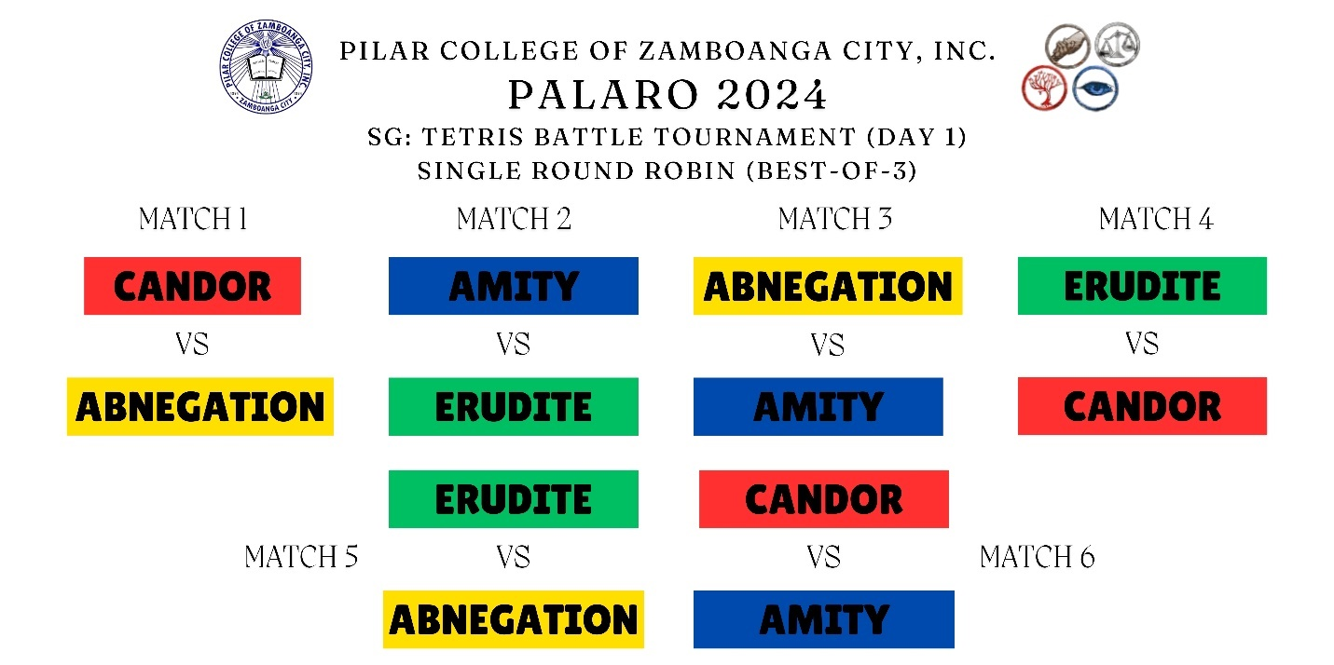

TOURNAMENT BRACKET:

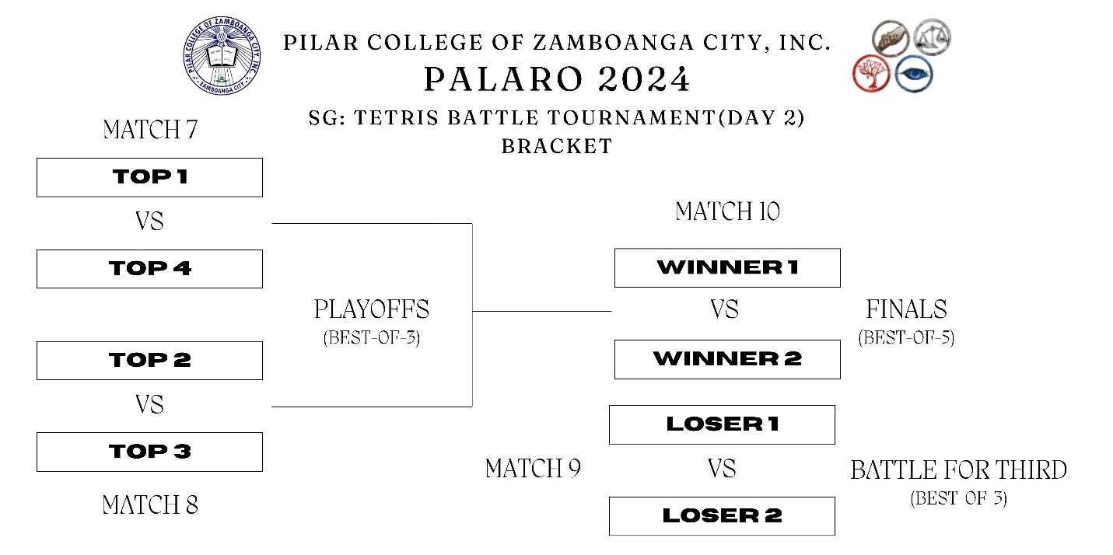

**PILAR COLLEGE OF ZAMBOANGA CITY, INC.**

R.T. Lim Boulevard, Zamboanga City

**HIGHER EDUCATION DEPARTMENT**

A.Y. 2024-2025

**E-SPORTS 2024: STREET FIGHTER 6 TOURNAMENT**

TOURNAMENT STRUCTURE:

1. Tournament is open to all-male, or all-female, or mixed teams.

2. Qualifying Stage is Single Round Robin (Point System).

3. Qualifying stage will be a best-of-3 series.

4. Playoffs stage will be a best-of-3 series.

5. Battle for Third will be a best-of-3 series.

6. Finals will be a best-of-5 series.

7. Winner of previous game must keep same character.

8. Loser of previous game may switch character.

9. Random stage select.

10. Training Room stage is banned.

11. Dynamic control type is banned.

POINTING SYSTEM:

Points: 2-0 series = 3 points

1-1series = 1 point

0-2 series = 0 points

PLAYER REQUIREMENTS:

1. A player can only join one team.

2. Players must be available during tournament dates.

3. Players must be a bona fide student of PCZC

4. Players must be currently enrolled in the school year (2024-2025)

TEAM REQUIREMENTS:

1. A team must consist of the following members:

- 2 main players (required)

2. Once nominated/registered, regular/reserved players cannot be replaced throughout the event.

SCHEDULES / TIMING OF MATCHES:

1. The tournament is an Online Tournament.

2. Players will be advised of schedule and timing of matches thru their registered email address.

3. Only Tournament Director can alter schedule and timing of matches.

GENERAL CONDUCT:

1. Players are expected to conduct themselves and compete with the spirit of sportsmanship, maintaining a friendly and polite demeanor in activities involving other participants.

2. The organizer has the right to apply penalties, disqualify and dismiss any registered player from the tournament, at their discretion, at any stage of the tournament.

3. Cheating doesn’t need to be successful to qualify as a violation. Conspiring to cheat is already a violation and will lead to an automatic disqualification for all conspirators.

Examples of cheating includes, but are not limited to:

- Ghosting

- Account Sharing

- Piloting

OTHER DETAILED RULES & TECHNICAL ASPECTS:

1. All participants will be advised of other rules or technical aspects of tournament prior to start of competitions.

TOURNAMENT MATCHES:

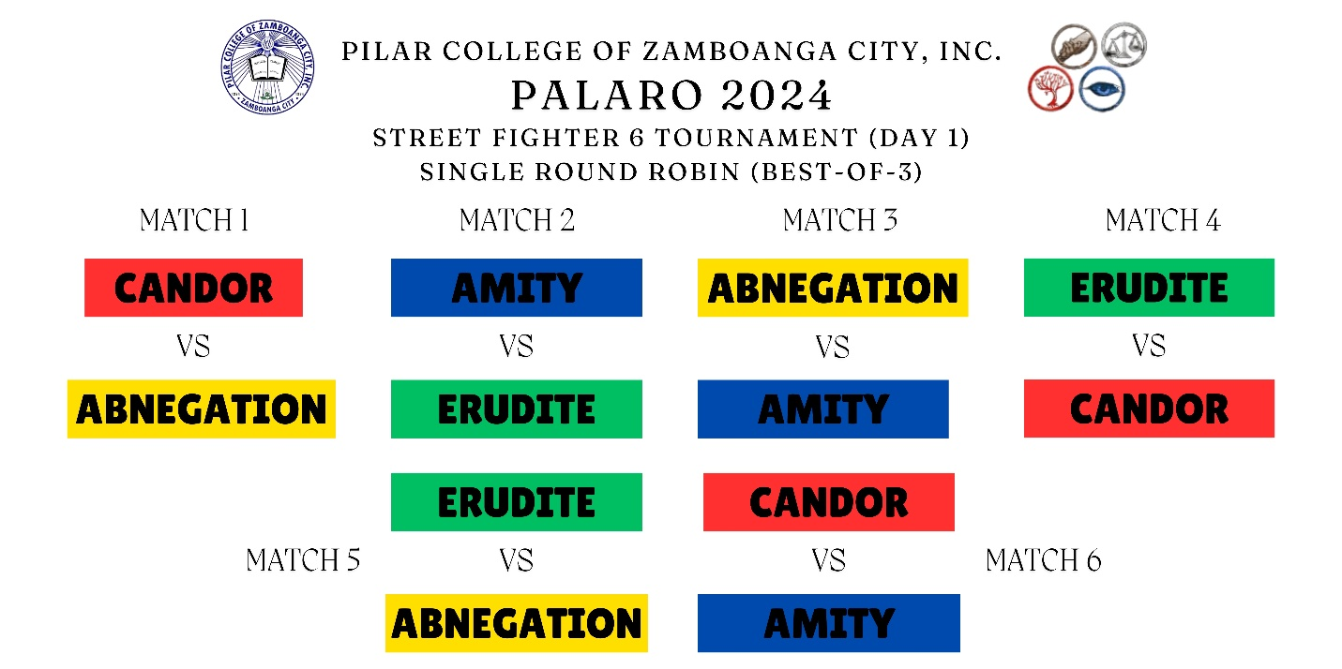

TOURNAMENT BRACKET:

