Research Talk on “Implementation of Sustainable Development Goals (SDGs) in Higher Education Institutions
https://www.instagram.com/p/DZg9lDGDyqS
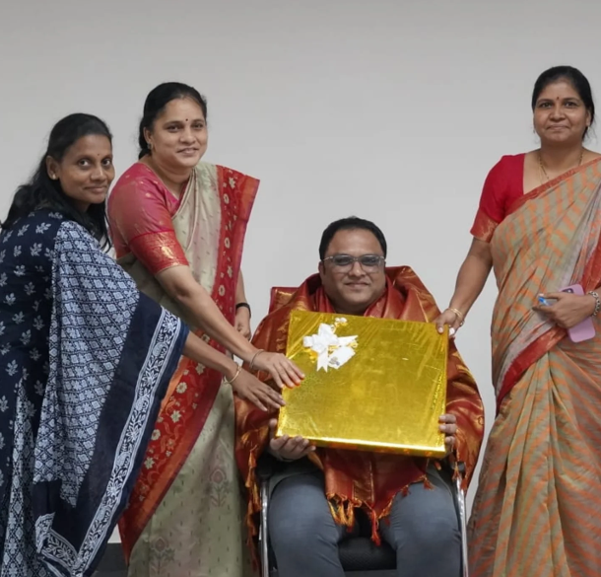
Event Name:
Workshop on “SDG's Implementation in Higher Education”
Tagline:
Planting the seeds of sustainable change through higher education.
Dates:
11 June 2026
Venue:
Mini Auditorium, MLRIT
Event Brief:
- Explored the implementation of the 17 SDGs in higher education.
- Discussed education, research, innovation, sustainable campus practices, and community engagement.
- Highlighted funding opportunities, partnerships, and institutional challenges.
- Introduced the TRIIMPACT SDG Centre of Excellence model.
- Encouraged measurable, collaborative sustainability initiatives.

ICRISAT
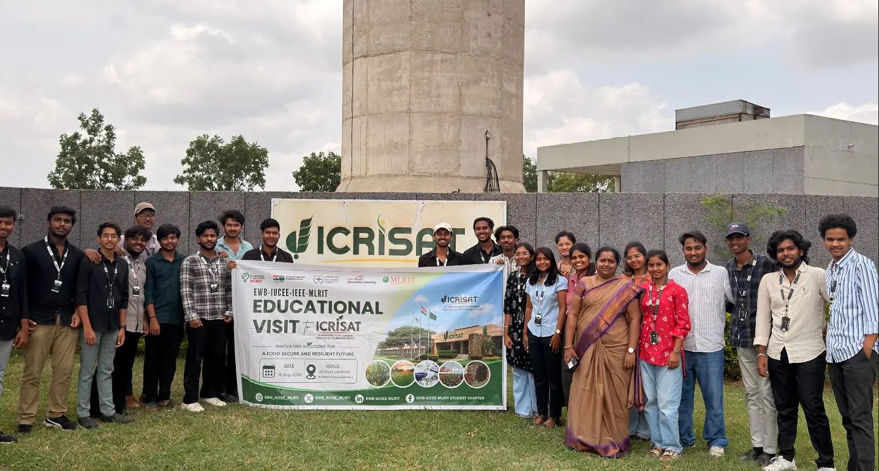
https://www.instagram.com/p/Da217Ndj0bK
Event Name:
Educational Visit to ICRISAT
Tagline:
Transforming Agriculture Through Research, Innovation & Technology
Dates:
16 July 2026
Venue:
International Crops Research Institute for the Semi-Arid Tropics (ICRISAT), Patancheru, Hyderabad
Event Brief:
- Explored digital agriculture, climate-resilient crops, soil research, and crop modelling.
- Visited experimental farms, glasshouse facilities, and research laboratories.
- Learned about smart irrigation, remote sensing, AI, and sustainable farming practices.
- Explored agribusiness, startup incubation, millet processing, and post-harvest technologies.
- Connected engineering, research, and innovation with real-world agricultural challenges.

HDSE
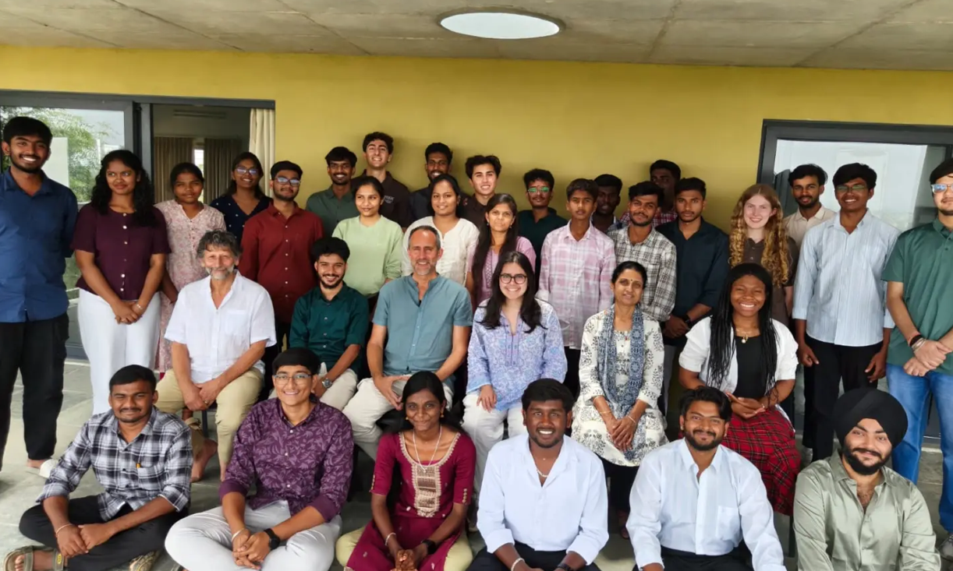
https://www.instagram.com/p/DbQSVBWDxRa

Event Name:
HDSE Leadership Intensive 2026
Tagline:
Humanitarian Design, Leadership & Social Innovation
Dates:
12–16 July 2026
Venue:
Agastya International Foundation Campus, Kuppam, Andhra Pradesh
Event Brief:
- Five-day immersive program focused on humanitarian design, design thinking, and leadership.
- Engaged engineering students in community-centered problem solving and field-based learning.
- Covered ideation, user research, value proposition, storytelling, financial planning, and teamwork.
- Participants developed and presented sustainable solutions to real-world challenges.
- The MLRIT participant’s team project, “PlastiNova – The New Life for Plastic,” secured 4th position in the project presentation and idea pitching competition.

6th National Education Policy
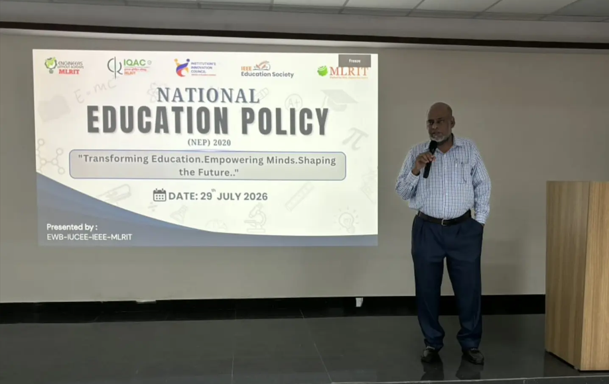
https://www.instagram.com/p/Dbkc2tjDytT

Event Name:
6th National Education Policy
Tagline:
Flexibility and Interdisciplinary Education
Dates:
29 July 2026
Venue:
TP-001 (Mini Auditorium), MLR Institute of Technology
Event Brief:
- Explored flexibility and interdisciplinary education under NEP.
- Discussed internships, credit transfer, and Multiple Entry and Multiple Exit opportunities.
- Covered AICTE guidelines, Course Outcomes, and faculty collaboration.
- Introduced digital learning platforms such as SWAYAM, SWAYAM Prabha, and SWAYAM Plus.
- Highlighted technology-enabled and student-centred learning.

MITTI SE MURTI 2026

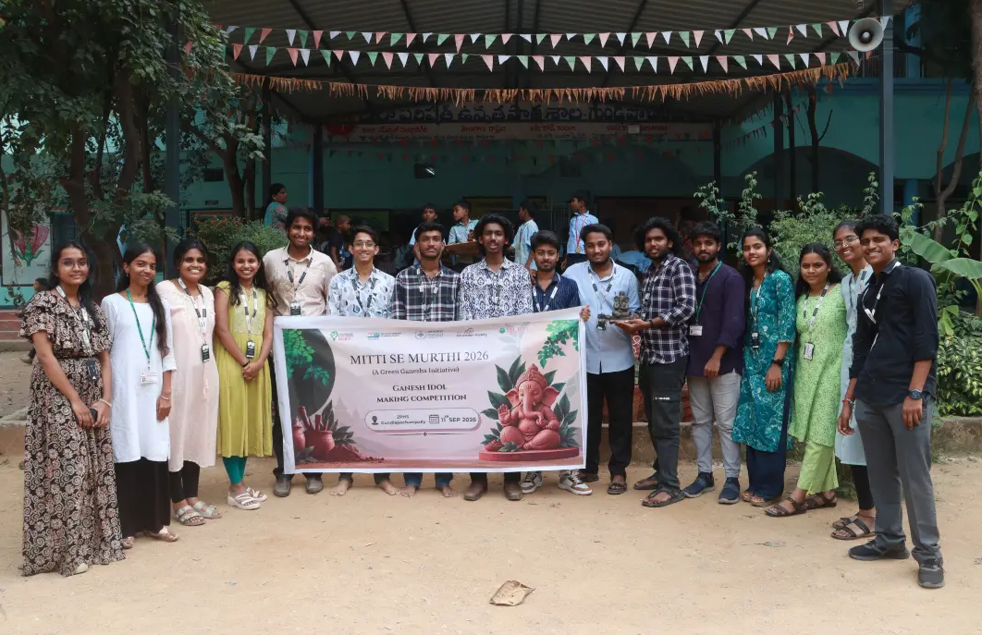https://www.instagram.com/p/DdK6yo2DxDM/
Event Name:
Mitti Se Murti 2026
Tagline:
Celebrate traditionally, create sustainably.
Dates:
11 September 2026
Venue:
Zilla Parishad High School, Gundlapochampally
Event Brief:
- Conducted an eco-friendly Ganesh idol-making workshop for primary school children.
- Promoted natural clay as an alternative to Plaster of Paris (POP).
- Created awareness about the impact of POP on water bodies and aquatic life.
- Encouraged creativity, hands-on learning, and sustainable festival practices.

