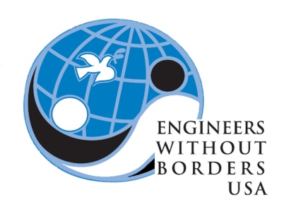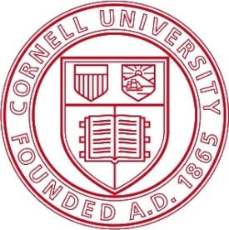**Engineers Without Borders:**

**Project Team Application Fall 2017**

Hello applicant! Thank you for your interest in applying for the EWB project team. Applications are due to: [ewbcornell@gmail.com](mailto:ewbcornell@gmail.com) on Wednesday, September 6th, 2017at 11:59PM.

Feel free to make your answers longer than the spaces provided but please do not write essays and keep the answers succinct. Please also attach your resume to the email with your GPA removed. Format the subject of your email as EWB Fall Application and title your application and resume as LastNameFirstName_Application (ex: SmithJohn_Application).

Also try to attend one of our information sessions on August 30th and September 5th to learn more about the team before you apply. After applications, we will be conducting interviews for those invited starting September 9th. We have a lot of fun things as well as important work ahead of us, so we really hope that you will apply! If you have any questions do not hesitate to email us.

Thanks!

Josh, Nathalie, Priya, Clare and Shelby

Project Team Leaders

**Name: Net ID:**

**Year: *Major:**

**\*If you are undecided on major please elaborate on your interest areas within your school.**

1. **EWB currently has positions available on the following subteams. Please indicate your top 3 preferences in the list below. See the last few pages of the application for summaries of what each subteam does.**

* **Calcha, Boliva**
* **Upala, Costa Rica**
* **Binghampton, NY**
* **Business and Design**
* **Construction Management**

1. **__________________________**
2. **__________________________**
3. **__________________________**
4. **Briefly elaborate on the reasoning behind your indicated preferences (100 words max).**
5. **Why do you want to be part of EWB? (250 words max)**

1. **Please tell us about any previous experience you have had that is relevant to EWB’s vision of “a world in which the communities have the capacity to sustainably meet their basic human needs” (250 words max)**

1. **If you are a freshman, you will sign up for this for 1 credit which corresponds to 3-5 hours a week. If you are an upperclassman, you may sign up to 2 credits which corresponds to 6-8 hours a week. Please indicate that you understand this time commitment.**

**Yes ______**

**No ______**

1. **What technical and language skills do you have (check all the apply)**

**____ AutoCAD**

**____ Adobe Photoshop or Illustrator**

**____ Adobe InDesign**

**____ Website design (HTML, PHP, Java Script)**

**____ Foreign Language (please list language and proficiency)**

**____ Other ( )**

1. **Are you interested in traveling with our team?**

**Yes _______**

**No ________**

**In addition to answering the questions above, please like our Facebook page (Cornell Engineers Without Borders), and join our LinkedIn group (Engineers Without Borders – Cornell University). Also, visit our website (http://ewb.engineering.cornell.edu) for more information.**

**PLEASE ATTACH YOUR RESUME (Do not include your GPA in your resume)!**

**___________________________________________________________________**

**EWB 2017-2018 Subteam Descriptions**

**Calcha, Bolivia**

Our team partnered with the community of Calcha, Bolivia in 2013 for our first project as an EWB chapter. We have been working closely with Engineers in Action, an NGO in Bolivia, on two projects. In summer 2016, we implemented a 50 meter long suspended bridge over the river in Calcha to provide year-round access to their farmland. In summer 2017, we lengthened and lined their irrigation channels with concrete to increase water flow, fixed the tiling in their water storage tank, and installed gabions to prevent erosion near the bridge foundations. The Calcha, Bolivia Team will be focused on the monitoring phase of both projects, including assessment of their impact as well as physical maintenance.

**Upala, Costa Rica**

Our second international project will be in Upala, Costa Rica! We have partnered with CENDEROS, a Costa Rican non-profit organization which addresses the lack of opportunities for Nicaraguan migrants, especially women. CENDEROS has a 24-hour center that can house women for 72 hours. Afterwards, these women are given work on a sustainable farm, which is able to accommodate 150 women a year. The Upala, Costa Rica Team is preparing for our first assessment trip to the community where we will gather information about our project. We are anticipating a potential hydroelectric or solar energy system and are researching these areas in order to have a successful assessment trip.

**Binghamton, NY**

The Binghamton, NY Team is working on our first domestic project! We have partnered with Every1s Home to design and build prototypes of portable trailer homes, called E-Pods. Homelessness is major problem in large cities and Every1s Home works to alleviate this issue by relocating and employing homeless people in lower cost cities, such as Binghamton. During the transition process, people will have the opportunity to live in E-Pods while they receive job training and assistance. We have created some preliminary designs for the E-Pods and plan on constructing our first prototype in fall 2017.

**Construction Management**

The Construction Management Team works closely with all of our community-based teams to design and implement their projects. They plan technical workshops to train our team members in skills necessary for project assessment and implementation, including land surveying, concrete mixing, and blueprint design. They are also responsible for creating the technical drawing sets for all of our designs and determining the materials and equipment necessary for each project. The Construction Management Team ensures that our projects will be well-constructed, sustainably sourced, and within our budget.

**Business and Design**

In addition to financing EWB’s projects, the Business and Design Team raises awareness of EWB-Cornell throughout our campus by organizing fundraisers, events, and showcases. They develop all of our promotional materials and maintain our online presence through our website and social media pages. Additionally, the Business and Design Team maintains our relationships with corporate sponsors, donors, and alumni and are essential to making our project a reality!