1.民声通道：三种类型分开
（如果是三种类型合并在一起：/component/interaction/main.js?callback=intercation_init&type=0）
如图所示：
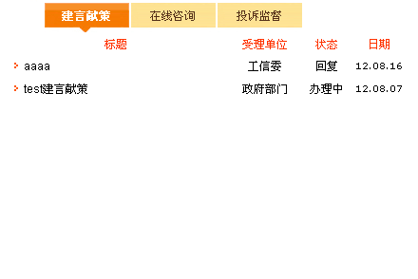
代码如下：
<div id="letter_list">
<table id="tdmndividd1" style="display: ">
<script type="text/javascript">
function intercation3_init(data){
var interactions = data.interactions;
var insertHtml = '<tr>' +
' <th class="bt">标题</th>'+
' <th class="dw">受理单位</th>'+
' <th class="zt">状态</th>'+
' <th class="rq">日期</th>'+
'</tr>';
var interactionLength = interactions.length;
if (interactionLength > 9){interactionLength = 9;}
for(var i = 0 ; i < interactionLength; i++ ){
var interaction = interactions[i];
if(i % 2 == 0){insertHtml += '<tr>';}
else{insertHtml += '<tr>';}
insertHtml += '<td class="lt_bt"><a class=hui href="/component/interaction/detail.do?id='+interaction.id+'" target=_blank>';
if(interaction.title.length > 16){insertHtml += interaction.title.substring(0,16) + "...";}
else{insertHtml += interaction.title;}
insertHtml += '</a></td>';
insertHtml += '<td>' + interaction.organ + '</td>';
insertHtml += '<td>' + interaction.state + '</td>';
insertHtml += '<td class="lt_dt">' + interaction.date + '</td>';
insertHtml += '</tr>';
}
document.write(insertHtml);
}
</script>
<script type="text/javascript" src="/component/interaction/main.js?callback=intercation3_init&type=3"></script>
</table>
<table id="tdmndividd2" style="display:none">
<script type="text/javascript">
function intercation1_init(data){
var interactions = data.interactions;
var insertHtml = '<tr>' +
' <th class="bt">标题</th>'+
' <th class="dw">受理单位</th>'+
' <th class="zt">状态</th>'+
' <th class="rq">日期</th>'+
'</tr>';
var interactionLength = interactions.length;
if (interactionLength > 9){interactionLength = 9;}
for(var i = 0 ; i < interactionLength; i++ ){
var interaction = interactions[i];
if(i % 2 == 0){insertHtml += '<tr>';}
else{insertHtml += '<tr>';}
insertHtml += '<td class="lt_bt"><a class=hui href="/component/interaction/detail.do?id='+interaction.id+'" target=_blank>';
if(interaction.title.length > 16){insertHtml += interaction.title.substring(0,16) + "...";}
else{insertHtml += interaction.title;}
insertHtml += '</a></td>';
insertHtml += '<td>' + interaction.organ + '</td>';
insertHtml += '<td>' + interaction.state + '</td>';
insertHtml += '<td class="lt_dt">' + interaction.date + '</td>';
insertHtml += '</tr>';
}
document.write(insertHtml);
}
</script>
<script type="text/javascript" src="/component/interaction/main.js?callback=intercation1_init&type=1"></script>
</table>
<table id="tdmndividd3" style="display:none">
<script type="text/javascript">
function intercation2_init(data){
var interactions = data.interactions;
var insertHtml = '<tr>' +
'<th class="bt">标题</th>'+
'<th class="dw">受理单位</th>'+
'<th class="zt">状态</th>'+
'<th class="rq">日期</th>'+
'</tr>';
var interactionLength = interactions.length;
if (interactionLength > 9){interactionLength = 9;}
for(var i = 0 ; i < interactionLength; i++ ){
var interaction = interactions[i];
if(i % 2 == 0){insertHtml += '<tr>';}
else{insertHtml += '<tr>';}
insertHtml += '<td class="lt_bt"><a class=hui href="/component/interaction/detail.do?id='+interaction.id+'" target=_blank>';
if(interaction.title.length > 16){insertHtml += interaction.title.substring(0,16) + "...";}
else{insertHtml += interaction.title;}
insertHtml += '</a></td>';
insertHtml += '<td>' + interaction.organ + '</td>';
insertHtml += '<td>' + interaction.state + '</td>';
insertHtml += '<td class="lt_dt">' + interaction.date + '</td>';
insertHtml += '</tr>';
}
document.write(insertHtml);
}
</script>
<script type="text/javascript" src="/component/interaction/main.js?callback=intercation2_init&type=2"></script>
</table>
</div>

2.在线服务：绿色通道(指人员信息)
如图所示：

代码如下：
<div id="zxfw_bar">
<ul>
<li class="lstd_icon"></li>
<script type="text/javascript">
function citizen_init(data){
var insertHtml = '';
var length = data.length;
if (length > 5) length = 4;
for(var i = 0 ; i < length; i++){
insertHtml += '<li><a href="/component/online/citizen.do?citizenId=' + data[i].id + '">' + data[i].name + '</a></li>';
}
document.write(insertHtml);
}
</script>
<script type="text/javascript" src="/component/citizen/main.js?callback=citizen_init"></script>
</ul>
</div>

3.办事指南：
如图所示：
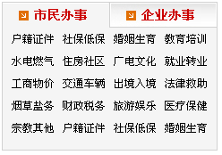

代码如下：
<div id="bs_list">
<script type="text/javascript">
function online_init(data){
var tab = working_tab_html(data);
document.write(tab);
var body = '';
for(var i = 0 ; i < data.length; i++){
body = body + working_body_html(data[i].children,data[i].id,i);
}
document.write(body);
}
function working_tab_html(workings){
var insertHtml = '<ul class="bs_list_menu">';
for(var i = 0 ; i < workings.length; i++ ){
var working = workings[i];
insertHtml += '<li id="dmndivide' + (i+1) + '" onclick="ChangeFoldern(this,\'dmndivide\',\'2\',\'bs_current\',\'bs_out\');" style="cursor:hand;"';
if (i == 0){insertHtml +=' class="bs_current">';}
else{insertHtml +=' class="bs_out">'}
insertHtml += working.name + '</li>';
if(i < 2){insertHtml += '<li class="bs_gexian"></li>';}
if(i == 2){break;}
}
insertHtml += '</ul>';
return insertHtml;
}
function working_body_html(workings,parentId,index){
var insertHtml = '<ul id="tdmndivide' + (index + 1) + '" style="display: " class="bs_content">';
for(var row = 0 ; row < 4; row++){
for(var col = 0 ; col < 4 ; col++){
var index = row * 4 + col;
if(index <= workings.length -1){
var working = workings[index];
insertHtml += '<li><a href="/component/online/working.do?workingId=' + working.id +'&parentId='+parentId+'">'+working.name+'</a></li>';
}
}
}
insertHtml += "</ul>";
return insertHtml
}
</script>
<script type="text/javascript" src="/component/online/main.js?callback=online_init"></script>
</div>

4.热点
如图所示：
代码如下：
<span id="hot_id"></span>
<script type="text/javascript">
function hot_init(data){
var html = '';
for(var i = 0 ; i < 3; i++){
var insertHtml = '';
var length=data.length;
if (length > 3) length = 3;
for(var i=0; i<length;i++){
var hotValue= data[i];
insertHtml += '·<a title="' + hotValue.title + '" href="' + hotValue.url + '" target="_blank">' + hotValue.title.substring(0,20) + ' ...</a>';
}
document.getElementById("hot_id").innerHTML = insertHtml;
}
}
</script>
<script type="text/javascript" src="/component/hot/main.js?callback=hot_init"></script>

5.政民互动（网民评论留言）在page/interaction/detail.jsp页面中引用
如图所示：
代码如下：
<s:if test="interaction.speakCount != 0">
<br/>
<span class="red_bt">－－回复评价－－</span><br/>
<s:iterator value="interaction.speaks">
<table width="80%" border="0" cellspacing="4" cellpadding="0">
<tr>
<td class="xu_di_line">
<div align="left" class="hui style9">
用户名：<s:property value="name"/>&nbsp;&nbsp;&nbsp;&nbsp;
评论时间：<s:date format="yyyy-MM-dd" name="date"/>
</div>
</td>
</tr>
<tr>
<td>
<div align="left">
<span class="hui"><s:property value="content"/></span>
<br/>
</div>
</td>
</tr>
</table>
</s:iterator>
<br/>
<table width="95%" border="0" cellspacing="0" cellpadding="0">
<tr>
<td height="30" bgcolor="#F2F2F2" class="li_line">
<div align="center" class="hui">共<s:property value="page.pageCount"/>页&nbsp;当前为第<s:property value="page.page"/>页&nbsp;
<s:if test="page.pagePrev == -1">上一页</s:if>
<s:else>
<s:url action="detail" id="pageUrl" escapeAmp="false">
<s:param name="id" value="%{id}"/>
<s:param name="counter" value="false"/>
<s:param name="pageNumber" value="%{page.pagePrev-1}"/>
</s:url>
<a href="<s:property value="pageUrl"/>">上一页</a>
</s:else>
<s:iterator value="page.pageList">
<s:if test = "page.page == top">
<strong><s:property value="top"/></strong>
</s:if>
<s:else>
<s:url action="detail" id="pageUrl" escapeAmp="false">
<s:param name="id" value="%{id}"/>
<s:param name="counter" value="false"/>
<s:param name="pageNumber" value="%{top-1}"/>
</s:url>
<a href="<s:property value="pageUrl"/>"><s:property value="top"/></a>
</s:else>&nbsp;
</s:iterator>
<s:if test="page.pageNext == -1">下一页</s:if>
<s:else>
<s:url action="detail" id="pageUrl" escapeAmp="false">
<s:param name="id" value="%{id}"/>
<s:param name="counter" value="false"/>
<s:param name="pageNumber" value="%{page.pageNext-1}"/>
</s:url>
<a href="<s:property value="pageUrl"/>">下一页</a>
</s:else>&nbsp;转到
<select name="select" class="hui" onchange="jumpPage(this)">
<s:iterator value="page.pageListAll">
<s:if test = "page.page == top">
<option selected><s:property value="top"/></option>
</s:if>
<s:else>
<option><s:property value="top"/></option>
</s:else>
</s:iterator>
</select>页
</div>
</td>
</tr>
</table>
</s:if>

6. 政民互动（我要评论）在page/interaction/detail.jsp页面中引用
如图所示：
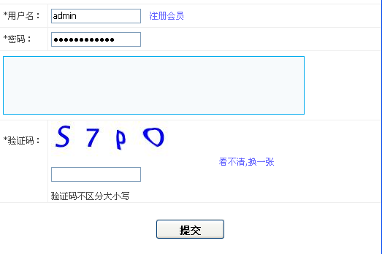
代码如下：
<iframe src="/component/interaction/speak.do?interactionId=911" height="375" width="600" id="imagefoifr" name="imagefoifr" class="editifr" scrolling="no">
</iframe>

