Proj4

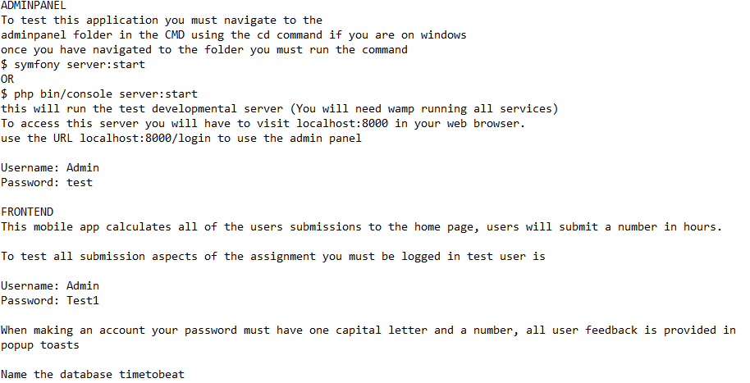

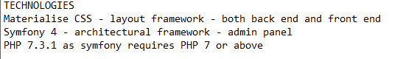

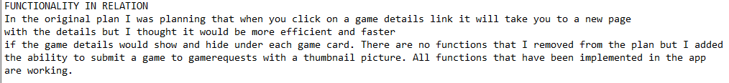

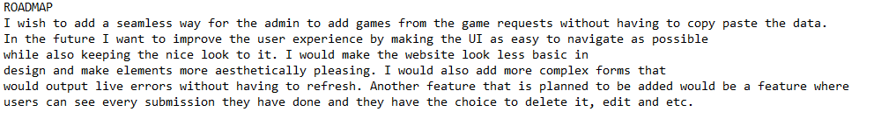

THERE ARE NO ADMIN ACOUNTS

**Referrer**



**Rate limit**

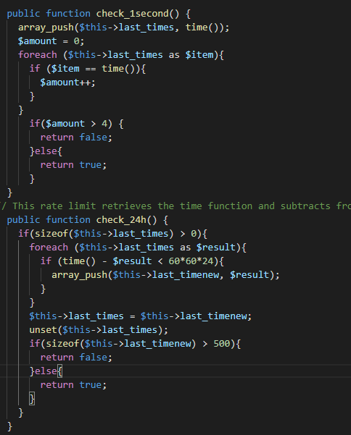

**SCRIPT**

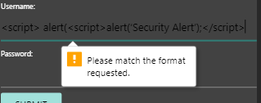

There are no deletes on this app

The reason why it didn’t accept the script was because of both client side and server-side validation being utilised to stop script injects and other results.