UX3 – Continuous improvement

**HTML HELP (This is also in the UI)**

The UI in the web app is quite straight forward to use the user will automatically be on the homepage upon entry. The anonymous user then can see the games and look at game details by clinking on the link. To access any other features on the website they must register and login by clicking on the login tab and navigating to the register form, they must register and then login. The user now has access to all features on the web app. First the game request feature under the request tab users can recommend games to the admin by filling out he form and adding a file as the thumbnail picture. The submission feature under the submission tab is very straight forward the user just enters his information and selects a game.

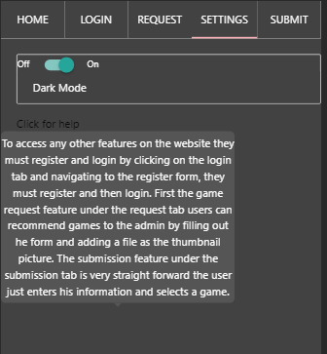

**CDN**

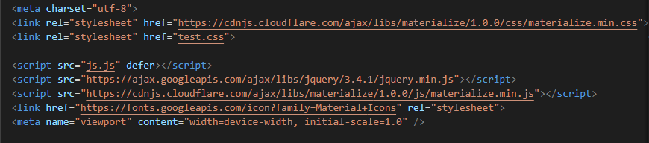

**ROAD MAP**

I wish to add a seamless way for the admin to add games from the game requests without having to copy paste the data. In the future I want to improve the user experience by making the UI as easy to navigate as possible while also keeping the nice look to it. I would make the website look less basic in design and make elements more aesthetically pleasing. I would also add more complex forms that would output live errors without having to refresh. Another feature that is planned to be added would be a feature where users can see every submission they have done and they have the choice to delete it, edit and etc.

**Why is it important**

The read me is very important for deployment so the client knows what to do with the files that have been sent, this file provides useful information to the client. Its important to more all 3rd party files to the CDN to assist in file size and aids security. It is also good since in will all be in one file and not all over the place.

**Other Types of Documentation**

Other types of documentation that is useful for this project would be the materialise CSS documentation for the web app.

**What went well**

My SQL query that averaged the user’s data went well and was relatively easy to do and I thought it would be more complicated then it actually was. The normalisation on the database worked well and I was able to create a well working system. Overall, I feel the project went well there were some problems at times, but nothing was a major problem.

**Most Difficult**

The hardest things to implement were ajax related requests specifically the file upload feature. This is because I was having problems with restricting files that were being submitted to the form. There was also an issue between the submission o jpg and jpeg files. Another difficult aspect of my project was figuring out how to provide the user feedback on a rate limit security die since it was dying too quickly for my messages to appear.

**Do Differently**

Something that I would do differently would be to incorporate a better-looking app that isn’t just two tone while also keeping it simple. I would put in more complex designs within the app as well as animation to make it more aesthetically pleasing for the users and not boring.

**Implementation Incomplete**

In the original plan I was planning that when you click on a game details link it will take you to a new page with the details but I thought it would be more efficient and faster if the game details would show and hide under each game card.

**Quality Assurance**

I ensured the best quality of my product through bug testing and through feedback from the clients.

**Prototype**

The prototype ended up being useful since I made in with materialise CSS. I used the prototype as the basis for the design of the frontend of the project. I used the same layout, but I changed the colour schemes to support a light and dark theme.

**OO Programming**

I use object orientated programming when I instantiate the database functions and the session functions away from the web service. These are called through the object and function name.