Multi-omic clustering in children with CF at the initiation of a pulmonary exacerbation
Authors: Ezra, Charlie, Brandie, Debashis, Kirk, Edith
Target Journal ideas: White journal, JCF, frontiers

Abstract
Key words

Introduction
- CF overview
- Heterogeneity in CF pex isn’t well understood
- The host immune response may differ depending on the microbiome/person (the same organism may not trigger a response in different people)
- A better understanding of clusters (sub-groups or variation in host microbe interactions) could be useful for deciding treatments (abx). Heterogeneity of immune phenotypes
- Why the flag mean approach was used (don’t have to assume same number of clusters across views, can handle difference in number of features across views)
Aims:
- Identify groups of subjects with similar patterns of joint microbiome/proteome
- Characterize these clusters/identify what makes them distinct when looking at their microbiome/proteome
- Identify clinical relevance of these clusters by identifying different clinical or demographic features
We want to create groups of subjects that have similar combinations of microbiome/proteome (understand how those two things interact and also identify groups where interactions are more similar within the group than between the groups – comparing two views and comparing the groups/clusters). Then what do the groups mean/are they useful (from a clinical standpoint) (part of problem with unsupervised clustering, may or may not be meaningful clinically but may still be mechanistically interesting (e.g. taxa has diff host response in one group vs another group even if treatment is still the same – why diff host response may be of interest))

Methods
Study cohort and sample collection
The CF data comes from a study with the primary aim of comparing the lower airway microbiota
in cystic fibrosis and control subjects in the pediatric age spectrum. Samples from subjects with cystic
fibrosis aged 0 to 21 years were collected along with relevant clinical data. Sputum and blood samples were obtained at the beginning of a hospitalization for a pex.
Microbiome methods
Total bacterial load was measured using quantitative polymerase chain reaction and performed 16S gene sequencing to characterize bacterial communities with species- level sensitivity for select genera.

Proteomics methods
For the proteomics assays SLaptamer technology was used to simultaneously measure approximately 3,000 proteins from each blood sample. For each sample assayed, the resulting SLaptamer mixture is quantified by hybridization to a custom Agilent DNA microarray that contains 10 replicate probe spots of complementary DNA for each SLaptamer, as well as probe spots complementary to internal hybridization controls. SLaptamer mixtures are hybridized for 17 hours, washed, and read with a microarray reader (Agilent G2505C). The resulting raw scanner data is processed and analyzed as described in the following section. The quantity of SLaptamer hybridized to each cognate probe spot on the microarray is measured by the scanner in raw fluorescent units (RFUs). Changes in RFU signal strength can occur between samples due to factors such as inconsistent hybridization conditions and laser power fluctuation in the scanner. To compensate for such changes, we normalize RFU values for all SLaptamers on an array using internal hybridization controls added just prior to hybridization. Assay normalization is performed to reduce signal variation potentially introduced during the assay. Each sample in a study is normalized using a set of normalization SLaptamers that have the lowest overall relative signal variation between
samples. Proteins are measured in the assay by transforming the quantity of each protein to be measured into proportional quantities of their corresponding SLaptamers. The result of this transformation is a mixture of SLaptamers that is reflective of the proteins present in the original sample. Because SLaptamers are single-stranded DNA molecules, the mixture is readily quantified by hybridization to a custom Agilent DNA microarray.

- Add description of data and table 1 – number of samples with both omics, number of proteins in proteomics, number of taxa in microbiome
Statistical analysis
For all timepoints, patients without successful collection of bacterial signal were removed (24% of subjects in time point 1). Proteins with ≥ 20% missingness were removed from the analysis. Microbes without ≥ 0.1% relative abundance in at least one subject were removed, and microbes that weren’t present in at least 10% of subjects (3 subjects) were removed. Microbiome data was analyzed using relative abundance rather than count data and were normalized with a CLR transformation. Proteins were normalized with a log2 transformation. Microbiome data were all normalized using the centralized log ratio transformation. After imputation, PCA was used to visually assess any outliers. One potential outlier was identified, patient 49, and was removed, leaving 31 remaining subjects.
With all data properly normalized and imputed, a spectral analysis on each view was conducted. The proper number of groups, kv, and eigenvectors were determined by the largest eigen gap within each view and a visualization of the adjacency matrix as a heat map. The traceW index was used to estimate k within the estimated joint spaces. Finally, k-means was used for clustering in the final combined clustering subspace.

Once the groups were estimated within each data set, we tested differences in the mean expression levels of each omics variable using ANOVA and follow up with Tukey’s HSD test to test for pairwise differences among the estimated groups. We apply a false discovery rate (FDR) correction to the p-values from the ANOVA.

All data were cleaned, normalized, and imputed in R: R version 4.4.1 (2024-06-14 ucrt)

Results
Start with results in Charlie’s dissertation
Cohort description
Cluster results
- Number of clusters, how many patients in each cluster, how distinct are the clusters
- There were 2 clusters for microbiome and for proteomics on their own.
- Using the approximate Laplacian method and the traceW index to estimate k in the joint space, we estimated 4 total clusters for joint. (Settled on 4 clusters due to Tracew estimates joint number of clusters in apxK)
- Looks like the mb groups are driving the differences in the overall groups more than the pt groups (they are more consistent/stable whereas the pt groups had more crossover). When looking at them overall, the overall cluster is giving additional information than just the two pt and mb clusts (no pair of pt and mb perfectly goes into one group clust). The group clusters are not fully 1-to-1, thus it is capturing something different than just combining the individual clusters

Cluster description
Which features define the clusters; do demographic or clinical outcomes differ by clusters
- Amount of missing is not significantly different by group
- After univariate analysis to compare the groups, the differences between time 3 and time 1 of FEV and FVC (percent predicted) were statistically significant after FDR adjustment. The differences between times 2 and 1 were marginally significant. Group 4 appears to have a faster recovery rate and group 2 appears to be recovering the slowest.
- Using ANOVA to find proteins that are significantly different by group and identifying them in Uniprot: FTMT is Ferritin, and deals with iron uptake and transport. Specifically, it catalyzes the oxidation of ferrous iron(II) to ferric iron(III) and stores iron in a soluble, non-toxic, readily available form (PubMed:11323407, PubMed:15201052). Important for iron homeostasis (PubMed:11323407, PubMed:15201052). Iron is taken up in the ferrous form and deposited as ferric hydroxides after oxidation (PubMed:11323407, PubMed:15201052). Significant bacteria were Granulicatella (aka nutritionally variant streptococci, typical oral bacteria but can cause severe infections) and Lachnoanaerobaculum (can cause infections in immunocompromised patients, commonly found in saliva)
  - Could also look at the immune system proteins specifically
    - None of the 5 identified by uniprot are significant with a 0.05 cutoff, but LRIT2 and Eotaxin.2 show marginal significance around 0.08 after adjustment. Need to verify that there are no more immune system proteins, this seems oddly low
  - Top 15 significant bacteria: "Lachnoanaerobaculum", "Granulicatella", "Stomatobaculum”, “Moryella”, “Lactobacillales", "Derxia", "Proteobacteria","Neisseriaceae", "Carnobacteriaceae", "Peptostreptococcus", "Stenotrophomonas", "Erysipelotrichaceae" "Moraxella", "Pseudomonas", "Atopobium".
    - Granulicatella, Neisseriaceae (higher level up from neisseria), and Stenotrophomonas are likely the relevant ones here
- Group 3 might be driven by non-common bugs like prevotella and neisseria and veillonella and rothia and haemophilus (also maybe burkholderia but I think that has low amounts here) because it has high inflamation but not higher levels of these bugs. Group 2 has higher pseudomonas but lower inflamation and group 1 has lower pseudomonas

Discussion
- Summary of findings
- Context with other findings - How do these results compare to Brenton’s paper
- Limitations (small sample size/single site (may not be generalizable, only kids so not generalizable to adults), matching the distances (Euclidian vs. ecological), looking at proteomics from blood (may not correspond to what we are seeing in the airway, have to decide the appropriate measure to determine the number of joint clusters)
References

Tables and Figures:
Proteomics Clustering:
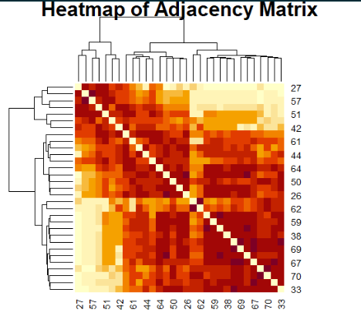
Microbiome Clustering:
Joint Clustering:
Clustering using the averaged approximate Laplacian: 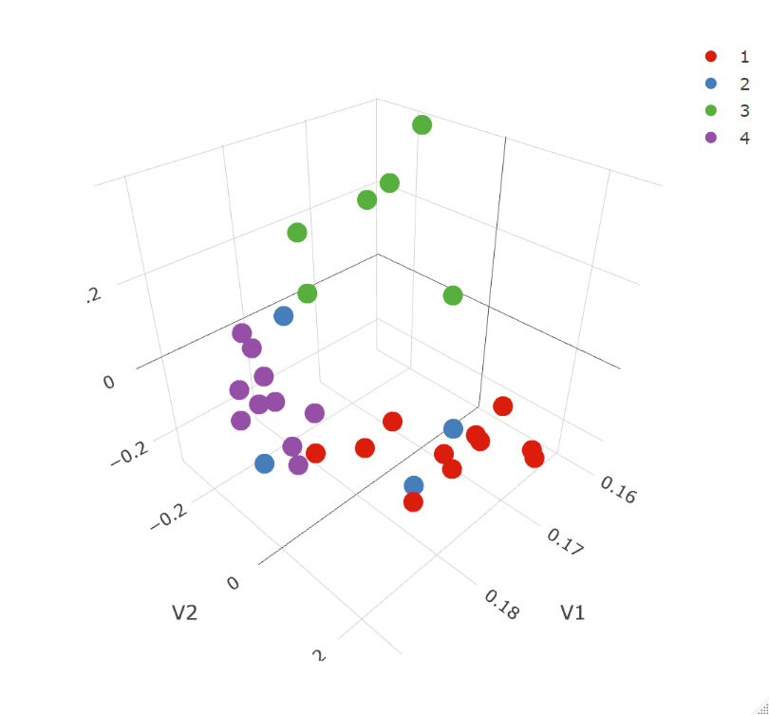
Clustering using the flag mean:
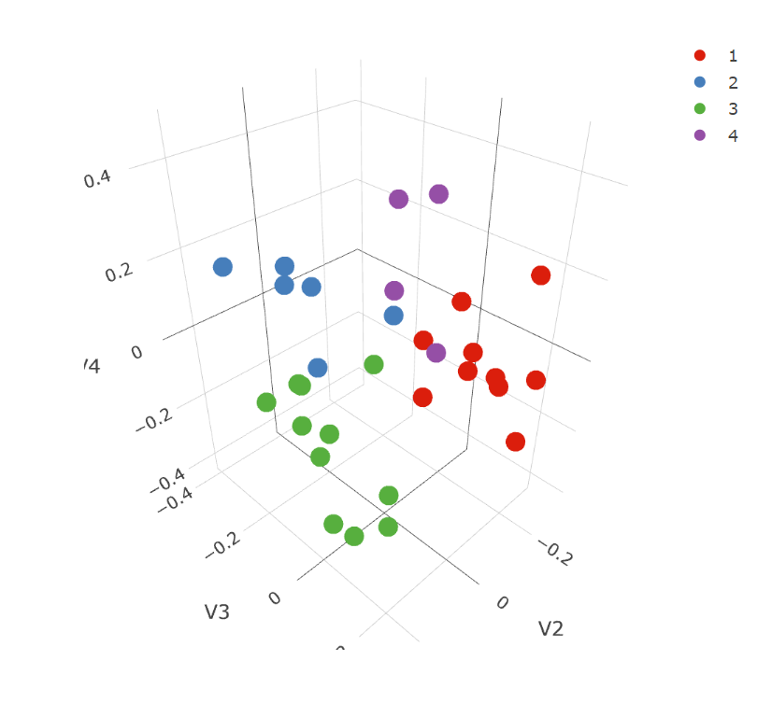
Validation of Number of Joint Clusters:
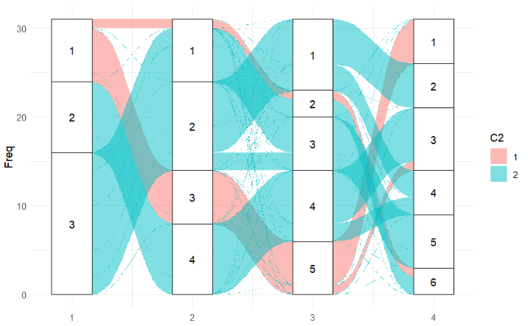
Group Cluster Comparisons:
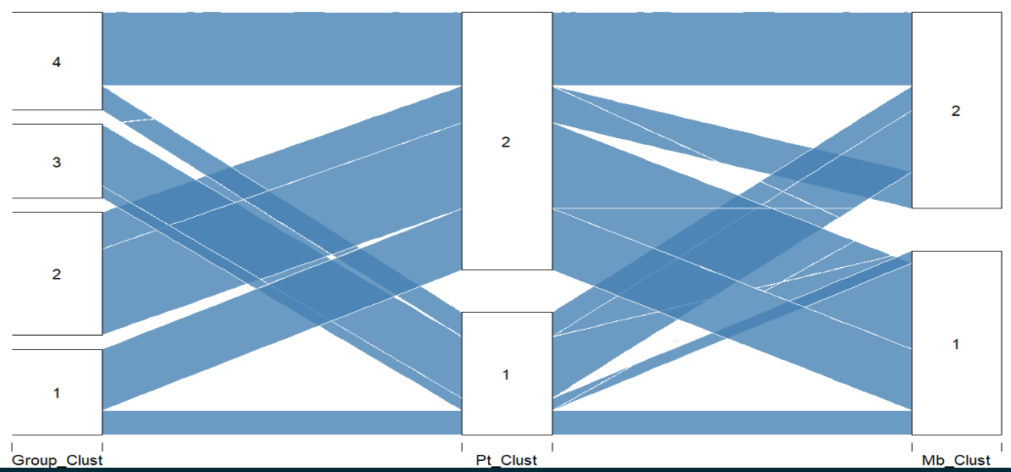
Clinical Applications/Cluster Descriptions:
