Chapter 1

Developing an assay for gene association

1.1 Preparation of CD34+ cells
There is mounting evidence that the founder translocations involving BCR and MLL in leukaemia may occur within the haematopoeitic stem cell compartment [#REFS]. As it is thought that the translocations happen within these cells, it is here that I was interested in investigating the organisation of the un-translocated genes.
Because the nuclear organisation of these cells starts to change as soon as they are removed from the body, it was important that I fixed them with formaldehyde as quickly as possible. Adding formaldehyde directly to the blood samples would have caused problems during cell separation, so I chose to run a Ficoll separation to isolate the lymphoblasts, and then fixed in PBS with EDTA and 2% formaldehyde. Following formaldehyde separation, I used a magnetic sort with anti-CD34+ antibodies to purify the CD34+ cells. Finally, I analysed an aliquot of the purified cells using FACS (using an antibody against a different epitope of CD34) to find the purity of the samples.
The first kit I used to separate the fixed CD34+ cells was the Invitrogen Dynal CD34 Progenitor Cell Selection System. I used this to process 17 separate blood samples from patients who had been treated with GCSF to mobilise their haematopoeitic cells into their peripheral blood stream. The FACS plots all show some material with low front scatter, likely to be debris resulting from the fix and sort (Fig 1.1). This was gated out, and a threshold set for anti-CD34+ fluorescence. The percentage of cells within the gate fluorescing above the threshold varied from 17% - 91%, with a median purity of 67%. 10 of 17 samples collected using the Invitrogen kit had to be discarded due to unsatisfactory purity.
I attempted a number of alterations to the cell separation protocol to improve this purity, and finally tried using the Miltenyi MACS CD34 MicroBead Kit instead. This immediately gave much better performance, with purities ranging from 90% - 97% with a median of 96% purity (Fig 1.1).

[Sorry. Ignored \begin{centering} ... \end{centering}]
Figure 1.1: CD34+ Separation FACS Plots
FACS plots after magnetic bead separation of fixed CD34+ cells.

1.2 Chromosome Conformation Capture
Chromosome Conformation Capture (3C) is a ligation based proximity assay. First published in 2002 by Dekker et. al. Dekker2002b it allows the physical association of sequences of DNA to be interrogated. 3C has become a key methodology in the field of nuclear organisation, and a number of new techniques use it as a base.
3C works by fixing protein and DNA in place with formaldehyde. A restriction enyme is used to cut the DNA, typically recognising a 6 base pair sequence, so cutting on average once every 1.2 Kb (). This results in “hairballs” of cross linked DNA and protein which are diluted into a large volume. A ligation reaction is then run, which favours ligations between sequences held together by the formaldehyde cross links. Cross links are reversed and the DNA is purified, leaving a 3C “library”. Within this library, the frequency with which restriction fragments are found ligated together corresponds to their degree of interaction within the nucleus.
The 3C library is a basis for a number of different assays that all measure interaction frequencies. Traditional 3C uses PCR with primers positioned adjacent to the restriction enzyme recognition sites of two loci of interest. If a PCR product is detected, these two sequences were physically close within the nucleus. The strength of bands on a gel can be used to quantify the strength of this interaction, and qPCR can be used to accurately assess this for a large number of primer pairs (3C qPCR). Both of these techniques are used to probe interactions on a “one-to-one” basis; that is, investigating the interaction between two specific loci at a time.

[Sorry. Ignored \begin{centering} ... \end{centering}]
Figure 1.2: Overview of the 3C methodology
R denotes the recognition sites for the first six-cutter restriction endonuclease.

1.3 Enriched 4C
Enriched 4C (e4C) starts with the preparation of 3C libraries as described above, and uses further processing to generate a “one-to-all” assay, which is capable of revealing the genome-wide interaction profile of a single sequence of interest.
A biotinylated primer annealing and extension step is used to do this, with magnetic streptavidin beads pulling down all ligation products containing the sequence of interest, or “bait”. A second restriction enzyme is then used to cut the enriched library, an enzyme with a 4 base pair recognition site is used to cut approximately once every 256 base pairs (). The resulting sticky end is then used to ligate an adapter to the end of the unknown partner sequence. This allows the libary to be amplified using PCR. Primers with overhanging tails are used to add the sequence needed for sequencing with the Illumina Genome Analyser IIx. A custom sequencing primer is used which binds to the bait region immediately before the first restriction enzyme cut site, preventing known sequence from being unnecessarily sequenced. A few remaining few base pairs are left betweenthe sequencing primer and the cut site, to use as a barcode region to allow multiplexing of libraries on the sequencing run. This sequence is also used to confirm the identity of the bait sequence. The remaining base pairs that are sequenced after the cut site are aligned to the genome, and their distribution used to plot a genome-wide interaction profile for the bait sequence.
See Chapter Error: Reference source not found for further details about the analysis of e4C data.

[Sorry. Ignored \begin{centering} ... \end{centering}]
Figure 1.3: Overview of the e4C methodology
R’ denotes the recognition site for the second four-cutter restriction endonuclease. BC denotes the barcode region used to confirm the identity of the bait sequence and identify sequences when multiplexing libraries for sequencing.

1.4 Restriction Enzyme Choice
The majority of chromosomal translocations within the BCR and MLL genes occur within tight breakpoint cluster regions. The MLL breakpoint cluster region is an 8.3 Kb region between exons 6 and 14 bordered by two BamHI restriction sites [# REF]. It is thought that the presence of 8 direct Alu SINE repeats, 4 L1 LINE and 2 MER2 repeats within the MLL breakpoint cluster region may provide regions of micro-homology with its translocation partners and increase the chance of aberrant repair via the NHEJ pathway. Additionally, a number of putative topoisomerase II binding sites are present within this region, leading to suggestions that topoisomerase II activity may lead to an increased likelihood of a double strand break in this region.
To provide as accurate a picture of the interaction with these translocation forming regions as possible, we looked into the fragments created by a number of six-cutting restriction enzymes. As the breakpoint cluster region of the MLL gene is flanked by BamHI restriction sites, it seemed a natural choice for the 3C enzyme.
After a number of test e4C runs using Human buffy coat cells it became clear that the assay was not working to its full potential. Due to the nature of the 3C protocol, the most common interaction partner will always be the germ line configuration, as the cut fragments will be held together during the ligation reaction, making re-ligation a likely possibility. This germ line band was clearly visible when the e4C libraries were run on a gel (Fig 1.4), however, the characteristic smear resulting from the varying lengths of 3C products was not.

[Sorry. Ignored \begin{centering} ... \end{centering}]
Figure : BamHI e4C Libraries
After a number of diagnostic tests I found that the underlying problem was poor digestion efficiency in the first steps of the 3C, with only 44% of BamHI recognition sites being cut. Further work on this step showed that the SDS treatment and subsequent Triton-X100 quenching of the SDS were having a dramatic effect on the digestion.
I ran a concentration gradient of Triton-X100 with a digestion using purified plasmid DNA which showed residual SDS inhibiting the reaction when there was insufficient Triton-X100 to quench all of the SDS (Fig 1.5A). The concentration of Triton-X100 had a similar effect on the digestion efficiency of BamHi with cross linked chromatin (Fig 1.5).
I followed these tests with an experiment using a panel of different restriction enzymes, some of which are commonly used in 3C based techniques. I used cells which were fixed with the normal 2% formaldehyde and a weaker 1% formaldehyde fix, and I ran the digestion step with and without the initial SDS disruption and Triton-X100 quenching (Fig 1.5). These digestions clearly showed that BamHI was far less efficient at digesting cross linked chromatin than the other restriction enzymes in every condition.
At this point, instead of continuing to try to optimise the 3C to work with BamHI, I went back to the drawing board and looked at which other enzymes could be suitable. The restriction enzyme AseI had good performance under all of the conditions, and gave suitable fragment sizes in and around the break point cluster regions of both BCR and MLL. Further digestion efficiency qPCR tests showed it’s efficiency at a far superior 81 - 99% of sites being cut.

[Sorry. Ignored \begin{centering} ... \end{centering}]
Figure 1.5: Restriction Enzyme Tests
Digestion tests with six enzymes in four different conditions. Cells were fixed in either 1% or 2% formaldehyde as described in Materials and Methods: 3C Error: Reference source not found, either with or without the pre-digestion SDS/Triton steps. Samples were treated with Proteinase K, RNase A and cleaned with a phenol / chloroform extraction and precipitation as described in Error: Reference source not found. Samples shown run on 1% gels.

1.5 Primer Design

1.6 e4C with low cell numbers
Initially, CD34+ cells were collected from peripheral blood supplied by Dr. George Follows in the Addenbrookes Haemotology Day Unit, with the help of apheresis coordinator / specialist nurse Paul Boraks (see Section Error: Reference source not found for details). Samples were collected on a weekly basis before being fixed and sorted as described in Section Error: Reference source not found. Typically, between 12 and 30 ml whole blood was received in each sample, giving a median final count of 3.6 x 105 CD34+ cells per collection. Typically, 3C experiments use 1 x 107 cells, or 28 collections pooled together. Between 2008 and 2009 I managed to collect and sort 23 peripheral blood samples, giving a total of 1.04 x 106 total cells, however 10 of these samples had to be discarded due to poor purity, as described in Section 1.1. This left me with 13 samples and a total of 7 x 106 cells (minimum 76% purity, average 91.6% purity). Because of this low cell number, combined with the need for more than one CD34+ 3C library, I worked on optimising the 3C protocol for use with low cell numbers. Some of this work was done with the help of Dr. Mayra Furlan-Magaril, who was a visiting student in our laboratory at the time.

1.6.1 ChIP e4C
My initial plans when making the interaction libraries was to incorporate a chromatin immunoprecipitation (ChIP) step to purity for 3C DNA-protein complexes containing RNA Polymerase II. This was done using an antibody against the Serine-5 phosphorylated elongating form of RNA Polymerase II, and was intended to enrich for DNA-DNA interactions specifically happening at transcription factories. This protocol was used with some success in my lab by Dr. Cameron Osborne and Allen Chong, though the extra immunoprecipitation step meant that only very low amounts of input DNA was available for the e4C stage, resulting in interaction datasets that were very low in complexity. This low complexity was offset by the specific nature of the hits and low signal to noise ratio (unpublished data).
Although the chromatin immunoprecipitation steps worked well in my hands for test samples, I soon decided to remove this enrichment step in favour of keeping as much library DNA as possible. I showed by RT-PCR that my bait genes were expressed in the cells I was investigating. Additionally, all interactions may be relevant to the formation of chromosomal translocations, so any resulting interaction data is useful.

[Sorry. Ignored \begin{centering} ... \end{centering}]
Figure 1.6: CD34+ RT-PCR
B = Buffy Coat cells, C = CD34+ cells, G = genomic DNA control. CD34+ cells not treated with DNaseI due to low cell numbers, hence genomic band contamination.

1.6.2 Carrier e4C
An established technique when using low cell numbers for techniques such as ChIP and BS-Seq is to use ’carrier’ chromatin to buffer loss of sample DNA [#REFS]. This is done by processing cells from another organism in with the sample, giving larger quantities of DNA to work with. Loss through non-specific binding of DNA to plastic such as tubes and pipette tips has less of an effect on the sample DNA, and steps such as precipitations are aided by having larger pellets to work with.
Intially I tried this technique by using the Sf9 cell line, derived from Spodoptera frugiperda (Fall Armyworm), obtained from Maureen Hamon at the Babraham Institute. Cells were processed in parallel with the sample as described in Section Error: Reference source not found up until the point of permeabilisation. Sf9 cells were then split into two aliquots of 1 x 107 cells, and 1 x 106 sample cells were added to one aliquot. Both samples were then processed as normal for the rest of the 3C protocol.
After this initial test run, I use the Schneider’s line 2 (S2R+) cell line, derived from Drosophila melanogaster, grown with help from Dr. Sarah Toscano at the Babraham Institute. The reason for this change was because the genome of Drosophila melanogaster is known, allowing easy design of PCR primers to test for carrier DNA contamination, and to allow identification of any products occuring as a result of a non-specific ligation event in the e4C. The protocol was followed as described for the Sf9 cells.
Initial tests with the carrier e4C were promising, showing good recovery of sample DNA and successful 3C product detection using primers designed for the Drosophila melanogaster genome (Fig 1.7). However, due to the removal of the removal of the RNA Polymerase II ChIP step (Section 1.6.1) and subsequent aquisition of much larger CD34+ cell collections (Section 1.7), the carrier e4C protocol was not needed.
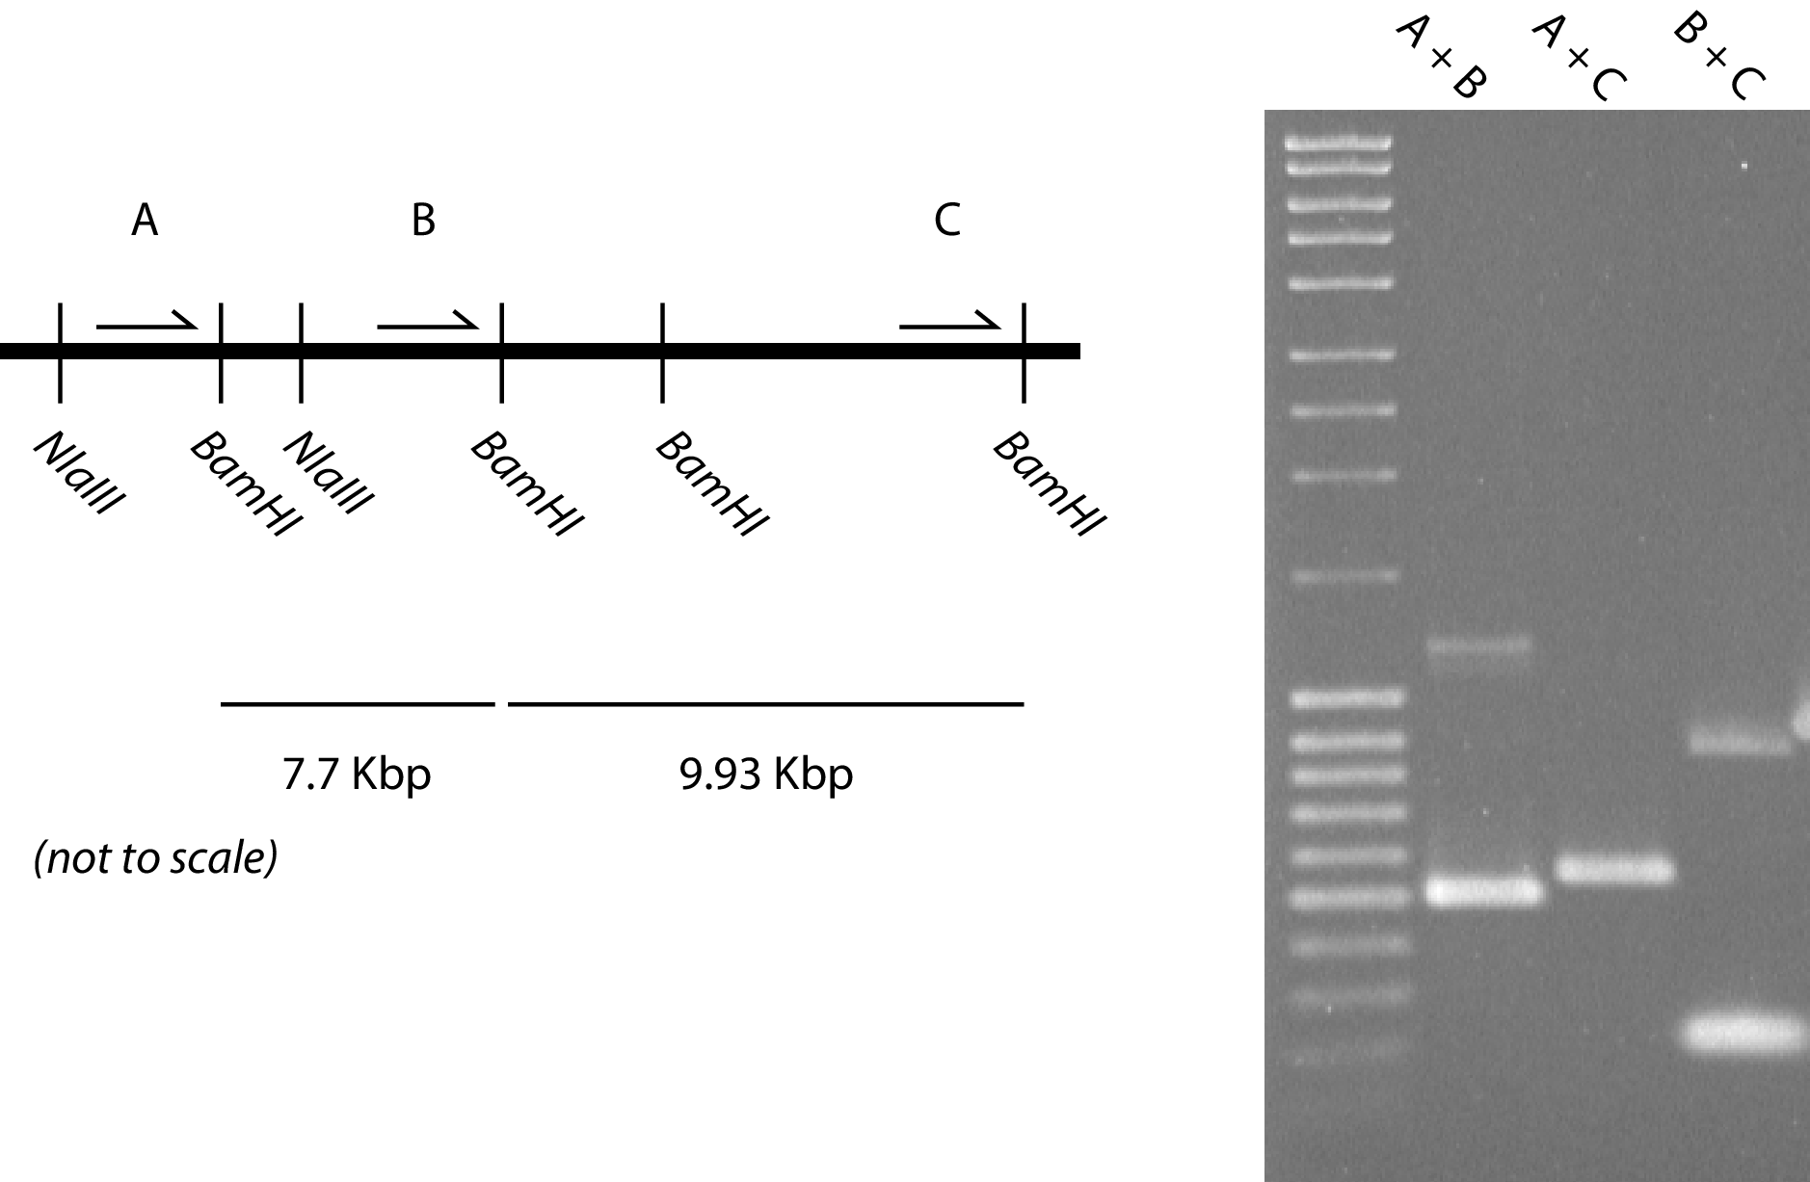
Figure 1.7: Drosophila melanogaster S2R+ 3C Tests

1.7 e4C with large cell numbers
In December 2009 I was able to obtain a leukapheresis sample from Dr. George Follows with the help of Kevin Jestice, the chief biomedical scientist within the Haematology Department at Addenbrookes Hospital, Cambridge. This sample came from a patient who had responded exceptionally well to G-CSF treatment and had such a large number of mobilised peripheral CD34+ cells that there was leukapheresis sample left spare after use by the Haematology Department. I processed this sample as described in Section Error: Reference source not found. The final yield of CD34+ cells from this single collection was 2.88 x 107 cells, over four times the number of cells collected from a year of weekly peripheral blood CD34+ sample collections. These collections also had the added benefit of coming from a single patient, so including one less variable in the population variation we may see within the interaction datasets. In a subsequent two leukapheresis collections 3.99 x 107 and 1.4 x 108 CD34+ cells were collected, with an average purity of 95.3%.
These three CD34+ collections were used to generate 3C libraries that went on to form e4C libraries.

Needs expanding / writing!

